**Original article:   
Comparison of radiological and clinical severity scoring system in predicting the severity of acute pancreatitis**

**1Dr Nivedita N Biradar*, 2DR Jeevika M U**

1 Junior Resident, Department Of Radiodiagnosis, J.J.M.M.C Davangere, Karnataka, India.

2 Head of Department , Department Of Radiodiagnosis, J.J.M.M.C Davangere ,Karnataka, India.

Corresponding author*

**ABSTRACT:**

**INTRODUCTION:** Acute pancreatitis is a condition of acute inflammation of pancreas with complications involving the pancreas , peri-pancreatic tissue and possible multiorgan involvement. Various scoring system are involved in the identification of severity of acute pancreatitis which vary in diagnostic accuracy. In our study we take in to consideration Modified CT severity index (Radiological scoring system) and Bedside index for severity in acute pancreatitis (Clinical severity Score) and measure their diagnostic accuracy and compare it to the RAC (Revised Atlanta classification) in predicting the severity of acute pancreatitis.

**MATERIALS AND METHODS :** Present study was a prospective analytical study which was conducted at Bapuji hospital attached to J.J.M.M.C , Davangere ,over a period of 1 year and included patients referred to the Department of Radiodiagnosis for CECT abdomen study with clinical and /or sonological impression of acute pancreatitis.

**RESULTS AND CONCLUSION :** Modified CT severity score had much higher sensitivity ,specificity and accuracy in predicting the severity of acute pancreatitis based on Revised Atlanta classification grading compared to the BISAP score .There was strong significant correlation between Modified CT severity score and BISAP score

**INTRODUCTION**

Acute pancreatitis is a condition of acute inflammation of pancreas with complications involving the pancreas , peri-pancreatic tissue and possible multiorgan involvement .Most common cause of pancreatitis being gallstones and alcoholism .Majority of patients with mild disease recover completely ,whereas approximately 15-20% of patients develop clinically severe acute pancreatitis with local and systemic complications and mortality in this group may reach 20-30%.Various scoring systems are involved in identifying the severity of the disease like Ransons’s score, APACHE score II (acute physiology and chronic health evaluation) ,modified Glasgow score which are inconvenient in clinical practice .Modified computed tomographic index uses various parameters like pancreatic inflammation ,pancreatic necrosis and extra pancreatic complications that correlates with risk of increased morbidity and mortality ,which was also found to be statistically relevant .

CECT being the excellent imaging modality with wide availability helps in delineation of pancreatic and extra pancreatic complications and even the cause of pancreatitis. CECT also helps in assessment of severity of pancreatitis and in image guided aspiration and drainage monitoring of treatment response through follow up studies.

Bedside index of severity in acute pancreatitis (BISAP) was another clinical prognostic scoring system for determination of severity of acute pancreatitis which was proposed by WU and et al and is obtained within first 24hrs of hospitalization. The components of BISAP include five variables :presence of pleural effusion, age>60years, systemic inflammatory response syndrome(SIRS) >/=2of 4 present, impaired mental status, Blood urea nitrogen>25mg/dl.

SIRS - defined by presence of 2 or more criteria -i) core temperature <36degree celcius >36degree celcius, pulse rate >90 beats /minute , Respiratory rate> 20/minute or PCo2<32mm of Hg,

white blood cell count>12000/microlitre, <4000cells/microlitre,>10%bands.

In our study we use BISAP scoring system as clinical scoring system and Modified CTSI as radiological prognostication and measure their diagnostic accuracy and compare it to the RAC (Revised Atlanta classification) in predicting the severity of acute pancreatitis which helps patients with severe pancreatitis to transfer to specialized intensive care unit where they can improve prognosis and survival.

**OBJECTIVES**

1. To study modified CT severity index and BISAP score in predicting the severity of acute pancreatitis
2. To study the correlation between modified CT severity index and BISAP score in acute pancreatitis.

**Materials and methods**

It was a hospital based prospective and analytical study which was conducted in Bapuji hospital attached to J.J.M medical college and included 40 patients .The study was conducted over a period of 1 year on patients with clinical/sonological impression of acute pancreatitis. The CT scan was done using Toshiba Actvion 16-slice third generation spiral CT .Non -ionic contrast media iopromide was the contrast agent used.

**INCLUISON CRITERIA**

Patients with sonological impression of acute pancreatitis and/or those suspected of complication

**EXCLUSION CRITERIA**

1) Pancreatitis due to trauma

2) Patients to whom contrast could not be given due to severe renal insufficiency.

**OBSERVATIONS:**

BISAP SCORING SYSTEM

1)BUN (Blood urea nitrogen ) was elevated (25>mg/dl)in 23(57.5%) patients at presentation.

2) Impaired mental status- 8 cases(20%) presented with impaired mental status.

3)age- 6 cases(15%) were above the age of 60 years.

4) SIRS- 35 cases(87.5%) showed features of systemic inflammatory response syndrome

5) Pleural effusion- 30 cases (75%) showed evidence of pleural effusion

**DISTRIBUTION OF PATIENTS ACCORDING TO BISAP SCORE**

|  |  |  |
| --- | --- | --- |
| BISAP SCORE | NUMBER OF PATIENTS | PERCENTAGE |
| 0 | 1 | 2.5 |
| 1 | 7 | 17.5 |
| 2 | 12 | 30 |
| 3 | 11 | 27.5 |
| 4 | 8 | 20 |
| 5 | 1 | 2.5 |

**REVISED ATLANTA CLASSIFICATION**

According to RAC ,25 (62.5%)of the patients had acute necrotising pancreatitis while 15 (37.5%)had interstitial edematous pancreatitis

|  |  |  |
| --- | --- | --- |
| RAC GRADE | NO OF CASES | PERCENTAGE |
| MILD | 15 | 37.5 |
| MODERATE | 10 | 25 |
| SEVERE | 15 | 37.5 |

**DIAGNOSTIC ACCURACY OF BISAP SCORE**

|  |  |  |  |  |
| --- | --- | --- | --- | --- |
| RAC GRADE | | | | |
| BISAP SCORE |  | SEVERE | NOT SEVERE | TOTAL |
| SEVERE | 11 | 10 | 21 |
| NOT SEVERE | 4 | 15 | 19 |
|  | 15 | 25 | 40 |

BISAP score had a sensitivity 73.3%, specificity of 40 %,Positive predictive value52.3 %,Negative predictive value 21% and accuracy 65% in detecting patients with severe acute pancreatitis according to RAC grade.

**DIAGNOSTIC ACCURACY OF MCTSI**

Modified CT severity scoring system is a 10 point scoring system and includes pancreatic inflammation(0 to 4 points), pancreatic necrosis(0 to 4points) and extra pancreatic complications(0 to 2 points). The severity is graded according to the score ,mild –(0to2),moderate –(score 4to6),severe (score 8-10).In our study 8 cases were mild ,13 cases were moderate and 19 cases were severe

|  |  |  |  |  |
| --- | --- | --- | --- | --- |
|  | RAC GRADE | | | |
| MCTSI GRADE |  | SEVERE | NOT SEVERE | TOTAL |
| SEVERE | 14 | 5 | 19 |
| NOT SEVERE | 1 | 20 | 21 |
|  | 15 | 25 | 40 |

Modified CT severity index score had a sensitivity 93.3%, specificity of 20%,Positive predictive value73.6%,Negative predictive value 4.76% and accuracy of 85% in detecting patients with severe acute pancreatitis according to RAC grade.

**COMPARISON OF MCTSI Score with BISAP score**

|  |  |  |  |  |  |  |
| --- | --- | --- | --- | --- | --- | --- |
|  | MCTSI GRADE | | | |  | P value  0.001 |
| BISAP SCORE |  | MILD | MODERATE | SEVERE | TOTAL |
| SEVERE | 1(14%) | 6(43%) | 14(74%) | 21 |
| NOT SEVERE | 6(86%) | 8(57.1%) | 5(26%) | 19 |
| TOTAL | 7 | 14 | 19 | 40 |

There was strong significant correlation between MCTSI score and BISAP score

**CONCLUSION AND RESULTS**

MCTSI score had much higher sensitivity , specificity and accuracy in predicting the severity of acute pancreatitis based on RAC grading compared to the BISAP score which had moderate sensitivity and specificity . The diagnostic accuracy of MCTSI was also much higher .There was significant correlation between MCTSI and BISAP score. Thus this study concluded that both MCTSI and BISAP scoring system are useful for screening of patients.

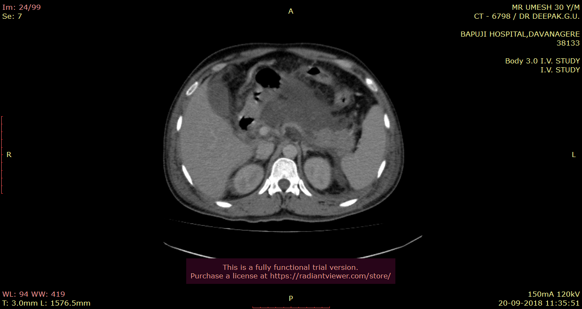

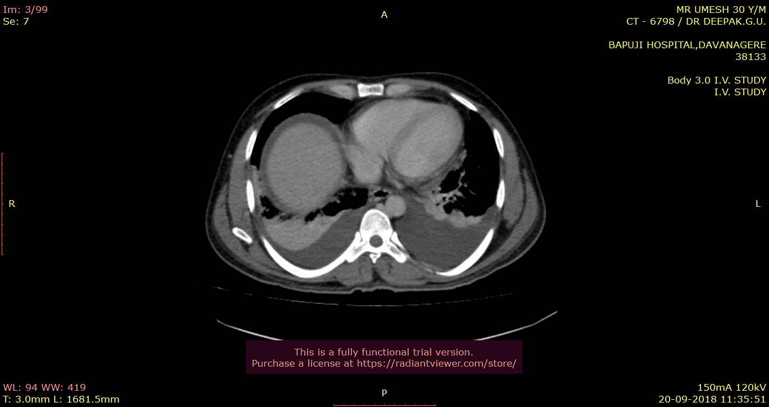

**Fig 1A and B: CECT axial section shows bulky pancreas with evidence of necrosis in head ,neck and body with bilateral pleural effusion .In this case MCTSI -10.**



**FIG 2: CECT axial section shows Bulky pancreas with features interstitial edematous pancreatitis. MCTSI was 2 in this case.**



**FIG 3: CECT axial section shows pancreatic pseudocyst adjacent to the esophagus**

**REFERENCES:**

1) Chauhan S, Forsmark C. Editorial: The Difficulty in Predicting Outcome in Acute Pancreatitis. The American Journal of Gastroenterology. 2010;105(2):443-445.

2) Leung T. Balthazar computed tomography severity index is superior to Ranson criteria and APACHE II scoring system in predicting acute pancreatitis outcome. World Journal of Gastroenterology. 2005;11(38):6049.S

3)Balthazar E, Robinson D, Megibow A, Ranson J. Acute pancreatitis: value of CT in establishing prognosis. Radiology. 1990;174(2):331-336.

4)Mortele K, Wiesner W, Intriere L, Shankar S, Zou K, Kalantari B et al. A Modified CT Severity Index for Evaluating Acute Pancreatitis: Improved Correlation with Patient Outcome. American Journal of Roentgenology. 2004;183(5):1261-1265.

5) Wu B, Johannes R, Sun X, Tabak Y, Conwell D, Banks P. The early prediction of mortality in acute pancreatitis: a large population-based study. Gut. 2008;57(12):1698-1703.