Case Report:  
ANAESTHETIC MANAGEMENT IN A CASE OF GORLIN GOLTZ SYNDROME

Dr. PSM Ramaganesh1, *Dr. B.E.V.Girish2

Department of Anaesthesia, NRI Institute of Medical Sciences, Visakhapatnam, India

Corresponding author*

**Abstract:**   
The Gorlin-Goltz syndrome is an autosomal dominant inherited syndrome related to mutation in “Patched” tumour suppressor gene on chromosome 9, with high penetration and variable expressivity, manifested by multiple defects involving the skin, nervous system, eyes, endocrine system, and bones and characterized by the presence of multiple odontogenic keratocysts along with various cutaneous, dental, osseous, ophthalmic, neurological, and sex organ abnormalities. Gorlin-Goltz syndrome has rarely been reported from India. Early diagnosis and treatment of Gorlin-Goltz syndrome, as well as family screening and genetic counselling are essential as it may be associated in 10% of the patients with aggressive basal cell carcinomas and malignant neoplasias.In order to establish a diagnosis of the Gorlin–Goltz syndrome, the criteria chosen were given by Evans *et al*. (1993) , which was later modified by Kimonis *et al*. (2004). The presence of two major and one minor or one major and three minor criteria are necessary to establish diagnosis.

INTRODUCTION:

The Gorlin-Goltz syndrome is an autosomal dominant inherited syndrome related to mutation in “Patched” tumour suppressor gene on chromosome 9, with high penetration and variable expressivity, manifested by multiple defects involving the skin, nervous system, eyes, endocrine system, and bones and characterized by the presence of multiple odontogenic keratocysts along with various cutaneous, dental, osseous, ophthalmic, neurological, and sex organ abnormalities. Gorlin-Goltz syndrome has rarely been reported from India.1,2,3 Early diagnosis and treatment of Gorlin-Goltz syndrome, as well as family screening and genetic counselling are essential as it may be associated in 10% of the patients with aggressive basal cell carcinomas and malignant neoplasias.4In order to establish a diagnosis of the Gorlin–Goltz syndrome, the criteria chosen were given by Evans *et al*. (1993)5 , which was later modified by Kimonis *et al*. (2004).6 The presence of two major and one minor or one major and three minor criteria are necessary to establish diagnosis7 .

**Major criteria**

* BCC (multiple or one occurring under the age of 20 years)
* Histologically proven KCOTs of the jaws
* Palmar or plantar pits (three or more)
* Bilamellar calcifications of the falx cerebri
* Bifid, fused, or markedly splayed ribs
* First-degree relative with NBCCS.

**Minor criteria**

* Macrocephaly
* Congenital malformation: Cleft lip or cleft palate, frontal bossing, coarse face, and moderate or severe hypertelorism.
* Other skeletal abnormalities: Sprengel deformity, marked pectus deformity, and marked syndactyly of the digits.
* Radiological abnormalities: Bulging of sella turcica, vertebral anomalies such as hemi vertebrae, fusion, or elongation of vertebral bodies, defects of the hands and feet, or flame-shaped hands or feet.
* Ovarian fibroma.

More than 100 minor criteria have been described. The presence of two major and one minor criteria or one major and three minor criteria are necessary to establish a diagnosis.

We report here one such patient, diagnosed at our hospital.

CASE REPORT:

A 52 year old male presented with chief complaints of lancinating type of pain, continuous in nature, moderate to severe degree in lower back region of neck and jaw since 5 months. Pain is radiating to ear. Patient had similar episodes in the 2017, for which marsupialization of odontogenic keratocyst involving right ramus and body of mandible was done under general anaesthesia in some rural hospital. Procedure went uneventful. Patient had no other comorbidities. Patient was 5feet 11inches height, with 84kgs weight, with well-coordinated gait. Vitals were stable

On local examination, face is grossly symmetrical, hypertelorism and strabismus were present (fig.1), frontal bossing, palmar pits (arrows in fig. 2). No significant changes on palpation, no signs of paraesthesia present, no lymph nodes were found to be enlarged. On airway examination, mouth opening was 2 finger breadth, high arched palate present, teeth were irregularly protruding with some teeth missing. (MOBILE TEETH: 1-1,2-1(grade I) MISSING TEETH: 1-2,4-7). TM joint was normal, and there were no clicking sounds on opening or closing of jaw, protraction and retraction of jaw were adequate. Thyromental distance within limits, there was no short neck, and there were no signs of restriction in neck mobility.

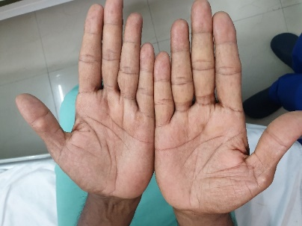



FIG 1

Mallampati classification grade 3. Generalized gingival recession, buccal and labial mucosa are apparently normal. Normal shape and size of tongue with no restriction in movements. No visible cysts seen in oral cavity. Chest X ray showed spaying of second rib (fig.5). All the blood investigation parameters were within normal limits. Computer tomography of brain revealed calcifications in the Falx cerebri. Other systemic examination revealed no significant abnormality.

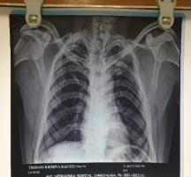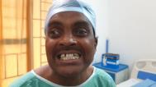





Fig.2

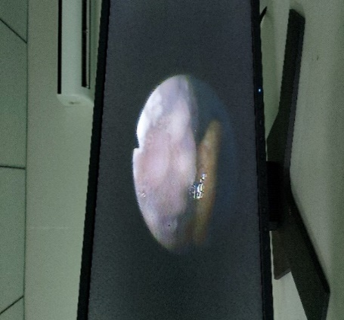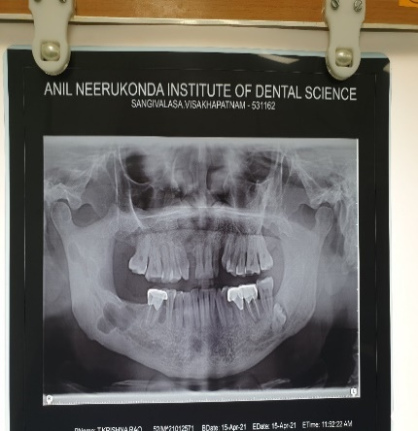

FIG 4

Fig.3

Fig.5

Surgery was planned under general anesthesia with awake fiberoptic intubation (nasal route) with flexometallic tube. In the preoperative room, patient was made to sit in semi recumbent position and 4% lignocaine nebulization was done for 20minutes followed by lignocaine viscous gargling was done. Xylometazoline drops were instilled into each nostril followed by lignocaine jelly in the most patent comfortable nostril. Antibiotic prophylaxis was given 1hour prior to surgery. Premedicated with inj. glycopyrrolate 0.2mg, iv, and inj. midazolam 2mg iv, inj. fentanyl 50mcg iv, then awake fiberoptic intubation, as depicted in image 4 was done (railroad technique for flexometallic endotracheal tube placement). Airway was anaesthetized using 2% lignocaine under landmark technique as well transtracheal instillation of 4% lignocaine. Spray as you go technique was used to anaesthetize the vocal cords, glottic area and other spared areas in the airway using 2% lignocaine. Flexometallic tube of size 7.5 ID was placed successfully under awake fibreoptic intubation. Inj. Propofol 110mg, inj. vecuronium 7mg, inj. fentanyl 50mcg iv were given during induction and maintained with oxygen, nitrousoxide and isoflurane with intermittent top ups of vecuronium as per dose. Surgical procedure was completed without any major adverse events and with moderate blood loss. Total 9 cysts were removed. Post procedure, throat pack was removed, extubation was done after achieving adequate recovery and residual relaxant effect was reversed with inj. myopyrolate (neostigmine + glycopyrrolate). The patient was shifted to post operative care unit for further management and follow up.

Histo-pathology/Biopsy confirmed the presence of thick coats of keratinised stratified epithelium, which is hallmark of odontogenic cyst.

Discussion:

An increased awareness as well as detailed history taking combined with clinical examination along with keeping the mind open to new diagnostic criteria acceptance will make the scenario well anticipated in advance and help us in prevention of major adverse events, in this patient we faced a cyst at vallecular area which might have ruptured when direct laryngoscopy was done. Since we proceeded with fibreoptics intubation, no adverse event had taken place. Since this disease has high degree of penetrance, along with patient the parents, siblings, progeny must be screened to reduce the transmission and further reduction in morbidity . Skeletal abnormalities like bifid ribs and splaying of ribs [as depicted in image 5], kyphoscoliosis can compromise pulmonary compliance and increase the risk of perioperative complications.These patients are known to have cardiac fibromas, meningiomas also, (in our case they were absent). Hence a detailed cardiac as well neurological evaluation must be done along with relevant radiological evidence.These patients are known to have skeletal anomalies and facial dysmorphism, cleft lip/palate, papillomatous growth in pharynx which makes mask ventilation difficult. These patients also have mandibular prognathism, high arched palate, malocclusion, impacted teeth, which make laryngoscopy difficult. Hence an alternate approach for ventilation and intubation must planned well in advance as per Difficult Airway Society guidelines to prevent unanticipated difficult intubation.

Threshold for using fibreoptic bronchoscopy assisted intubation must be kept as low as possible. In our patient this saved us from rupturing the cyst which is at very crucial point that is vallecula.Unanticipated nasal intubation can lead to risk of airway trauma, bleeding due to rupture of cysts which may make mask ventilation difficult. Hence awake fibreoptic intubation remains gold standard in such scenario. As this syndrome spreads through genetic mutations, there is need for antenatal screening/diagnosis by amniocentesis or by chorionic villous sampling and ultrasound scans. Hence there might be early diagnosis and intervention to manage effectively. 8,9

**REFERENCES:**

1. Jawa DS, Sircar K, Somani R, Grover N, Jaidka S, Singh S. Gorlin-Goltz syndrome. J Oral Maxillofac Pathol. 2009;13(2):89-92. doi:10.4103/0973-029X.57677
2. Totten JR,Cancer. 1980 Sep 15; 46(6):1456-62,The multiple nevoid basal cell carcinoma syndrome. Report of its occurrence in four generations of a family.
3. Walter AW. Gorlin Syndrome.http://www.emedicine.com/PED/topic890.htm.
4. Complications of the naevoid basal cell carcinoma syndrome: results of a population based study.Evans DG, Ladusans EJ, Rimmer S, Burnell LD, Thakker N, Farndon PA J Med Genet. 1993 Jun; 30(6):460-4.
5. Radiological features in 82 patients with nevoid basal cell carcinoma (NBCC or Gorlin) syndrome. Kimonis VE, Mehta SG, Digiovanna JJ, Bale SJ, Pastakia B Genet Med. 2004 Nov-Dec; 6(6):495-502.
6. Gorlin-Goltz syndrome. Joshi PS, Deshmukh V, Golgire S Dent Res J (Isfahan). 2012 Jan; 9(1):100-6.
7. Location of gene for Gorlin syndrome. Farndon PA, Del Mastro RG, Evans DG, Kilpatrick MW Lancet. 1992 Mar 7; 339(8793):581-2.
8. Victor A, McKusick VA. Basal cell nevus syndrome; BCNS-1986; OMIM: #109400.edited- mccolton- 03/04/2015 ref- http://www.omim.org/entry/109400.
9. Nevoid basal cell carcinoma syndrome (Gorlin syndrome). Lo Muzio L Orphanet J Rare Dis. 2008 Nov 25; 3():32.