Original Article.
A Comparative Study on Blood Pressure Measurement by Automated versus Manual Mercury Sphygmomanometer in the Urban Population of Deoghar, Jharkhand
Dr. Heemanshu Shekhar Gogoi

Department of Physiology, AIIMS, Deoghar (Panchayat Training Institute campus) in front of Daburgram , P.O. - Jasidih. P.S. & Dist. – Deoghar , State: Jharkhand
corresponding author: Heemanshu Shekhar Gogoi.

Abstract
Introduction Accuracy of a sphygmomanometer is very important to know the precise blood pressure readings as deviations in values outside the normal range is hazardous to health. The manual mercury sphygmomanometer is considered to be the gold standard in blood pressure measurement but due to the toxic nature of mercury it is gradually being banned globally. Automated sphygmomanometers are environment-friendly as they are mercury free as well as user friendly and so it is important to find out whether automated sphygmomanometers can take the place of conventional mercury sphygmomanometers in clinical and ambulatory settings.
Aim To evaluate the accuracy of the blood pressure measurement by automated sphygmomanometer in comparison with the blood pressure measurement by manual mercury sphygmomanometer in the urban population of Deoghar, Jharkhand.
Method It was a comparative study among 204 male and female subjects who were selected according to inclusion and exclusion criterias in urban areas of Deoghar. Their blood pressure was measured by mercury sphygmomanometer and then immediately after by automated sphygmomanometer. Statistical analysis was done with ‘MedCalc’ software considering p < 0.05 as significant.
Results It was seen that the systolic and diastolic blood pressure values obtained by both automated and mercury sphygmomanometer were in agreement with each other as it was statistically significant as p < 0.0001 which was suggestive of strong correlation between the two methods.
Conclusion The study suggests that the automated sphygmomanometers can be used in place of the conventional manual mercury sphygmomanometers as a primary tool of blood pressure measurement.
Key words Blood pressure, sphygmomanometer, comparison.

Introduction
Blood pressure measurement is vital in our day-to-day lives. Blood pressure is defined as the force exerted by the blood against any unit area of the vessel wall. This pressure is not constant but is pulsatile. The highest pressure is achieved during systole and is referred to as systolic pressure and the lowest pressure occurs in diastole and is referred to as diastolic pressure¹. Accurate and precise measurement of blood pressure is very important as both increase as well as decrease in blood pressure values outside the normal range is hazardous to one’s health. Hypertension is the subsequent elevation of the systemic arterial pressure to a level that places the patients at increased risk for target organ damage^{2,3}.
Approximately 7.6 million deaths which is around 13-15% of the total and 92 million disability adjusted life years world-wide were attributable to high blood pressure and also in India the prevalence of hypertension was 29.8%⁴. Researches document that hypertension is also directly responsible for 57% of all stroke deaths and 24% of all coronary heart disease deaths⁵. Hypertension doubles the risk of cardiovascular diseases, including coronary heart disease, congestive cardiac failure, ischemic and hemorrhagic strokes, renal failure and peripheral arterial disease. Studies also say hypertension may be genetically linked to the genes determining blood groups and hence according to some researches such as the one conducted by Gogoi et al. the prevalence of certain blood groups may be more in hypertension^{6,7}. Some researches also say that co-morbidities like diabetes mellitus and hypertension may influence and decrease the iron stores in multigravidas^{8,9}. Hypertension is also associated with additional cardiovascular disease risk factors and the risk of cardiovascular disease also increases with the total burden of risk factors.
For obtaining the correct readings the accuracy of the measuring device is very important. Both overestimation and underestimation of blood pressure measurement is hazardous to health. A false over-estimated reading exposes the patient to the hazards of treatment of hypertension whereas a false under-estimated reading puts the patient at a risk of hypertension related diseases and their complications, which can significantly reduce one’s life expectancy. So, accurate estimation of blood pressure is essential¹⁰.
There are different invasive and non-invasive methods available for blood pressure measurement¹¹. There are three non-invasive modalities commonly used globally for blood pressure estimation namely the manual mercury sphygmomanometer, aneroid sphygmomanometer and the digital or automated sphygmomanometer. Out of these, the blood pressure estimation by aneroid and mercury sphygmomanometers are manually performed by palpatory and auscultatory methods. The mercury sphygmomanometry is considered to be the gold standard in blood pressure measurement¹² and hence it is used in hospitals and ambulatory settings as a gold standard methodology¹³.
It is a pre-requisite to undergo professional training to operate mercury sphygmomanometers and also a mercury sphygmomanometer is tiresome to use in ambulatory settings. Researches also document that professional use of mercury sphygmomanometer makes the patient prone to white coat hypertension. Also due to the toxic nature of mercury it is gradually being banned globally in many countries especially in several of the European nations and in United States of America^{12, 14}. In India also the banning of mercury sphygmomanometer has started. So, it is very important to identify an alternative device which is easier and competent for blood pressure measurement.
Automated sphygmomanometers are considered environment-friendly as they are mercury free. The automated sphygmomanometers translate arterial pressure into oscillometric wave with system built algorithm display readings that uses oscillometric method¹³. They also donot require professional training to function and have easy operability which obviates the need of auscultation skill of the examiner¹⁵. They are also free from the bias of white coat hypertension^{16,17}. These devices are user-friendly in ambulatory settings and also in monitoring one’s blood pressure in home¹⁸. So, it is important to find out whether automated sphygmomanometers can take the place of conventional manual mercury sphygmomanometers in clinical and ambulatory settings.

Aims and objectives
To evaluate the accuracy of the blood pressure measurement by automated sphygmomanometer in comparison with the blood pressure measurement by manual mercury sphygmomanometer in the urban population of Deoghar, Jharkhand.
Materials and methods
The present study which is a community based cross sectional comparative study was done in the urban areas namely Daburgram and Tower chowk areas of Deoghar district among 204 subjects who were selected by purposive sampling who belonged to community dwelling male and female population of age group 18 to 60 years during the period from 15th October, 2019 to 10th March, 2020 for a duration of a little more than four and a half months.
Informed consent was obtained from the subjects before initiating the study.
Inclusion criteria
1. Both male and female persons with or without hypertension
2. Age group 18 to 60 years
Exclusion criteria
1. Pregnant females
2. Persons having pruritus and suffering from dermatologic infections such as dermatitis, psoriasis, scabies etc.
In this study the automated sphygmomanometer used was Bio Plus upper arm electronic blood pressure monitor. Model: BE-BP04. This device complied with the electromagnetic compatibility requirement of EN60601-1-2 and safety standards of EN60601-1 and performance of IEC 80601-2-30 as specified in EEC directive 93/42/EEC. The manual mercury sphygmomanometer used in the study was Bio Plus mercurial sphygmomanometer. Model: BE-BP02. This model was ISI certified (IS: 3390. CM/L– 8522676).
In this study a total of 204 subjects based on inclusion and exclusion criterias were selected. They were given mental and physical rest for 15 minutes prior to starting the test and then after that their blood pressures were measured on their left hand by palpatory and auscultatory methods by the mercury sphygmomanometer. Then immediately after their blood pressures were again measured on the same hand by the automated sphygmomanometer. The systolic and diastolic blood pressure findings as measured by the automated and mercury sphygmomanometers were compared and analysed.
Statistical analysis was done using ‘MedCalc’ software. Bland-Altman plot and Passing and Bablock regression analysis were performed considering p < 0.05 to be significant.
Observations and Results
Statistical analysis shows that the arithmetic mean of the systolic blood pressures measured by mercury sphygmomanometer is 129.12 ± 22.67 mmHg and the arithmetic mean of the systolic blood pressures measured by the automated or the digital sphygmomanometer is 130.83 ± 20.867 mmHg. After applying Bland-Altman plot and Passing and Bablock regression it was seen that the Spearman rank correlation coefficient was 0.933 with a statistically significant p < 0.0001, suggestive of strong correlation between two methods (refer fig.1, fig.2 and table-1). Thus it shows that the systolic blood pressure values as obtained by both manual mercury and automated sphygmomanometers have found to in agreement with each other.
Statistical analysis shows that the arithmetic mean of the diastolic blood pressures measured by manual mercury sphygmomanometer and digital or automated sphygmomanometer is 77.16 ± 13.83 mmHg and 78.97 ± 13.54 mmHg respectively. After applying Bland-Altman plot and Passing and Bablock regression it was seen that the Spearman rank correlation coefficient was 0.84 with a statistically significant p < 0.0001, suggestive of strong correlation between two methods (refer fig. 3, fig. 4 and table 2). Thus, it shows that the distolic blood pressure values as obtained by both manual mercury and automated sphygmomanometers have found to in agreement with each other.
The arithmetic mean of the systolic blood pressure values measured by mercury sphygmomanometer and automated sphygmomanometer are 129.12 ± 22.67 mmHg and 130.83 ± 20.86 mmHg respectively (refer fig. 5) . Also, the arithmetic mean of the diastolic blood pressure values measured by mercury sphygmomanometer and automated sphygmomanometer are 77.16 ± 13.83 mmHg and 78.97 ± 13.54 mmHg respectively (refer fig. 6). The mean difference of systolic pressures and diastolic pressures in between mercury and automated sphygmomanometer is 6.30 ± 4.708 mmHg and 5.471 ± 4.379 mmHg respectively. It also shows that as compared to mercury sphygmomanometer the automated sphygmomanometer shows a slightly higher values of systolic and diastolic blood pressure. But the difference is very minimal and as Bland-Altman plot and Passing and Bablock regression analysis showed that both the manual and the automated methods showed a strong and significant correlation, so the minimal blood pressure value difference in between the mercury and the automated sphygmomanometer can be considered insignificant.

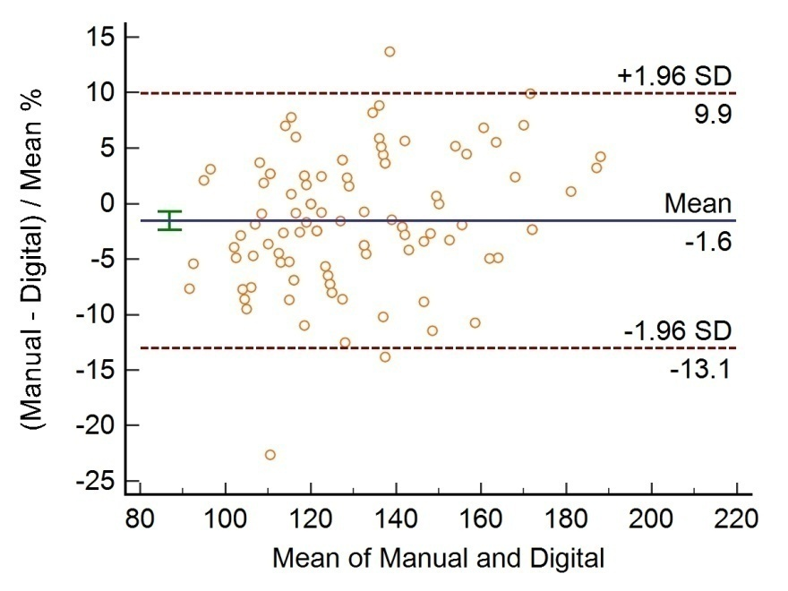
Fig. 1: The Bland-Altman plot of systolic blood pressures measured by manual mercury and digital or automated sphygmanometer.

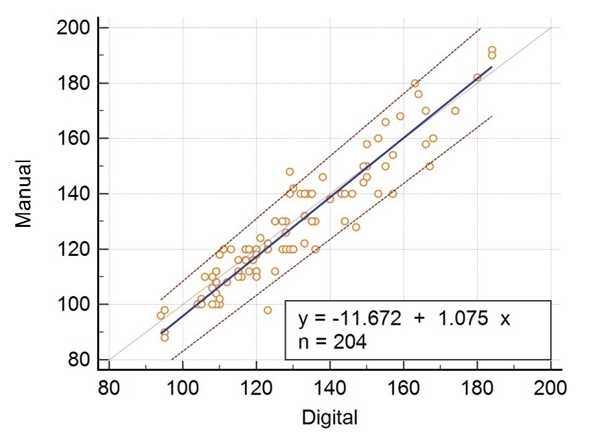
Fig. 2: The Passing and Bablock regression analysis of the values of the systolic blood pressures measured by manual mercury and digital or automated sphygmomanometer.

Table 1: After applying Bland-Altman plot and Passing and Bablock regression the results were:-
S. No. | Group | n | Arithmetic mean | Spearman rank correlation coefficient = 0.933.  p < 0.0001  (Considered extremely significant).
1. | Systolic blood pressure measured by manual mercury sphygmomanometer | 204 | 129.12
2. | Systolic blood pressure measured by digital or aneroid sphygmomanometer | 204 | 130.83

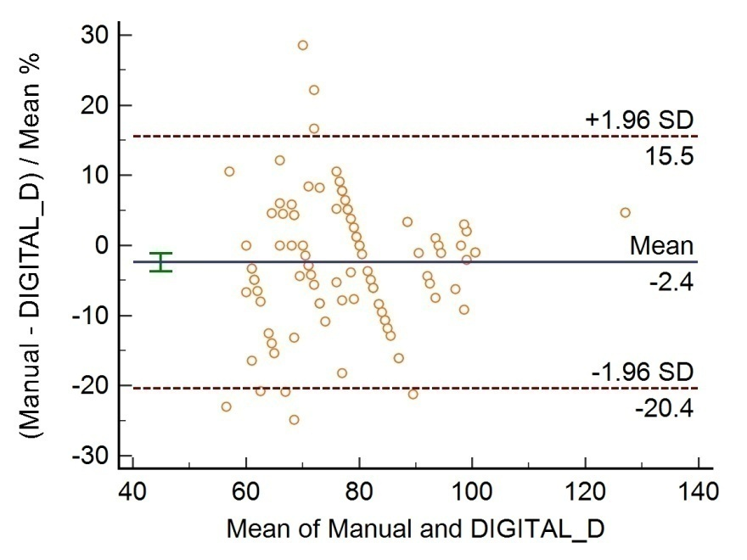
Fig. 3: The Bland-Altman plot of diastolic blood pressures measured by manual mercury and digital or automated sphygmanometer.

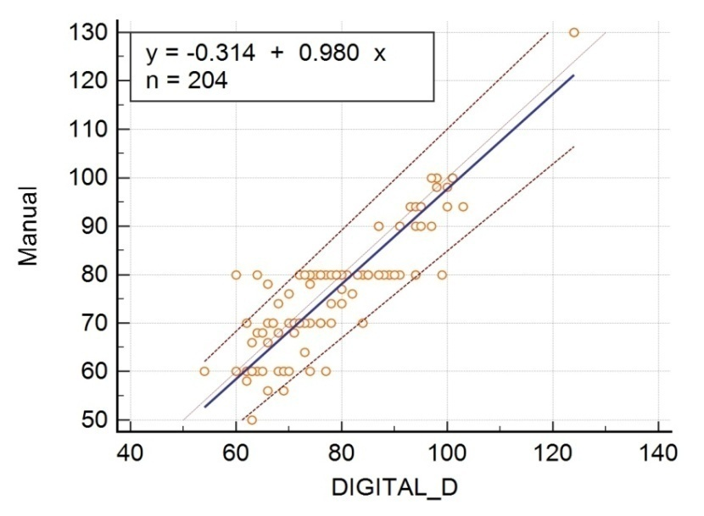
Fig. 4: The Passing and Bablock regression analysis of the values of the diastolic blood pressures measured by manual mercury and digital or automated sphygmanometer.

Table 2: After applying Bland-Altman plot and Passing and Bablock regression the results were:-
S. No. | Group | n | Arithmetic mean | Spearman rank correlation coefficient = 0.841  p < 0.0001  (Considered extremely significant).
1. | Diastolic blood pressure measured by manual mercury sphygmomanometer | 204 | 77.16
2. | Diastolic blood pressure measured by digital or aneroid sphygmomanometer | 204 | 78.97

Fig. 5: This figure shows the mean of systolic blood pressure values measured by mercury and automated sphygmomanometer.

Fig. 6: This figure shows the arithmetic mean of diastolic blood pressure values measured by mercury and automated sphygmomanometer.

Discussion
Arterial blood pressure measurement in an accurate way is very important as deviations from its expected normal range invites trouble and even may pose a threat to one’s life. Accurate and precise blood pressure measurement plays a crucial role in controlling the menace of hypertension as early diagnosis of hypertension is essential for timely management and prevention of its complications. Uncontrolled blood pressure may lead to cerebro-vascular accidents, coronary heart disease to name a few and also the study by Gogoi et al. and some other researchers noted that mental stress and anxiety associated with hypertension may lead to depression as it is an important factor of its prevalence¹⁹.
It is generally observed that the community level blood pressure surveys are generally been performed using the conventional mercury sphygmomanometer and for this the health professionals undergo rigorous and extensive training to standardize blood pressure measurement procedures to ensure continued compliance with the study protocol for blood pressure measurement until the survey is completed so that the blood pressure measurements of a very large number of subjects are accurately done. The net result is an estimate of the status of blood pressure of a population based upon conventional blood pressure readings, but obtained at great expense with extensive human resource efforts in training and execution. Thus, to simplify the tiring process of evaluating the blood pressure status of a huge population an attractive alternative method is the use of a validated automated sphygmomanometer designed specifically for the office, ambulatory and clinical settings¹⁶. Mercury sphygmomanometers have been used for more than one hundred years and regarding to advances in blood pressure recording methods, mercury sphygmomanometry seemed to have been removed from the clinics, but, mercury sphygmomanometer remains available as a reference standard until an alternative device is recognized as much¹⁴. However, in the recent past oscillometric equipment had gain importance²⁰. Also, previous studies have suggested that mean blood pressure readings by automated sphygmomanometer have exhibited a close approximation to the conventional manual blood pressure readings in different validation studies²¹ and clinical practice²².
Some studies have demonstrated that conventional readings by using mercury sphygmomanometer can be replaced by a validated automated recorder¹⁶. Several studies have revealed that automated apparatus was found with significant agreement of reporting approximately similar degree of blood pressure measurement in detecting hypertension when compared to manual one²³ which correlates with the results of other studies which showed that the differences between manual and electronic readings were statistically significant¹⁸.
But there are other studies also that say otherwise such as in their study Lim et al. found that the strength of agreement in between the automated and mercury sphygmomanometer was only moderate to good in the classifications and did not reach the predefined level in the majority of the quartiles, especially in the diastolic blood pressure and it was concluded that the automated sphygmomanometers are not recommended for the blood pressure measurement in epidemiological surveys, even though its performance appears good enough for clinical use²⁴. Moreover, adoption of the automatic device may result in underestimation of the prevalence of hypertension such as the one performed using the OMRON HEM 907XL automated device, which showed the sensitivity decreasing to 68%²⁵. Such studies showed the sensitivity to diagnosis of hypertension at 60s to 80s percent, despite the difference in the average values even below 2 mmHg^{25,26,27}. Research conducted by Suokhrie et al. revealed that there is a significant difference between manual and automatic systolic blood pressure readings so that automated readings averaged 3.9 points higher, but they found no remarkable differences in diastolic reading²⁸. In their research Myers et al. showed that automated office blood pressure measurement reduced office-induced hypertension and also they found a decrease in manual office blood pressure measurement but it was not related to any specific intervention. Also it was demonstrated that using automated office blood pressure measurement in routine primary care significantly reduced the white coat response in comparison with manual office blood pressure assessment^{29,30}. Also, results of the study conducted by Mirdamadi et al. suggested that manual method in measurement of blood pressure frequently show higher values especially in patients admitted to hospitals affecting up to 15 mmHg higher and is strongly associated with age, sex, different disease, and obesity and thus it was concluded that one cannot completely trust to automatic findings in measurement of blood pressure in hospital settings and especially in critical conditions, and manual method should be considered as a reference standard³¹.
Researches show that validated automated sphygmomanometers were designed to minimize the impact of observer–subject interaction on the measurement of blood pressure in the office or clinical settings and that this approach removes several aspects of bias associated with conventional blood pressure measurement using mercury sphygmomanometry¹⁰. The role of the observer in recording the blood pressure is eliminated and replaced with a validated and an accurate digital device which is programmed to measure readings at specific time intervals, thus eliminating imprecision due to factors such as digit preference, too rapid deflation of the cuff, or reading up or down to influence the patient’s blood pressure status. The absence of the observer from the room during readings also precludes conversation between the subject and the observer, which is a factor known to increase the blood pressure³². Some researchers also believe that many individuals exhibit a fall in blood pressure within one or two minutes after being left alone in a quiet room especially in the context of a treatment setting such as a doctor’s office or clinic and also it is emphasised that the benefits of taking readings using a validated automated device are generally applicable to population surveys and thus demonstrated that blood pressure readings taken using conventional mercury sphygmomanometer can be replaced by a validated, automated sphygmomanometer¹⁶. However, in their research Ma Y et al. showed that variation in blood pressure findings by both the automated and the mercury sphygmomanometers within participant or technician accounts for most of the variation³³. Also, it was observed in some studies that the automated or digital sphygmomanometers are easy to use as once the patient and cuff are positioned properly, the operator needs only to press a button on the unit to start blood pressure measurement without the help of a stethoscope. Both blood pressure and pulse readings are displayed on the unit’s screen and this was noted that automated wrist and arm manometers are being used in health care settings and by many individuals in their homes³⁴.
In the present study it was also seen that the mean difference of systolic blood pressures and the diastolic blood pressures in between manual and digital sphygmomanometer is 6.30 ± 4.708 mmHg and 5.471 ± 4.379 mmHg respectively and still these methods have a strong statistical correlation. This is in agreement with some studies which concluded that there may be difference of the automated and mercury sphygmomanometers’ readings in systolic and diastolic blood pressures which is still statistically significant^{23,35}.
Conclusion
This study shows that the automated sphygmomanometers can be used in place of mercury sphygmomanometers for blood pressure measurement in different settings as the blood pressure readings of both the devices show a strong and significant statistical correlation. In this study it was also seen that the systolic and diastolic pressure readings were slightly higher in automated sphygmomanometer as compared to mercury sphygmomanometer. So, while operating the automated sphygmomanometer in clinical settings such as in diagnosing hypertension adequate caution along with the appropriate standardisation of the automated device should be implemented and strictly followed.
The present study has also its limitations. The blood pressure findings of this study is applicable to only one model of automated sphygmomanometer and cannot be generalized to other models of automated sphygmomanometers of same or different companies. Some automated devices may have better or lower performance than the one used for the study for intermittent measurements, even though data for direct comparison are not yet available. Additionally, our study results cannot be directly applied to other populations, even with the same model of automated sphygmomanometer because of the fact that the factors related to errors might be different between populations. Also, the sample size of our study was a small one and also this study was limited to certain localities only. Hence, there lies a scope of performing similar large scale studies with a greater sample size involving different population groups in different regions and localities.
Thus, the present study concludes that as the automated sphygmomanometers possess a strong and significant statistical correlation with the gold standard mercury sphygmomanometers and an environment friendly non-toxic nature as well as simple and easy operability of use so the automated sphygmomanometers can be used interchangeably as an alternative methodology in place of the conventional manual mercury sphygmomanometers as a primary tool of blood pressure measurement in clinical and ambulatory settings as well as in home monitoring.

Acknowledgement
I express my heartfelt gratitude to my parents Mr. Harendra Nath Gogoi and Mrs. Kiran Gogoi for their unending love and support as well as to all the participants of this study without whom this study was not possible. A special thanks to Dr. Varikasuvu Seshadri Reddy and Dr. Vikas Maharshi, Assistant Professors of Department of Biochemistry and Department of Pharmacology respectively of All India Institute of Medical Sciences, Deoghar for their valuable help and support.

References

- John E Hall, Mario Vaz, Anura Kurpad, Tony Raj. Guyton & Hall Textbook of Medical Physiology. A South Asian Edition. Elsevier. 2013. Chapter 42: Determinants of Arterial Blood Pressure. Pg. 241.
- Braunwald, Fausi, Kasper, Hauser, Longo, Jameson. Harrison's principles of internal medicine 14th edition. Volume 2, McGraw-Hill publication 1998. Page no: 2074-2075, 2142-2143.
- William F. Ganong. Review of medical physiology, 21st edition, McGraw-Hill publication 2003. Page no. 644.
- Lim SS, Vos T, Flaxman AD, Danaei G, Shibuya K, AdairRohani H, et al. A comparative risk assessment of burden of disease and injury attributable to 67 risk factors and risk factor clusters in 21 regions, 1990-2010: a systematic analysis for the Global Burden of Disease Study 2010. Lancet 2012; 380:2224–2260.
- Gupta R. Trends in hypertension epidemiology in India. J Hum Hypertens 2004; 18:73-78.
- Gogoi HS, Bora B. Prevalence of ABO and Rh positive blood groups among the hypertensive male and female populations in greater Guwahati. Asian Journal of Science and Technology. March 2016.Vol. 07. Issue 03. Pg. 2635-2641.
- Gogoi HS, Bora B. A Cross Sectional Study of Prevalence of ABO and Rh Positive Blood Groups among the Pre-Menopausal and Post-Menopausal Women with Relation to Hypertension in Kamrup (Metropolitan) District. IOSR-Journal of Dental and Medical Sciences. April 2016. Vol. 15. Issue 4. Ver. IX. Pg. 47-54.
- Gogoi HS, Bora B. A Comparative Study of Haemoglobin Levels in Primigravidas and Multigravidas after Oral Iron Supplementation in Gauhati Medical College and Hospital. International Journal of Pharmacy and Pharmaceutical Research. July 2015. Vol 3. Issue 4. Pg. 178-190.
- Gogoi HS, Bora B. Oral Ferrous Sulphate Therapy and Moderately Anaemic Antenatal Subjects in Relation to Changes in Haemoglobin Levels. IOSR-Journal of Dental and Medical Sciences. June 2016. Vol. 15. Issue 6. Ver. XIII. Pg. 52-57.
- Reeves RA. Does this patient have hypertension? How to measure blood pressure.JAMA1995;273:1211-1216.
- Chobanian AV, Bakris GL and Black HR. The seventh report of the Joint National Committee on the Prevention, Detection, Evaluation, and Treatment of High Blood Pressure. Hypertension 2003; 42(6)1206-1252.
- Ogedegbe G and Pickering T. Principles and techniques of blood pressure measurement. Cardiology Clinics 2010; 28(4):571-586.
- Kakkad K, Damor P, Parmar B, Patel S and Dhivar N. Comparative Study of Blood Pressure Measurement by Aneroid and Digital Manual Sphygmomanometer. Natl J Community Med2016; 7(8):700-702.
- O’Brien E. Has conventional sphygmomanometry ended with the banning of mercury? Blood Press Monit 2002; 7:37-40.
- Shahbabu B, Dasgupta A, Sarkar K and Sahoo SK. Which is More Accurate in Measuring the Blood Pressure? A Digital or an Aneroid Sphygmomanometer. J Clin Diagn Res 2016;10(3):LC11-LC14.

- Myers MG, McInnis NH, Fodor GJ and Leenen FHH. Comparison between and Automated and manual sphygmomanometer in a population survey. Am J Hypertens 2008; 21(3):280-283.
- O’Brien E, Petrie J, Littler WA, de Swiet M, Padfield PL,Altman D, et al. The British Hypertension Society protocol for the evaluation of blood pressure measuring devices. J Hypertens1993; 11(Suppl 2):S43–S63.
- Mansoor K, Shahnawaz S, Rasool M, Chaudhry H, Ahuja G and Shahnawaz S. Automated Versus Manual Blood Pressure Measurement: A Randomized Crossover Trial in the Emergency Department of a Tertiary Care Hospital in Karachi, Pakistan: Are Third World Countries Ready for the Change? Open Access Maced J Med Sci 2016; 4(3):404-409.
- Gogoi H S. A Cross Sectional Study of the Prevalence of Depression among the Male Post-Graduate Medical Students in Gauhati Medical College and Hospital, India. European Scientific Journal. May 2016 edition. Vol 12, No. 14. Pg. 262-276.
- Rustagi N and Singh R. Mercury and Health Care. Indian J Occup Environ Med 2010; 14:45-48.
- Mattu GS, Perry TL Jr, Wright JM. Comparison of the oscillometric blood pressure monitor (BPM-100β) with the auscultatory mercury sphygmomanometer. Blood Press Monit 2001; 6:161–165.
- Myers MG. Automated blood pressure measurement in routine clinical practice. Blood Press Monit 2006; 11:59–62.
- Wadhwani R, Siddiqui NI, Sharma B. Assessment of accuracy of mercury sphygmomanometer and automated oscillometric device of blood pressure measurement in population of normal individuals. Asian Journal of Medical Sciences. Sep-Oct 2018. Vol 9. Issue 5.
- Lim YH, Choi SY, Oh KW, Kim Y, Cho ES, Choi BY, Kim YM, Shin J. Comparison Between an Automated Device and a Manual Mercury Sphygmomanometer in an Epidemiological Survey of Hypertension Prevalence. American Journal of Hypertension. April 2014. Volume 27. Issue 4.
- Ostchega Y, Nwankwo T, Sorlie PD, Wolz M, Zipf G. Assessing the validity of the Omron HEM-907XL oscillometric blood pressure measurement device in a National Survey environment. J Clin Hypertens 2010; 12:22–28.
- Vera-Cala LM, Orostegui M, Valencia-Angel LI, Lopez N, Bautista LE. Accuracy of the Omron HEM-705 CP for blood pressure measurement in large epidemiologic studies. Arquivos brasileiros de cardiologia 2011;96:393–398.
- Chiolero A, Gervasoni JP, Rwebogora A, Balampama M, Paccaud F, Bovet P. Difference in blood pressure readings with mercury and automated devices: impact on hypertension prevalence estimates in Dar es Salaam, Tanzania. Eur J Epidemiol 2006;21:427–433
- Suokhrie LN, Reed CR, Emory C, White R, Moriarity CT, Mayberry J. Differences in automated and manual blood pressure measurement in hospitalized psychiatric patients. J Psychosoc Nurs Ment Health Serv 2013; 51(3): 32-7.
- Myers MG, Godwin M, Dawes M, Kiss A, Tobe SW, Kaczorowski J. Conventional versus automated measurement of blood pressure in the office (CAMBO) trial. Fam Pract 2012; 29(4): 376-82.

- Myers MG, Godwin M, Dawes M, Kiss A, Tobe SW, Grant FC, et al. Conventional versus automated measurement of blood pressure in primary care patients with systolic hypertension: Randomised parallel design controlled trial. BMJ 2011; 342: d286.
- Mirdamadi A, Etebari M. Comparison of manual versus automated blood pressure measurement in intensive care unit, coronary care unit, and emergency room. ARYA Atheroscler 2017. Volume 13. Issue 1.
- Le Pailleur C, Helft G, Landais P, Montgermont P, Feder JM, Metzger JP, Vacheron A. The effects of talking, reading, and silence on the “White Coat” phenomenon in hypertensive patients. Am J Hypertens 1998; 11:203–207.
- Ma Y, Temprosa M, Fowler S, Prineas RJ, Montez MG, Friday JB, et al. Diabetes Prevention Program Research Group. Evaluating the accuracy of an aneroid sphygmomanometer in a clinical trial setting. Am J Hypertens 2009; 22(3):263-266.
- Nelson D, Kennedy B, Regnerus C and Schweinle A. Accuracy of automated blood pressure monitors. J Dent Hyg 2008; 82(4):35.
- Sujanitha V, Kumanan T, Guruparan M and Inthuja T. Mercury versus Oscillometric Device in Measuring Blood Pressure in Elderly: Which Is Authentic? OALib J2018;5:e4353

Date of Submission: 21 August 2020 Date of Publishing: 30 September 2020
Author Declaration: Source of support: Nil, Conflict of interest: Nil
Ethics Committee Approval obtained for this study? YES
Was informed consent obtained from the subjects involved in the study? YES
For any images presented appropriate consent has been obtained from the subjects: YES
Plagiarism Checked: YES
Author work published under a Creative Commons Attribution 4.0 International License

DOI: 10.36848/IJBAMR/2020/18215.56055

