Original article:
Study of hyponatremia in critically ill patients
¹ Dr. Akshay Pujari * , ² Dr. J. C. Awalekar, ³ Dr.Vijay Kulkarni

¹ Junior Resident, Department of Medicine , Bharati Hospital and Research Centre, Sangli.
^{2,3} Professor, Department of General Medicine, Bharati Hospital and Research Centre, Sangli.
Corresponding author *

This work is licensed under a Creative Commons Attribution-NonCommercial 4.0 International License
Date of submission: 24 January 2023
Date of Final acceptance: 11 March 2023
Date of Publication: 30 March 2023
Source of support: Nil
Conflict of interest: Nil

Abstract:
Background: Hyponatremia is a common electrolyte abnormality that affects critically ill patients. It can have a range of symptoms and is classified based on serum osmolality, volume status, and urine sodium levels.
Methods: This cross-sectional observational study was conducted in a tertiary care hospital. All indoor general medicine ward admissions were screened for hyponatremia over a period of nine months (January 2022-September 2022), and patients requiring medical ICU care and satisfying inclusion criteria were studied. Patients over the age of 18 with serum sodium levels less than or equal to 135 mEq/L were included in the study.
Results: The most common symptoms were lethargy (36.37%), nausea (33.33%), and headache (16.67%). The majority of patients had hypovolemic hyponatremia (50%). The mean duration of stay in the ICU was 4.5 days, and the mean duration of sodium correction was 3.8 days. There were no complications associated with the treatment of hyponatremia in any of the patients, and there were no deaths.
Conclusion: Hyponatremia is a common electrolyte abnormality in critically ill patients. The most common causes of hyponatremia in this study were gastrointestinal loss and endocrine disorders. The majority of patients had hypovolemic hyponatremia. Proper treatment of hyponatremia can prevent neurological consequences. There were no complications associated with the treatment of hyponatremia in this study.
Keywords: hyponatremia, critically ill, ICU, electrolyte imbalance, hypovolemic hyponatremia.

INTRODUCTION
A typical electrolyte abnormality that affects people who are critically unwell is hyponatremia.¹ The symptoms might be anything from nausea and malaise to lethargy, a little drop in serum sodium, headache, convulsions, and coma. Based on the serum osmolality, volume status, and urine sodium levels, hyponatremia can be divided into hypertonic, isotonic, and hypotonic forms. Hypervolemic, euvolemic, and hypovolemic hypotonic hyponatremia are further classified as follows^{: [2]} Hypovolemic hyponatremia: reduced total body water and sodium levels. Sodium deficiency is greater than water deficiency Euvolemic hyponatremia: A rise in body water volume and normal blood sodium levels. Hypervolemic hyponatremia: A rise in the body's sodium content accompanied by a bigger increase in its water content.³ Hyponatremia is treated according to the patient's volume status and how long they have been hypnotized. When hyponatremia is improperly treated, there are substantial neurologic consequences. There is not enough information to determine if higher mortality is independently correlated with hyponatremia on ICU admission. In order to determine the prevalence, cause, and prognosis of critically sick patients admitted to the ICU with hyponatremia, this study was conducted.³
METHODS AND MATERIALS-
The study was approved by the Institutional Ethics committee of Bharati Vidyapeeth (Deemed to be University), medical college, and Hospital, Sangli. Informed consent was taken from each participant. This study was a cross-sectional observational study in tertiary care hospital. all indoor general medicine ward admissions over a period of 9 months ( January 2022-September 2022) were screened for the presence of hyponatremia and patients requiring medical ICU care and satisfying inclusion criteria were studied. serial serum electrolytes and urine sodium were tested for all patients in the ICU satisfying the inclusion criteria. type of fluid given and daily correction of serum sodium of all patients were noted.
Patients over the age of 18 who are admitted to the ICU and have serum sodium levels that are less than or equal to 135 mEq/L meet the inclusion criteria.
Exclusion Standards Patients under the age of 18, post-operative patients, those receiving renal replacement therapy, people with hyperlipidemias, paraproteinemias (Pseudohyponatremia), people taking mannitol, people using radiographic contrast agents, and people with hyperglycemia (translocational hyponatremia) were all excluded from the study.
PROCEDURE AND ASSESSMENT-
The outcome was measured in terms of mortality, duration of stay in ICU, number of days required for sodium correction, and complications of treatment if any. patients were followed up till hospital discharge or death. Less than 135 mmol/L of serum sodium was defined as hyponatremia. Patients with translocational hyponatremia (hyperlipedemia), paraprotenemias (Pseudohyponatremia), consuming mannitol, radiographic contrast agents, or experiencing hyperglycemia, as well as those with hypernatremia, were excluded.
Hyponatremic patients (serum sodium level less than 135 mmol/L) and normal serum sodium patients (serum sodium level 135–145 mmol/L) groups were created from the patients. As previously mentioned, three groups of hyponatremic individuals were further classified based on their volume status. At the time of ICU admission, history and clinical assessment were documented for each patient. The use of thiazide diuretics and selective serotonin reuptake inhibitors (SSRIs) was particularly noted in the detailed pharmacological history, and a clinical evaluation of volume status was performed. Patients' characteristics, such as the presence of acute renal failure, the number of days spent on a mechanical ventilator, the length of time spent in the intensive care unit, and other factors that could be used to determine. Complete blood count, fasting blood sugar, serum potassium (K), serum urea, serum creatinine, serum uric acid, liver function tests, lipid profiles, morning serum cortisol, and thyroid function tests were among the laboratory results.

RESULTS -
In the present study, the data were evaluated by using descriptive analysis in terms of frequency and percentage.
Table no.1 Distribution of the demographic variables of participants with hyponatremia in terms of frequency and percentage n-30
Clinical Variables | Clinical Values | f | %
Age in years | 21-30 | 4 | 13.33
 | 31-40 | 8 | 26.27
 | 41-50 | 10 | 33.33
 | 51-60 | 9 | 30
Gender | Male | 18 | 60
 | Female | 12 | 40
Medical Diagnosis associated with hyponatremia
 | Hypertension | 12 | 40
 | Diabetes Mellitus | 6 | 20
 | Chronic liver diseases | 9 | 30
 | Renal Failure | 1 | 3.33
 | Ischemic Heart disease | 2 | 6.67
Causes of Hyponatremia
 | Gastrointestinal loss | 10 | 33.33
 | Endocrine disorders | 7 | 23.33
 | Heart Failure | 8 | 26.27
 | Chronic liver diseases | 5 | 16.67
Common symptoms
 | Nausea | 10 | 33.33
 | Headache | 5 | 16.67
 | Drowsiness | 4 | 13.33
 | Lethargy | 11 | 36.37
Type of Hyponatremia
 | Hypervolemic | 13 | 43.33
 | Hypovolemic | 17 | 56.67
Serum sodium level (mEq/L)
 | Mild(130-135) | 4 | 13.33
 | Moderate(125-129) | 3 | 10
 | Severe(<125) | 23 | 76.67
Hospital Stay in days
 | 3-5 | 19 | 63.33
 | 6-10 | 7 | 23.33
 | 11-15 | 4 | 13.34

Distribution of age with gender
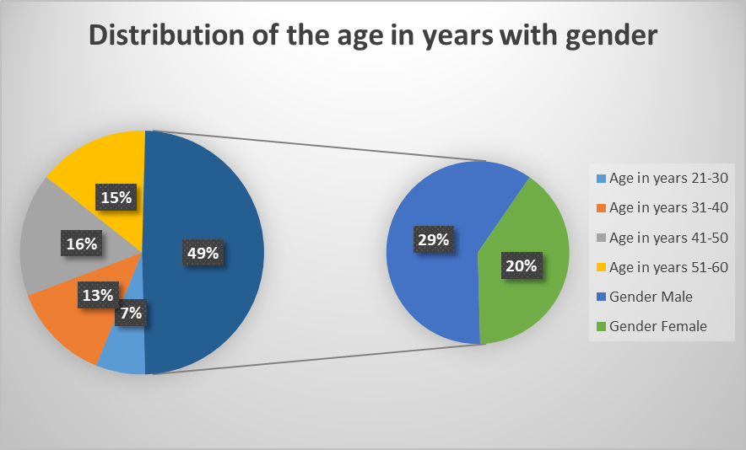
Figure No.1 shows the findings on distribution of the age in years with gender
The above table no.1 and figure no.1 depicts findings that the majority of the participant’s age groups showed a male predominance, and discovered that males 18(60%), and 12(40%) were females. Further, the majority of the participants 10(33.33%) comprised in 41-50 years and 9(30%) the 51-60 years of age, and the remaining4(13.33%), 8(26.27%) were from the age group of 21-30 years and 41-40 years of age respectively.

Distribution of medical diagnosis associated with hyponatremia-
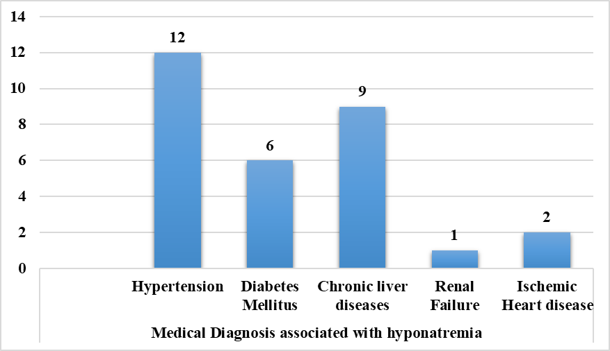
Figure No.2 shows the findings on the distribution of the medical diagnosis associated with hyponatremia
Table no.1 and figure no.2 shows regard to medical diagnosis associated with hyponatremia- revealing the findings that the majority of the participants 12(40%) had hypertension while 6(20%) had diabetic Mellitus, 9(30%) suffered from chronic liver diseases, 1(3.33%) had renal failure and 2(6.67%) had a case of ischemic heart diseases.
Distribution of the causative factors of hyponatremia-

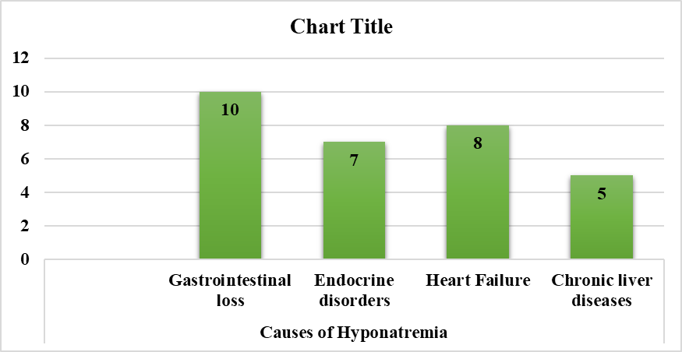
Figure No.3 shows the findings on distribution of the causative factors of hyponatremia
Table no.1 and figure no.3 shows when the causative factors assessed majority of the Hyponatremia patients had due to Gastrointestinal loss10(33.33%), 7(23.33%), had Endocrine disorders, 8(26.27%) had Heart Failure and Chronic liver diseases 5(16.67%).

Distribution of the common symptoms-
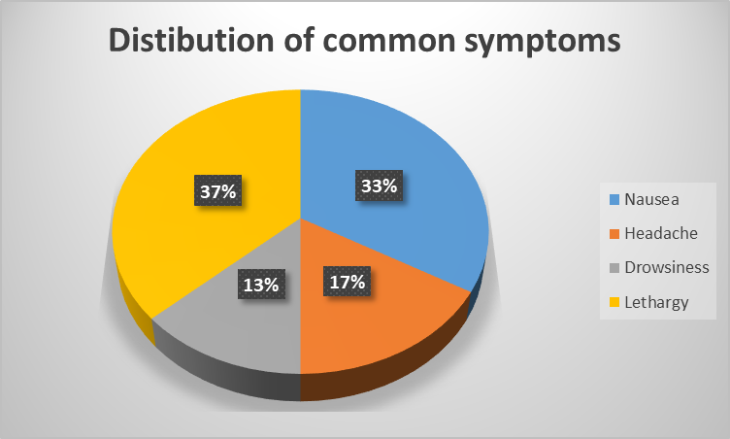
Figure No.4 shows the findings on distribution of the common symptoms of hyponatremia
Table no.1 and figure no.4 show regards to common symptoms shown in patients with hyponatremia, the majority of the participants 11(36.37) had complaints of lethargy, some participants 10(33.33%) had nausea 5(16.67%) had a headache, and 4 (13.33% had drowsiness.
Distribution of the types of hyponatremia-

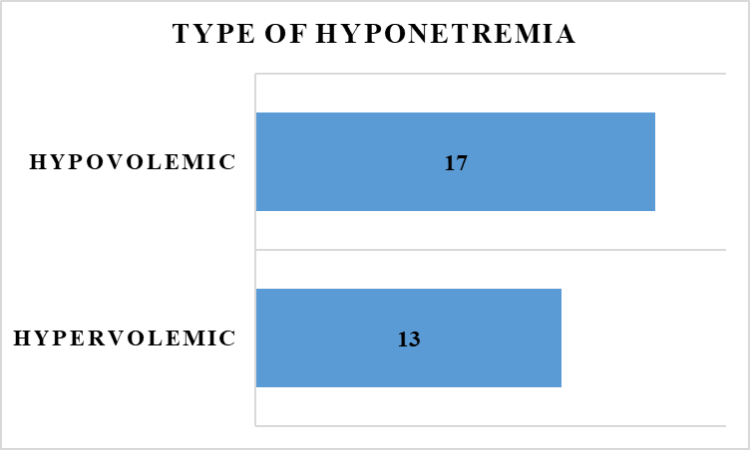
Figure No.5 shows the findings on the distribution of the types of hyponatremia
Figure no.5 shows the findings that when the types of hyponatremias were assessed in all the participants The majority of the participants 17(56.67%) had hypovolemic types of hyponatremias and the remaining 13(43.33%) had the hypervolemic type of hyponatremia.
Distribution of the serum sodium level-

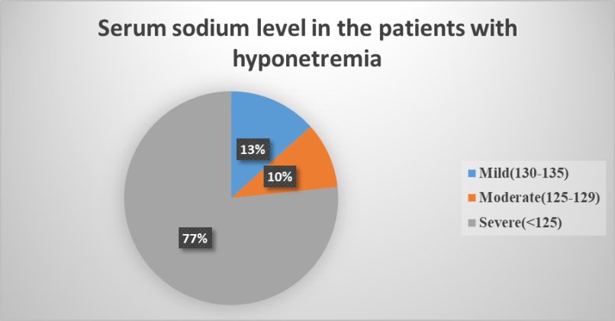
Figure No.6 shows the findings on the distribution of the level of serum sodium level leads to hyponatremia
Figure no.6 shows that in the laboratory investigation when serum sodium level was checked the majority of the samples 23(76.67% ) had less than 125 mEq/L of serum sodium level which interpreted that it is severe in a patient with hyponatremia and the remaining 4(1333%) had serum sodium level from 130-135 mEq/L which indicate the patient had mild hyponatremia and only 3(10%) participant had serum sodium level from 125-129 mEq/L which indicate the patient had moderate hyponatremia.
DISCUSSION:
This study is a cross-sectional observational study that aims to determine the prevalence, causes, and prognosis of critically ill patients with hyponatremia in the ICU. The study was conducted over a period of 9 months from January to September 2022 in a tertiary care hospital. Patients admitted to the general medicine ward were screened for hyponatremia, and those who required medical ICU care and met the inclusion criteria were included in the study. The inclusion criteria were patients over the age of 18 with serum sodium levels less than or equal to 135 mEq/L. Exclusion criteria were patients under 18 years of age, post-operative patients, those receiving renal replacement therapy, hyperlipidemia, paraproteinemias, those taking mannitol, using radiographic contrast agents, or experiencing hyperglycemia.
The outcome was measured in terms of mortality, duration of stay in the ICU, number of days required for sodium correction, and complications of treatment. Patients were followed up until hospital discharge or death. The data were evaluated using descriptive analysis in terms of frequency and percentage. The results of the study show that there were 30 patients with hyponatremia in the ICU during the study period. The age range of the patients was 21-60 years, with a mean age of 40 years. 60% of the patients were male, and 40% were female. Hypertension was the most common medical diagnosis associated with hyponatremia, followed by chronic liver diseases and diabetes mellitus. The most common causes of hyponatremia were gastrointestinal loss, endocrine disorders, heart failure, and chronic liver diseases. The common symptoms observed were nausea, lethargy, drowsiness, and headache. Thus this study provides valuable information on the prevalence, causes, and prognosis of critically ill patients with hyponatremia in the ICU. The results of this study can help healthcare professionals in the early diagnosis, appropriate management, and improved outcomes of patients with hyponatremia.
CONCLUSION:
In the present study, these investigations also decide the stay of the participants at the hospital which means the patients 19 (63.33%) with severe hyponatremia stay for an average of 3-5 days, and remaining the mild and moderate type patients stays less than 3-5 days respectively. However, statistical significance in terms of frequency and percentage shows that the severity of hyponatremia depends on the serum sodium level so if the patients admitted in ICU are treated for reducing the serum sodium level can lead to a reduction in the mortality rate.

REFERENCES-
- Baran D, Hutchinson TA: The outcome of hyponatremia in a general hospital population. Clin Nephrol 1984, 22:72-76.
- Hew-Butler T, Ayus JC, Kipps C, Maughan RJ, Mettler S, Meeuwisse WH, Page AJ, Reid SA, Rehrer NJ, Roberts WO, Rogers IR, Rosner MH, Siegel AJ, Speedy DB, Stuempfl e KJ, Verbalis JG, Weschler LB, Wharam P: Statement of the Second International Exercise-Associated Hyponatremia Consensus Development Conference, New Zealand, 2007. Clin J Sport Med 2008, 18:111-121.
- Arieff AI, Llach F, Massry SG: Neurological manifestations and morbidity of hyponatremia: correlation with brain water and electrolytes. Medicine (Baltimore) 1976, 55:121-129.
- Restuccia T, Gómez-Ansón B, Guevara M, Alessandria C, Torre A, Alayrach ME, Terra C, Martín M, Castellví M, Rami L, Sainz A, Ginès P, Arroyo V: Eff ects of dilutional hyponatremia on brain organic osmolytes and water content in patients with cirrhosis. Hepatology 2004, 39:1613-1622.
- Videen JS, Michaelis T, Pinto P, Ross BD: Human cerebral osmolytes during chronic hyponatremia. A proton magnetic resonance spectroscopy study.J Clin Invest 1995, 95:788-793.
- Tomlinson BE, Pierides AM, Bradley WG: Central pontine myelinolysis. Two cases with associated electrolyte disturbance. Q J Med 1976, 45:373-386.
- Sterns RH, Riggs JE, Schochet SS Jr: Osmotic demyelination syndrome following correction of hyponatremia. N Engl J Med 1986, 314:1535-1542. Brunner JE, Redmond JM, Haggar AM, Kruger DF, Elias SB: Central pontine
myelinolysis and pontine lesions after rapid correction of hyponatremia - a prospective magnetic resonance imaging study. Ann Neurol 1990,27:61-66.
- Sterns RH, Cappuccio JD, Silver SM, Cohen EP: Neurologic sequelae after treatment of severe hyponatremia: a multicenter perspective. J Am Soc Nephrol 1994, 4:1522-1530. Mount DB: The brain in hyponatremia: both culprit and victim. Semin Nephrol 2009, 29:196-215.
- Lohr JW: Osmotic demyelination syndrome following correction of hyponatremia: association with hypokalemia. Am J Med 1994, 96:408-413. Adrogue HJ, Madias NE: Hyponatremia. N Engl J Med 2000, 342:1581-1589.
- Verbalis JG, Goldsmith SR, Greenberg A, Schrier RW, Sterns RH: Hyponatremia

