Original Research Article:
Study of pattern of nutritional issues of special children attending neurology OPD and its correlation with upper arm length
Dr. M. Birla Pavalam*

Sr. Asst. Prof. of Neurology, Madurai Medical College, Madurai.
Corresponding author*

ABSTRACT
Aim: Special children under motor, cognitive and social categories have different nutritional issues which influence the physical growth. This study addresses these issues with correlation of upper arm length which is an alternative anthropometry marker in special children.
Material and methods: We selected forty special children coming to department of neurology outpatient department at Madurai medical collage, Madurai and the study period was between February 2021 to August 2021
Results: We studied 10 female children out of 40 and 30 male children out of 40. Age group less than 2.5 years contribute 20, (50 percent) and between 2.5 to by 6 years, 15 (37.5) and more than 6 years, 5 (12.5 percent). Motor, cognitive and social disabilities contribute 15 (37.5 percent), 10(25 percent) and 15 (37.5 percent) respectively. Nutritional issues are met with 35 children (87.5 percent) and 5 children (12.5 percent) don’t have any nutritional issues. Upper arm length falls below 50th centile in motor and cognitive disabilities whereas in social disabilities it is above 50th centile.
Conclusion: Nutritional issues are common in special children. Upper arm length, a marker of physical growth in these children is above average in special children belonging to social disabilities or autisms category.

INTRODUCTION
psycho
bio

Special children’s nutritional issues can be addressed on the basis of biopsychosocial concept, each factor operating in an independent manner, yet with significant interaction with other.

social

Children with moderate-severe disabilities have a markedly increased risk for mainutrition. Usually there is a high prevalence of under nutrition (failure to thrive and marasmus) and less frequently overnutrition (over weight or obesity). In these children, nutritional assessment is complicated by the intereaction of primary disease process like muscle atrophy, contractures, CNS pathology, movement disolders and both chronic and acute malnutrition.
Children with CP and oro motor dysfunction require significantly increased feeding time and exhibit marked reduction in growth and nutritional status. With this background, nutritional issues of forty children attending neurology OPD was asscessed.
METHODOLOGY
This is a cross sectional study conducted in a neurology OPD at our tertiary care hospital from February 2021 to August 2021.
Inclusion criteria:
1) Cerebral palsied children with delay in motor milestones and alteration in tone and posture.
2) Mentally retardation children with intelligent quotient assessment from psychologist opinion.
3) Children with impairment of socialization fulfilling the Indian scale of Autism Asscessment.
Exclusion criteria:
1) Regression of motor milestones or MRI brain evidence of leucodystrophy
2) Seizures of varying semiology leading on to cognitive decline
After selection, nutritional issues were asked in semi structured questionerre and upper arm length is measured as follows.
For children between 0 to 24 months, upper arm length is measured as shoulder elbow length. With the arem flexed at a 90 degree angle, the upper arm is measured from the superior lateral surface of the acromion to the inferior surface of the elbow. In children 2 to 18 years of age, upperarm length is measured from the superior lateral surface of the acromion to the radiale (head of the radius with the arm relaxed).
Upper arm length was plotted against centile chart and statistical analysis with P values are done at appropriate places apart from percentages.
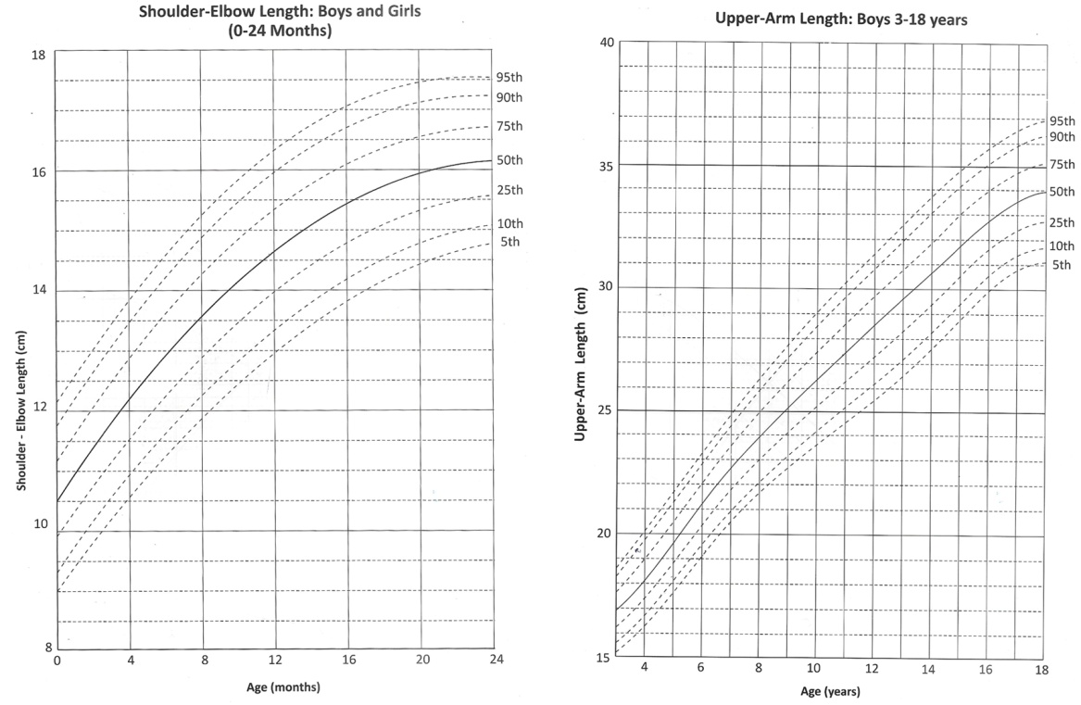

RESULTS:
Total children : 40
Male :30
Female :10
Tabe: 1 Age group distribution of special children
S.No | Age range | No. of children | Percentage
1 | < 2.5 years | 20 | 50
2 | 2.5 to 6 years | 15 | 37.5
3 | > 6 years | 5 | 12.5

Tabe:2 Disabilities distribution among special children
S.No | Nature | No. of children | Percentage
1 | Motor  Spastic CP & dyskinetic CP | 15 | 37.5
2 | Cognitive  Hypothyroidin & Mental retardation | 10 | 25
3 | Social  Autism spectrum disorder | 15 | 37.5

Flow chart of nutritional issues among special child nutritional issues

Not present present
5 children (12.5 percent) 35 children (87.5 percent)

Motor cognitive social
Just taking liquid diet (5) eat well the food he likes , differential eating, vomiting
Not chewing well (10) eat in small amounts.(10) most of food hel she dislikes (10) Indigestion with frequent stools (7) aversion in touching food (6)

Table : 3 Centile distribution of upper arm length of special children
S.o | Disability type | Centile level
 |  | 5th | 10th | 50th | 75th | Value
1 | Motor | 10 | 5 | - | - | <0.001
2 | Cognitive | 10 | - | - | - | <0.001
3 | Social | - | - | 10 | 5 | <0.001
P<0.05 significant
DISCUSSION
As already said, biopsychosocial factors influence each special child’s nutritional profile in an unique way. For example, even though abnormal movements may be an important contributing factor, poor food intake in dyskinetic CP, the temper difficulties associated with it may also contribute to the overall nutritional issues of that child. Similarly a child with autistic features have restrictive food interests which may be further worsened by anticonvulsant induced letharginess. In children with severe disabilities biological or physical factors contribution is predominant.
In our study male children out numbered female in special children attending neuro op. young (age < 6 years) children with disabilities contribute 87.5 percent of special children attending neuro autpatient. Motor and social disabilities share an equal percent of 37.5 percent, remaining by cognitive disabilities. Nutritional issues of varying pattern in an overlapping were found in 87.5 percent of special children. Upper arm length indicative of physical growth fall below 50th centile in motor and cognitive disabilities.
CONCLUSION:
Special children seeking medical attention are young and nutritional issues are common among them. Nutritional issues along with biological factors impair physical growth in motor and cognitive disabilities rather than in social disabilities. Addressing the nutritional issues may be one important aspect of multidisciplinary management of special children.
ABBREVIATIONS:
CP – Cerebral Palsy
MR – Mental Retardation
ASD – Autism Spectrum Disorder
OP – Out Patient

References:
1. Journal of neurodevelopment, official publication of Academy of Neurodevelopmental Sciences vol 1; Issue 2 july – December 2017
2. Text book of Pediatric nutrition gupte cragte peepes.
3. Wallace Helan M., ‘Nutrition and Handi capped children’ Jour. Am. Dietetic Association Vol 61 1991
4. Children with special health care needs: betty L. Lucas, Sharon A. Feucht 2004.
5. Dietry intakes and nutritional issues in neurologically impaired children Pediatric dept, V. Buzzi Children’s hospital, university of Milan Nov 2015
6. Dahi, M., Thommessen, M., Rasmussen, M., selberg, T. Feeding and nutritional characteristics in children with moderate or severe cerebral palsy. Acta pediatr. 1996, 85,697-701
7. Thommessen, M., Riis, G., Kase, B.F., Larsen, S., Heiberg, A. Energy and nutrient intakes of disabled children: Do feeding problems make a difference? J. Am. Diet. Assoc, 1991,12,1522-1525
8. Hals, J., Ek, J., Svalastog, A.G., Nilsen, H Studies on nutrition in severely neurologically disabled children in an institution. Acta paediatr. 1996. 12, 1469-1475.
9. Hals, J., Bierve, K.S., Nilsen, H., Svalastog, A.G., Ek, J. Essential fatty acids in nutrition of severely neurologically disabled children. Br.J. Nutr.2000, 83, 219-225
10 Sullivan, P.B., Lambert B., Rose, M.,Ford Adams, M., Johnson, A., Griffiths, P. Prevalence and severity of feeding and nutritional problems in children with neurological impairment: Oxford feeding study, Dev. Med. Child Neurol. 2000, 42, 674-680
11. Gangil, A., Patwari, A.K., Aneja, S., Ahuja, B., Anand, V.K. Feeding problems in children with cerebral palsy. Indian J. Pediatr. 2001, 38, 839-846

