Case report
Variegated presentations of systemic lupus erythematosus (SLE)
– A pulmonologist’s perspective
Dr Sachin Vidyasagar, Dr Natesh G, Dr Priya Joy

Name of the Institute/ College: Saveetha Medical College and Hospital
Pournami Arimpur P.O , Thrissur, Kerala, 680620.
Corresponding author: Dr Sachin Vidyasagar; Email id: sachinvidyasagar@ymail.com

Abstract:
Systemic lupus Erythematosus is an autoimmune disease in which organs and cells undergo damage initially mediated by tissue binding auto antibodies and immune complexes. Its presentation and course vary greatly ranging from indolent to fulminant. Here we present three cases of SLE with unusual presentations. In case 1 a 16 years old female presented with multiple swelling on the neck and loss of weight with generalized lympadenopathy. Routine investigations showed decreased haemoglobin and increased ESR. FNAC of cervical and axillary lymphnode shows reactive hyperplasia. Chest Xray showed bilateral pleural effusion, Ultrasound showed pericardial effusion and Ascites. Rheumatology work up was positive for ANA, anti RNP & anti SM . In case 2 a 13 year old girl presented with continuous low grade fever, shortness of breath, non productive cough. Chest Xray showed B/L effusion and fluid tapped was exudative, lymphocytic and was started on ATT empirically. Patient after 2 months came with dyspnea and hyperpigmented macules with scaling all over the body .Adverse drug reactions were ruled out after witholding ATT. Rheumatology work up was positive for ANA and dsDNA. In case 3 a 27 year old female presented with right sided shoulder pain , dyspnea and left cervical lymphnode enlargment. Chest Xray showed right mild pleural effusion. CT pulmonary angiogram showed thromboembolic occlusion of right lower lobe segmental pulmonary. FNAC of cervical lymphnode showed reactive hyperplasia. Connective tissue workup , was positive for APLA, anti RO /SSA.These case reports helps Pulmonologist recognise various presentations of SLE.
Keywords: Systemic lupus erythematosus , Systemic lupus erythematosus , by tissue-binding autoantibodies

Introduction:
Systemic lupus erythematosus (SLE) is a multigenic autoimmune disease in which organs and cells undergo damage initially mediated by tissue-binding autoantibodies and immune complexes. Its presentation varies from indolent to fulminant. SLE is diagnosed as per either the Systemic Lupus Erythematosus International Collaborating Clinics (SLICC) or American College of Rheumatology (ACR) criteria. Neither of them takes lymphadenopathy or pulmonary embolism as a criteria for SLE as it is a rare occurrence. But it should be taken in to consideration by the treating physicians so that a ailment like SLE should not be missed. Here we present three variegated presentation of SLE.
Case report 1:
A16 year old female, complaints of generalised weakness, significant loss of weight and multiple swellings on the neck since 6 months with no history of fever, cough, malar rash, photosensitivity. On examination pallor was present, generalised lymphadenopathy was noticed ( bilateral cervical, matted axillary and inguinal) largest measuring 2 x 3 cervical lymph node on the left side. Multiple hyperpigmentedmacule’s and papule’s with excoriation was also seen. Reduced breath sounds noted over infraaxillary and infrascapular areas. Other systems were normal. Blood investigations showed haemoglobin 5.8g/dl, TLC 4000,. ESR 69. She was transfused 1 pint of PRBC. Chest radiograph and USG thorax showed evidence of bilateral pleural effusion. Thoracocentesis done showed predominantly lymphocytic, with ADA 25, LDH 156 and no evidence of acid fast bacilli. Mantoux test was positive . She was negative for HIV. FNAC of left cervical and axillary nodes was taken, reports showed reactive lymphoid hyperplasia. Later excisional biopsy was performed from cervical lymph node. The results of the biopsy were reported as benign follicular hyperplasia with no evidence of tuberculosis, malignancy or sarcoidosis. Also in CBNAAT, MTB was not detected. USG of the abdomen showed mild ascites with bilateral increased renal cortical echoes. Due multisystemic involvement rheumatology work up was done. Patient had direct Coombs test positive. Compliments C3 and C4 was low. ANA-IFA was positive, homogenous 3+ pattern. ANA immunoblot showed positive for anti SM RNP, anti SM and Nucleosome. Patient was started on Immunosuppersive therapy

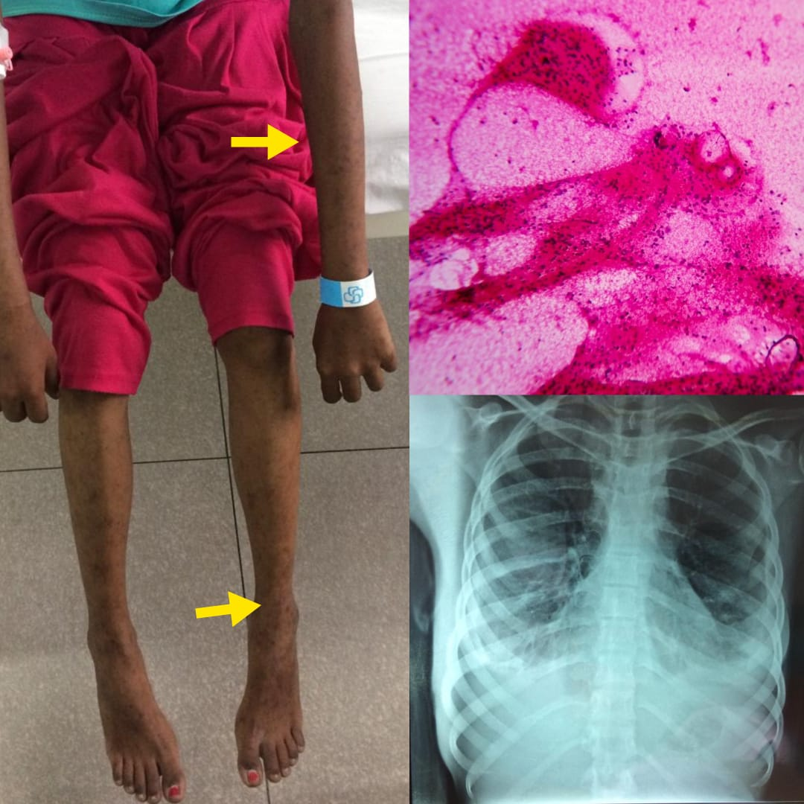

Figure 1 : Showing multiple rashes, Bilateral pleural effusion and Hyperplastic lymph nodes.

Case report 2:
A 13 years old female, complaints of continuous low grade fever, shortness of breath, nonproductive cough since 10 day’s with no history of loss of weight, skin lesions. On examination, reduced breath sounds over bilateral interscapular, infrascapular, axillary and infraaxillary area’s. Chest x ray showed bilateral pleural effusion. Aspiration done showed exudative, predominantly lymphocytic, ADA 30. Mantoux test was positive. All other routine investigations where normal. She was started on empirical ATT . Unfortunately patient did not follow up and came after 2 months with complaints of shortness of breath, fever and rashes all over the body since 1 week. Suspected of drug induced lesions, ATT stopped immediately. On examination well to ill defined hyperpigmentedmacule’s with scaling present all over thebody. Multiple enlarged nodes over the right supraclavicular region, which were mobile, not matted, largest node measuring about 1x2cms. Reduced breath sounds over bilateral interscapular, infrascapular, axillary and infraaxillary area’s. USG guided biopsy of the neck lymph nodes showed reactive hyperplasia.CT scan of thorax, abdomen and pelvis taken, found to have left lower lobe basal segments ground glass opacity (GGO) with bilateral moderate pleural effusion with minimal pericardial effusion, hepatomegaly (17cm), splenomegaly (12.5cm) and mild ascites with multiple lymph nodes of <1cm. Urine analysis showed proteinuria 3+, 24-h urine protein was 719.6mg/dl. Due to multisystemic involvement, rheumatology work up was done. ANA-IFA was positive, homogeneous 3+ pattern.ANA imunoblot showed anti dsDNA.. Patient was started on Immunosuppersive therapy.

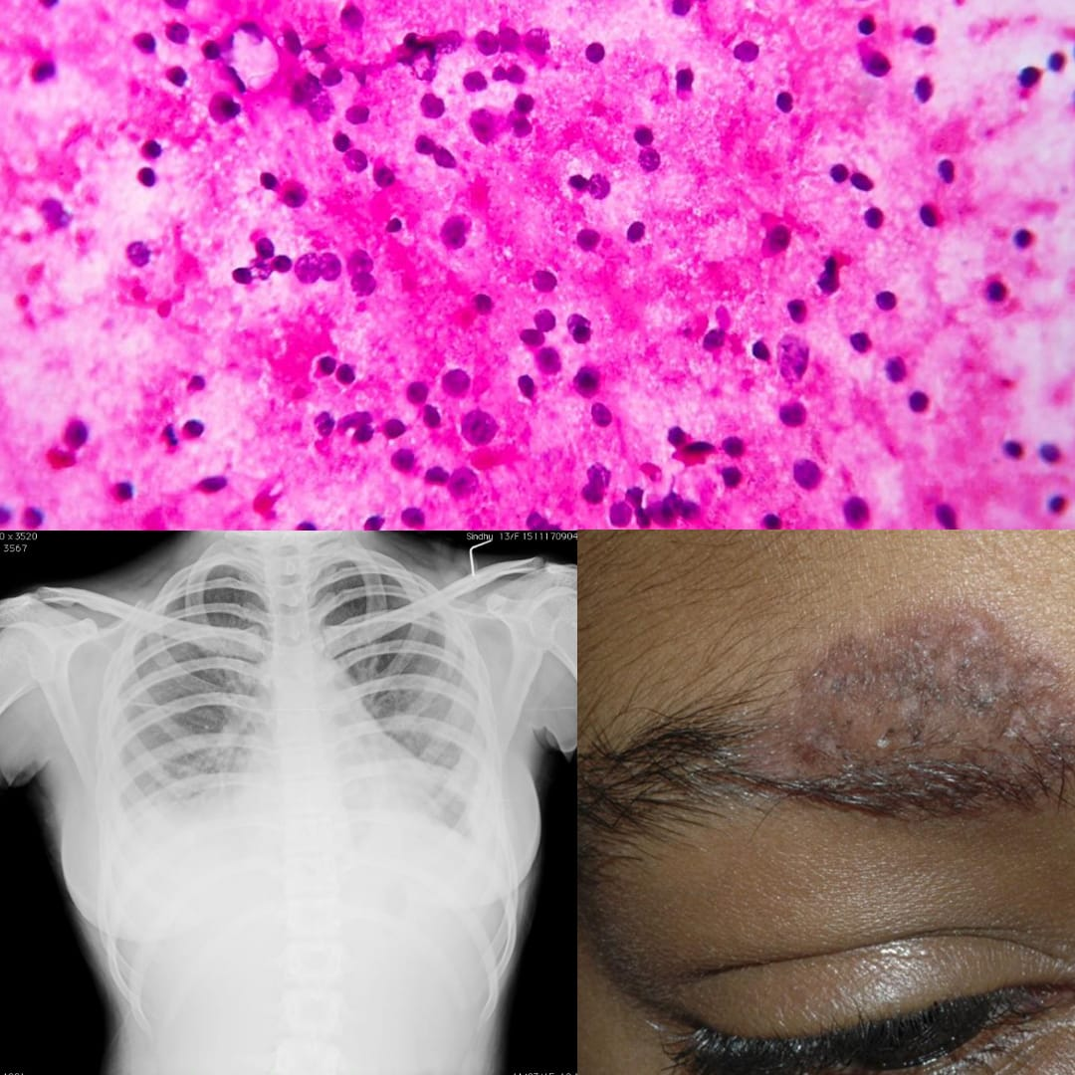

Figure 2: Showing Hyper pigmented macules with scaling , Bilateral effusion and Histopathology of hyperplastic lymph nodes.

Case report 3:
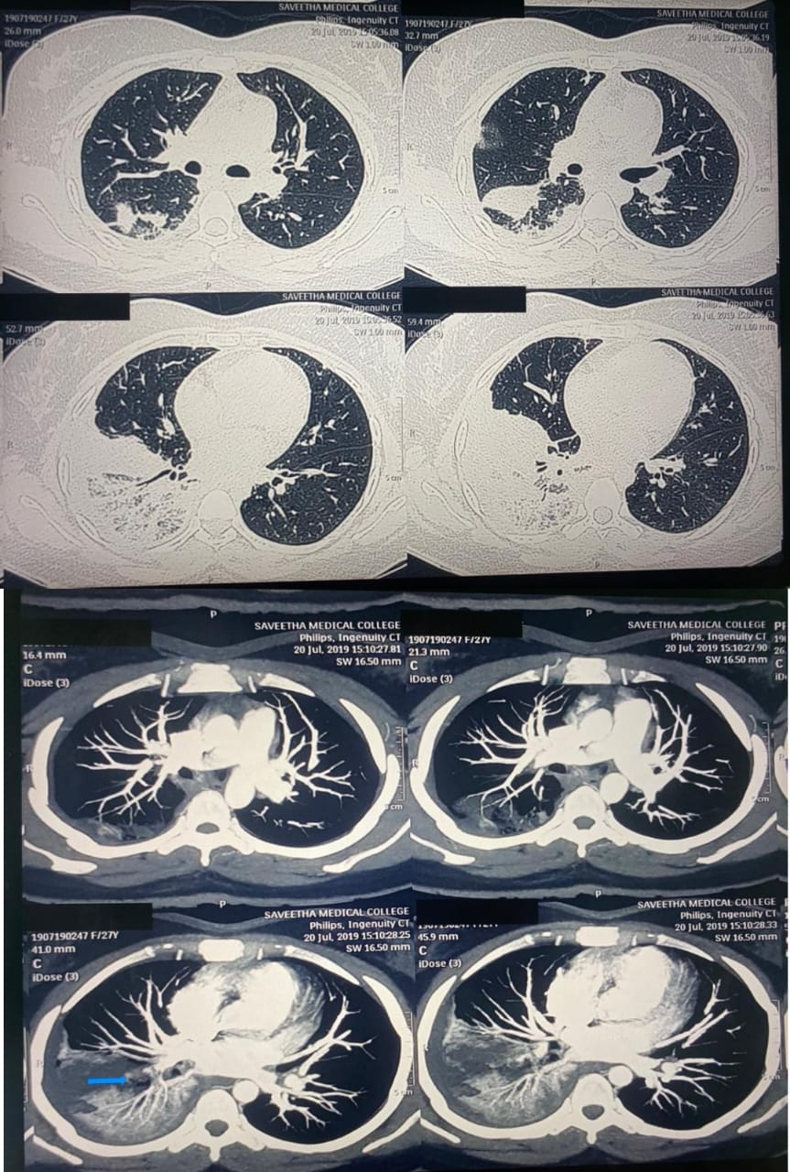
A 27 year old female, was admitted with complaints of fever since one week, shortness of breath since three days, right sided chest and shoulder pain since one day and loss of weight. On systemic enquiry, she had previous episodes of polyarthralgia. She gave history of being in contact with father who was treated for pulmonary tuberculosis. On examination she was dyspneic ( MMRC grade 4), reduced breath sounds over right infrascapular and infraaxillary areas. Initial blood picture showed TLC : 15900, haemoglobin 11.2. ESR 95mm. Urine analysis showed proteinuria ++. Troponin I was less than 0.012ng/mL. Chest radiograph taken showed nonhomogeneous opacity over right mid zone and right costophrenic angle blunting. Diagnostic thoracocentesis was done, but no effusion was obtained. CT scan of thorax showed calcific and non calcific lymph nodes in mediastinal and bilateral axillary regions, patchy consolidatory and GGO changes in right lower lobe, right pleural effusion with located fissure effusion. ECG had S1 Q3-T3 and incomplete RBBB, ECHO showed mild dilated RV, paradoxical movement of septum, mild TR, mild PAH, normal RV/LV function. As features were suggestive of pulmonary thromboembolism (PTE) later CT pulmonary angiogram done, which showed acute bland thrombotic/ thromboembolic occlusion of right lower lobe segmental pulmonary artery and corresponding subsegmental branches. D-Dimer was 2657. She was started on anticoagulants. FNAC of cervical lymph node was done which showed reactive lymphoid hyperplasia. Presence of antiphospholipid antibodies where checked but was negative. ANA IFA was positive, speckled cytoplasmic (3+) pattern, ANA by Immunoblot was positive for antiSmith, Ro SSA and Anti RIB. Patient was started on Immunosuppersive therapy.

Figure 3 : CT thorax - Right pleural effusion with located fissure effusion and patchy consolidation and GGO in right lower lobe. CT PA - Thromboembolic occlusion of right lower lobe segmental pulmonary artery .

Discussion:
The pleuropulmonary manifestations of SLE range in severity from minor pleuritic pain to serositis to the life threatening consequences of pulmonary haemorrhage, with pleurisy being the most common presentation¹. In case 1, patient presented initially lymphadenopathy. Patients developing lymphadenopathy during the course of disease is 12-15% and at the onset of disease is 5-7%². Histologically SLE lymphadenopathy have follicular hyperplasia, scattered immunoblasts and plasma cells with increased vascularity³. In case 1 malignancy and tuberculosis remained high on deferential. But after the tissue biopsy, it was ruled.
Prevalence of tuberculosis as the etiology of pleural effusion depends on the prevalence of tuberculosis in a particular population. Since tuberculosis is highly prevalent in our geographical region case 2 was evaluated for the same at first. When patient reviewed later, her symptoms were thought as due to drug induced lesions. More then 25% of patients on ATT have reported at least one type of adverse reaction, gastrointestinal or cutaneous reaction being the most common⁴. Pleuritis is the most common thoracic manifestation of SLE. Clinically apparent pleural effusion have been reported in up to 50% of patients with SLE ⁵.
In case 3 initially thought to have tuberculosis but later found to be having PTE. Considering age and PTE being unprovoked, Antiphospholipid syndrome (APS) was suspected diagnosed by the presence of antiphospholipid antibodies. These antibodies has been demonstrated in patients with SLE and is associated with an increased risk of intravenous thrombosis⁶. PTE due to SLE usually occurs in active phase of disease, as seen in our case. Polymorphism in the toll-like receptor 2 (TLR2) has recently been linked to the pathogenesis of thrombosis in SLE patients⁷. SLE by itself is a systemic inflammatory disease. In all the 3 cases renal biopsy should be done which we have not at present done. Nine in ten lupus patients will develop renal involvement during the course of the disease⁸. In cases one and two ATT treatment was continued for 6 months. Lupus nephritis is considered a risk factor for tuberculosis and some patients develop disseminated tuberculosis even before use of corticosteroids⁹.
Conclusion:
Extensive generalized diffuse lymphadenopathy as a presenting feature is so rare, that it was rejected by the systemic lupus international collaborating clinics in their new classification criteria for SLE. However our case demonstrates that this rare presentation of SLE should not be forgotten by clinicians. Many symptoms of SLE may not be the initial presentation but can appear later on the course of disease. We would also want to emphasis that pleural effusion being most common manifestation of pleural disease should not always be misdiagnosed as tuberculosis

With the available studies in SLE patients it is evident that SLE patients have a greater prevalence of thrombotic events with respect to healthy subjects even in the absence of antiphospholipid antibodies. Therefore these cases are presented to make pulmonologists aware of such a variegated presentation of SLE and diagnose earlier.

References:
- Keane MP, Lynch JP 3rd. Pleuropulmonary manifestations of systemic lupus erythematosus. Thorax 2000; 55:159.
- Cervera R, Khamashta MA, Font J, Sebastiani GP, Gil A, Lavilla P et al. Systemic lupus erythematosus: clinical and immunologic patterns of disease expression in a cohort of 1,000 patients. The European Working Party on Systemic Lupus Erythematosus Medicine (Baltimore) 1993;72:113.
- Papadaki HA, Xylouri I, Katrinakis G, Foudoulakis A, Kritikos HD, Stathopoulos EN, Boumpas DT, et al. Non-Hodgkin's lymphoma in patients with systemic lupus erythematosus. Leuk Lymphoma. 2003;44(2):275-279.
- Hong Kong Chest Service/British Medical Research Council. Controlled trial of four three-times-weekly regimens and a daily regimen all given for 6 months for pulmonary tuber- culosis. Second report: the results up to 24 months. Tubercle 1982;63:89-98.
- Orens JB, Martinez FJ, Lynch JP III (1994) Pleuropulmonary manifestations of systemic lupus erythematosus. Rheum Dis Clin North Am 20:159–193,
- Goldhaber SZ (1998) Pulmonary embolism. N Engl J Med 339:93–104, .
- Kaiser G, R Tang LF, Taylor KE, Sterba K, Nititham J, Brown EE, et al. A polymorphism in TLR2 is associated with arterial thrombosis in a multiethnic population of patients with systemic lupus erythematosus. Arthritis. Rheumatol. 2014;66:1882–7.
- Cameron JS (1999) Lupus nephritis. J Am Soc Nephrol 10:413–424.
- Li Y, Zhao H, Zuo X: Systemic lupus erythematosus with lung, brain, liver, and spleen tuberculosis. J Clin Rhematol. 2012, 18 (7): 385-10.1097/RHU.0b013e31826d67ac.

