Original Article
Recent Trends in the management of Peptic Ulcer Disease and its complications
Dr.Abdul Kareem Baig, Prof Dr. Shekar R.M, Dr.Kaveri.A

Department of General Surgery, Vydehi Institute of Medical Sciences and Research Centre, Bangalore, India-560066.
Corresponding Author: Dr.Abdul Kareem Baig

This work is licensed under a Creative Commons Attribution-NonCommercial 4.0 International License
Date of submission: 29 April 2023
Date of Final acceptance: 8 May 2023
Date of Publication: 02 June 2023
Source of support: Nil
Conflict of interest: Nil

ABSTRACT
INTRODUCTION: Gastric and duodenal peptic ulcer disease (PUD) had been the nightmare to the doctors in the 19th to 21 century. The number of registered PUD cases increased at the time of industrial revolution . There has been sharp decline in the prevalence of PUD in the past few years. The concept of Helicobacter pylori has brought the drastic change in understanding the disease and its management. Peptic ulcer disease remains a significant healthcare problem consuming considerable amount of financial resources of the patient. In complicated peptic ulcers, successful management involves prompt recognition, resuscitation when required, appropriate antibiotic therapy and timely surgical and radiological treatment.
METHODS: This is a prospective and observational study including 70 patients with Peptic Ulcer Disease who are undergoing treatment in the Department of General Surgery and Medical Gastroenterology. The study includes previously diagnosed patients appearing with complications in the EMD at Vydehi Institute of Medical Sciences and Research Centre. The patient is followed up for 8 weeks. Data will be collected in person and from hospital records
RESULTS: Majority of the patients from the studyhave the association of H.pylori as predisposing factory for the peptic ulcer disease(82%) . These patients are treated effectively with appropriate medical management with no complications. Out of all the complicated peptic ulcer disease bleeding peptic ulcers(11.5%) were the major case followed by perforated peptic ulcer(2.8%) and oesophageal peptic stricture(2.8%). Bleeding peptic ulcers and oesophageal peptic strictures are better managed with minimal invasive procedure like hemoclip application and CRE dilatation respectively, where as perforated peptic ulcer is managed surgically with GRAHAM omentoplasty.
CONCLUSIONS : Peptic Ulcer Disease, was a common disease in the past few decades, for which surgery was the main stray of treatment. In today’s scenario, it can be treated effectively with conservative management. This study reveals that there is a high curable rate for PUD with appropriate medical management, yet complications developed due to improper medications and undiagnosed disease such are better treated with invasive procedures.
KEYWORDS: Pain abdomen, Peptic ulcer disease, Perforated peptic ulcer, Bleeding peptic ulcer, Hemoclips, Oesophageal peptic stricture

INTRODUCTION:
Gastric and duodenal peptic ulcer disease (PUD) had been the nightmare to the doctors in the 19th to 21 century. The number of registered PUD cases increased at the time of industrial revolution . There has been sharp decline in the prevalence of PUD in the past few years. Theodor Billroth in 1881 first performed gastric resection which led to era of resective gastric surgery for PUD. The variants of Billroth I & II total gastric resection had been the main course of treatment for PUD for many decades. Later in the 1977 with the introduction of H2 receptor antagonist the prevalence of the disease decreased. This further declined by 1980 due to the proton pump inhibitors.(1)
The concept of Helicobacter pylori has brought the drastic change in understanding the disease and its management. The discovery of H pylori and it’s appropriate treatment with a higher rate, PUD has now become nearly a curable disease. even though a new challenge appeared with changing resistance of the bacteria to the antibiotics, the management of the PUD depends on the understanding the pathogenesis of ulcer formation and selecting appropriate therapy. Peptic ulcer disease remains a significant healthcare problem consuming considerable amount of financial resources of the patient. In complicated peptic ulcers, successful management involves prompt recognition, resuscitation when required, appropriate antibiotic therapy and timely surgical and radiological treatment.
In India, after acute appendicitis, peptic ulcer perforation is the next most common cause of Acute abdomen leading to emergency surgical intervention(2). Of the 11 emergency general surgical conditions as defined in the 2010 WHO global burden of disease study, PUD accounted for 27% of all disability adjusted life years (DALY) and deaths in the developing world, while lower to middle income countries accounted (LMICS) for 90% of DALYs and 85% of PUD related death(3). Older age of presentation, increase in use of non-steroidal anti- inflammatory drugs (NSAIDs) and associated comorbidities lead to high mortality rate in elderly. This is making people to rethink the management protocol. Initially it was thought that surgery was most effective, but nowadays it is shifting towards less invasive procedures and measures. This study summarises the current scenario in the management of peptic ulcer disease and its complication rates after appropriate medical management
AIMS AND OBJECTIVES:
- To ascertain the appropriate management of the Peptic Ulcer Disease according to its etiology in present day scenario based on the WSES guidelines.
- To understand the role of Helicobacter pylori in the Peptic Ulcer Disease and study present day scenario diagnostic and management modalities of the disease
- To evaluate what percentage of treated Peptic Ulcer Disease land in complications like bleeding ulcer and gastric or duodenal perforation and it’s management
MATERIALS AND METHODS:
This is a Prospective and observational study of 70 patients with Peptic Ulcer Disease who is undergoing treatment in Department of General Surgery and Gastroenterology at Vydehi Institute of Medical Sciences and Research Centre. From this study , pre-treatment detailed history and thorough physical examination and necessary laboratory and radiological investigations will be done to arrive at pre-treatment diagnosis. The patient is followed up for 8 weeks. Data will be collected from person and from hospital records.
Sample size calculation:
n= z2pq/d2
z= 1.96 at 95% confidence level
p= proportion of people having disease(22%) q=1-p d= precision(10%)
n = (1.96)2(0.22)(0.78)/(0.1)2 n= 66 ~ 70

INCLUSION CRITERIA:
- Patients of both sexes
- Patients in the age group more than 18 to 65 years
- All patients diagnosed with peptic ulcer disease clinically, endoscopically and histopathologically .
- Patients or legal relatives willing to provide voluntary written informed consent for participating in the study

EXCLUSION CRITERIA :
- Causes of dyspepsia other than peptic ulcer like GERD, carcinoma stomach, Cholelithiasis, Pancreatitis .
- Proven malignant perforations
- Multiple endocrinal adenopathy with perforation and anastomotic ulcer perforation
- Patients with esophageal varices
RESULTS:
A study of 70 patients with peptic ulcer disease at Vydehi Institute of Medical Science and Research Center, the results were analyzed from the observations and tabulated as follow.

(Table-1. showing Age distribution of patients)
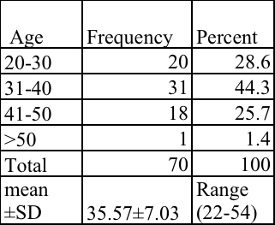
Above table shows the age distribution of patients in the study, where the majority of patients presented between the age groups of 31-40 years, accounting for 31 patients(44.3%). It was observed the mean age of patients was 35.57±7.03 years

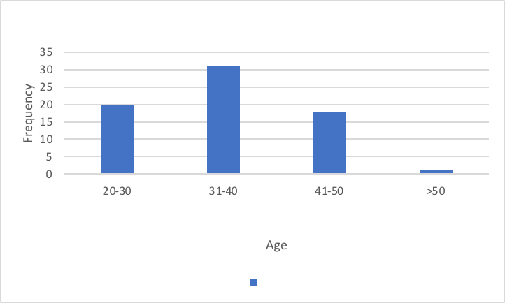

(Graph-1.Bar graph showing the age distribution) (Table-2. showing Sex distribution of patients )
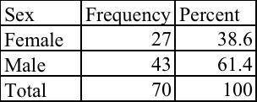

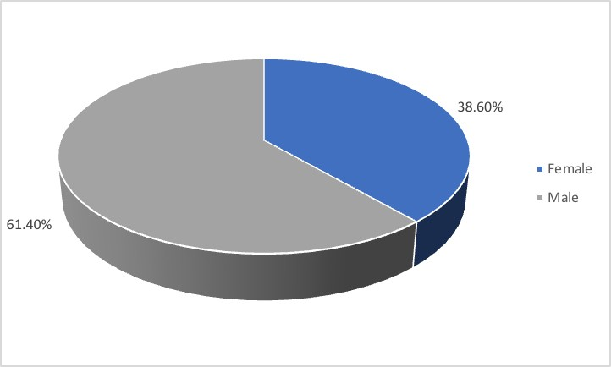
In our study, there was male predominance with 43 males (61.4%) and M:F ratio of 1.6:1

(Graph-2. Pie chart showing sex distribution) (Table-3.Symptoms of the patients)
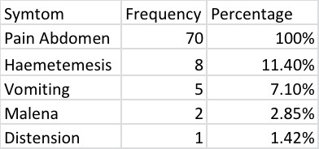

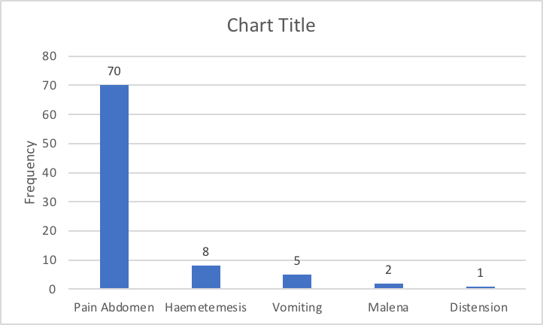
In our study, Abdominal pain was the primary parenting feature in all 70 patients(100%), associated with haemetemesis in 8 patients (11.4%), vomtings in 5 patients(7.10%) and Malena in 2 patients (2..85%)

(Graph-3.Bar graph showing symptoms)

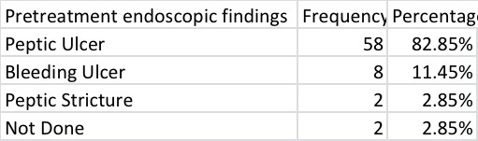
(Table-5. showing pre treatment endoscopic findings of the patients)

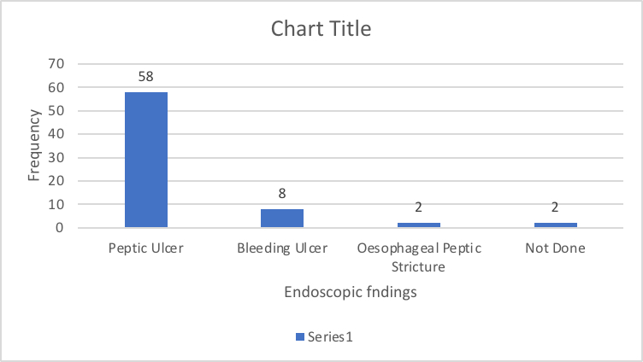
In this study, endoscopy was taken before the starting the treatment, the observations of the investigation reveled most of patients that is 58 patients(82.85%) has only peptic ulcers, 8 patients (11.45%) has bleeding peptic ulcers and 2 patients (2.85%) gas oesophageal peptic stricture, where as investigation was not done in 2 patients (2.85%)

(Graph-5.showing the pretreatment endoscopic findings of the patients)
( Table-6. showing biopsy findings of the patients)

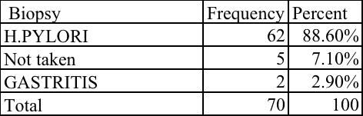
In our study, out of 70 patients biopsy from the ulcer edge was taken in 64 patients (91.5%) out of which 62 patients(88.6%) patients had H.pylori infection and gastritis, 2 patinet(2.90%) had only gastritis, where as biopsy was not taken in 5 patients (7.10%).
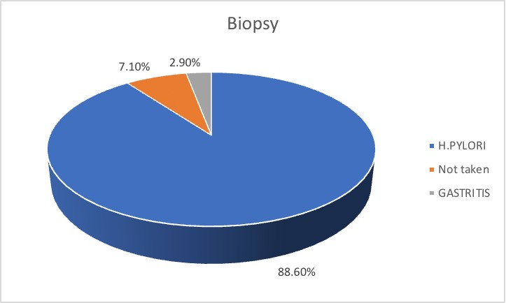

(Graph-6.Pie diagram showing the biopsy findings of the patients) (Table-7. showing the complications of PUD)
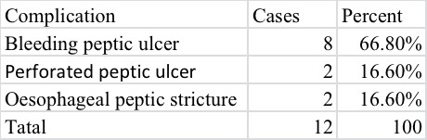
In our study, out of 12 patients with complicated PUD 8 patients(66.80%) has bleeding ulcer and perforated peptic ulcer and oesophageal stricture was in 2 patients (16.60%) each.
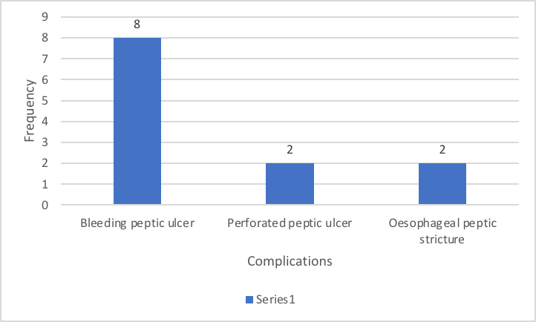

(Graph-7showing complicated peptic ulcer disease)

(Table-8.showing the treatment of the patients)
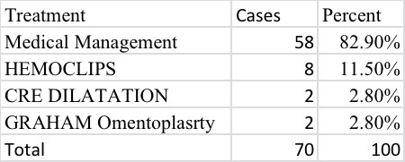
The 58 patients (82.90%) from this study underwent medical management, 8 patients (11.50%) underwent haemoclip application, 2 patients (2.80%) underwent CRE dilatation and 2 patients (2.80%) underwent GRAHAM omentoplasty
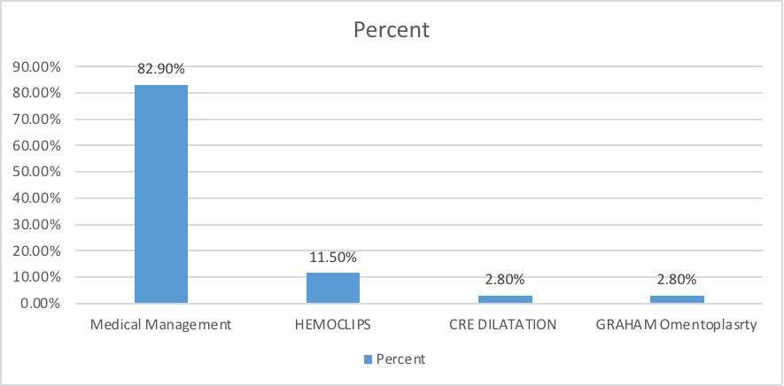

(Graph-8.the treatment of the patients)

(Table-9. showing post treatment endoscopic findings of the patients)
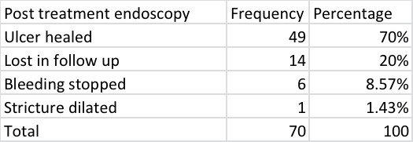
An another endoscopy taken after the treatment, the observations of the investigation reveled most of patients ulcer healed that is 49 patients(70%), bleeding stopped in 6 patients(8.57%) and 1 patient (1.43%) had oesophageal peptic stricture dilated, where as investigation was not done in 14 patients (20%) as they are lost in followup

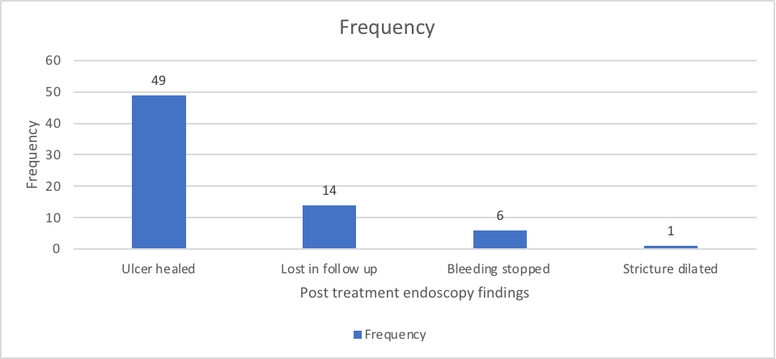

(Graph-9.showing the post treatment endoscopic findings of the patients)
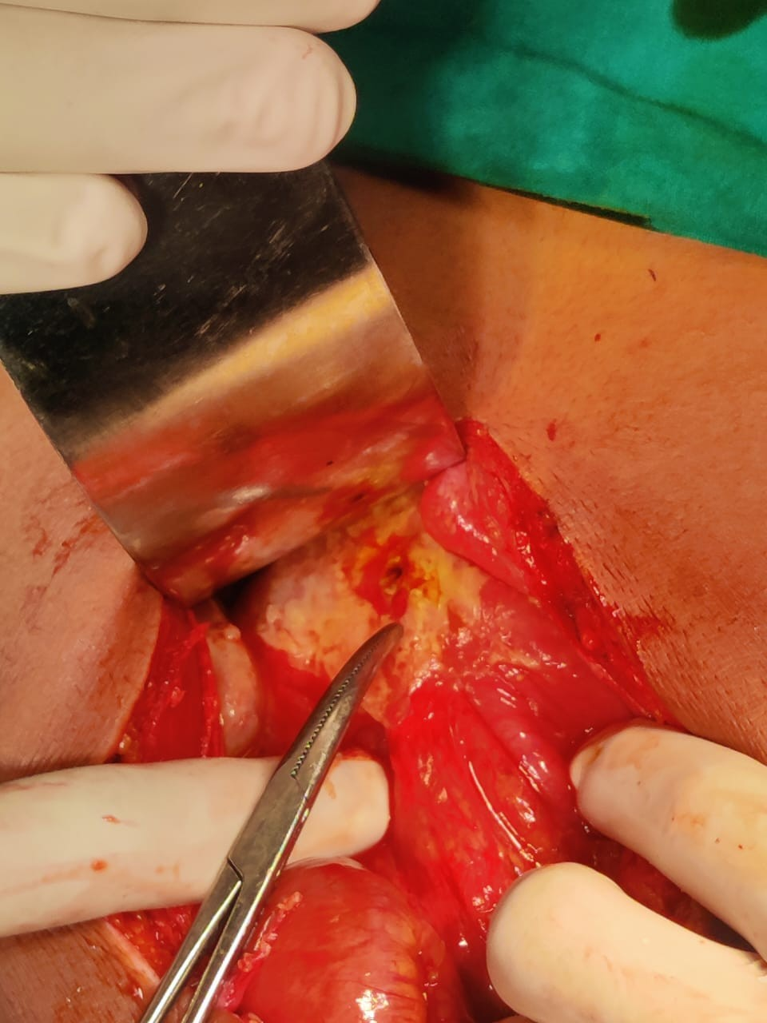
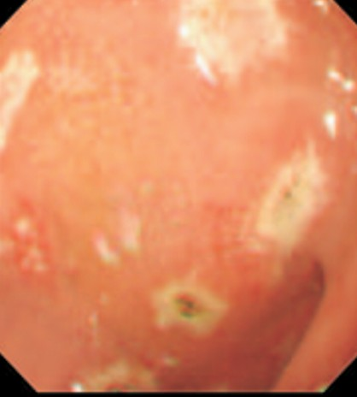
(Fig-1.Perforated Duodenal Ulcer)

(Fig-2.Peptic Ulcers ) DISCUSSION:
Peptic ulcer disease, was a common disease in the past few decades, for which surgery was main stray of treatment. In today’s scenario, it can be treated effectively with conservative management . 70 patients was admitted with peptic ulcer disease to Department of General Surgery and Medical Gastroenterology at VIMS & RC between February 2021 to August 2022. Bath males and females were included in the study. In this study majority of the patients presented from the age groups of 31-40 years(44.3%). Other study conducted by Deepa Jahagirdaar, Nitin Bomanwar, Sneha Joshi⁽⁸⁾ also supported predominantly younger age groups of patients with PUD

This study predominantly had male patients with an M:F ratio of 1.4:1.Other studies have also concluded about male predominance. Other study conducted by Deepa Jahagirdaar, Nitin Bomanwar, Sneha Joshi⁽⁸⁾ also supported male predominance in patients with PUD. Abdominal pain was the primary presenting feature in 100% of patients followed by hemetemesis, malena, and abdominal tenderness. In study conducted by Deepa Jahagirdaar, Nitin Bomanwar, Sneha Joshi⁽⁸⁾ similar clinical features of pain abdomen was found. In our study we found most of the patients with PUD had relevance with H.pylori on biopsy i.e in 62 patients(88.2%). In study conducted by Deepa Jahagirdaar, Nitin Bomanwar, Sneha Josh⁽⁸⁾i similar association with H.pylori was found
Most of the patients(82.85) presented with only peptic ulcer on pre-treatment endoscopy, yet there are few patients (17.1%) with complicated PUD like bleeding peptic ulcer(11.45%), perforated peptic ulcer(2.8%) and esophageal peptic stricture(2.8%). All the patients with complicated PUD have previous history of PUD and appropriate previous medical management. The history of PUD in the subject and such relation with complications was also found by Deepa Jahagirdaar in 2019⁽⁸⁾, Ali Yasen Y et.all in 2020⁽⁹⁾ and the study conducted by Felipe Lankelevich, et.all on 39 patients in 2019^{(10).} . Patients with uncomplicated disease were manage medically with H.pylorin eradication therapy and PP inhibitors . The follow up endoscopy of these patients revealed satisfactory findings ulcer healed with scar tissue.
Out of 8 patients with bleeding peptic ulcer disease, 7 patients had underwent hemoclip application and hemostasis was achieved , these patients are followed up medical management. One patient had underwent hemoclip application and adrenaline inject at the ulcer site. The was no re bleed was found in all 8 patients. Endoscopic HEMOCLIPS application was considered as better mode of treatment for bleeding peptic ulcer, yet if bleeding in is not controlled then embolization or surgical management has to be confirmed. The study conducted by Felipe Lankelevich, et.all on bleeding peptic ulcer on 39 patients in 2019⁽¹⁰⁾ has showed similar results with HEMOCLIPS application
The patients with oesophagial peptic stricture (2.8%) underwent CRE dilatation endoscopically. The study conducted by Josino IR, et al in 2018⁽¹¹⁾ concluded the similar results endoscopic dilatation.
The patients with perforated peptic ulcer (2.8%) came with an acute presentation. These patients underwent emergengency laparotomy followed by Grahams omentoplasty. Both patients had the D1 anterior perforation. The postoperative period of these patients was uneventful. The study conducted by Ali Yasen Y et.all in 2020⁽⁹⁾ on perforated peptic ulcer had used similar technique on the patients and similar results were found

CONCLUSION:
This is a prospective observational study, this study was conducted to ascertain the appropriate management of the Peptic Ulcer Disease, to understand the role of Helicobacter pylori in the Peptic Ulcer Disease and study present day scenario diagnostic and management modalities of the disease and to evaluate what percentage of treated Peptic Ulcer Disease result in complications like bleeding ulcer and gastric or duodenal perforation and it’s management. Both male and female patients were included in the study but we found a male

predominance of ratio M:F 1.4:1 . Age of the patients ranged from 22-51 years with maximum patients seen in younger age groups.
Amongst all the patients abdominal pain and EPIGASTRIC tenderness were the primary presenting features associated with hematemesis, malena, vomiting and dark colour stools on digital rectal examinations. Most of the patients biopsy revealed presence of H.pylori relation with the disease. Pre-treatment endoscopy done for the patients revealed maximum case were only non complicated peptic ulcer i.e 82.8% where as remaining complicated ulcer shows bleeding peptic was the commonest complications followed by perforated peptic ulcer. Patients with uncomplicated disease were manage medically with H.pylorin eradication therapy and PP inhibitors . The follow up endoscopy of these patients revealed satisfactory findings ulcer healed with scar tissue. The patients with bleeding peptic ulcer were managed with HEMOCLIPS application and oesophageal peptic stricture was managed with CRE ballon dilatation as minimal invasive management , where as perforated peptic ulcer was better managed surgically GRAHAM omentoplasty. This study reveals that PUD managed medically has a high cure rate with appropriate medical management. However, complications that occur due to improper medications and undiagnosed disease are better managed by invasive procedures.

REFERENCE:
  - Tarasconi A, Coccolini F, Biffl WL, Tomasoni M, Ansaloni L, Picetti E, Molfino S, Shelat V, Cimbanassi S, Weber DG, Abu-Zidan FM, Campanile FC, Di Saverio S, Baiocchi GL, Casella C, Kelly MD, Kirkpatrick AW, Leppaniemi A, Moore EE, Peitzman A, Fraga GP, Ceresoli M, Maier RV, Wani I, Pattonieri V, Perrone G, Velmahos G, Sugrue M, Sartelli M, Kluger Y, Catena F. Perforated and bleeding peptic ulcer: WSES guidelines. World J Emerg Surg. 2020 Jan 7;15:3
  - Jahagirdaar D, Bomanwar N, Joshi S. A Prospective Clinicoendoscopic Follow-up Study in Young Patients with Peptic Ulcer Perforation at a Tertiary Institute in Central India. Euroasian J Hepatogastroenterol. 2019 Jul-Dec;9(2):91-95
  - Malfertheiner P, Schulz C. Peptic Ulcer: Chapter Closed? .Dig Dis. 2020 Jan 6:1-5.
  - Jahagirdaar D, Bomanwar N, Joshi S. A Prospective Clinicoendoscopic Follow-up Study in Young Patients with Peptic Ulcer Perforation at a Tertiary Institute in Central India. Euroasian J Hepatogastroenterol. 2019 Jul-Dec;9(2):91-95
  - Mohamedahmed AYY, Albendary M, Patel K, Ayeni AA, Zaman S, Zaman O, Ibrahim R, Mobarak D. Comparison of Omental Patch Closure Versus Simple Closure for Laparoscopic Repair of Perforated Peptic Ulcer: A Systematic Review and Meta-Analysis. Am Surg. 2022 Mar 25:31348211067991.
  - Baracat FI, de Moura DTH, Brunaldi VO, Tranquillini CV, Baracat R, Sakai P, de Moura EGH. Randomized controlled trial of hemostatic powder versus endoscopic clipping for non-variceal upper gastrointestinal bleeding. Surg Endosc. 2020 Jan;34(1):317-324
  - Josino IR, Madruga-Neto AC, Ribeiro IB, Guedes HG, Brunaldi VO, de Moura DTH, Bernardo WM, de Moura EGH. Endoscopic Dilation with Bougies versus Balloon Dilation in Esophageal Benign Strictures:Systematic Review and Meta-Analysis. Gastroenterol Res Pract. 2018 Jul 15;2018:5874870

