Case series:
Case series on rare congenital heart disease “GERBODE DEFECT”
¹Dr. Satish Kumar D*, ² Dr. Sameer Lal, ³ Prof. Dr. Saket Agarwal, ⁴ Dr. S. E. H. Naqvi,
⁵ Dr. Subodh Satyarthi

- Senior Resident, Department of Cardiothoracic and Vascular Surgery (CTVS), GIPMER.
- Senior Resident, Department of Cardiothoracic and Vascular Surgery (CTVS), GIPMER.
- Director and Professor, Department of Cardiothoracic and Vascular Surgery (CTVS), GIPMER.
- Associate Professor, Department of Cardiothoracic and Vascular Surgery (CTVS), GIPMER.
- Professor, Department of Cardiothoracic and Vascular Surgery (CTVS), GIPMER.
Corresponding author *

This work is licensed under a Creative Commons Attribution-NonCommercial 4.0 International License
Date of submission: 27 April 2023
Date of Final acceptance: 29 Aug 2023
Date of Publication: 15 September 2023
Source of support: Nil
Conflict of interest: Nil

Abstract:
Congenital heart diseases encompass a diverse spectrum of cardiac anomalies, some of which are exceedingly rare. Gerbode defect, a congenital heart disorder first described by Frank Gerbode in 1958, falls into this category, representing a distinctive and infrequently encountered condition. This heart anomaly involves an abnormal communication between the left ventricle and the right atrium, creating an anomalous pathway for blood flow that can lead to a range of clinical manifestations.
While Gerbode defect is a remarkable medical rarity, it carries significant clinical implications, often necessitating surgical intervention for correction. Due to its uncommon nature, limited research has been conducted on this defect, and case series have the potential to shed light on the various facets of the condition, its presentation, diagnosis, and treatment.
Keywords: Congenital heart diseases , diverse spectrum , cardiac anomalies

Introduction:
Congenital heart diseases encompass a diverse spectrum of cardiac anomalies, some of which are exceedingly rare. Gerbode defect, a congenital heart disorder first described by Frank Gerbode in 1958, falls into this category, representing a distinctive and infrequently encountered condition. This heart anomaly involves an abnormal communication between the left ventricle and the right atrium, creating an anomalous pathway for blood flow that can lead to a range of clinical manifestations.
While Gerbode defect is a remarkable medical rarity, it carries significant clinical implications, often necessitating surgical intervention for correction. Due to its uncommon nature, limited research has been conducted on this defect, and case series have the potential to shed light on the various facets of the condition, its presentation, diagnosis, and treatment.
This study aims to provide an insightful examination of Gerbode defect through the analysis of a series of cases, contributing to our understanding of this condition's clinical course and management. By delving into these cases, we hope to expand the body of knowledge surrounding this rare congenital heart disease and, in doing so, potentially improve patient outcomes and treatment strategies. Being extremely rare and most of them being iatrogenic making a diagnosis is extremely difficult so care must be taken to establish the diagnosis and experienced cardiologist can identify the disease. Here in we present 3 cases of gerbode defect that were operated our institute and the outcomes of the patients that were operated .
Cases Presentation:
Case 1
2 year old male child
Presented with recureent lrti with hyperactive precordium and poor growth.two years child was 6 kilos shunted height and poor over all mieston development
Echo was done and revealed to have vsd asd and sev tr upon further work up patient was found to have gerbode defect without asd patient was put on furoped 1 ml bd patient was worked up and operated for pericadial patch closure of gerbode defect on feb 4 2022 .patient cpb time was 94 mins shifted to icu in a stable state . extubated on day 1 needed extended period of inotropic support for 4 days patient recovered well patient was accidentally found to have a weak ant abdominal wall(fig 1). patient started walking from day 10 d was discharged on 12 th day follow up is on continuously patient achieved all milesones rapidly in next 1 year and now is 3 rd percentile in growth to the age ratio .figure 2 shows intr operative finding of gerbode defet hitting the tricuspid valve

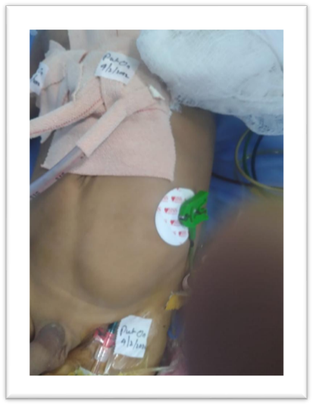
Fig 1 depicts weak left abdominal wall compared to the rt sided wall

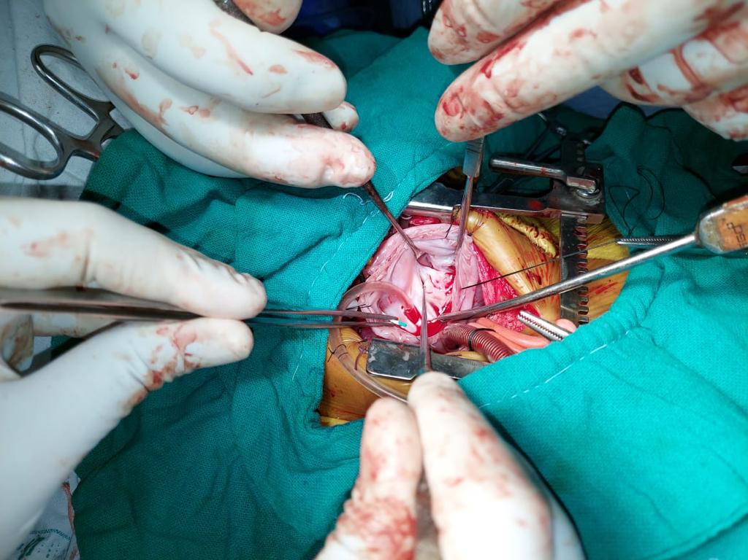 SHAPE \* MERGEFORMAT

Fig 2 : Intra opertive findings of gerbode defect
Case 2 : 22 year old patient was admitted after working up for gerbode defect with features of raised bilurubin derranged liver enzymes with class 3 dyspnea and palpitations ,raised jvp.patient taken up for surgery on 7.3.22 patient underwent normal cardio pulmonary bypass through ra approach gerbode defect was closed patient found to have temporary heartblock which reverted back to normal sinus rhythm postoperatively patient needed 4 days of inotopic support . labs improved patient discharged on pod 9 and healthy till the last follow up .
Fig 3 is the TEE finding of the patient on day of surgery , fig 4 is after closure
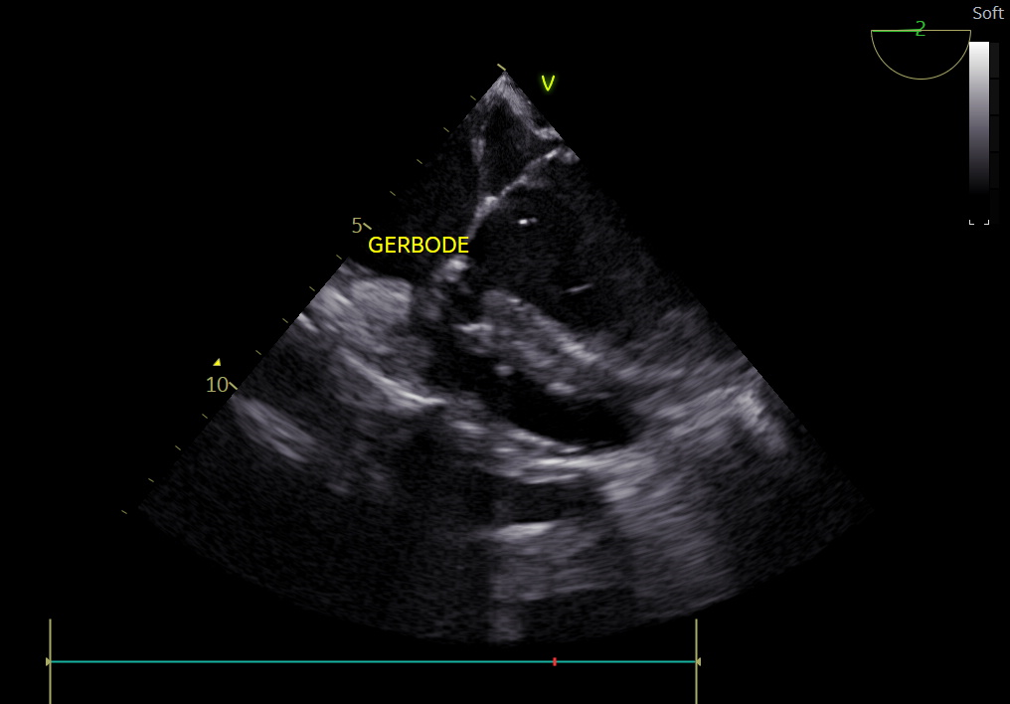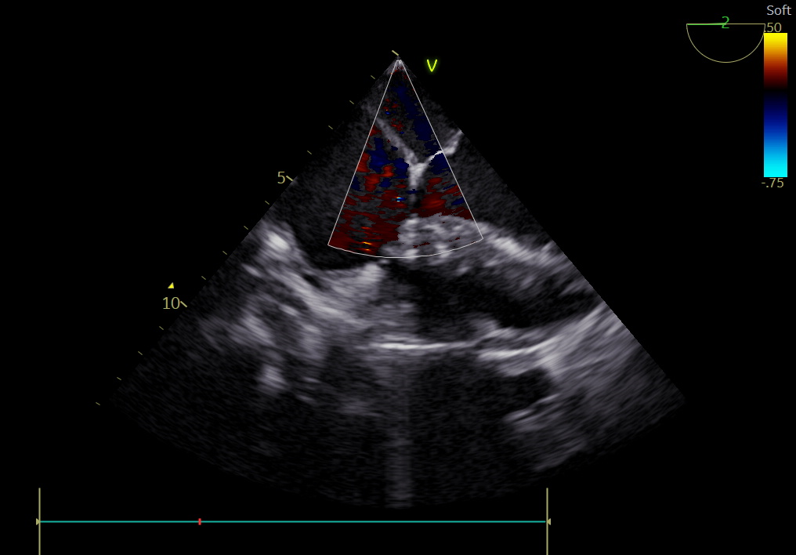
Fig 3 fig 4
Case 3 :patient was an 18 month old male child who was 7 kg with 4 episodes of lower respiratory tract infections transferred from picu on dobutamine . patient taken on emergecy basis. Patient was operated on 28/8/2022 with standard cpb patient had high PA pressures was difficult to wan of extubated on pod 2 patient needed inotropic support for 5 days .patient improved labs became better . on pod 8 patient developed fever on pod 9 and then had continuous high grade fever with reduced urine out put increased .echo was done which revealed infective endocarditis of tricuspid valve and patient deteriorated and inspte good antibiotic coverage inotropic support couldn’t be saved, expired on pod 21
Fig 5 shows vegetation on TTE tricuspid valve

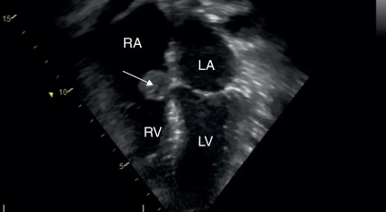

Case 4: is an interesting case patient a 24 year old male with grade 3 dyspnea and nocturnal angina was diagnosed to have RSOV to RA with bicuspid aortic valve and severe AORTIC REGRGITATION (fig 6)patient was worked up and taken up for RSOV closure + aortic valve replacement on TEE patient was found to have gerbode defect with severe AR (fig 7) and on 28/2/23 patient on standard cardiopulmonary bypass, AVR 23 SJM MS VALVE AND PERICARDIAL PATCH CLOSURE OF GERBODE DEFECT DONE .patient was extubated on day 2 and needed inotropic support of five days with mild sepsis recovered with antibiotics and discharged on POD 15 and doing well on last follow up in july
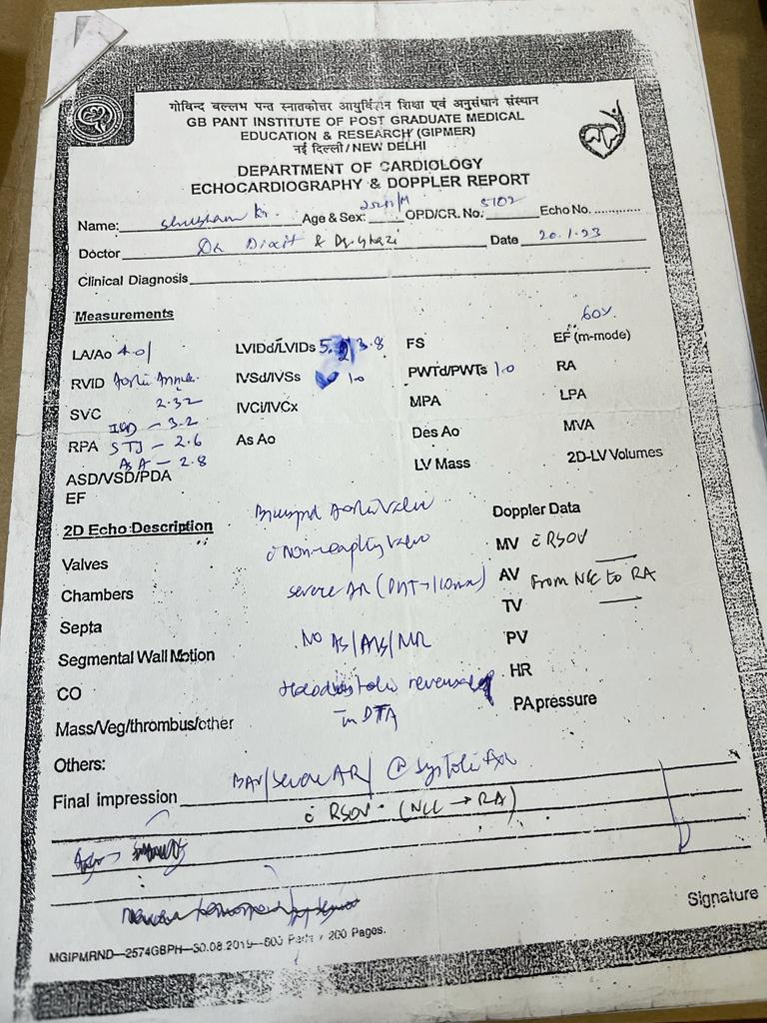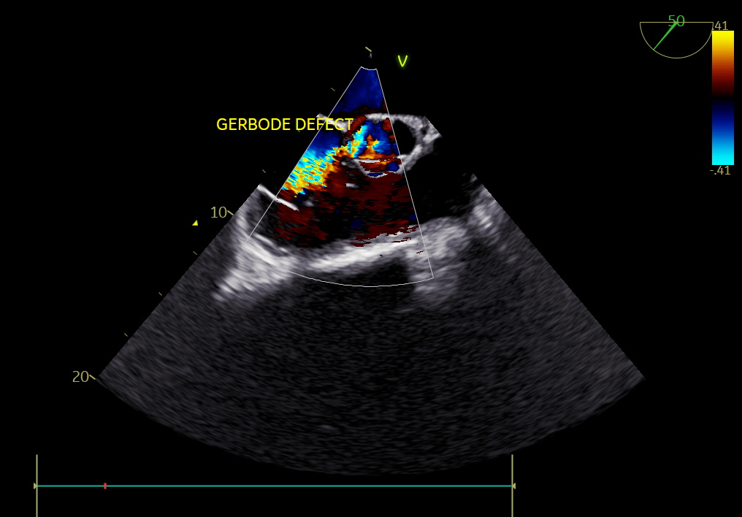
Fig 5 fig 6
Discussion
Left ventricular to right atrial (LV-RA) communications was first described in the 19th century by BUHL [2]. It is however to GERBODE that one owes the first series of surgical correction in 1957 in the USA [3]. The Gerbode defect is a rare form of shunt from the LV to RA due to either congenital or acquired causes, and estimated less than one percent of all congenital heart diseases [1].
Understanding Gerbode shunt means understanding the membranous septum and the structures it separates. This septum is divided into two portions based on the implantation of the septal leaflet of the tricuspid valve: the apical portion is interventricular while the basal portion is atrioventricular. Since the implantation of the tricuspid valve is one centimeter below that of the mitral valve, it is easy to imagine that the atrioventricular portion separates the RA and the hunting chamber from the LV [4] (see Figure 7).
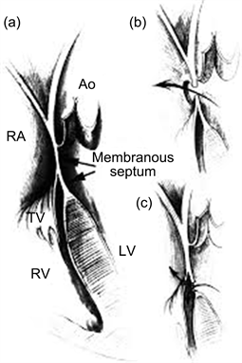
Figure 7. Anatomic relationship of the septal leaflet of the tricuspid valve to the membranous septum [4]. (a) The septal leaflet divides the membranous septum into interventricular and atrioventricular portions; (b) A supravalvular defect within the atrioventricular septum permits shunting directly from the left ventricle to the right atrium; (c) An infravalvular defect within the interventricular septum is associated with a perforation of the septal leaflet of the tricuspid valve. Abbreviations: RA = right atrium; RV = right ventricle, Ao = aorta.
The defect occurs in the membranous portion of the interventricular septum above the level of the tricuspid valve. Thus, two types of Gerbode shunts are distinguished: The indirect type (type 1) which is the most common. The interventricular apical portion that carries a defect and generally associated with a jet lesion on the septal tricuspid leaflet that it can perforate, thus creating an indirect shunt in the RA.The direct type (type 2) where it is the basal atrial-ventricular portion which has a gap causing a reflux in the RA [1].
These septal anomalies can be whether acquired often or congenital as shown in Table 1. However, the clinical features are the same as ventricular septal defect.
The diagnosis is made often by TTE, thereby cardiac catherisation is exceptional. The natural history of the disease is cardiac cavities dilatation and pulmonary hypertension. The best option for treatment is surgery under cardiopulmonary bypass [5] [6].
We present 4 cases of tis rare gerbode entity They are among the oldest in the literature, which explains the symptoms of heart failure and annihilates the illusion of spontaneous closure.all the four of them were direct gerbode defects .1 st case was a boy with poor growth and symptoms of cardiac failure 2nd case was an adult with features of severe TR.te third one was an emergency with multiple lrti and failure and couldnt be saved as patient died of infective endocarditis .the last case was a misdiagnosed case was planned for RSOV repair + avr and turned out to be gerbode +AR. giving us the prospect of how challenging is it to diagnose.the diagnosis was made intraoperatively. Thus before any abnormal dilation of the RA and a strong maximum gradient, the Gerbode shunt must be suspected.
All of them were closed via the RA Approach and pericardium was used close the defect wih 5-o prolene in children and 4-o in adults .none of them required tricuspid valve repair and 2nd case had transient heart block which was anticipated (predictable) [3] complete surgical repair has allowed our patients to recover a clear improvement and a disappearance of symptoms in the long term, also proven by TTE control: normal sized cavities, absence of shunt, tricuspid insufficiency and residual PAH.
Conclusion
Gerbode defects are rare forms ventricular septal defects of congenital heart diseases which require proper diagnosis and surgical closure, because of close proximity to the bundle it needs careful closure. Careful pre op assesment but prudent and experienced cardiologist can pick it easily.its always advisable to seek consent for permanent pacemaker .long term implications as the age increases

References
[1] Kelle, A.M., Young, L., Kaushal, S., Duffy, C.E., Anderson, R.H. and Backer, C.L. (2009) The Gerbode Defect: The Significance of a Left Ventricular to Right Atrial Shunt. Cardiology in the Young, 19, 96-99.
[2] Meyer, H. (1857) Uber angeborene Enge oder Verschluss der Lungenarterienbahn. Archiv für pathologische Anatomie und Physiologie und für klinische Medicin, 12, 497-538.
[3] Gerbode, F., et al. (1958) Syndrome of Left Ventricular-Right Atrial Shunt. Successful Repair of Defect in Five Cases, with Observation of Bradycardia on Closure. Annals of Surgery, 148, 433-446.
[4] Riemenschneider, T.A. and Moss, A.J. (1967) Left Ventricular—Right Atrial Communication. The American Journal of Cardiology, 19, 710-718.
[5] Tidake, A., Gangurde, P. and Mahajan, A. (2015) Gerbode Defect—A Rare Defect of Atrioventricular Septum and Tricuspid Valve. Journal of Clinical and Diagnostic Research, 9, OD6-OD08.
[6] Jeffrey, J., Kamran, M., Handwerker, S., Kumar, N. and Marcali, M. (2009) The Gerbode Defect: Left Ventricular to Right Atrial Communication—Anatomic, Hemodynamic, and Echocardiographic Features. Echocardiography, 26, 993-998.
[7] Carpenter, R.J. et al. (2012) Gerbode Defect Associated with S. lugdunensis Native Valve Infective Endocarditis Requiring Cardiac Surgery. Journal of Cardiac Surgery, 27, 316-320.

