Case Report:
Unusual presentation of endotracheal tube entrapment in Boyle Davis Gag
Dr. Pabitra Ghoshal, Dr. Uma Sahakari, Dr. Kaushal Bhonsle, Dr. Shreya Walke

Department of Anaesthesia , Goa Medical College , Goa
Corresponding author: Dr. Uma Sahakari

Abstract:
Endotracheal tube herniation is extremely rare. Physical examination is important to judge the amount of tube herniation and to decide if it can be safely corrected. Our patient did not show any increase in peak pressure or any decrease in time to reach peak pressure during inspiration suggesting that patient’s ventilation was not affected and ruled out obstruction of ET tube. A 14 yr old male with adenotonsillitis was posted for adenotonsillectomy. Pre anesthesthetic check up was done. Airways examination showed Malampatti grade 1 with no anticipated difficulty in intubation. After obtaining IV access patient was premedicated with ondansetron, glycopyrollate, midazolam and fentanyl as per weight. Patient was induced using propofol and intubated after giving atracurium with cuffed oral No.6 South Pole RAE tube, cuff was inflated, air entry checked bilaterally and tube was fixed. Patient was maintained with O₂+ Sevoflurane + N₂O via closed circuit and controlled ventilation.
Keywords: Adenotonsillectomy, Airway, Tracheal intubation, Boyle Dawis Gag, Complications, Endotracheal tube Herniation.

Introduction:
The use of a mouth gag (Boyle-Davis) is standard to ensure proper imaging throughout the procedure. The Boyle-Davis mouth gag consisting of tongue blade, mouth opener, and suspension system for fixing the endotracheal tube in the midline provides excellent imaging during the operation, but it may cause complications such as dental injuries, laryngospasm, and displacement of the tracheal tube [1,2].
Case Report:
A 14 yr old male with adenotonsillitis was posted for adenotonsillectomy. Pre anesthesthetic check up was done. Airways examination showed Malampatti grade 1 with no anticipated difficulty in intubation. After obtaining IV access patient was premedicated with ondansetron, glycopyrollate, midazolam and fentanyl as per weight. Patient was induced using propofol and intubated after giving atracurium with cuffed oral No.6 South Pole RAE tube, cuff was inflated, air entry checked bilaterally and tube was fixed. Patient was maintained with O₂+ Sevoflurane + N₂O via closed circuit and controlled ventilation.
Patient was hemodynamically stable intaoperatively. Adenotonsillectomy was done and hemostasis was achieved using cautery and harmonic scalpel.
At the end of surgery, surgeons noticed that the tube impinged into the tongue blade of the oral retractor and cannot be dislodged from it. Thus it was impossible to remove the retractor without extubating the patient. So after ensuring haemostasis and adequate suctioning, the cuff was deflated and the tube was removed along with the retractor.
Patient was ventilated and maintained in deep plane with oropharyngeal airway in situ. Patient was reversed with neostigmine with glycopyrollate. Patient was shifted to recovery once fully awake and breathing well.
Discussion:
Endotracheal tube herniation is extremely rare. Physical examination is important to judge the amount of tube herniation and to decide if it can be safely corrected. Our patient did not show any increase in peak pressure or any decrease in time to reach peak pressure during inspiration suggesting that patient’s ventilation was not affected and ruled out obstruction of ET tube.
Two unsuccessful attempts of trying to dislodge the tube from retractor confirmed that the tube had remodeled. It could have been because of dissociation or dissection of inner layer of tube or kinking of endotracheal tube.
Few dreaded complications could be identified in this presentation. Accidental extubation can occur with removal of retractor if the herniation of tube goes unnoticed. If this occurs in a light plane of anaesthesia there is high risk of aspiration and also laryngospasm.
If such an incident occurs intra-op there is risk of bleeding , dislodgement of clot into the airway. Thus ensuring haemostasis prior to removing the retractor is important. Oral Suctioning and maintaining the patient in a deep plane till the extubation also helped in preventing these Complications.
Search for literature revealed few reports of similar incidents ⁽¹⁾ ⁽³ ⁾wherein patient had to be reintubated. There have been evidences of displacement of ET tube after opening of the mouth gag blade as shown in study by Fenessy et al ⁽⁴⁾. Also, if width of slot in tongue blade is large ⁽⁶⁾, the endotracheal tube might herniate and become fixed and unseparable from blade. Warming of tube intraoperatively might have led to herniation and resultant kinking and widening prevented dislodging from the blade ⁽³⁾.
Conclusion:
BDG is commonly used for tonsillectomy procedures and entrapment if unnoticed can lead to dreaded complications.
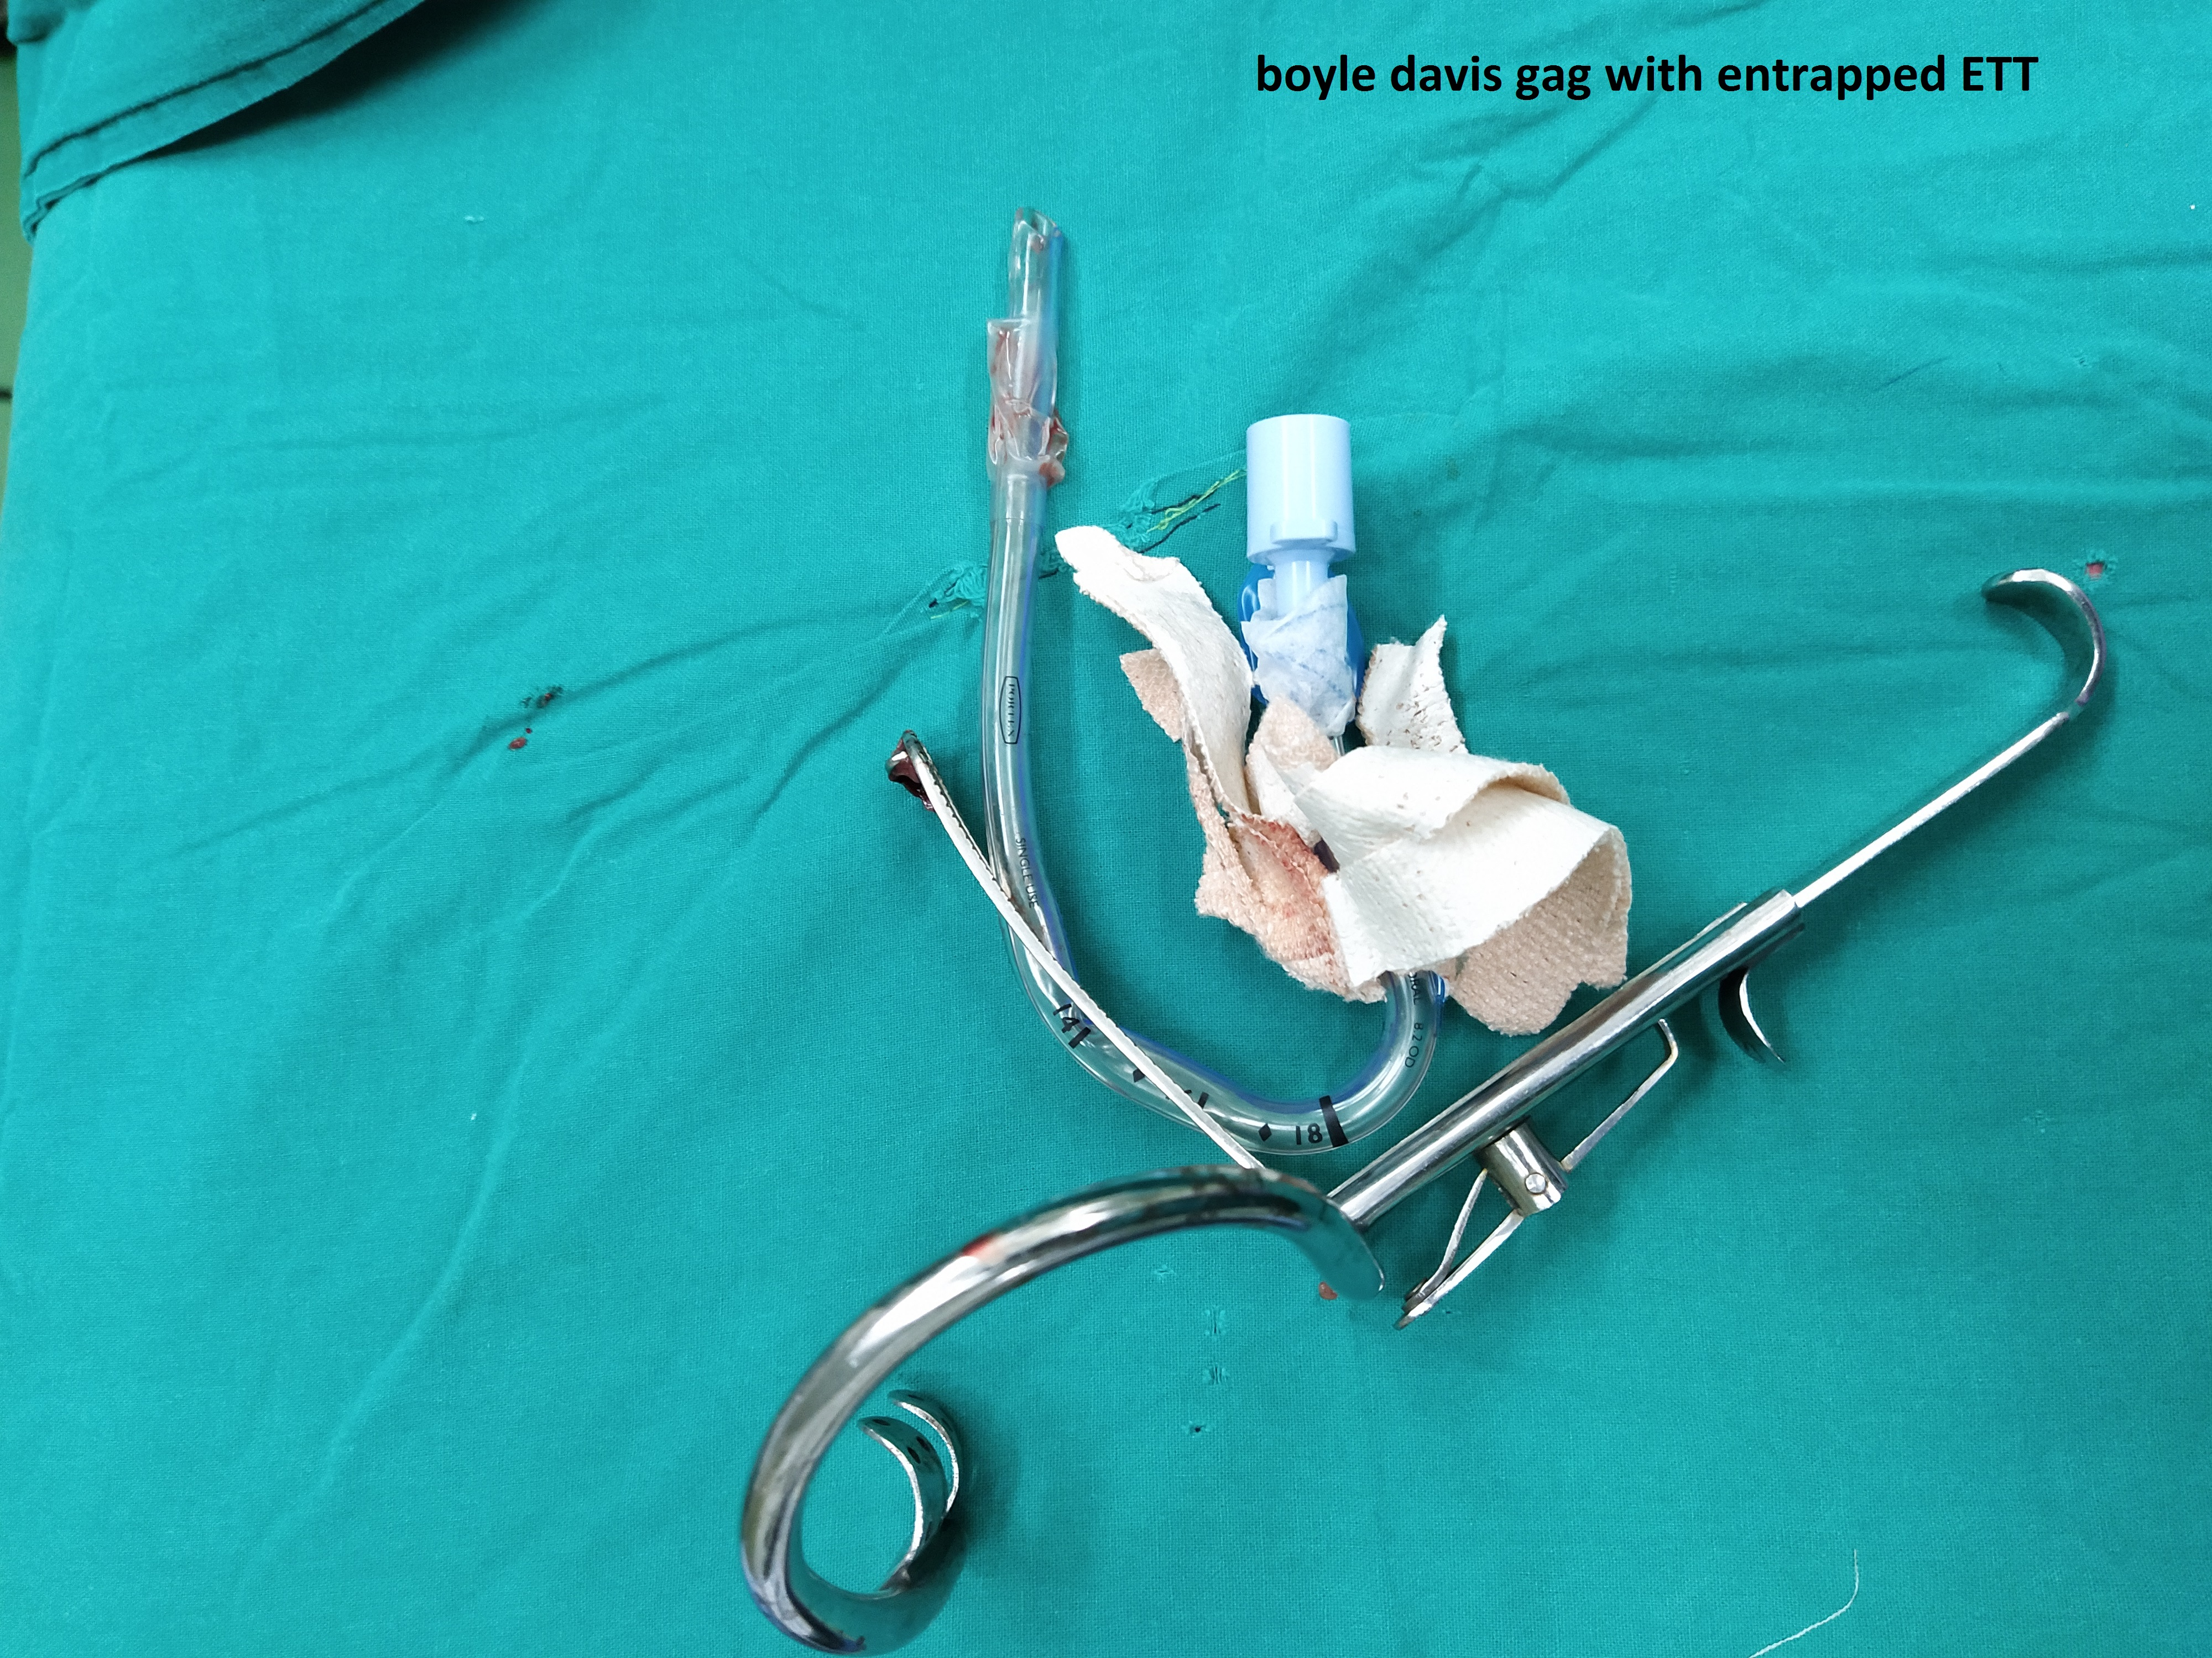
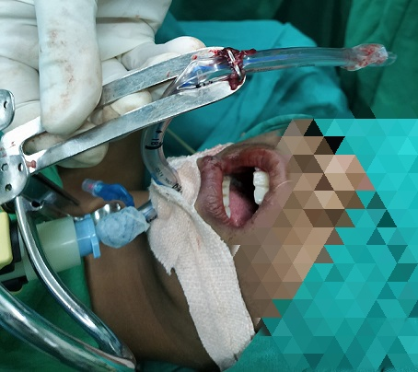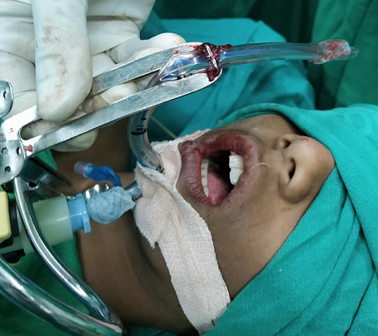

References:
1.David A Lawlor, Herniation of an endotrachial tube through the tongue blade of the Boyle-Davis Gag during paediatric adenotonsillectomy, BJA: British Journal of Anaesthesia, Volume 111.

2. Sen AK, Gupta B. Herniation of RAE tube through split Boyle Davis gag. Anaesth Intensive Care. 1990;18(4):577‐578.
3.Lowe D, Hoare T. Dangerous Doughty--a quantitative study of disproportion between the size of endotracheal tubes and splits in tonsillectomy gag blades. J Laryngol Otol. 2002; 116(11): 914-6.
4.Fennessy BG, O'Connor R, Cronin M, Fenton JE, Hughes JP. Safety implications of the Boyle Davis mouth gag and tracheal tube position in tonsillectomy. Br J Anaesth. 2010; 105(6): 863-6.
5. A Sanusi, M Akinwale, O Uchendu, A Lasisi. Perianaesthetic Complications Associated With Adenotonsillectomy At The University College Hospital, Ibadan, Nigeria. The Internet Journal of Anesthesiology. 2012 Volume 30 Number 3.
6. Mandappa JM, Chandrasekhara PM, Siddhanthi RB, Gupta BL. Letter: Modified tongue blade for Boyle-Davis gag. Br J Anaesth. 1976;48(5):501‐502.

