Review article:
Formulation of carminative gel for children
*Sumaira Nasreen Md Tahir, ** Abuzar Husain Mohammad Jaleel Ahmed
, ** Khan Naziya Banu Matin, **Ansari Daniyal Aaquieb Ateeque Ahmed

*Assistant professor department of pharmacognosy , K.B.H.S Institute of Pharmacy malegaon nashik
**Third year B.pharm student
Corresponding author*

Abstract:
Context: Gastrointestinal disorder a common childhood complaints. Abdominal pain is one of the most common reason for parent to bring his/her child to medical attention. Particular types of the complimentary and alternative medicine, such as herbal medicine are commonly used among children. Stomach pain in children include gas (flatulence),rubbing around the belly button, especially if the pain located low and down of the right side of the abdomen. Herbal medicine has become popular form of health care , globally . Herbal medicine is preferred option now a days even though few contrast exist between herbal medicines and customary pharmacological medicines. Herbal formulations have been more effective for various disease conditions.
Keywords: Gastrointestinal disorder , Abdominal pain, Stomach pain, Herbal medicines ,customary pharmacological medicines .

Introduction:
Stomach ache can be hard to diagnose. Many children with stomach pain get better in hours or days without special treatment and often no cause can be found. Sometimes the cause becomes more obvious with time and treatment can be started. Some children suffer repeat attack of stomach pain, which can be worrying for the parents. Often, no health problem can be found. For stomach ache we can offer a natural home remedy proven to ease your pain and get back to feeling better.
Carminative Agents :
They are soothing medicaments that act by reliving pain in the stomach and intestine and expel flatulence and gas from the GIT by increasing peristalsis.
Examples : Fennel , Cardamom ,Cinnamon, Coriander, Clove, Caraway, Ginger etc.
Used in indigestion, gastric discomfort and loss of appetite.
Ginger is most commonly used as carminative agent even in home remedies.

GINGER
Ginger is an herbal supplement , which can be used as natural remedy in treatment of antiemetic, carminative, stimulant and also as an anti-inflammatory.
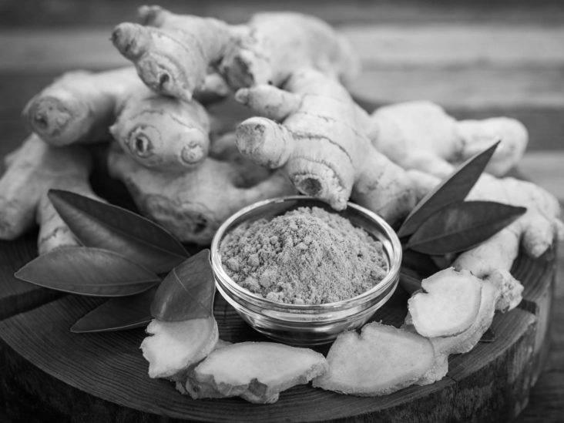
It can be effective in treatment of dyspepsia, migraine headache , morning sickness, nausea (chemo induced), post-operative nausea and/or vomiting, osteoarthritis, respiratory infections, rheumatoid arthritis.
Ginger consist of the dried rhizomes of the zingiber officinale Roscoe , belonging to family Zingiberaceae. It is also known as Rhizoma zingiberis, Zingibere . It is mainly cultivated in West Indies, Nigeria, Jamaica, India, Japan and Africa. Ginger contains 1 to 2% volatile oil, 5 to 8% pungent resinous mass and starch. The volatile oil is responsible for aromatic odour and the pungency of the drug is due to the yellowish oily body called Gingerol which is odourless. Volatile oil is composed of sesquitrpene hydrocarbon like alpha-zingiberol;alpha-sesquiterpene alcohol alpha-bisabolene,alpha-farnesene, alpha-sesquiphellandrene. Less pungent components like gingerone and shogaolare also present. Shogal is formed by the dehydration of gingerol and is not present in fresh rhizomes.
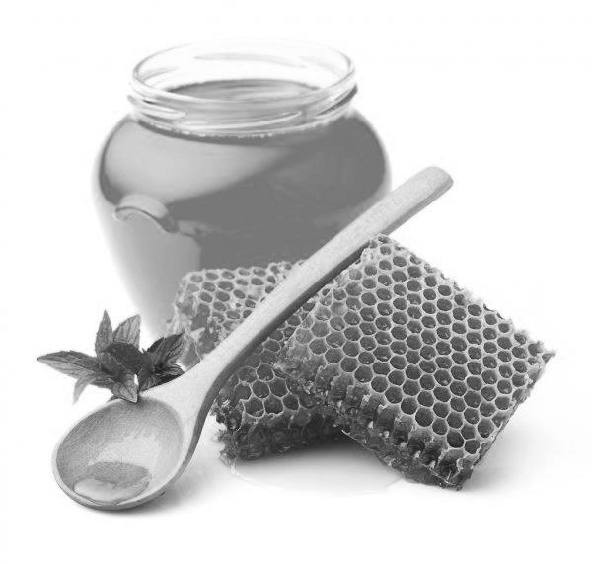
Sweetening agent : They are used to avoid/coat the pungent/bitter taste of the medicaments. Sweetening agents and sweeteners are major addetives used in the production of dietary supplements , they fulfil both technological and organoleptic functions. Formulations of products, has to be suited to consumption abilities of the target group as well as to the children`s taste requirement. We are using HONEY as a sweetening agent.

HONEY : Honey is a viscid and sweet secretion stored in the honey comb by various species of bees, such as Apis mellifera, Apis dorseta, Apis folrea, Apis indica and other species of Apis , belonging to the family Apideae (Order : Hymenotera). It is also known as Madhu, Madh, Male, Purified honey. Honey is available in abundance in Africa, India, Jamaica, Australia, California, Chili, Great Britian and Newzeland .
The average composition of honey is as follows :
Moisture 14 to 24 %, Dextrose 23 to 36%, Levulose (fructose) 30 to 47%, Sucrose 0.4 to 6%, Dextrine and Gum 0 to 7% and Ash 0.1 to 0.8%. Besides, it is found to contain small amount of essential oils, Bees wax, Pollen grains, Formic acid, acetic acid, succinic acid, Maltose, Dextrine, Coloring pigments, Vitamins and and add mixtures of enzymes, For example, Diastase, Invertase and Enulase. Intrestingly , the sugar content in honey varies widely from one country to another as it is exclusively governed by the source of the nectar (Availability of Frag-ment flowers in the region) and also the enzymetic activity solely controlling the conversion into honey. Honey shows the mild laxative, bactericidal, sedative, antiseptic and alkaline characters it is used for cold, cough, fever, sore eye and throat, tongue and duodenal ulcer , constipations ,diarrhoea. It prevents infection and promotes healing.
Formation of Gel :
Flaxseed: Falx latin name: Linum usitatissimum , synonyms :Alsi, Linn seed, Common flax, Flax weed, Lint bells, Toad flax Family: Linaceae Habitat: The plant is native to the temperature regions of Europe and Asia . Description: Katan/Flax is an annual herb of about 0.7 m high with blue flowers and a globular capsule its leaves are linear lenceolat or ovate attenuated at both ends, acute at the apex and up to the 3.8 cm long. Flax seed is one of the oldest crop having beans cultivated since the beginning of the civilasation. Flax seed was first introduced in United state by colonists, primarily to produce fiber for clothing . Flaxseed which is also known as Alsi or Katan is one of the famous Unani Drug used in a number of pathological conditions it is also known as Bazar-ul-Katan or Tukhm-E-Katan although the entire plant has medical value but its seed and oils are more important and have wide medical applications .
Phytochemistry:
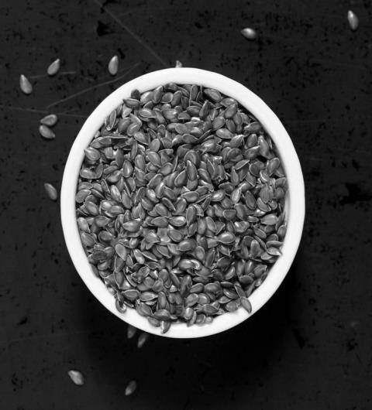
Flax seed have hard shell that is smooth and shiny and the colour ranges from deep amber to the reddish brown depending upon weather the flax is of the golden or brown variety. The envelope or testa of the seed contains about 15% of mucilage. Flax seed is rich in fat, protein and dietary fiber. The composition of flax seed can vary with genetics, growing environment and method of seed processing. An analysis of flaxseed averaged 41% fat, 20% protein, 28% total dietary fiber, 7.7% moisture and 3.4% ash. The protein content of the seed decreases as the oil content increases. It is well known that flaxseed are a source of high content of poly unsaturated fatty acid. Flaxseed has become known as functional food due to its nutritional composition, which has positive effects on disease prevention providing health beneficial components.

Latest Scientific studies :
Anti-ulcer effect : Water extract of whole seed of flax in gunia pig and mouse stomach has shown significant spasmolytic effect and protective effect against experimental ulcero genesis ( P<0.01), both effect was observed to increase with increase in soaking period.
Anti-allergic effects: Flaxseed often act like estrogen, that leads to hormonal dis balance in human body in certain cases it also could lead changes in mensturation cycle. Some women also experience hormonal issues like PCOS (Polycystic Ovary Syndrome), uterine cancer and overian diseases due to their similarity with estrogen it may be harmful for pregnant women. Omega- 3-fatty acid may alter the T-helper 2 cells defferentiantion. PUFAs (Polyunstaturated Fatty acids) may further modify cellular membrane, induced eicosanoids metabolism, and alter gene expression.
Natural Treatment for Bowel Syndrome : Flaxseed is a rich source of soluble fiber which dissolves in water and making stools softer and easier to pass this may help in reliving constipation associated with irregularity and digestive conditions.
Material and Methods :
- Flaxseed is used as a Gel base
- Ginger is used as Carminative agent
- Honey is used as Sweetening agent and Preservative
Procedure for Carminative gel Prepration:
Flaxseed was boiled slowly and with constant stirring in 60ml water for 30 mins until it shows the gel like appearance to avoid the agglomeration .Take ginger into the mortar and pestle and crush it with force to obtain the ginger extract filter it in muslin cloth.
Sr No | Name of Ingredient | F1 | F2 | F3 | F4
1 | Ginger | 1ml | 2ml | 1ml | 2ml
2 | Flaxseed | 6gm | 5gm | 7gm | 4gm
3 | Honey | 3ml | 3ml | 2ml | 4ml
Prepare 4 batches of the formulation as given in above table.
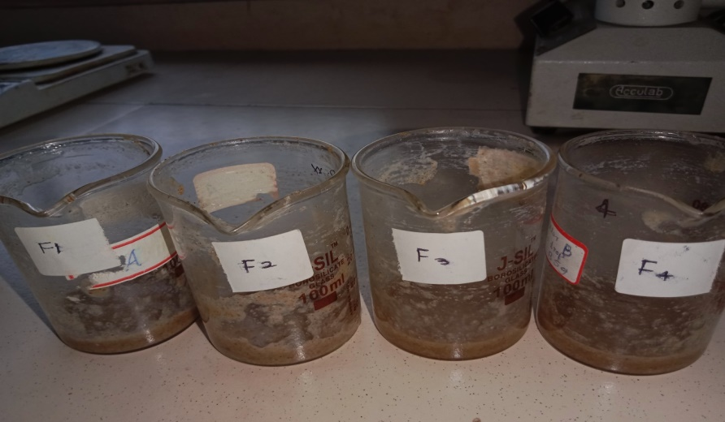
Quality Control for Gel :
- Appearance and Homogeneity : Physical and homogeneity of prepared gel were evaluated by the visual perception .

- PH Measurement : PH measurement of the gel was carried out by using a digital PH meter by dipping the glass electrode completely into the gel system to cover the electrode. The measurement was carried out in triplicates and the average of the 3 reading was recorded.
- Viscosity: Viscosity of the gel was determined using Brookfield Viscometer at 20C with a spindle speed of the viscometer rotated at 12 rpm .

Result table:
Sr.No. | Formulation | Appearance | Homogeneity | PH | Viscosity  (cps)
1 | F1 | Colour: Pale Brown  Odour: Sweet, Honey like  Taste: Sweet and Intense | Good | 5.8 | 1,51,798
2 | F2 | Colour: Pale Brown  Odour: Sweet, Honey like  Taste: Sweet and Intense | Good | 5.4 | 1,50,785
3 | F3 | Colour: Pale Brown  Odour: Sweet, Honey like  Taste: Sweet and Intense | Good | 6.8 | 1,52,876
4 | F4 | Colour: Pale Brown  Odour: Sweet, Honey like  Taste: Sweet and Intense | Good | 4.8 | 1,50,232

Conclusion:
Various herbal plants play an important role in health care practices. Stomach pain in children is serious if he or she has a high fever, had diarrhoea longer than 24 hours or vomiting longer than 24 hours. Flaxseed has many health benefits as well as rich of nutrients. Ginger is used as carminative agent to relive the pain in stomach and to coat its bitter taste honey is used as sweetener and preservative because of its composition and chemical properties honey is suitable for long-term storage.

References:
- Daun J.K., Barthet V.J., Chornick T.L. and D (2003). Structure, composition, and variety development of flaxseed. Flaxseed in human nutrition Thompson LU, Cunnane SC. 1-40.
- Singh K. K., Mridula D., Rehal J. and Barnwal P. (2011). Flaxseed: A Potential Source of Food, Feed and Fiber Critical Reviews in Food Science and Nutri-tion Volume 51, (3): 210-222
- Laurence E. F. and Mike E. B.V. (2014). Flaxseed (Lin-seed) fibre – nutritional and culinary uses – a review. Food New Zealand. April/May.
- Rodriguez-Leyva D., Dupasquier C., McCullough R. and Pierce G. (2010). The cardiovascular effects of flaxseed and its omega-3 fatty acid, alpha-linolenic acid. The Canadian Journal of Cardiology. Volume 26(9), 489-496.
- Harper C.R., Edwards M.J., DeFilippis A.P. and Jacobson T.A.(2006). Flaxseed oil increases the plasma concentrations of cardioprotective (n-3) fatty acids in humans. See comment in PubMed Commons below J Nutr. volume 136: 83-87.
- Rabetafika H.N., Van Remoortel V., Danthine S., Paquot M., Blecker C.(2011). Flaxseed proteins: food uses and health benefits. Int. J. Food Sci. Technol. volume 46: 221-228.
- Chung M.W.Y., Lei B. and Li-Chan E.C.Y.(2005) Isolation and structural characterization of the major protein fraction from NorMar flaxseed (Linum usitatissimum L.). Food Chem. 90: 271-279.
- Health Canada. (2014). Summary of Health Canada’s assessment of a health claim about ground whole flaxseed and blood cholesterol lowering.
- Cummings J. and Mann J. (2012). Carbohydrates. In J. Mann & S. Truswell (Eds.) Essentials of human nutrition (4th ed.). New York, NY: Oxford University Press. Cunnane, S., & Thompson, L. (1995). Flaxseed in human nutrition. Champaign, IL: AOCS Press
- Singh, K., Mridula, D., Rehal, J. and Barnwal, P. (2011). Flaxseed: a potential source of food, feed and fiber. Critical Reviews in Food Science and Nutrition, 51(3), 210-222.
- Ho C., Cacace J. and Mazza G. (2007). Extraction of lignans, proteins and carbohydrates from flaxseed meal with pressurized low polarity water. LWT-Food Sci Technol. 40: 1637-1647.
- Rubilar M., Gutierrez C., Verdugo M., Shene C. and Sineiro J.(2010) Flaxseed as a source of functional I gredients. J Soil Sci Plant Nutr. 10: 373-377.
- MARTIN, A.Physical pharmacy, kinetic. First Indian Reprint. New Dehli: B.I Waverly,1994.WALKER, R.V.; SMITH, E.W.The role of percutaneous Penetration inhancer. Adv. Drug Deliv. Rev. V.18,n.3,p.295-301,1996.
- Sanz ML, Polemis N, Morales V, Corzo N, Drakoularakou A, Gibson GR, Rastall RA. (2005). In vitro investigation into the potential prebiotic activity of honey oligosaccharides. Journal of Agricultural and Food Chemistry, 53, 2914–2921. 75. Salem, SN. (1981). Honey regimen in gastrointestinal disor-ders.” Bulletin of Islamic Medicine, 1, 358–362.
- Saxena S, Gautam S, Maru G, Kawle D, Sharma A. (2012). Sup-pression of error prone pathway is responsible for antimutagenic activity of honey. Food and Chemical Toxicology, 50(3-4), 625–633
- Schley PD, Field CJ. (2002). e immune-enhancing eects of dietary bres and prebiotics. e British Journal of Nutrition, 87(2), S221–S230.
- Samarghandian S, Afshari AT, Davoodi S. (2011). Honey in-duces apoptosis in renal cell carcinoma, Pharmacognosy Maga-zine, 7(25), 46–52.
- Shishodia S, Majumdar S, Banerjee S, Aggarwal BB. (2003). Ursolic acid inhibits nuclear factor-B activation induced by carcinogenic agents through suppression of IBα kinase and p65 phosphorylation: correlation with down-regulation of cycloo-xygenase 2, matrix metalloproteinase 9, and cyclin D1. Cancer Research, 63(15), 4375–4383. 80. Siddiqui IR. (1970). e sugars of honey. Advances in Carbo-hydrate Chemistry, 25,285-309.
- Simon A, Traynor K, Santos K, Blaser G, Bode U, Molan P. (2008). Medical honey for wound care - still the ‘Latest Resort’. Ev-idence- Based Complementary and Alternative Medicine, 10,1093114. Langner E, Greifenberg S, Gruenwald J. Ginger: History and use. Adv Ther. 1998;15:25. [PubMed] [Google Scholar]
- Srivastava KC. Aqueous extracts of onion, garlic and ginger inhibit platelet aggregation and alter arachidonic acid metabolism. Biomed Biochim Acta. 1984;43:S335–346. [PubMed] [Google Scholar]eidner MS, Sigwart K. Investigation of the teratogenic potential of a Zingiber officinale extract in the rat. Reprod Toxicol. 2001;15:75–80. [PubMed] [Google Scholar]
- Rong X, Peng G, Suzuki T, Yang Q, Yamahara J, Li Y. A 35-day gavage safety assessment of ginger in rats. Regul Toxicol Pharmacol. 2009;54:118–23. [PMC free article] [PubMed] [Google Scholar]

