Original article:
A study of role of magnetic resonance in detection of oral cavity malignancy in a tertiary care centre
¹Dr Tanushree Poddar* , ²Dr.Devidas Dahiphale , ³Dr.Prasanna Mishrikotkar, ⁴Dr. Shreya Shashi

^{1, 4} Resident, Department of Radiology, MGM Medical College, Aurangabad
²Head of Department, Department of Radiology, MGM Medical College, Aurangabad.
³ Associate Professor, Department of Radiology, MGM Medical College, Aurangabad
Corresponding author*

Abstract:
Introduction: In India, oral cancer accounts for major health problem with statistics suggesting 8th most common cancer in men and ranks 14th among women.Most of the oral cavity lesions are though benign but malignant propensity is seen to be higher with associated risk factors including tobacco, betel quid chewing and smoking consistently over a period of at least 10 years.The perspective of this study is to evaluate the role of MRI in early diagnosis as a gold standard modality to aid the histopathological staging and pre surgical evaluation of disease condition.
Aim: To evaluate the role of MRI in exact location and extent of oral cavity malignancy in tertiary care centre.
Methodology : The cases coming to the OPD and then forwarded to department of Radiology, MGM medical college and hospital, Aurangabad for MRI scan ,formed the source of data with detailed history of course of disease.Written and informed consent were taken for undergoing MRI scan. Patients were scanned using 1.5 tesla PHILIPS (MULTIVA)machine using dedicated 16 channel head and neck coil for both conventional and DW sequences. The data was tabulated and observed with conclusions discussed as by the study.
Results and conclusion: Total 26 patients were included in the study and MRI scan for oral cavity lesions were conducted. Diagnosis of the oral cavity ,malignancy(benign and malignant)were done and the lesions were staged and further classified according to age, gender, location etc. According to our study >50years of age group was the most common age group to be involved in group of malignancy.

Key words: MRI, oral cavity malignancy, nodal spread

Introduction:
The most commonly recognized risk factors for squamous cell Ca. of oral cavity include long term overuse of alcohol & tobacco in addition to the human papilloma virus. Oral cavity cancer classified into following:
- Buccal mucosa
- Alveolar & Gingiva
- Hard palate
- Tongue & floor of mouth
MRI is used to assess the extent of loco-regional tumour spread depth of invasion extent of lymphodenopathy. The invasion of floor of mouth by tumors is depicted in all the planes using T1W sequences & contrast enhanced T1W images to assess perineural spread,soft tissue extent, tumor thickness & best evaluate the locoregional spread in nodes and adjacent soft tissue planes.Factors affecting tissue contrast to delineate the tumour characterization are :-
- Proton density images.
- T1 relaxation time and T1 contrast images.
- T2 relaxation time
These MR pulse sequences in clinical use can be grouped under three basic classes.
- Spin Echo Sequence.
- Inversion recovery sequence.
- Gradient echo sequence
Classification of tumours based on site :-
- Cancer of lip
- floor of mouth
- Gingiva & alveolar area.
- buccal mucosa & palate.
Tumours of Minor salivary glands :-
- Adenoid cystic carcinoma
- Mucoepidermoid carcinoma
- Adeno-carcinoma
OBJECTIVES:
- To identify the most common age group and sex involved in oral cavity malignancy.
- To assess the most common sites involved in oral cavity malignancy.
- To assess the nodal spread of disease with its Histopathological correlation.
Materials and methods:
It is a time bound retrospective observational study.The study was done over a period of 8 months and total 26 patients were included in the study. Patients included in the study were patients who were referred to the department of radiology, MGM medical college and hospital Aurangabad for MR scan in a setup of clinically suspected oral cavity malignancy. Detailed history, presenting complaints of the patient were taken. The data was tabulated and observed and conclusions were made.
Inclusion criteria:
- Patients with complaint of oral cavity lesions or clinically suspected pre-malignancy.
- Patients opting for surgery for suspected malignancy.
- Premalignant conditions
Exclusion criteria:
- Patient not giving consent to be part of this study
- Patients with non compatible MR implants

67

Results:
The frequency of oral cavity malignancy according to different age group was distributed. Commonest age group involved was 50-60 years of age (40%), succeeded by 31- 40 years (26%). The youngest age at presentation was 22 years and the oldest patient was of 74 years.
Table 1)
Distribution of Patient according to gender
Gender | No of patients | %
Female | 6 | 8
Male | 20 | 92
Frequency of oral cavity malignancy was found to be more in male than females.

Graph 1)

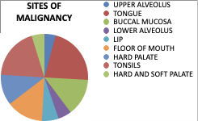
Majority of study subjects showed malignancy of tongue 26% followed by buccal mucosa and lower alveolus.

Table 2)
Distribution according to TNM staging
T-stage | Number of cases | %
T0 | 1 | 4
T1 | 3 | 6
T2 | 10 | 38
T3 | 4 | 8
T4a | 3 | 6
T4b | 5 | 6

T2 staging was seen only in 36% which was maximum among all study subjects.
68
Table 3)
Graph 2)
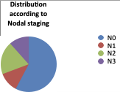

Stage | MRI staging cases | HP
N0 | 15 | 20
N1 | 3 | 4
N2 | 5 | 6
N3 | 3 | 3
TOTAL | 26 | 33

Diagnosis was made by HP,it was found that N0 was maximum in 20% subjects.

Discussion:
The study was conducted in department of radiology, MGM medical college and hospital. According to our study 50-60years of age group was the most common age group to be involved in oral cavity malignancy with positive histopathology findings. kittipong dhanuthai et al.found the age of patients ranged from 18 to 68 years with a mean +SD=58.37+_15.7 years.
Incidence of oral cavity malignancy was found to be predominant in males than females, affecting 20 male patients and only 6 female patients .(Table 2). Kieser et al study also showed similar results with 80% proven cases of malignancy in males (11).Tobacco chewing was found as the most important factor for causation of oral cavity malignancy (12,13). Smoking and HPV infection was seen as the second most common cause as seen in our study, although few of the authors concluded smoking as the most common cause (12,13).In distribution of various sites of malignancy, tongue was found as the most common site followed by buccal mucosa and palate. (Table3) Amandeep singh et al study showed that Tongue was the most common to be involved(14) followed by lip and other sites. Only 8 patients showed involvement of upper alveolus and floor of mouth Table 3. In (table 4) showed the distribution of patients according to TNM staging with most of patients involved accounting for 10 patients out of total 26 patients withT2 staging, Valecha j et al. found amongst nodal staging level I b lymph node was most commonly involved.The tumor with depth of invasion greater than 9mm show cervical node one or other level in 705 patients ,however nodal metastasis detected in 12 % patients in whom tumor thickness was less than 3mm. correlation with nodal staging in MRI was done in (table 5 ) were 15 MRI staging cases with 20 HP cases found and 5 N2 staging cases with 6 HP positive findings were found. In the study no cervical metastasis was found in patients with tumor less than 9mm of RTT were Hiroshi iwai et al. stated that no cervical metastasis was found in patients with tumor less than 6mm of TMR including two in whose MR images of tumor was not evident.
Conclusion:
Magnetic resonance imaging is an accurate, non-invasive technique for evaluation of patients with oral cavity malignancy. MRI provides a satisfactory accuracy for preoperative estimation and predict the occult cervical nodal metastasis. This study aims to know the over all rationale behind early diagnosis and decide role of surgery/radiotherapy for treatment and management of oral cavity lesions as they are slow and indolent in their course. The study emphasises on the role of MRI in early diagnosis and to locate the subtle changes of pre-malignancy with excellent soft tissue contrast and knowing its extent with staging for treatment care as well as post op follow up. Early treatment and screening indeed reduces the number of unnecessary biopsies. For these reasons based on the results of study we suggest pilot use of MRI as an auxiliary and complementary method to biopsy for pre-treatment and monitoring of oral cancer patients.
69
Cases:
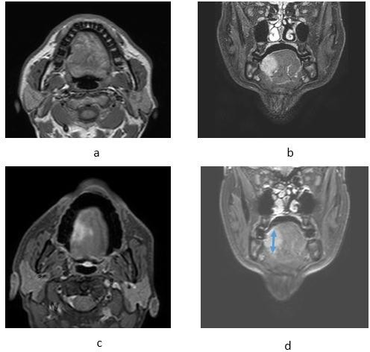
Photograph 01: Oral cavity cancer, involving tongue.

A: axial T1weighted, B :coronal STIR, C: axial post-contrast T1-weighted MRI images with fat suppression, D : coronal contrast-enhanced T1-weighted MRI images with fat suppression: demonstrate carcinoma of the tongue.

70

Photograph 02: Carcinoma involving Floor of mouth Oral cavity cancer, located in the floor of the mouth region.
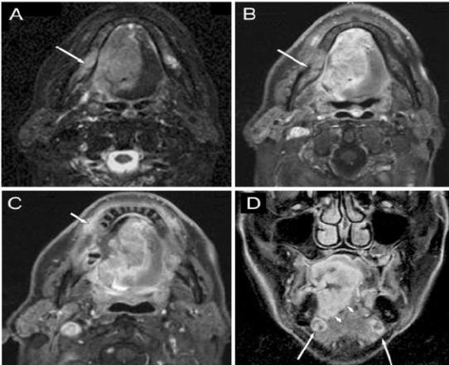

A : axial STIR-, B , C : axial post-contrast T1-weighted MRI images with fat suppression, D : coronal contrast-enhanced T1-weighted MRI images with fat suppression: demonstrate expansive carcinoma of the tongue infiltrating the gingiva ( C image, short arrow), crossing the midline, invading the right mandibular base ( A , B images, long arrows) and involving the extrinsic muscles of the tongue ( D image, arrow-heads). On the coronal image bilateral small, well-defined submandibular lymph nodes are seen with sign of colliquation.

REFERENCES:
- American Cancer Society (homepage on the internet). (Cited 2006 Oct. 20)
- Klussmann JP, Weissenborn SJ, Wieland U, et al. Prevalence, distribution, and viral load of human papillomavirus 16 DNA in tonsillar carcinomas. Cancer 2001;92(11):2875–2884.
- Dr. Sankaranarayanan. Oral cancer screening saving lives. Lyon, France International agency for research on cancer WHO. Press release 3rd June 2005.
- Castelijns JA: Diagnostic radiology of head and neck oncology. Curr Opin Oncol, 1991; 3(3): 512–18
- Van den Brekel MW, Castelijns JA, Snow GB: The role of modern imaging studies in staging and therapy of head and neck neoplasms. Semin Oncol, 1994; 21(3): 340–48 5.
- Madison MT, Remley KB, Latchaw RE, Mitchell SL: Radiologic diagnosis and staging of head and neck squamous cell carcinoma. Radiol Clin North Am, 1994; 32(1): 163–81 6.
- Imaizumi A, Yoshino N, Yamada I et al: A potential pitfall of MR imaging for assessing mandibular invasion of squamous cell carcinoma in the oral cavity. Am J Neuroradiol, 2006; 27(1): 114–22 7.
71

