Case report:

A rare case of internal hernia with bowel ischemia in pediatric patient

*Dr. Deeksha Singh MBBS ** Dr. Dodamani Diwakar MBBS,DNB.

* Junior Resident, Department of Radiodiagnosis , JJMMC , Davanagere, Karnataka
** Assistant Professor, Department of Radiodiagnosis , JJMMC , Davanagere , Karnataka
Corresponding author: Dr Dodamani Diwakar

This work is licensed under a Creative Commons Attribution-NonCommercial 4.0 International License

Date of submission: 12 January 2023
Date of Final acceptance: 23 February 2023
Date of Publication: 15 March 2023
Source of support: Nil
Conflict of interest: Nil

Abstract:
Paraduodenal hernias accounts for most common type of internal hernias. Left paraduodenal hernia occurs through paraduodenal fossa of Landzert ; which is peritoneal pocket present behind descending mesocolon and towards the left of 4th part of the duodenum. Errors of midgut rotation during embryological development results into paraduodenal hernia. Patients may present in emergency with acute or subacute intestinal obstruction and according to the presentation- Radiography may either show air fluid levels or can also be normal. In such cases, Computed Tomography of abdomen & Pelvis serves as more reliable investigation for diagnosis. Adequate embryological and anatomical knowledge of adjacent structures will contribute to accurate diagnosis and ease in the surgical management. In cases of left sided paraduodenal hernia, sac should be identified carefully in order to avoid injury to the vessels. Elective laparoscopic surgery and emergency exploratory laparotomy is considered for non-obstructive and obstructive features of left paraduodenal hernia respectively .
Keywords: Fossa of landzert, internal hernia

Case report:
A 3-year-old female patient presented in the paediatrics department with complaints of abdominal distention , pain in abdomen and vomiting. There were no complains of constipation or obstipation. Patient had similar complains of pain abdomen, non-projectile vomiting containing food particles 15days back and no complains of fever or burning micturition , for which she was symptomatically treated and discharged. Patient was diagnosed with disseminated tuberculosis at age of 6 months for which she received treatment. Cervical lymph node biopsy came negative for tuberculosis 3 months back after which treatment was stopped.
On physical examination, Abdomen was distended and non-tender. Abdominal radiograph was normal with single gastric fundic shadow and no other abnormally dilated bowel loops. Ultrasonography showed overdistended stomach and duodenum, distal to which jejunal loops appeared collapsed. There was mesenteric lymphadenopathy with no demonstrable bowel wall thickening. CECT-abdomen was performed which revealed encapsulated clumping of the small bowel loops with sac like appearance in left upper quadrant , which was seen displacing pancreas anteriorly and transverse colon inferiorly. The wall of involved bowel loops were showing subtle patchy areas of reduced enhancement. CT-scan was suggestive of left para duodenal hernia with suspicion of bowel ischemia. Further barium follow through revealed passage of contrast reaching up to 3rd part of duodenum with cut off and a well circumscribed mass of herniated bowel loops noted in left upper quadrant.
Patient underwent exploratory laparotomy to release the gastric outlet obstruction caused by narrowing secondary to left para-duodenal hernia. Intraoperative findings confirmed the diagnosis of left Para duodenal hernia. Hernial opening was situated just left and lateral to the 4th part of the duodenum with jejunal, proximal and mid ileal loops as a part of hernia sac. Neck was arched antero-medially by Inferior Mesenteric vein. Few herniated loops were found to be gangrenous, trapped bowel loops were released, 100% O₂ and hot mop were applied, resulting into significant improvement in vascularity . Non-viable segment was resected. The defect was sutured and haemostasis was achieved. Patient later succumbed to death due to septicaemia.

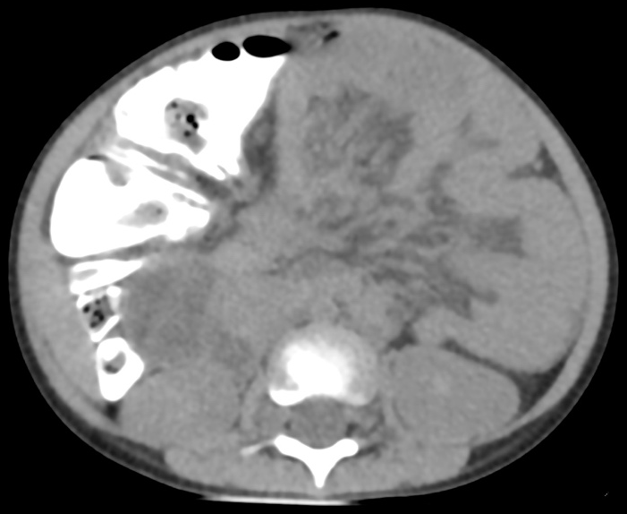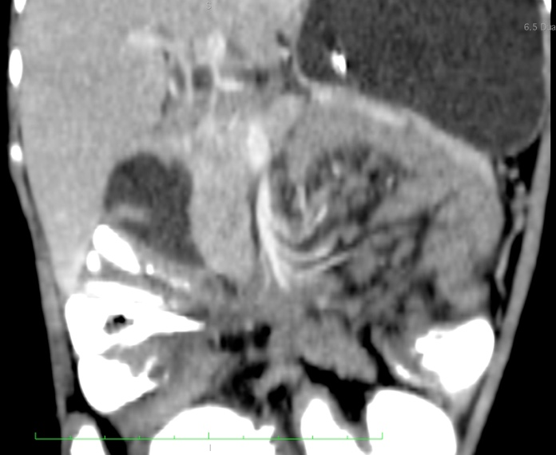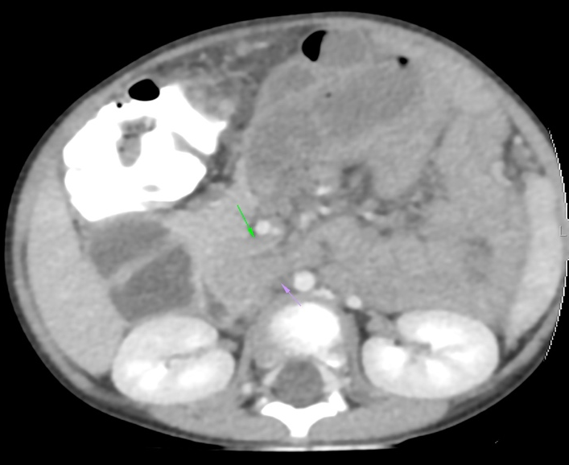
Fig 1 : NCCT and CECT Images demonstrating left paraduodenal hernia with the defect and the content in the hernia.

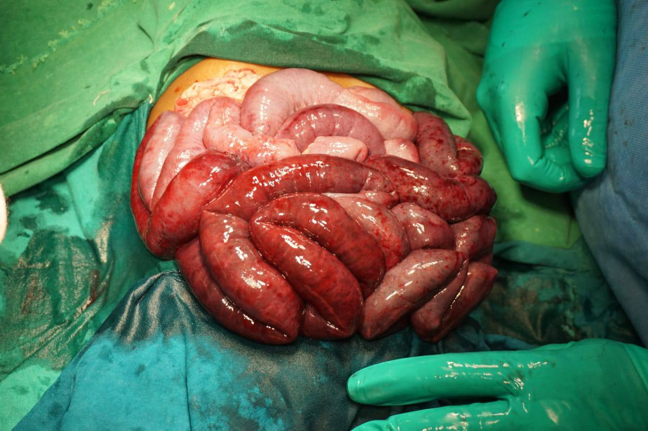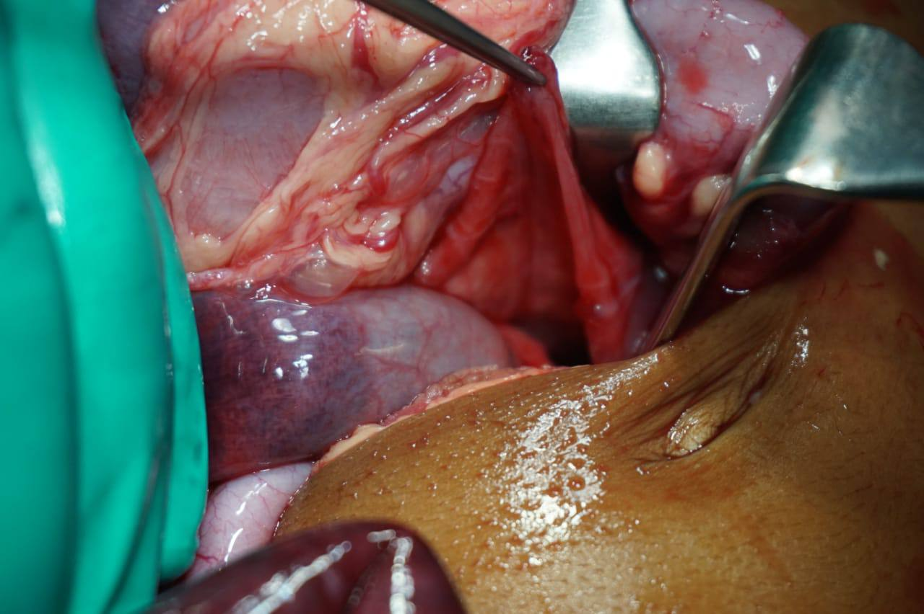
Fig 2: Intra Operative photographs showing the ischemic loop and the defect through which herniation occurred.

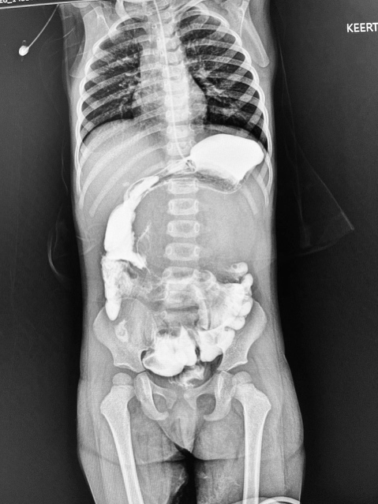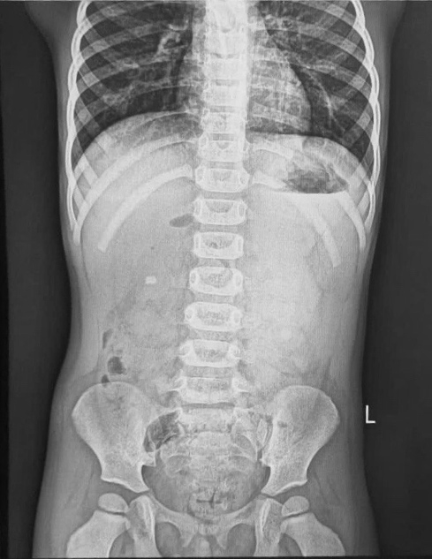
Figure 3 : Radiographs and Barium Meal study of the patient.

Discussion :
The most common types of internal hernias according to the classification of Welch [1] in descending order of frequency are as follows:
- Paraduodenal hernias (left > right) : 53 %
- Pericecal hernia : 13 %
- Through the foramen of Winslow : 8 %
- Transmesenteric : 8 %
- Intersigmoid : 6 %
- Supravesical and pelvic : 6 %
- Transomental : 1–4 %
CT findings of internal hernias include small bowel obstruction (SBO); the most common manifestation of internal hernias is strangulating SBO, which occurs after closed-loop obstruction. Therefore, in patients who are suspected to have internal hernias, early surgical intervention may be indicated in order to reduce high morbidity and mortality rates. In left-sided paraduodenal hernias small-bowel loops herniate into an unusual fossa to the left of the duodenum referred to as the paraduodenal fossa, or Landzert's fossa, that results from a congenital defect in the descending mesocolon. This abnormal peritoneal pocket is bordered anteriorly by a peritoneal fold overlying the inferior mesenteric vein and ascending left colic artery ⁽³⁾ .
Paraduodenal hernia a result of complex events during embryological development of the midgut. During rapid development of the midgut in comparison to that of abdominal cavity, the midgut herniates. The herniated bowel is reduced counter clock wise direction, during further development. Instead of going into the free peritoneal cavity, if the reducing bowel enters the unsupported area which is created by the Inferior Mesenteric artery and is located to its left side. This area is present anterior to the left colic branch of inferior mesenteric artery, posterior to the left colon and left side of the midline. This is now called as left paraduodenal hernia. Lateral to the fourth part of duodenum and bounded anteriorly by inferior mesenteric artery is the neck of paraduodenal hernia. Posterior to this neck is the left colic branch of the inferior mesenteric artery
Treitz has dictated three necessary prerequisites for the occurrence of left para-duodenal hernia:
- Presence of a fossa;
- Presence of inferior mesenteric vein in neck of the sac;
- Sufficient mobility of the small bowel to allow it into the sac derived from this fossa ^{(4).}
Earlier , before introduction of modalities like CT, the diagnosis of paraduodenal hernia was done by conventional radiography. Barium studies shows herniated bowel loops as encapsulated , well circumscribed mass of bowel loops in left upper quadrant.⁽⁵⁾ They may also be seen as causing mass effect in the form of displacement of transverse colon inferiorly and causing indention or compression over posterior wall of stomach with mild dilatation of efferent loop , showing abrupt change in calibre. ⁽⁶⁾ On CT , similar findings will be seen along with abnormalities of mesenteric vessels which are supplying the herniated bowel loops, as crowding and stretching of vessels and displacement of inferior mesenteric vein laterally to the left can also be seen. The IMV and ascending left colic artery is located at the anteromedial border of the left paraduodenal hernia sac. ⁽⁷⁾
Chaudhary B et al had reported a case of left paraduodenal hernia which presented with subacute intestinal obstruction. Radiographic findings and ultrasonography were unremarkable in that case. CT-abdomen with oral contrast was suggestive of left paraduodenal hernia.⁽⁸⁾ Similarly, in our case, Abdomen radiograph and ultrasonography were inconclusive, and the diagnosis was solely made on CT and later, barium study performed was also indicated towards similar diagnosis.
Conclusion
Paraduodenal hernias are rarely seen in clinical practice , so as radiologist thorough knowledge and able to diagnose the unsuspected or unidentified outcomes of PDH can significantly reduce the mortality. Cross- section modalities like CT and careful interpretation is useful for diagnosis of Para duodenal hernia. Early pre-operative diagnosis aids to significant ease in surgical management. In cases, PDH causing acute conditions like small bowel obstruction, ischemia and strangulation, immediate surgical intervention is considered to be lifesaving. However, elective laparoscopic surgery can be opted for non-obstructing presentations in left paraduodenal hernia.

References:
- Welch CE. Hernia: intestinal obstruction. Chicago: Year Book Medical; 1958. pp. 239–268.
- Takeyama N, Gokan T, Ohgiya Y, et al. CT of internal hernias. Radiographics. 2005;25:997–1015
- Mathieu D, Luciani A, Group G. Internal abdominal herniations. AJR Am J Roentgenol. 2004;183:397–404
- Desjardins AU. Left paraduodenal hernia. Ann Surg. 1918; 67(2):195-201
- Bartlett MK, Wang CA, Williams WH. The surgical management of paraduodenal hernia. Ann Surg. 1968;168(2):249
- Carlos Augusto Marques Batista, Laís De Souza Coutinho, Jodson Fernandes Rêgo, Mariana Baylão Penna, Joaquim Ferreira de Paula. 2022. Abdome agudo obstrutivo por hérnia paraduodenal esquerda: relato de caso. Revista Saber Digital 15:2, e20221509.
- Murali Appavoo Reddy UD, Dev B, Santosham R. Internal hernias: surgeons dilemma-unravelled by imaging. Indian J Surg. 2014;76:323–8
- Chaudhary B, Anand U, Priyadarshi RN. Left paraduodenal hernia. J Anat Soc India. 2014;63(3):S39-41

