Original article:
Study on bacteriological profile and antibiogram of surgical site infection in tertiary care hospital
Dr. Sanjaykumar More¹, Dr.V.S.Rathod², Dr. Pratibha Sanjay Mane³ , Dr Rohit sinha⁴

¹Professor and Head of Department, Dept of Microbiology, Dr. Shankarrao Chavan Government Medical College and Hospital, Vishnupuri, Nanded.
²Associate Professor, Dept of Microbiology, Dr. Shankarrao Chavan Government Medical College and Hospital, Vishnupuri, Nanded.
³Junior Resident Third, Dept of Microbiology, Dr. Shankarrao Chavan Government Medical College and Hospital, Vishnupuri, Nanded.
⁴ Assistant Professor, Dept of Microbiology, Dr. Shankarrao Chavan Government Medical College and Hospital, Vishnupuri, Nanded.
Corresponding Author - Dr Rohit sinha , Assistant Professor, Dept of Microbiology, Dr. Shankarrao Chavan Government Medical College and Hospital, Vishnupuri, Nanded.

This work is licensed under a Creative Commons Attribution-NonCommercial 4.0 International License

Date of submission: 2 January 2023
Date of Final acceptance: 11 March 2023
Date of Publication: 30 March 2023
Source of support: Nil
Conflict of interest: Nil

ABSTRACT
Background: Surgical site infection is major healthcare infection which causes significant morbidity and mortality. It is the second major cause of hospital acquired infection after CAUTI. Worldwide SSI rate varies from 2.5% to 41.9%.
Material and Methods: The study was conducted on 1106 clinically suspected SSI patients for a period of one year (January 2021 to Dec 2021) in the Department of Microbiology at DRSCGMC, Nanded. Two sterile cotton swabs were collected maintaining aseptic precautions. Gram stained smear was prepared from one swab and other swab was inoculated on blood agar and MacConkey agar. After overnight incubation organisms were identified by using standard microbiological methods. Antibiotic sensitivity was done by Kirby Bauer disc diffusion method.
Results: Out of 1106 clinically suspected SSI patients, microorganisms were isolated from 39.72% patients. The most frequently isolated organism was Staphylococcus aureus followed by Klebsiella pneumoniae, Escherichia coli, Acinetobacter baumanni, pseudomonas aeuroginosa. Gram positive organisms were susceptible to linezolid and resistant to penicilins and gram negative organisms were susceptible to meropenem and piperacillin-tazobactum and most of them resistant to ciprofloxacin,amoxyclav.
Discussion: In our study, the rate of surgical site infections was 39.72% which is comparable with the study conducted by Dharmraj et al and Budhani et al. A prolonged hospital stay, instrumentation, duration of surgery may contribute to increased rate of SSI.
Conclusion: Unrestricted use of antibiotics is leading cause of antibiotic resistance. Proper maintenance of hand hygiene, proper intraoperative care and proper use of antibiotics can reduce the incidence of SSI.
Keywords- SSI,Antibiogram

Introduction
Infections caused by an invasive surgical procedure that occurs in the wound are commonly referred to as surgical site infections (SSIs). Surgical site infections (SSI), one of the most common cause of healthcare associated infections¹.It is clinically characterized as an infection that occurs within 30 days of surgery (or within a year if an implant is left in place after the procedure) and affects either the incision or deep tissue at the site of the surgery. In SSI there is proliferation of pathogenic microorganisms at the site of surgical incision which may involve skin and subcutaneous fat (superficial), Musculofacial layers (deep) in an organ/cavity². Staphylococcus aureus is the most common organism isolated³. It continues to be a major source of morbidity. Infection is usually caused by exogenous and endogenous micro-organisms that enter the operative wound during the surgery. Recently Gram-negative organisms are also noted as cause of SSI. The overuse of antibiotics has led to a major problem of resistant organisms.
Materials and methods
The study was conducted on 1106 clinically suspected SSI patients for a period of one year (January 2021 to Dec 2021) in the Department of Microbiology at DR Shankarrao Chavan Government Medical College, Nanded. Samples were collected from either gender and different age groups after taking intra operative and post operative details. Samples were collected from SSI from patients with complaint of pain, swelling, discharge, delayed or nonhealing wound at surgical site. Two sterile cotton swabs were collected maintaining aseptic precautions. Gram stained smear was prepared from one swab and other swab was inoculated on blood agar and MacConkey agar. After overnight incubation organisms were identified by using standard microbiological methods. Antibiotic sensitivity was done by Kirby Bauer disc diffusion method as per CLSI guidelines 2021.
Results
Out of 1106 clinically suspected SSI patients, microorganisms were isolated from 439(39.72%) patients. The most frequently isolated organism was Staphylococcus aureus followed by Klebsiella pneumoniae, Escherichia coli, Acinetobacter baumanii, pseudomonas aeuroginosa. Gram positive organisms were susceptible to linezolid and resistant to Penicilin and gram negative organisms were susceptible to meropenem and piperacillin-Tazobactum and most of them resistant to Ciprofloxacin, Amoxiclav.

Table 1: Shows total number of surgical procedures done during study period and rate of Hospital Acquired Infection (HAI)

No. of surgical procedures | 1106(100%)
SSI rate | 439(39.72%)

Table.2 : Bacterial Organism isolated from specimens.

Staphylococcus aureus | 184(42%)
MRSA | 53(12%)
Escherichia coli | 62(14%)
Klebsiella pneumoniae | 75(17%)
Pseudomonas aeruginosa | 35(8%)
Acinetobacter baumanii | 4(1%)
Proteus mirabilis | 13(3%)
Enterococcus species | 13(3%)

Table.3:Showing the antibiotic susceptibility pattern of gram positive organisms Staphylococcus aureus, Enterococci and MRSA to various antibiotics.

Sr  no | Name of antibiotic | No of isolates =237
 |  | Sensitive | intermediate | Resistant
1 | Vancomycin | 237(100%) | - | -
2 | Linezolid | 237(100%) | - | -
3 | Erythromycin | 128(54.01%) | 69(29.11%) | 40(16.87%)
6 | Penicillin | 12(5.06%) | - | 225(94.93%)
7 | Amoxycilin clavulanic acid | 122 (51.47%) | 73(30.80%) | 42(17.72%)
8 | Gentamycin | 185 (78.05%) | 42(17.72) | 10(4.21%)
9 | Clindamycin | 138 (58.22%) | 63(26.58%) | 36(15.18%)
10 | Cotrimoxazole | 133(56.11%) | 86(36.28%) | 18(7.59%)

Table.4: Showing the antibiotic susceptibility pattern of gram negative organisms to various antibiotics.

Sr  no | Name of antibiotic | No of isolates=202
 |  | Sensitive | intermediate | Resistant
1 | Amoxycilin -Clavulanic acid | 38(18.81%) | 137(67.82%) | 27(13.36%)
2 | Ceftazidime | 57(28.21%) | 43(21.28%) | 102(50.49%)
3 | Ceftazidime clavulanic acid | 69(34.15%) | 78(38.61%) | 55(27.22%)
4 | Ciprofloxacin | 93(46.03%) | 84(41.58%) | 25(12.37%)
5 | Imipenem | 151(74.75%) | 32(15.84%) | 19(9.40%)
6 | Meropenem | 157(77.72%) | 34(16.83) | 11(5.44%)
7 | Piperacilin Tazobactum | 105(51.98%) | 84(41.58%) | 13(6.43%)
8 | Amikacin | 147(72.77%) | 28(13.86%) | 27(13.36%)

In the present study out of 439 isolates, 237(53.98%) isolates were gram positive organisms and 202(46.02%) isolates were gram negative organisms . Gram negative organisms were more frequently isolated than Gram positive organisms. Staphylococcus aureus (MSSA) (42%) is the predominant pathogen followed by MRSA (12%), and Enterococcus species (3%). Out of Gram negative isolates Klebsiella species (17%) followed by Escherichia coli, Pseudomonas aeruginosa (8%), Acinetobacter species 1(1%) .
Discussion
In our study, the rate of surgical site infections was 39.72% which is comparable with the study conducted by Dharmraj et al and Budhani et al. study conducted by Vikrant Negi and Shekhar Pal SSI rate was 17.8%, study conducted by Ruby Naz, Seth Hussain rate is 21%. A prolonged hospital stay, instrumentation, duration of surgery may contribute to increased rate of SSI. Despite the advances in surgical techniques and better understanding of the pathogenesis of wound infection, SSIs management remains a significant concern for surgeon and physicians in a health care facility .Patients with SSIs face additional exposure to microbial populations circulating in a hospital set up which is always charged with microbial pathogens in present study staphylococcus aureus is most common isolated organism .
Conclusion
Indiscriminate use of antibiotics,duration of hospital stay are leading cause of antibiotic resistance. Proper maintenance of hand hygiene, proper intraoperative care and proper use of antibiotics can reduce the incidence of SSI.

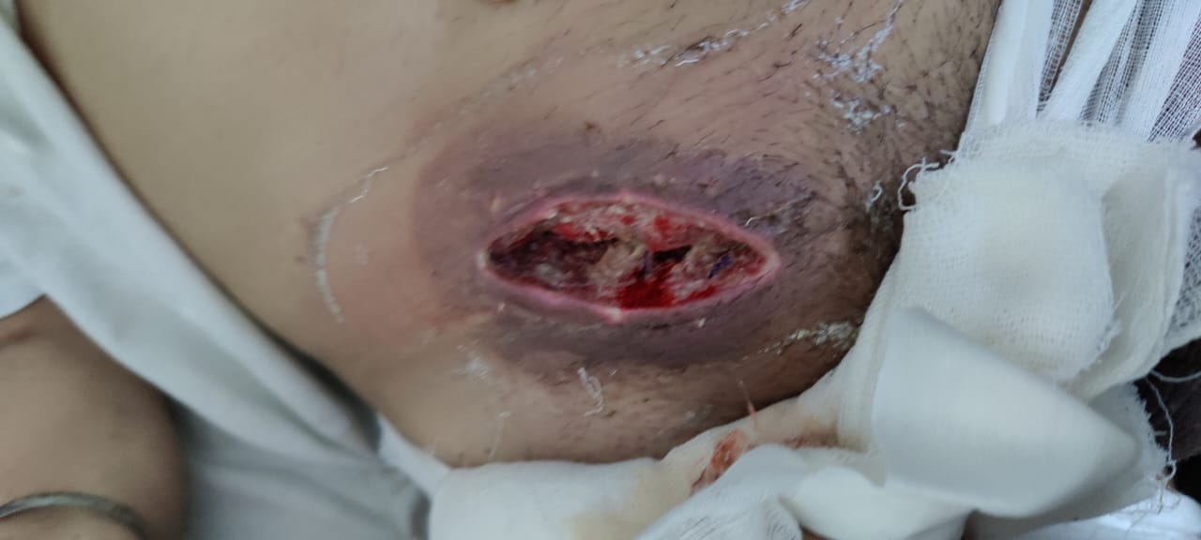
- Surgical site infection in postoperative case of direct inguinal hernia.
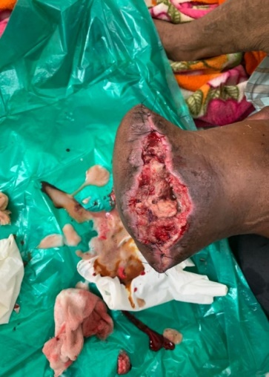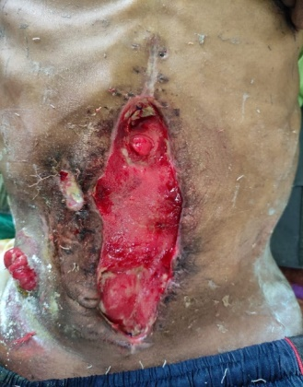
- .Amputation limb. C. Laparotomy wound

REFERANCES:

- Negi V, Pal S, Juyal D, Sharma MK, Sharma N. Bacteriological Profile of Surgical Site Infections and Their Antibiogram: A Study From Resource Constrained Rural Setting of Uttarakhand State, India. J Clin Diagn Res. 2015 Oct;9(10):DC17-20. doi: 10.7860/JCDR/2015/15342.6698. Epub 2015 Oct 1. PMID: 26557520; PMCID: PMC4625239.
- M.S.S Pradeep, K Vishnu Vardhana Rao. A Study on surgical Site Infections, their bacteriological profile and antimicrobial susceptibility pattern..IJMMTD. Volume : 5, Issue : 1, Year : 2019 Article Page : 9-13
- Bhatta DR,Adhikari A,Gurung JL,AmatyaNM,Nayak N,Gokhle S.Bacteriological profile of surgical site infections in a tertiary care hospital of western Nepal.JGMC Nepal 2021:14(1) :33-8
- Khan, Ambreen & Sarwat, Tarana & Mohan, dr.sneha & Dutta, Renu. (2021). Surgical Site Infection: Bacteriological and Clinicopathological Profile and Antibiogram in a Tertiary Care Hospital. Journal of Medical Sciences and Health. 6. 51-57. 10.46347/jmsh.2020.v06i03.009.
- Kanwalpreet Kaur, Loveena Oberoi, Pushpa Devi. Bacteriological profile of surgical site infections. IAIM, 2017; 4(12): 77-83.
- Misha G, Chelkeba L, Melaku T. Bacterial profile and antimicrobial susceptibility patterns of isolates among patients diagnosed with surgical site infection at a tertiary teaching hospital in Ethiopia: a prospective cohort study. Ann Clin Microbiol Antimicrob. 2021 May 10;20(1):33. doi: 10.1186/s12941-021-00440-z. PMID: 33971896; PMCID: PMC8112062.
- Naz R, Hussain SM, Ain QUl. Bacteriological Profile of Surgical Site Infections and their Antibiotic Susceptibility Pattern. SSR Inst. Int. J. Life Sci., 2019; 5(2): 2224-2229.
- Budhani, Diksha & Kumar, Dr & Sayal, Pallavi & Singh, Dr. (2016). Bacteriological profile and antibiogram of surgical site infection/ post-operative wound infection. International Journal of Medical Research and Review. 4. 1994-1999. 10.17511/ijmrr.2016.i11.17.
- Verma, Usha & Ashopa, Vishakha & Gupta, Eshank & Gupta, Anita & Lal, Parmeshwar & Gupta, P & Prakash, Prabhu. (2021). Bacteriological Profile of Surgical Site Infection in a Tertiary Care Centre.
- Narula H, Chikara G, Gupta P. A prospective study on bacteriological profile and antibiogram of postoperative wound infections in a tertiary care hospital in Western Rajasthan. J Family Med Prim Care. 2020 Apr 30;9(4):1927-1934. doi: 10.4103/jfmpc.jfmpc_1154_19. PMID: 32670942; PMCID: PMC7346923.

