Case Report:
Case report: Small intestine GIST presenting as bleeding per rectum
Dr. Shubham Gawas, Dr. Jude Rodrigues, Dr. Reshama Salelkar, Dr. Agasin Meddemal

Department of General Surgery, Goa Medical College, Bambolim, Goa, India
Corresponding author: Dr. Shubham Gawas

Abstract:
Gastrointestinal stromal tumors (GISTs), formerly referred to as smooth muscle neoplasms, are now recognized as a unique group of mesenchymal tumors based on electron microscopic (EM) and immunohistochemical (IHC) characteristics. Mazur and Clark introduced the name GIST in 1983 to distinguish this distinct mesenchymal neoplasm as a specific clinicalopathologic entity different from leiomyomas and leiomyosarcoma. GIST is currently defined as spindle cell, epithelioid, or occasionally pleomorphic mesenchymal tumors of the gastrointestinal tract typically expressing KIT proteins acquired by IHC.1 These tumors are associated with a variety of clinical presentation. General presentation of GIST intestinal bleeding . GIST arise from mesenchymal tissue and constitute about 20% of malignant neoplasms of small bowel . These tumours arise from interstitial cells of cajal which serve as gut pacemakeras they create basal electric rhythm leading to peristalsis and segmentation of smooth muscle. Most common site is stomach(50 - 60%) followed by small intestine(30 - 40%). Rare sites include colorectum(7%), esophagus(1%), mesentry, omentum. Herewith we reported a case of 45 yr old male presented with bleeding PR for 5 days. Patient had similar episodes in the past which were managed conservatively.
Keywords: Gastrointestinal stromal tumors , small intestine , rectum

Background:
Gastrointestinal stromal tumors (GISTs), formerly referred to as smooth muscle neoplasms, are now recognized as a unique group of mesenchymal tumors based on electron microscopic (EM) and immunohistochemical (IHC) characteristics. Mazur and Clark introduced the name GIST in 1983 to distinguish this distinct mesenchymal neoplasm as a specific clinicalopathologic entity different from leiomyomas and leiomyosarcoma. GIST is currently defined as spindle cell, epithelioid, or occasionally pleomorphic mesenchymal tumors of the gastrointestinal tract typically expressing KIT proteins acquired by IHC.1 These tumors are associated with a variety of clinical presentation. General presentation of GIST intestinal bleeding . GIST arise from mesenchymal tissue and constitute about 20% of malignant neoplasms of small bowel . These tumours arise from interstitial cells of cajal which serve as gut pacemakeras they create basal electric rhythm leading to peristalsis and segmentation of smooth muscle. Most common site is stomach(50 - 60%) followed by small intestine(30 - 40%). Rare sites include colorectum(7%), esophagus(1%), mesentry, omentum.
Case report:
Herewith we reported a case of 45 yr old male presented with bleeding PR for 5 days. Patient had similar episodes in the past which were managed conservatively.
Colonoscopy done was normal.
Susequently CECT abdomen done which showed spiculated mesentric mass in right paraumbilical region causing clumping of ileal bowel loops and asymmetric hyperenhancing bowel wall thickening with non-necrotic mesentric lymphadenopathy
Patient subsequently underwent laparotomy which showed ileal growth for a length of 20cms, 10 cm from IC junction for which limited right hemicolectomy was performed
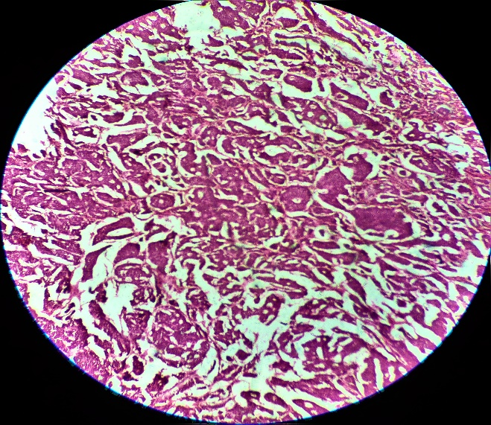
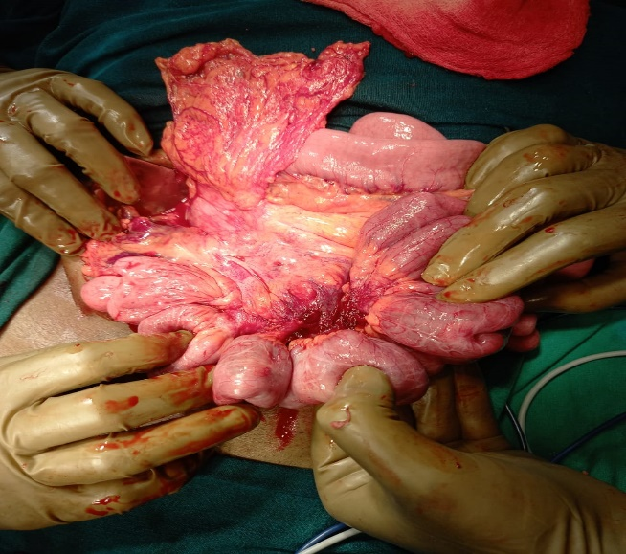
HPE revealws NET of small intestine which was GIST confirmed on IHC

Discussion:
GIST, although rare, represents the most common mesenchymal neoplasm of the gastrointestinal tract. They make up about 0.1% -0.3% of all stomach tumors. Their native cell is proposed to be interstitial Cajal cells (ICCs) or stem cells of CD 34 dividing to ICCs. ICCs ICCs are intestinal pacemaker cells that are identified by C-KIT exposure and are located in the myenteric plexus. They link gut peristalsis, which when examined by ultrastructural reveals your features in both smooth and neural muscle spasms. GIST-induced GIST-induced conversion of C-KIT proto-oncogene, as well as the expression of the C-KIT protein (CD 117) distinguish them from other malignant mesenchymal disorders of the stomach. About 5% of GISTs have a CD117 negative and ports of PDGFR-α. Wild GIST genes are those where C-KIT or PDGFR-α are detected by IHC.
Most common presentation of GIST is bleeding leading to anemia, malena, hematochezia. It can also present as bleeding into peritoneal cavity, obsruction, rupture and peritonitis. These tumours are universally associated with mutation of tyrosine kinase c-kit oncogene and these tumours are sensitive to tyrosine kinase antagonist imatinib (80% response rate is seen).
It cane be sporadic or associated with syndromes( CARNEY’S TRIAD, CARNEY - STRATAKIS SYNDROME, NF type 1)
Most common indication for surgery is bleeding and obstruction. Free perforation may occur 2⁰ to hemorrhagic necrosis of large tumour mass . 3 mutations in pathogenesis of GIST - KIT (CD117) GENE, PDGFRA GENE, CD34 GENE. Most common site of metastasis is liver(65%) followed by peritoneum(21%).
GIST tumors of biological diversity whose clinical presentation is largely determined by their location and size. Symptoms that show symptoms are usually large, and the most common symptom is luminal bleeding of the intestines. It introduces the patient's condition that develops peritoneal symptoms and hemodynamic hemorrhage second to severe intratumoral bleeding, which is a rare manifestation. The final diagnosis was confirmed by immunohistochemistry. Gastrointestinal bleeding is the most common presentation of GIST. However, doctors should always be aware that, although rare, large tumors and blood vessels may indicate severe intratumoral bleeding.
Conclusion:
Treatment of choice of GIST is complete surgical resection with negative margins (R₀ resection), with adjuvant treatment with imatinib . Lymph node metastasis is rare. They are radioresistant tumours and not sensitive to conventional chemotherapy . Follow up of patient is vital as most patients have recurrence within 5 years.

References:
- Karthigeyan M, V A, Maroju NK, Badhe BA, K S. Intratumoral Bleed in Small Bowel GIST Mimicking Peritonitis: An Unusual Presentation. Gastrointest Cancer Res. 2011;4(4):137-140.
- 1. Joensuu H: Gastrointestinal stromal tumor (GIST). Ann Oncol 17(Suppl 10):280–286, 2006
- 2. Kindblom LG, Remotti HE, Aldenborg F, Meis-Kindblom JM: Gastrointestinal pacemaker cell tumor (GIPACT): gastrointestinal stromal tumors show phenotypic characteristics of the interstitial cells of Cajal. Am J Pathol 152(5):1259–1269, 1998
- 3. Corless CL, Fletcher JA, Heinrich MC: Biology of gastrointestinal stromal tumors. J Clin Oncol 22(18):3813–3825, 2004
- 4. Fletcher CD, Berman JJ, Corless C, et al. : Diagnosis of gastrointestinal stromal tumors: a consensus approach. Hum Pathol 33(5):459–465, 2002
- 5. Filippou DK, Pashalidis N, Skandalakis P, Rizos S: Malignant gastrointestinal stromal tumor of the ampulla of Vater presenting with obstructive jaundice. J Postgrad Med 52(3):204–206, 2006

