Original article:
Profile of dengue cases studied in a tertiary care hospital
¹Dr.Vanlalhmingthanpuii, ²Dr.J.B.Bhakre, ³Dr.J.A.Iravane (Bajaj), ⁴Dr. Ajit S.Damle, ⁵Dr.Pankaj A.Joshi

¹PG Registrar, Dept. of Microbiology, G.M.C Aurangabad, Maharashtra, India-431001
²Associate Professor, Dept. of Microbiology, G.M.C Aurangabad, Maharashtra, India-431001
³Professor & Head, Dept. of Microbiology, G.M.C Aurangabad, Maharashtra, India-431001
⁴Professor & Head, Dept. of Microbiology, Indian Institute of Medical Science & Research, Aurangabad-Jalna road, Warudi. Tq. Badnapur, Maharashtra, India
⁵Associate Professor, Dept. of Microbiology, G.M.C Miraj, Maharashtra, India-416410
*Correspondence & Address:
Dr. J.B.Bhakre, Associate Professor ,Department of Microbiology, G.M.C Aurangabad, Maharashtra , India -431001 ; E-mail: jbbhakre@gmail.com

ABSTRACT:
INTRODUCTION: Dengue is a growing public health problem. This study is carried out to find out the seroprevalence of dengue infection & its clinical profile. An early and accurate diagnosis of dengue is essential to keep a watch on complication such as DHF/ DSS, for initiation of therapy, for early enhancement of epidemic control measures and in undertaking effective vector control measures.
METHODS: Blood samples were received from clinically suspected dengue cases and patients were divided into 2 groups based on history of duration of fever. GroupA comprising of patients having history of fever for 5 days or less, samples were subjected to testing for dengue NS1 antigen using NS1 ELISA kit. Group B comprising of patients having history of fever for more than 5 days were subjected to testing for dengue IgM using dengue specific IgM capture ELISA.
OBSERVATION & RESULTS: Out of 1237 suspected cases, 186 tested positive for dengue virus infection either by NS1 ELISA or IgM ELISA. Infection was commonly seen in young adults with a male preponderance. It was common during monsoon and post monsoon season and the common clinical presentations were fever, headache, body ache & joint pain. Platelet count less than 1 Lakh was seen in 48 (16.84 %) dengue positive cases. Mortality rate was 1%.
CONCLUSION: In India, we require a national awakening program about the sanitation and garbage disposal which result in many infectious diseases like Dengue, malaria, Chikungunya, hepatitis, diarrhoea.
KEYWORDS: NS1 ELISA, IgM ELISA

INTRODUCTION:
Dengue fever is an arboviral disease caused by dengue virus belonging to the family Flaviviridae.⁽¹⁾ It is a single-stranded, positive sense enveloped RNA virus. The genome is composed of three structural protein genes, encoding the nucleocapsid or core protein (C), a membrane associated protein (M), an envelope protein (E), and seven non-structural (NS) protein genes NS1, NS2a, NS2b, NS3, NS4a, NS4b, and NS5 (Deubel et al., 1988). ⁽²⁾ Dengue is transmitted by Aedes mosquitoes, particularly Aedes aegypti and, less frequently by Aedes albopictus. ⁽³⁾ There are four serotypes of the virus referred to as DV-1, DV-2, DV-3, and DV-4.⁽⁴⁾ All four serotypes can cause the full spectrum of disease from a subclinical infection to a mild self-limiting disease, the dengue fever (DF) and a severe disease that may be fatal, the dengue haemorrhagic fever/dengue shock syndrome (DHF/ DSS).⁽⁵⁾ Since there is no specific therapy and vaccine against dengue, timely diagnosis is therefore necessary for patient management.⁽¹⁾
It is estimated that more than 2.5 billion people are at risk of infection and more than 100 countries including India have endemic dengue virus transmission (Guzman MG et al, 2010).⁽¹ ⁾
Case definitions recommended by WHO.⁽⁴⁾
Dengue Fever : Clinical description -An acute febrile illness of 2-7 days duration with two or more of the following manifestations:
• Headache
• Retro-orbital pain
• Myalgia
• Arthralgia
• Rash
• Haemorrhagic manifestations
• Leukopenia
DENGUE HAEMORRHAGIC FEVER:
a) A probable or confirmed case of dengue plus
b)Haemorrhagic tendencies evidenced by one or more of the following
•Positive tourniquet test
•Petechiae, ecchymosis or purpura
•Bleeding from mucosa, gastrointestinal tract, injection sites or other sites
•Hematemesis or melena plus
c) Thrombocytopenia (<100,000 cells per cumm) plus
d) Evidence of plasma leakage due to increased vascular permeability, manifested by one or more of the following :
•A rise in average haematocrit for age and sex > 20%
• A more than 20% drop in haematocrit following volume replacement treatment compared to baseline
•Signs of plasma leakage (pleural effusion, ascites, hypoproteinaemia)
DENGUE SHOCK SYNDROME :
All the above criteria for DHF plus evidence of circulatory failure manifested by rapid and weak pulse and narrow pulse pressure (<20 mm Hg) or hypotension for age, cold and clammy skin and restlessness.
ELISA-based NS1 antigen tests: Dengue NS1 antigen has been detected in the serum of DENV infected patients as early as 1 day post onset of symptoms (DPO), and up to 18 DPO.⁽⁶⁾ There is no need of repeating the test for rising titers.⁽⁷⁾ The NS1 assay may also be useful for differential diagnosis between flaviviruses because of the specificity of the assay.⁽⁸⁾
IgM-capture Enzyme-Linked Immunosorbent Assay : The anti-dengue IgM antibody develops a little faster than IgG and is usually detectable by day five of the illness. In some primary infections, detectable IgM may persist for more than 90 days, but in most patients it wanes to an undetectable level by 60 days. MAC-ELISA has become an invaluable tool for surveillance of Dengue. In areas where dengue is not endemic, it can be used in clinical surveillance for viral illness or for random, population based serosurveys, with the certainty that any positives detected are recent infections. It is especially useful for hospitalized patients, who are generally admitted late in the illness after detectable IgM is already present in the blood.⁽⁸⁾ MAC-ELISA has a sensitivity and specificity of approximately 90% and 98%, respectively but only when used five or more days after onset of fever. Dengue diagnosis becomes even more challenging because dengue IgM antibodies also cross-react to some extent with other flaviviruses such as JEV, WNV and YFV. ⁽⁶⁾
Haematological tests: Platelets and haematocrit values are commonly measured during the acute stages of dengue infection. A drop of the platelet count below 100 000 per µL may be observed in dengue fever but it is a constant feature of dengue haemorrhagic fever. ⁽⁹⁾
AIM & OBJECTIVE: The main objective of this study was to evaluate the utility of serodiagnosis of dengue virus infection and correlate the results with demographic, clinical and laboratory profile in patients clinically diagnosed to be suffering from dengue.
MATERIAL AND METHODS:
The study protocol was approved by the institutional ethics committee and informed consent for using the patient sample and data was taken. This was a cross-sectional study carried out from January 2017 to June 2018 at Department of Microbiology, Government medical college and hospital, Aurangabad . Blood samples from all suspected cases of dengue virus infection were included in the study. The patients were evaluated by clinicians for dengue virus infection based on WHO-2009⁽⁴⁾ criteria to identify patients suspected to have dengue. Platelet count of dengue positive patients (confirmed by IgM & NS1Ag ELISA) were also observed and correlated.
Government of India (GoI) recommends use of ELISA-based antigen detection test (NS1) for diagnosing the cases from the first day onwards and antibody detection test IgM capture ELISA (MAC-ELISA) for diagnosing the cases after the fifth day of onset of disease.⁽⁸⁾
Sample collection& laboratory methods:
Blood samples (3-5ml) from clinically suspected cases of dengue virus infection were collected in container without anti-coagulants and serum was separated. Patient history was taken on structured clinical data sheet provided by NIV, Pune. While sending the samples for lab confirmation, the duration of onset of fever and day of sample collection were mentioned to guide the laboratory for the type of ELISA test to be performed (NS1 ELISA for samples collected from day1 to day5 and IgM ELISA after day5).⁽⁸⁾
Patients were divided into 2 groups:
Group A comprising of patients having history of fever for 5 days or less, the serum samples were subjected to testing for dengue NS1 antigen using NS1 ELISA kit according to manufacturer’s guidelines. (Pan bio Dengue Early ELISA, manufactured by Standard Diagnostics, INC.)
Group B comprising of patients having history of fever for more than 5 days, the serum samples were subjected to testing for dengue IgM , by Dengue specific IgM capture ELISA according to manufacturer’s guidelines (manufactured by NIV ,Pune, India).
Statistical analysis: The data was collected, compiled and analysed using EPI info (version 7.2).The qualitative variables were expressed in terms of percentages. Difference between two proportions was analysed using chi square test. All analysis was 2 tailed and the significance level was set at 0.05.

OBSERVATION & RESULTS:
All 1237 clinically suspected dengue patients were divided into 2 groups based on history fever.
Group A comprising of 444 patients
Group B comprising of 793 patients .

Table-1: Total clinically suspected dengue patients
Group A  Patients having h/o  fever ≤ 5days | Group B  Patients having h/o  fever > 5days | Total clinically suspected dengue cases  (Group A + Group B)
444 | 793 | 1237

Majority of clinically suspected dengue cases were in Group B i.e., patients having h/o fever > 5days.
Table-2: Seropositivity of dengue virus infection
Total no. of clinically suspected dengue cases  (Group A + B) | Total positive cases  (IgM /NS1 positive) | Seropositivity by ELISA
1237 | 186 | 15.03%

15.03 % of the suspected cases were found serologically positive for dengue

Table-3: Seropositivity by NS1 ELISA
Total no. of samples in Group A  (h/o fever ≤ 5days) | Total no. of positive cases | Seropositivity by NS1 ELISA
444 | 71 | 15.99%

71 cases (15.99%) were serologically dengue positive with a history of fever for 5 days or less.

Table-4: Seropositivity by IgM ELISA
Total no. of samples in Group B  (h/o fever >5days) | Total no. of positive cases | Seropositivity by IgM ELISA
793 | 115 | 14.50%

Majority of suspected cases i.e., 793 were with a history of fever for more than 5 days & with 115 positive cases (14.50%) amongst them.

Fig 1: Age wise distribution of Dengue Positive Cases (n=186)

In the present study, maximum serologically dengue positive cases were seen in young adults in the age groups of 21 to 30 years (33.87%). Second most commonly affected age groups was shared by the paediatric and adolescent population (25.26%).
Fig 2: Month wise distribution of dengue positive cases

Above figure shows that out of 186 dengue positive cases, majority of cases i.e,100 ( 53.76 %) were seen in the months of September to November 2017 (monsoon & post monsoon season) and started declining thereafter. The incidence of dengue during both the years from January to May was observed. During the period from January to May 2017 there were no positive cases, in contrast to that of the period from January to May 2018 showed many positive cases i.e., 45 cases. This requires further epidemiological investigation for search of factors which increased dengue transmission in non seasonal months.
Fig 3: Sex wise distribution of Dengue Positive cases
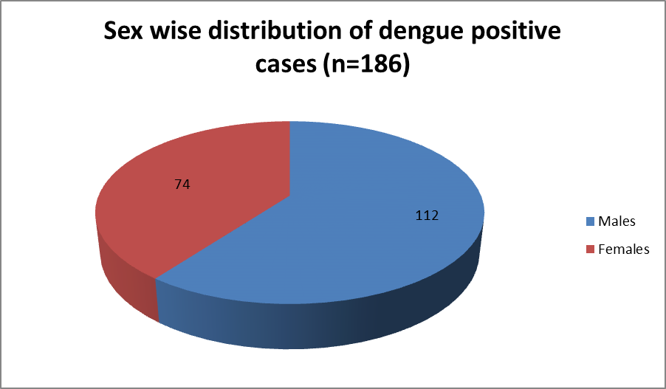
Above figure shows majority of dengue positive cases i.e., 112 (60.21%) were males & 74(39.78%) were females .Male to female ratio was 1.51 : 1
Fig 4:Geographical distribution of dengue positive cases (n=186)

The present study shows maximum number of dengue positive cases i.e., 135 (72.58 %) belonged to urban areas, whereas 51 cases (27.41%) belonged to rural areas. Urban : rural ratio being 2.64 : 1.

Fig 5: Clinical Signs & Symptoms in dengue positive cases
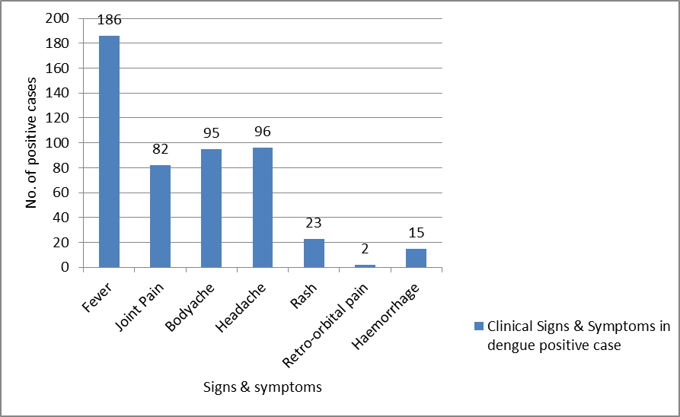
The present study shows the most common clinical presentation was fever, which was present in all 186 (100%) of cases followed by headache which was observed in 96 cases (51.61%), body ache in 95 cases (51.07%), joint pain in 82 cases (44.08%), rash in 23 cases (12.36%), haemorrhagic manifestations in 15 cases (8.06%) and retro-orbital pain in 2 cases (1.07%). Out of 186 dengue positive cases, death occurred in 2 (1.07%) cases who presented with DSS. In spite of best treatment given , they succumbed to the infection because of late presentation of these patients to the hospital. The DSS patients were already in shock during their presentation to the hospital and in spite of adequate fluids and supportive therapy given, they could not be revived.
TABLE 5: Haemorrhagic manifestations seen in platelet count range in positive cases.
Platelet count | < 1 Lakh (n=48) | >1 Lakh (n=138) | Total (n=186) | P value
Haemorrhagic manifestations | 15 | 0 | 15 | <0.001
Without haemorrhagic manifestations | 33 | 138 | 171

In our study, a total of 25.80 % (48/186) dengue seropositive patients were thrombocytopenic [platelet count <1,00,000/mm³].In positive patients with platelet count less than 1 Lakh, 15 had haemorrhagic manifestations & 33 patients showed no haemorrhagic manifestations. The common haemorrhagic manifestations seen were haematemesis and malaena. The patients with platelet count less than 1Lakh had significantly higher chances of haemorrhagic manifestations in the present study. (p<0.001)
DISCUSSION:
Gender distribution of cases revealed that 60.21% cases were males and 39.78% were females. These findings are similar to other studies by Bhat et al ⁽¹⁰⁾ ,Dash et al ⁽¹¹⁾, Gupta et al ⁽¹²⁾ and Patel et al ⁽¹³⁾ with male preponderance. Majority of dengue positive cases were in the age groups of 21 to 30 years (33.87%). This study is comparable with studies by Patel et al ⁽¹³⁾ (16-30 years), Meheta et al ⁽¹⁴⁾ (16-30years), Ukey et al ⁽¹⁵⁾ (15-30 years).Reason could be these young adults involved in more of outdoor activities, more exposed for mosquito bites. ⁽¹⁶⁾ Majority of the cases belonged to urban areas. Similar findings were observed by Patel et al ⁽¹³⁾ with an urban : rural ratio of 4 : 1 ,Nisarta et al ⁽¹⁷⁾ , Mistry et al ⁽¹⁸⁾ whose study says two-third (68.7%) suspected cases were residing in urban areas. This maybe due to rapid unplanned urbanization with unchecked construction activities and poor sanitation facilities which can contribute as fertile breeding grounds for mosquitoes.
Most of the cases were reported in monsoon and post-monsoon periods which coincides with increased breeding of mosquitoes during these seasons. During the period from January to May 2017 there were no positive cases in our study, in contrast to that of the period from January to May 2018 which showed many positive cases i.e., 45 cases. Various studies of Ukey et al ⁽¹⁵⁾, Padhi et al ⁽¹⁹⁾ , Mehta et al ⁽¹⁴⁾, Chakravarti et al ⁽²⁰⁾ and Bandyopadhyay et al ⁽⁵⁾ also observed maximum cases during the monsoon and post-monsoon seasons.
Among the clinical signs, we noticed a higher proportion of febrile syndrome followed by headache, body ache, joint pain, retro-orbital pain & rash in patients with DF. Haemorrhagic manifestations in 15 cases (8.06%) and Mortality rate was 1% which is similar to a study by Dash et al ⁽¹¹⁾ and Neeraja et al ⁽²¹⁾.
*Anti-dengue IgG testing is not done in this study which needs to be further explored which would allow distinction between primary and secondary infections.
CONCLUSION:
In conclusion, an increase in DF cases was seen in 2018 as compared to previous year. Long term laboratory based surveillance systems should be made that can forecast dengue epidemics. This will help alert the public and physicians to diagnose and properly treat DF/DHF cases. Vector control measures like eliminating larval habitats, using insect repellents/indoor space-spray insecticides/outdoor fogging and use of mosquito nets should come into full swing before monsoon and at the end of monsoon during water stagnation periods to prevent the outbreaks of dengue.
ABBREVIATIONS:
DHF: Dengue Haemorrhagic Fever; DF: Dengue Fever; ELISA: Enzyme Linked Immunosorbent Assay; DSS: Dengue shock syndrome NS1: Non-structural protein WHO: World Health Organization
Acknowledgements:
First and foremost, thanks to the Lord Almighty Jehovah throughout the work which shaped the present work as it shows. A heartfelt gratitude is owed to all departmental staff.

REFERENCES:

1. Badave GK, Swaroop PS, Rao PN. Importance of NS1 antigen detection and its association with platelet count for early diagnosis of dengue virus infection. Int J Curr Microbiol Appl Sci. 2015;4(March):779–84.
2. Kong YY, Thay CH, Tin TC, Devi S. Rapid detection, serotyping and quantitation of dengue viruses by TaqMan real-time one-step RT-PCR. J Virol Methods. 2006;138(1–2):123–30.
3. Pandey N, Nagar R, Gupta S, Omprakash, Khan D, Singh DD, et al. Trend of dengue virus infection at Lucknow, north India (2008- 2010): A hospital based study. Indian J Med Res. 2012;136(5):862–7.
4. NVBDCP. Guidelines for Clinical Management of DF, DHF and DSS. 2008;
5. Bandyopadhyay B, Bhattacharyya I, Adhikary S, Konar J, Dawar N, Sarkar J, et al. A Comprehensive Study on the 2012 Dengue Fever Outbreak in Kolkata, India [Internet]. Vol. 2013, ISRN Virology. 2013. p. 1–5. Available from: http://www.hindawi.com/ journals/isrn/ 2013/207580/
6. Laboratory Guidance and Diagnostic Testing .Dengue/CDC.
7. Sushma G, Lakshmi R, Nagamani K, Soujanyai KN, Rani M, Pakalapaty S, et al. A Study on NS1 Antigen Detection ELISA Assay in Comparison with RNA Detection by Reverse Transcription Polymerase Chain Reaction for the Early Diagnosis of Dengue. IntJCurrMicrobiolAppSci. 2017;6(12):1586–96.
8. National Guidelines for Clinical Management of Dengue Fever.
9. Diagnosis GFOR. New edition 2009. 2009;
10. Bhat S SA, S. S. ISSN ( o ): 2321 – 7251 Seroprevalence of dengue viral infection in patients attending to a tertiary care hospital in Kanchipuram , Tamil Nadu , India Abstract : Results : Materials and Methods : Int J Res Heal Sci. 2014;2(3):818–22.
11. Dash PK, Saxena P, Abhyankar A, Bhargava R, Jana AM, Establishment D. S OUTHEAST A SIAN J T ROP M ED P UBLIC H EALTH EMERGENCE OF DENGUE VIRUS TYPE-3 IN NORTHERN INDIA. 2005;36(2).
12. Gupta E, Dar L, Narang P, Srivastava VK, Broor S. Serodiagnosis of dengue during an outbreak at a tertiary care hospital in Delhi. 2005;(November 2003):36–8.
13. Patel LR, Municipal SNHL, College M. Sero prevalence of Dengue NS-1 Antigen in Tertiary care hospital , Ahmedabad. 2013;(7):694–701.
14. Mehta KD, Gelotar PS, Vachhani SC, Makwana N, Sinha M. Profile of dengue infection in Jamnagar city and district , west India. 2014;3(March):1–3.
15. Ukey P, Bondade S, Paunipagar P, Powar R, Akulwar S. Study of seroprevalence of dengue fever in central India. Indian J Community Med [Internet]. 2010;35(4):517. Available from: http://www.ijcm.org.in/text.asp?2010/35/4/517/74366
16. Lall H, Gupta P, Debbarma M, Sharma P, Ansari SK, Jais M, et al. Sero-Prevalence of Dengue in Tertiary Care Hospital in Delhi. 2016;5(6):439–45.
17. Nisarta A, Ahir H. Study of Seroprevalence of Dengue Virus Infection in a Tertiary Care Hospital in Patan , Gujarat , India. 2016;5(10):819–24.
18. Mistry M, Goswami Y, Chudasama RK, Thakkar D. Epidemiological and demographic characteristics of dengue disease at a tertiary care centre in Saurashtra region during the year 2013. J Vector Borne Dis. 2015;52(4):299–303.
19. Padhi S, Dash M, Panda P, Parida B, Mohanty I, Sahu S, et al. A three year retrospective study on the increasing trend in seroprevalence of dengue infection from southern Odisha, India. Indian J Med Res. 2014;140(November):660–4.
20. Chakravarti A, Kumaria R, Berry N, Sharma VK. Serodiagnosis of dengue infection by rapid immunochromatography test in a hospital setting in Delhi, India, 1999-2001. Dengue Bull. 2002;26(3):107–12.
21. Communication B. SERODIAGNOSIS OF DENGUE VIRUS INFECTION IN PATIENTS PRESENTING TO A TERTIARY CARE HOSPITAL m o fr a n i o l m r o c n fo b n a l M d k a y e v m d w o w h s i i m o fr t n a w c do ubl e P ). e r w om r o c e w b n a l k i y M d Conjunctival a v e b h P t. 2006;24:280–2.

Date of Submission: 11 September 2020
Date of Publishing: 14 December 2020
Author Declaration: Source of support: Nil, Conflict of interest: Nil
Ethics Committee Approval obtained for this study? YES
Was informed consent obtained from the subjects involved in the study? YES
For any images presented appropriate consent has been obtained from the subjects: NA
Plagiarism Checked: Urkund Software
Author work published under a Creative Commons Attribution 4.0 International License
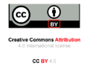

DOI: 10.36848/IJBAMR/2020/16215.55587

