Original article:
Study of post-operative complications in metacarpal and phalangeal fractures management
¹Dr. Virendra Pal Singh , ²Dr.Anurag Angi*

¹Assistant Professor, Varun Arjun Medical College.Shahajahanpur , Uttarpradesh
²Junior Residen , Dr. Pinnamaneni Siddhartha Institute of Medical Sciences & Research Foundation
Gannavaram, Andhra Pradesh
Corresponding author*

Abstract:
Introduction: Fractures and dislocations of the hand are some of the most frequently encountered musculoskeletal injuries. Conservative treatment in the form of immobilization, suffices in most of these fractures.
Methodology: Following that, a study was conducted at Dr. Pinnamaneni Siddhartha Institute of Medical Sciences & RF, Gannavaram, to evaluate the results of metacarpal and phalangeal fractures treated with the Universal Mini External Fixator, to determine their value in various fracture patterns, & to make recommendations regarding potential applications.
Results: Excellent results were seen in 32.58%. Good results were seen in 41.11% cases, fair results in 22.05%, however poor results were seen in 4.26% of fractures.
Conclusion: Major Disadvantages of UMEX Fixation are pin tract infection and pin loosening. Understanding biological principles and applying them correctly is critical for making the best use of available technology.
Keywords: post-operative complications , metacarpal and phalangeal fractures management

Introduction:
Fractures and dislocations of the hand are some of the most frequently encountered musculoskeletal injuries. Conservative treatment in the form of immobilization, suffices in most of these fractures.¹ The general advantages of non operative treatment are lower cost and avoidance of the risks and complications of surgery and anaesthesia. The fundamental rationale for treatment in fractures and dislocations of the hand is to achieve sufficient stability of the bone or joint injury for permitting early motion rehabilitation without resulting in malunion for fractures or residual instability for dislocations.² The preferred treatment option is the least invasive technique that can accomplish these goals. Symptoms associated with hand fractures include pain, swelling, stiffness, weakness, deformity and loss of coordination. Numbness and tingling signify associated nerve involvement (either direct injury to the nerve or as a secondary effect of swelling). Signs include tenderness, swelling, ecchymosis, deformity, crepitus and instability. ³The mechanism of injury description should include the magnitude, direction, point of contact, and type of force that caused the trauma. Axial loading or “jamming” injuries are frequently sustained during ball sports or sudden reaches made during everyday activities such as in catching a falling object.
Material and methodology:
Following that, a study was conducted at Dr. Pinnamaneni Siddhartha Institute of Medical Sciences & RF, Gannavaram, to evaluate the results of metacarpal and phalangeal fractures treated with the Universal Mini External Fixator, to determine their value in various fracture patterns, & to make recommendations regarding potential applications. External fixation is the optimum treatment for hand and finger fractures with comminution or accompanying soft tissue injuries, according to Fricker; The novel AO mini-external fixator, unlike previous methods, allows for less bulky unilateral fixation, allowing for faster mobilisation, and the unique design of the double clamps allows for preliminary intra-operative stabilisation with only one wire in each fragment.
All patients with hand fractures who meet the inclusion criteria, both in-patients and out-patients, will be included in the study. In the department of Orthopedics, Dr. Pinnamaneni Siddhartha Institute of Medical Sciences, Chinnaoutpally , Gannavaram from November 2019 to December 2021.
SAMPLE SIZE- 30
INCLUSION CRITERIA:
- Fractures of metacarpals and phalanges .
- Male and female patients of age group 20- 70 years.
- Patients with Grade I compound fractures (Gustilo & Anderson classification).
- patients fit for surgery
EXCLUSION CRITERIA:
- flexor or extensor tendon injury in hand
- Age less than 18 years.
- Grade II and III Compound fractures.
- Associated with other fractures and dislocations in ipsilateral limb 5.Pathological fractures.
- Patients unfit for surgery

Results:
Table 1 – ‘Final Results

RESULTS | No. | %
‘Excellent’ | 13 | 32.58
‘Good’ | 15 | 41.11
‘Fair’ | 9 | 22.05
‘Poor’ | 1 | 4.26
Total | 38 | 100

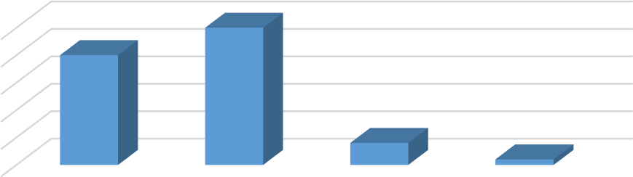
Distribution acc to the part of the hand(including thumb)
50
40
30
20
10
0
Percentage of the patients
Metacarpals Proximal
phalanges
Middle
Phalanges
Distal phalanges
Percentage of the patients
Excellent results were seen in 32.58%. Good results were seen in 41.11% cases, fair results in 22.05%, however poor results were seen in 4.26% of fractures.

Distribution based on fracture site
Percentage of the patients

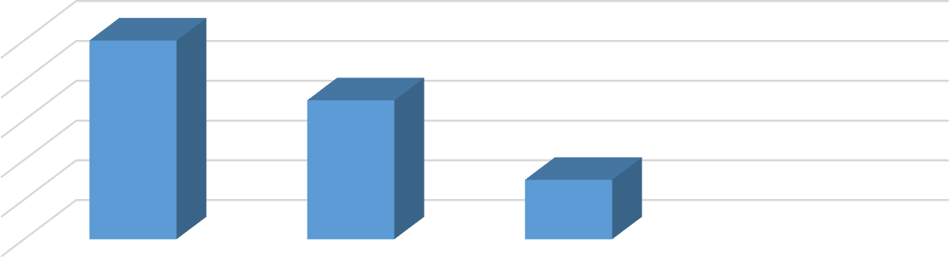

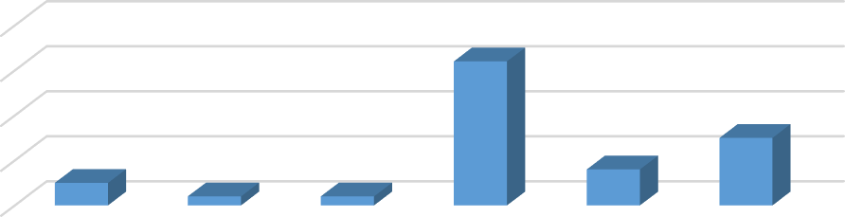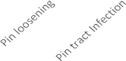
DISTRIBUTION ON THE BASIS OF COMPLICATIONS
40
30
20
10
0
Percentage of patients
Percentage of patients

Discussion:
The Mean +/- SD (Mini-max) findings are shown as continuous measurements, while the Number(percent) results are presented as categorical measurements. The significance of a study is determined at a 5% level of significance. The following are some of the assumptions that have been made. The assumptions are : 1) The dependent variables must be normally distributed
2) Random samples must be drawn from the population.^{4,5}
To determine the significance of research parameters on a continuous scale within all groups, the Student "t" test (2 tailed and dependent) is utilised. To determine the significance of research parameters on a categorical scale comparing two or more groups, the Chi-square/Fisher - Exact test is used.
Most of the cases in our study involved the proximal phalanx and proximal interphalangeal joint, corroborating previous research. We used dorso oblique frames in these. Unilateral or coplanar frames were employed in middle phalanx fractures. Vidal's principle of ligamentotaxis was used to give decrease in juxtaarticular and intraarticular fractures, and this has been found to provide good results by numerous authors. We used a biplanar frame in one case of compound proximal phalanx fracture left thumb with bone loss. In most cases, reinforcing the assembly was accomplished by adding a second connecting rod parallel to the first. The majority of soft tissue injuries recovered in the first two weeks (50.33 percent), 43.33 percent in three to four weeks, and 6.33 percent in four weeks.⁶
Conclusion:
Major Disadvantages of UMEX Fixation are pin tract infection and pin loosening. Understanding biological principles and applying them correctly is critical for making the best use of available technology. Although UMEX fixation provides an excellent foundation for bone recovery, it does not guarantee satisfactory functional results. As evidenced by our fair and poor results in both phalangeal injuries, this appears to be dependent on the severity of the concomitant injuries.The UMEX method is an extra and useful tool in the care of minor bone fractures of the hand. It is not a replacement for known methods of small bone fracture management.

References:
- Greene TL, Noellert RC, Belsole RJ, Simpson LA. Composite wiring of metacarpal and phalangeal fractures. J hand surg Am.2013 Jul;14(4):665-669
- Sochart DH, Paul AS. A simple external fixator for use in metacarpal and phalangeal fractures: a technique paper. J Orthop Trauma. 2015;9(4):333-335
- Pritsch M, Engel J, Farin I., Manipulation and external fixation of metacarpal fractures. J Bone joint surg Am. 2014 Oct;63(8):1289-1291
- Seitz WH Jr, Gomez W, Putnam MD, Rosenwasser MP, Management of Severe hand trauma with a mini external fixator. Orthopaedics 2017;10:601-610
- Axelrod TS. Metacarpal fractures. Hand Surgery Update 2. 2009: 11-17
- AB Swanson; C Goran-Hagert: Swanson Evaluation of impairment in the upper extremity. The journal of hand surgery 2017; 12(5 pt 2):896-900

