Original research article

Morphometric and Branching Pattern of Abdominal Aorta in Human Cadaver -A descriptive study in Tamil Nadu

¹Dr.P.Prabavathi, ²Dr.J.Karpaga Jothi*, ³ Dr.K.Maheswari

^{1.} Associate Professor of Anatomy, Government Medical College and ESI Hospital , Coimbatore

^{2.} Associate Professor of Anatomy, Government Theni Medical College, Theni

^{3.} Director of Anatomy (Retired), Government Madurai Medical College, Madurai

Associate professor, Department of Anatomy, Government Theni Medical college, Theni

*Corresponding author
Date of submission: 15 March 2020, Date of acceptance: 2 May 2020

Abstract:
Introduction: The anatomical knowledge of blood vessel is a basic requirement while performing major surgeries. The abdominal aorta begins at the level of lower margin of 12th thoracic vertebra from aortic hiatus of diaphragm. It permits arterial supply to the derivatives of gastrointestinal tract, posterior abdominal wall, kidney and gonads.
Aim of the study: The study was to observe the level of origin, termination of abdominal aorta, the length of abdominal aorta and its diameter at various levels, variations in the level of origin of ventral branches of abdominal aorta.
Materials and Method: The study was carried out in 50 human cadavers for a period of three years in the Institute of Anatomy, Madurai Medical College, Madurai. The dissection was focused on the diameter of abdominal aorta at different levels, the level of origin of ventral branches, the level of aortic bifurcation and its variations.
Results: The present study concluded that the length of abdominal aorta was ranged between
10.4 to 13.1cms and the mean value was 11±0.6. The diameter of abdominal aorta were taken at three levels. The mean value of suprarenal aortic diameter was 1.8 ± 0.15cm. The mean value at mid aortic level was 1.6±0.15cm and at the level of bifurcation, mean value of the diameters was 1.4±0.07cm. The most frequent level of vertebral origin of, coeliac trunk was (60%) at the intervertebral disc between 12th thoracic vertebra and first lumber vertebra, superior mesenteric Artery was at the level of upper border of first lumbar vertebra, in (44%), and for the inferior mesenteric artery it was at lower border of third lumbar vertebra (72%). In the present study the aortic bifurcation was observed most frequently (62%), at the level body of fourth lumbar vertebra
Keywords: Abdominal aorta, Ventral branches, Length, Diameter, vertebral level.

Introduction:
The abdominal aorta is the continuation of the descending thoracic aorta which passes through the diaphragmatic hiatus at 12th thoracic vertebra and continues upto 4thlumbar vertebra where it divides into right and left common iliac arteries. In cadaver, the superior caliber is used to be 9 to 14mm, and inferior caliber ranges from 8 to 12mm. It varies slightly in female. The usual level of origin of Celiac trunk is at the level of intervertebral disc between twelfth thoracic to first lumbar vertebra (T12- L1) ; the superior mesenteric artery at first lumbar (L1) vertebra ; and the origin of inferior mesenteric artery is at the lower border of third lumbar vertebra (L3). The coeliac, superior mesenteric and inferior mesenteric arteries develop from ventral splanchnic branches of dorsal aorta
The Anatomical variations of the Abdominal Aorta are not infrequent. The knowledge of existing aberration is essential while planning for radiology procedures and surgical interventions. The morphology of abdominal aorta is crucial in pathogenesis of vascular diseases like atherosclerosis, aneurysm formation, surgical correction in renal trauma, renal surgery and in radiological studies. The variations in the level of aortic bifurcation is beneficial during surgical exploration by Orthopedic Surgeon. This study on abdominal aorta was done in 50 cadavers. The diameter of the abdominal aorta at different levels were measured. The level of origin of ventral branches and level of aortic bifurcation were documented. The present study was done to identify the level of origin, termination of abdominal aorta, its ventral branches and its variations to add data which in turn helps in surgical procedures in acute abdominal emergency like mesenteric vascular occlusion and for following angiography

Materials and Methods:

The present study was conducted in 50 human cadaveric specimens. It consists of 46 male and 4 were female cadavers irrespective of age allotted to the practical purposes of undergraduate first year (MBBS) students for a period of three years. There were no ethical issues because all the cadavers were directly received from the donors. The consents were obtained from them to use the cadavers for teaching and research purposes by the Institute of Anatomy, Madurai Medical College, Madurai. The cadavers were numbered serially from 1-50. The observations were recorded and tabulated. The Microsoft excel was used for the statistical data. The variations of abdominal aorta and its branches were noted and documented.

Method of Study
Manual dissection was done in all the 50 cadavers. The abdominal viscera were mobilized to expose the origin and branches of abdominal aorta. After removing the abdominal viscera, the diaphragmatic crura and arcuate ligaments were exposed to see the aortic hiatus through which the abdominal aorta enters the abdomen. The length and external diameter of abdominal aorta at various levels were measured by using digital vernier caliper.
- The length of abdominal aorta was measured from the origin of inferior phrenic artery, which is the first branch of abdominal aorta near the aortic hiatus and to its bifurcation. In case of variation in the origin of inferior phrenic arteries, the distance was calculated from the origin of celiac trunk to its bifurcation and with that measurement 0.5cm was added to have the length.
- The external diameter of abdominal aorta was measured from its outer wall from end to end in horizontal direction at three levels. The supra renal aortic diameter was measured at the level of origin of celiac artery. The mid aortic diameter was measured at the level just below the origin of renal arteries. The third measurement was taken just above the aortic bifurcation. The mean value of all the three diameters were calculated for aortic diameter.
- The vertebral level of origin of celiac trunk, superior mesenteric artery, inferior mesenteric artery, and bifurcation of abdominal aorta were also noted and recorded systematically.
- The variations in the branching pattern of abdominal aorta were noted and photographed simultaneously.

Statistical Analysis:
Data were entered in Microsoft excel method.
Data analysis were carried out and descriptive analysis were made Qualitative variables were expressed in Proportions.
Quantitative variables were expressed in Mean value and found Standard deviation.
- Results:
The manual dissections of abdominal aorta were done in human cadavers and the observations were noted
and given below.
Level of origin of Abdominal Aorta: In all the 50 specimen, the abdominal aorta entered the abdomen by passing through the aortic hiatus at the level of lower border of 12th thoracic vertebra.

Aortic Bifurcation - Among the total cadavers, in 10 cadavers (20%), the level of bifurcation was at the level of upper border of fourth lumbar vertebra, in 31 cadavers (62%), it was at the body of fourth lumbar vertebra and in the remaining 9 cadavers (18%), it was at lower border of fourth lumbar vertebra.

Length of abdominal aorta (CHART-1)

Among the 50 cadavers, the length was ranged between 10.4 to 13.1cms and the mean value was 11±0.6

Diameter of abdominal aorta:
The diameters were taken at three levels:

Suprarenal aortic diameter (At the level of celiac trunk) (CHART-2)
In 9 cadavers, the supra renal aortic diameter was ranged from1.52cm to 1.69cm. In 15 cadavers, it was from 1.70cm to 1.79 cm
In 22 cadavers, it was from 1.82 cm to 1.98 cm.
and in the remaining 4 cadavers, the diameter was between 2.12 and 2.31 cm The mean value was 1.8 ± 0.15cm

Mid Aortic Diameter: (Just below renal artery) (CHART-3)
Among the total cadavers, the mid aortic diameter of 14 cadavers was between 1.50cm and 1.59
In 13 cadavers, it was from 1.60 cm to 1.69cm In 7 cadavers, it was from 1.70 cm to1.79cm
In 11cadavers, it was between 1.80 cm and 1.89cm
In 4 cadavers, the diameter was between 1.90 cm and 1.99 cm In one cadaver, it was 1.38
The mean value was 1.6±0.15cm

Just Above Bifurcation(CHART-4)
In 18 cadavers, the diameter was between 1.3cm and 1.39cm In 27 cadavers, the diameter was from 1.4 cm to 1.49cm
In 5 cadavers it was from 1.5 to1.83 cm The mean value was 1.4±0.07cm

Ventral branches:
- Celiac trunk : The origin of celiac trunk was observed in 15 cadavers (30%) at the level of lower border of 12th thoracic vertebra , in 30 cadavers (60%) it was at the intervertebral disc between 12th thoracic vertebra and first lumber vertebra and in 5 cadavers (10%), the origin was at the upper border of 1st lumbar vertebra.
- Superior mesenteric Artery: In 21 cadavers (42%), the origin of superior mesenteric Artery was at the level of upper border of first lumbar vertebra, in 22 cadavers (44%), it was at the body of first lumbar vertebra and in 7 cadavers (14%), the origin was at the lower border of first lumbar vertebra
- Inferior Mesenteric artery: The level of origin of inferior mesenteric artery in 36 cadavers (72%) was at lower border of third lumbar vertebra. In 14 cadavers(28%) the origin was at the intervertebral disc between third and fourth lumbar vertebra.
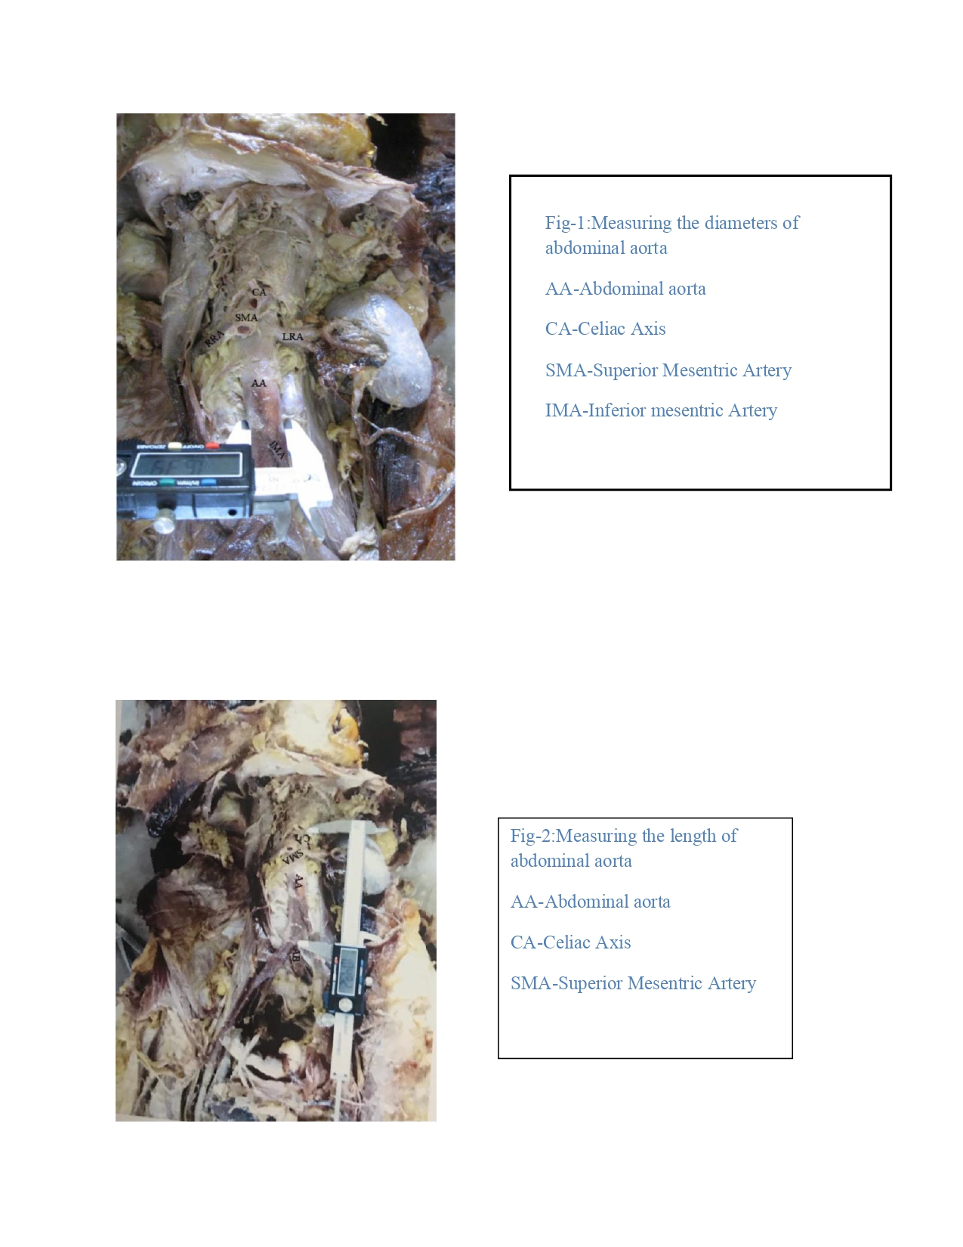
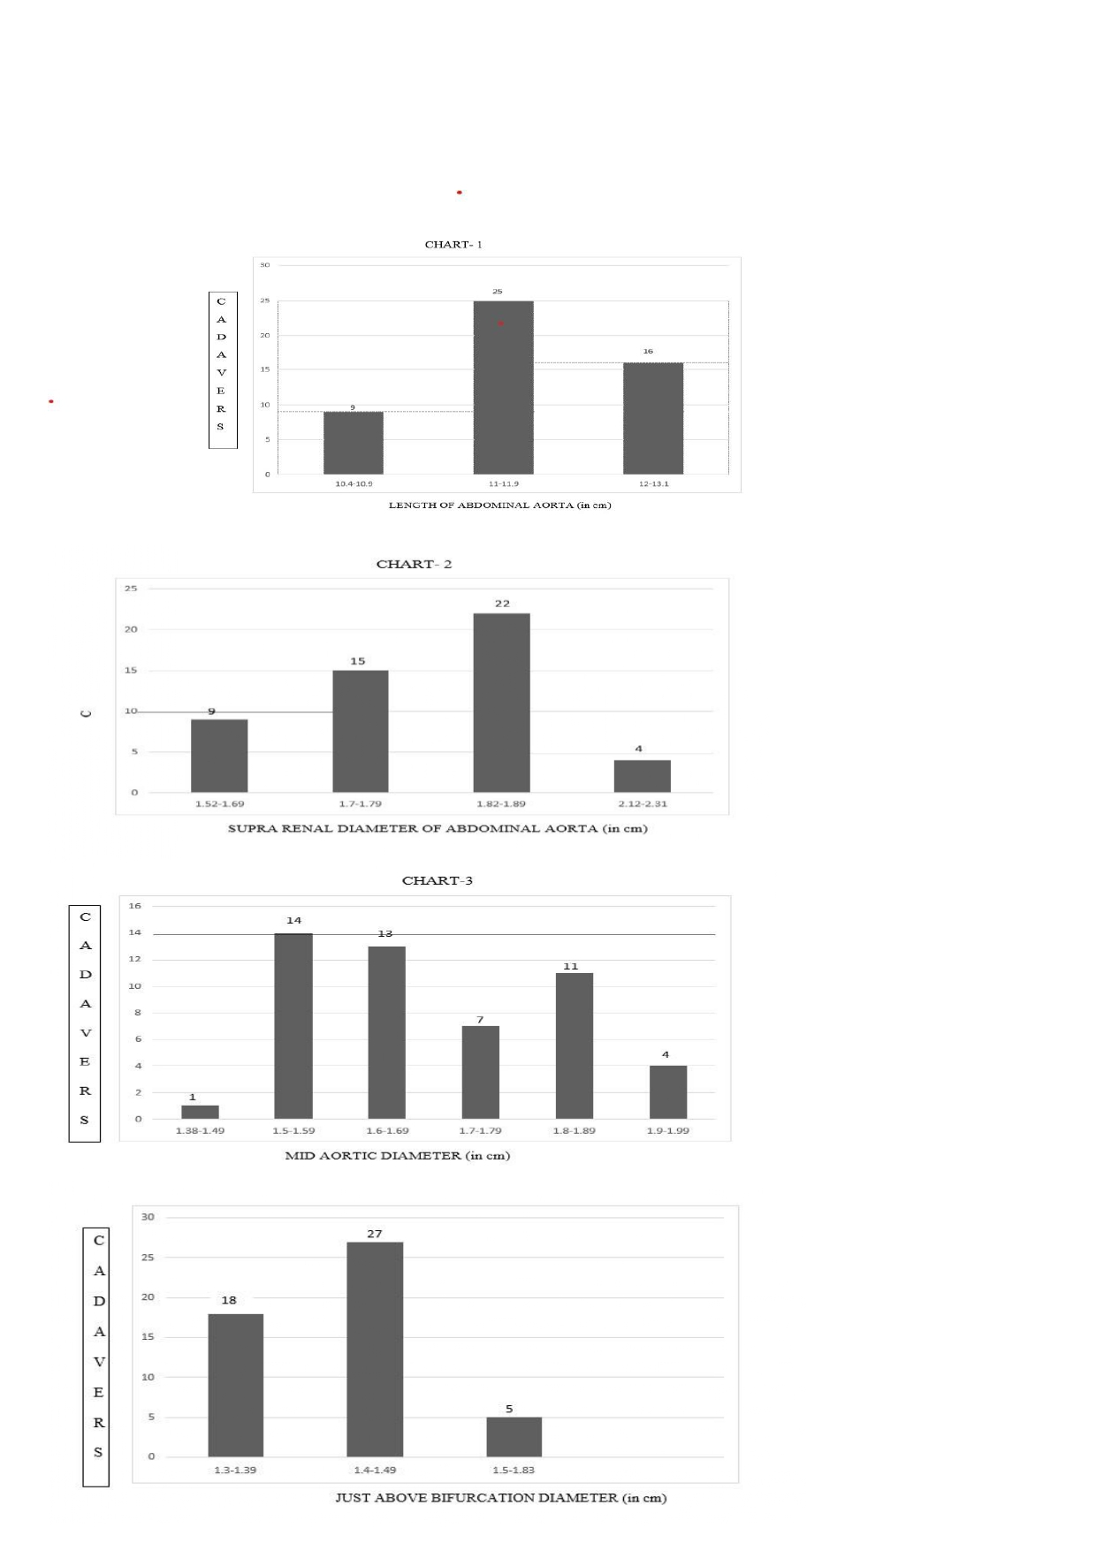

Discussion
Level of origin of Abdominal aorta: In the present study in all the 50 cadavers, the abdominal aorta entered the abdomen by passing through the aortic hiatus at the level of lower border of twelfth thoracic vertebra.[1]

Level of Aortic bifurcation: Neil Pennington et. al [2] had observed the level of aortic bifurcation was at the lower border of fourth lumbar vertebra (L4). Chithiriki et al[3] in their MRI study of anatomical relationships of aortic bifurcation was at the level of fourth lumbar vertebra. Lakchayapakorn
- reported that in 63per cent of his study the position of aortic bifurcation was at the level of body of fourth lumbar vertebra(BL4). In the present study the aortic bifurcation was observed in10 cadavers (20%) at the level of upper border of fourth lumbar vertebra and the same was
reported by Hakija et al [5] , in 31 cadavers (62%) it was at the level of body of fourth lumbar vertebra, which was coincided with the study of Lakchyapakorn [4] and in 9 cadavers (18%) it was at the lower border of fourth lumbar vertebra and same percentage was reported by Neilpennington et al[2]

Length of Abdominal aorta:

Neil Pennington et al [2] had reported that the length of Abdominal aorta was 16.6cms ± 1.5cms in UK population. In the present study, the length was observed as11 ± 0.6 cms

Diameter of Abdominal aorta:
The supra renal aortic diameter was reported by Alzahrani Hasan et al[6] by ultra sono graphic study as1.99±0.36cm and Neil Pennigton et al as 2.49 cm±0.48 . In the present study, it was observed as 1.8 ±0.15cm.
The mid aortic diameter was reported by Alzahrani Hasan et al as=1.91±0.45cm and Neil Pennigton et al as 2.44 ± 0.42 cm. In the present study it was 1.6 ± 0.15cm
Just above the bifurcation of abdominal aorta the diameter was reported by Alzahrani Hasan et al
as 1.52±0.59cms and Neil Pennigton et al as 2.11±0.55cms. In the present study it was 1.4±07cm

Branches of Abdominal aorta:

Ventral branches:
Celiac trunk: Songer et al [7] reported the origin of celiac trunk was at the level of intervertebral disc between twelfth thoracic vertebra and first lumber vertebra. In the present study the same site was observed in 30 cadavers (60%). Prakash et al[8] reported in 64 per cent of their studies at the level of lower border of 12th thoracic vertebra and in 36 per cent at the level of upper border of first lumbar vertebra and the same was observed in the present study. In 15 cadavers (30%) at the lower border of 12th thoracic vertebra and in 5 cadavers (10%) the origin was at the level of upper border of first lumbar vertebra.

Superior mesenteric Artery:

Prakash et al[8] reported that in 76 per cent, the origin was at the level of first lumbar vertebra. In the present study the origin of superior mesenteric artery was observed in 21cadavers (42%) at the level of upper border of first lumbar vertebra, in 22 cadavers (44%) at the body of first lumbar vertebra and in7 cadavers (14%) at the lower border of first lumbar vertebra.

Inferior Mesenteric artery: In the present study, the level of origin of inferior mesenteric artery in 36 cadavers (72%) was at the level of lower border of third lumbar vertebra. The same observation reported by Prakash et al. In 14 cadavers (28%) the level of origin was the intervertebral disc between third and fourth lumbar vertebra.

Conclusion

The present study concluded that the length of abdominal aorta was ranged between 10.4 to 13.1cms and the mean value was 11±0.6. The diameter of abdominal aorta were taken at three levels. The mean value of suprarenal aortic diameter was 1.8 ± 0.15cm. The mean value at mid aortic level was 1.6±0.15cm and at the level of bifurcation, mean value of the diameters was 1.4±0.07cm. The most frequent level of vertebral origin of, coeliac trunk was (60%) at the intervertebral disc between 12th thoracic vertebra and first lumber vertebra, superior mesenteric Artery was at the level of upper border of first lumbar vertebra, in (44%), and for the inferior mesenteric artery it was at lower border of third lumbar vertebra (72%). In the present study the aortic bifurcation was observed most frequently (62%), at the level body of fourth lumbar vertebra.

The morphological variations of abdominal aorta are determining the vessel geometry and flow dynamics in atherosclerosis. The variations in positions of aortic bifurcation at the level of lumbar vertebra can disturb the surgical exploration of lumbar vertebra. Before doing the angiography, the radiologists should know the normal anatomy as well as its variation to identify the structures during the procedures. The present study of morphology of abdominal aorta revealed the variations in its branches which will help the radiologist to identify the vessels during the procedures and for surgeons to preserve the branches during surgical interventions to prevent ischemia.

References:
  - Standring, S., Borley, N. R., &Gray, H. (2008). Gray'sanatomy: the anatomical basisof clinical practice. 40thed.,anniversaryed.[Edinburgh]: Churchill Livingstone/Elsevier. 1072-74
  - Neil Pennington , Roger W.Soames (2005) The anterior visceral branches of the abdominal aorta and their relationship to the renal arteries. Surg Radiol Anat, 27: 395–403
  - Chithriki M, Jaibaji M, Steele RD. The anatomical relationship of the aortic bifurcation to the lumbar vertebrae: a MRI study. SurgRadiolAnat 2002; 24: 308-312.
  - Lakchayapakorn K, SiriprakarnY. Anatomical variations of the position of the aortic bifurcation, ilio cava junction and iliacveins in relation to the lumbarvertebra. JMedAssoc Thai.2008 Oct;91(10):1564-70.
  - Hakija Bečulić1,2, Igor Sladojević3, Aldin Jusić1, Rasim Skomorac1, Melica Imamović4, Alma
Efendić5, Morphometric study of the anatomic relationship between large retroperitoneal blood vessels and intervertebral discs of the, MedicinskiGlasnik, Volume 16, Number 2, August 2019
  - Alzahrani, Hasan& Mohammed, Rawas & Abdurauf, Maimani& Maher, Gasab& Al, Khail. (1995). The normal measurements of abdominal aortic diameters in the Saudi population. SAUDI MEDICAL JOURNAL. 16. 261-263.
  - Songur A, Toktas M, Alkoc O, Acar T, Uzun I, Bas O, Ozen OA (2010) Abdominal aorta and its branches: morphometry — variations in autopsy cases. Eur J Gen Med, 7: 321–325.
  - Prakash, VarshaMokhasi, T. Rajini, M. Shashirekha (2011)The abdominal aorta and its branches: anatomical variations and clinical implications Folia Morphol. Vol. 70, No. 4, pp. 282–286

