Case Report:
Carcinoma of Gall Bladder – Anterior wall abscess: Case Report
¹Dr. Ritu Kumari, ²Dr.Vikas Yedshikar, ³Dr.Niranjana, ⁴Dr.Kiran Bharti

¹Jr-III, Deparment Of Pathology, SVNGMC ,Yavatmal
² Asso. Professor and HOD, Deparment Of Pathology, SVNGMC ,Yavatmal
³Assis.Professor, Deparment Of Pathology, SVNGMC ,Yavatmal
⁴Asso.Professor, Deparment Of Pathology, SVNGMC ,Yavatmal
Corresponding author: Dr Kiran Bharti

This work is licensed under a Creative Commons Attribution-NonCommercial 4.0 International License

Date of submission: 28 January 2023
Date of Final acceptance: 11 March 2023
Date of Publication: 30 March 2023
Source of support: Nil
Conflict of interest: Nil

Abstract:
According to GLOBOCAN 2018 data, gallbladder cancer is the 22nd most incident but 17th most deadly cancer worldwide. According to the Indian cancer registry data, incidence of carcinoma gallbladder is 0.8%–1%. While New Delhi and Bhopal are the leading states, lowest incidence is seen in Chennai .carcinoma gallbladder is more commonly found in females than in males which is 3.3:1.9 per 100000 population globally. Incidental gallbladder carcinoma is defined as carcinoma gallbladder diagnosed histopathologically after cholecystectomy done for benign gallbladder disease. Most of these patients do not have a radiological or intraoperative suspicion for malignancy. The concern whether routine histopathological examination is needed for all cholecystectomy specimens done for benign gallbladder diseases is still debatable.
Keywords: Gall bladder carcinoma, anterior wall abscess

Background:
A 34 year old male reported to emergency department with complaint of pain in abdomen since 15 days and was aggravated since 5 hours. Patient had history of fever since one day.On examination patient had pulse rate of 110/min. Blood pressure of 100/70 mmhg. ¹Abdomen was tender and had physical sign of localised peritonitis.USG abdomen was suggestive of ruptured gallbladder wall with abdominal wall abscess.patient underwent open cholecystectomy intraoperative finding was cholecutaneous fistula with choledocholithiasis. Gallbladder specimen received on gross examination was showing gall bladder of size 8x3x2cm. E/S - Irregular, blackish with attached fibrofatty tissue.² C/S-Wall is diffusely thickened (0.8cm), greyish white. Multiple blackish, irregular stones identified, largest of size 1x0.5cm. Mucosa is irregular.³
Sections studied from gall bladder show tumour composed glands, villi and few papillary structures lined by columnar epithelium. The glands also forming wide lumina lined by cuboidal epithelim with surrounding desmoplastic stroma infiltrating Rokitansky-Aschoff sinuses, muscle layer upto serosa. Many glands were cystically dilated showing intraluminal mucin and few cystically dilated spaces fille The tumour cells show high N C ratio, loss of nuclear polarity, pleomorphism, nucleomegaly, irregular nuclear membrane and hyperchromacia. Few cells showing intracytoplasmic mucin. Surrounding muscle layer, fibrous tissue and serosa show dense lymphoplasmacytic infiltrate. Perineural and vascular invasion seen.⁴
Case Report:
Incidence of incidental carcinoma gallbladder carcinoma has been declining due to beer availability and more usage of radiological investigations in cases of abdominal pain in the right hypochondrium(5). The predisposing risk factors for gallbladder carcinoma include cholelithiasis, choledochal cysts, porcelain gallbladder, sclerosing cholangitis, gallbladder polyps, etc(7).The incidence of incidental carcinoma gallbladder is reported to be 0.2%–2.1%.(4,5).here is not a uniform distribution according to ethnic or geographic diversity(6).
Gallbladder perforations were classified by Niemeier in 1934 into three clinical types: 1, perforation into the peritoneal cavity with resulting bile peritonitis; 2, localized perforation with an abscess in the area of the gallbladder; and 3, perforation into an adjacent organ, usually the duodenum, resulting in fistula formation. Although most gallbladder perforations result in a localized abscess, the development of a subcutaneous abscess and colecutaneous fistula is rare. In this case patent was presented in emergency as acute abdomen with no radiological findings suggesting carcinoma gall bladder
Gross Examination:
-Received cholecystectomy specimen in 10% formalin measuring 8x3x2cm.
E/S-irregular, blackish with attached fibrofatty tissue
-A perforation of size 0.2x0.2cm seen at fundus.
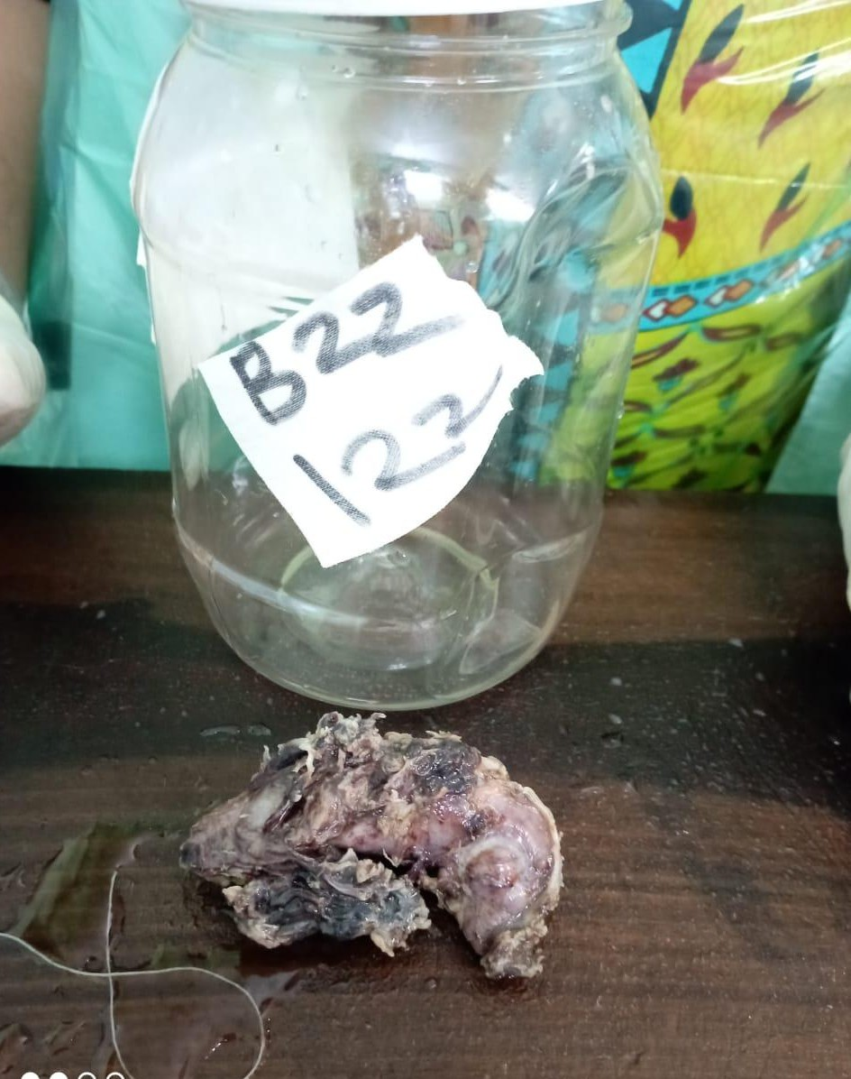

Cut surface-
Shows diffusely thickened greyish-white wall and irregular roughened mucosa.(maximum
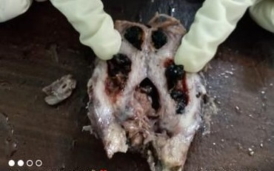
thickness of wall-1cm)

On microscopy

- Initial sections from gal
- l bladder showed few atypical glands and Rokitansky aschoff sinuses. So, was suspicious.
- Multiple grossing sessions were conducted and extensive sampling was done. Also, found 1 lymph node in fibrofatty tissue
- Lumen was impacted with multiple blackish irregular stones (larges of size 1x1x0.5cm).

Microscopy:
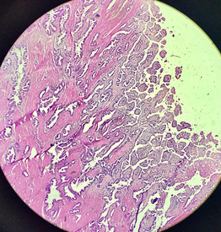
- Low power view(10x)- Multiple sections studied from gall bladder and perforated (?fistula area) show tumour composed of glands, villi and few papillary structures lined by columnar epithelium show tumour composed of closely arranged glands, villi and few papillary structures lined by columnar epithelium. The glands are also forming wide lumina lined by cuboidal epithelium with surrounding desmoplastic stroma infiltrating.
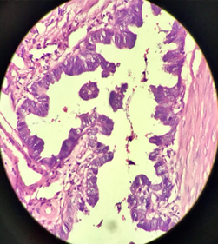
- High power view(40X): The tumour cells show high N :C ratio, loss of nuclear polarity, pleomorphism, nucleomegaly, irregular nuclear membrane and hyperchromasia.
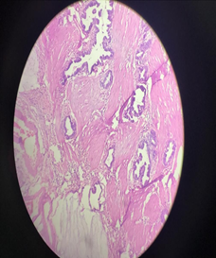
- Low power view(10x)- show tumour composed of glands, villi and few papillary structures lined by columnar epithelium. The glands are also forming wide lumina lined by cuboidal epithelium with surrounding desmoplastic stroma infiltrating
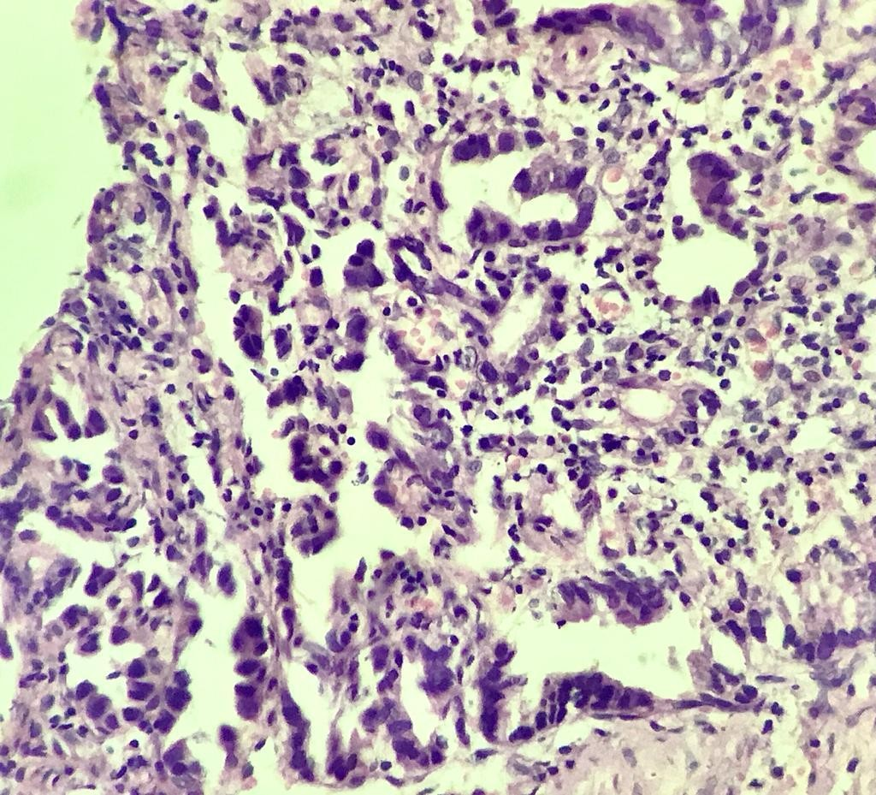
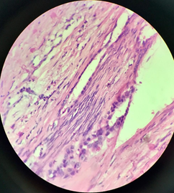
- Section shows perineural invasion by tumour.
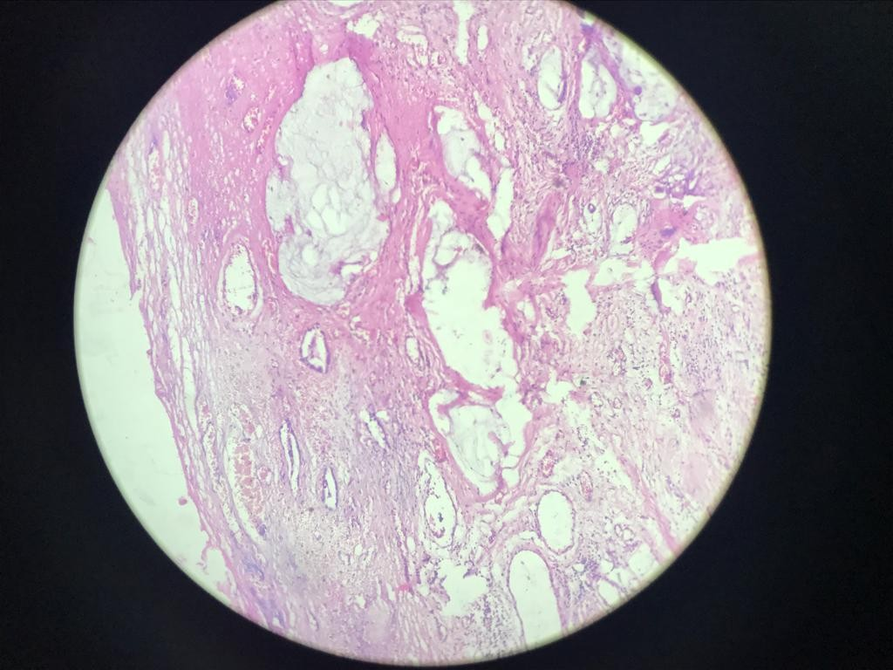
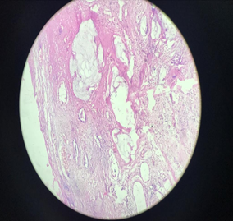
- Mucin filled glands
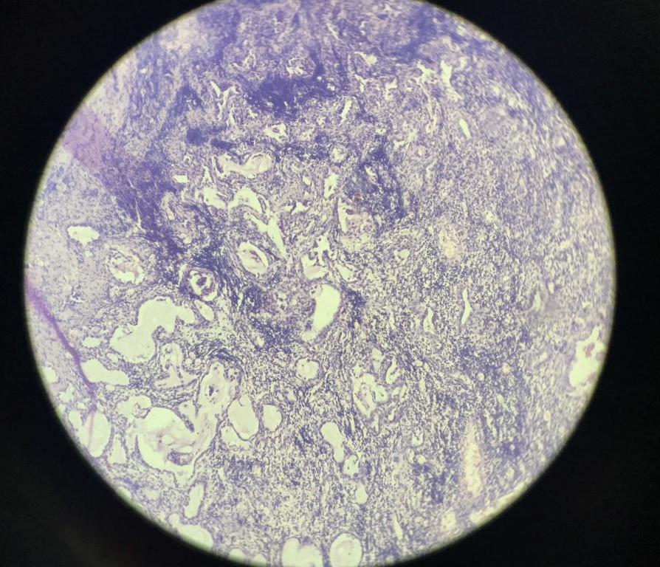
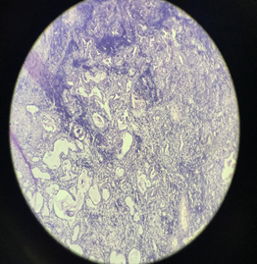
- Low power view(10x)-Section from lymph node showing tumour metastasis.

Discussion:
Gallbladder carcinosarcomas are highly aggressive tumors associated with a very poor prognosis.⁴ These are rare malignancies which are identified by the presence of both mesenchymal and epithelial components on histopathology and fewer than 100 cases are reported in the literature. Preoperative diagnosis poses a significant challenge due to a nonspecific and insidious clinical presentation. We report a case of a 64-year-old lady in whom a giant carcinosarcoma of the gallbladder masqueraded clinically as a hepatic abscess. Following the failure of antibiotic treatment and extensive multidisciplinary discussions, she underwent surgical resection with central hepatic lobectomy and cholecystectomy which revealed her rare diagnosis.⁵ From our case report, we strongly recommend histological assessment of all cholecystectomy specimens regardless of the clinical presentation or radiological diagnosis or macroscopic findings.

Conclusion:
To conclude we strongly recommend histological assessment of all cholecystectomy specimens regardless of the clinical presentation or radiological diagnosis or macroscopic findings.

References:

- Rosai and Ackerman’s surgical pathology,11th edition Robbins and Cotran, 8th edition , Fletcher book of histopathology
- Rawla P, Sunkara T, Thandra K, Barsouk A. Epidemiology of gallbladder cancer. Clinical and Experimental Hepatology. 2019;5(2):93-102. doi:10.5114/ceh.2019.85166
- Jha V, Sharma P, Mandal KA. Incidental gallbladder carcinoma: Utility of histopathological evaluation of routine cholecystectomy specimens. South Asian J Cancer 2018;7:21-3.
- Sharayu Mhatre, Ben Lacey, Paul Sherliker, Nilanjan Chatterjee, Preetha Rajaraman, Mahesh Goel, Shraddha Patkar, Vikas Ostwal, Prachi Patil, Shailesh V Shrikhande, Garvit Chitkara, Rajendra Badwe, Sarah Lewington, Rajesh Dikshit, Reproductive factors and gall-bladder cancer, and the effect of common genetic variants on these associations: a case–control study in India, International Journal of Epidemiology, Volume 51, Issue 3, June 2022, Pages 789–798
- Shih SP, Schulick RD, Cameron JL, Lillemoe KD, Pitt HA, Choti MA, et al. Gallbladder cancer: The role of laparoscopy and radical resection. Ann Surg 2007;245:893-901.

