Original article:
Relationship of chest CT findings of admitted covid-19 patients with their course of illness: A hospital based retrospective study
V.B Singh¹, Rashmi Gupta ², Ruchita Banseria³, Gaurav Meratwal⁴, Abhishek Kawatra⁵ Saranshi Singh⁶

¹ Senior Professor, Department of Medicine, JLN Medical College, Ajmer
² Associate Professor, Department of Community Medicine, JLN Medical College, Ajmer
^{3,4} Assistant Professor, Department of Community Medicine, JLN Medical College, Ajmer
⁵ Associate Professor, Department of Community Medicine, S P medical College, Bikaner
⁶ Final Year MBBS Student, RUHS, Jaipur
Corresponding Author: Abhishek Kawatra, Associate Professor, Department of Community Medicine, S P medical College Bikaner ; e-mail: drkawatrapsm@gmail.com

Abstract:
Introduction: Corona virus belongs to the family of viruses that may cause various symptoms such as pneumonia, fever, breathing difficulty, and lung infection⁽¹⁾. The outbreak of coronavirus disease (COVID-19) was first reported on December 31, 2019, in Wuhan, China⁽²⁾. On January 30, 2020, the World Health Organization (WHO) declared COVID-19, a Public Health Emergency of International Concern (PHEIC) and thus a pandemic⁽³⁾. India reported its First case on 30 January, 2020; a medical student who had travelled from Wuhan, China, the epicenter of COVID-19
Methodology: It is a retrospective, hospital based study conducted from 25 November 2020 to 15 December 2020 in J.L.N Medical College and Associated Group of Hospitals, Ajmer. A total of 118 Laboratory confirmed Covid-19 cases who underwent chest CT were taken in the study.
Results and Conclusion: From present study it can conclude that the constancy of CT chest findings is related to duration of illness. It also shows that time course of infection is of utmost importance not onlyto understand the pathophysiologic features and natural history of disease, but also help to predict the disease in its early stages and to prevent potential complications. As the disease is very virulent and potentially fatal, the risk stratification through CT chest is necessary so during triage, CT should be done as early as possible along with RT-PCR so that early detection of disease provides window for early initiation of treatment thus avoiding complications especially in co-morbid patients.

INTRODUCTION

Corona virus belongs to the family of viruses that may cause various symptoms such as pneumonia, fever, breathing difficulty, and lung infection⁽¹⁾. The outbreak of coronavirus disease (COVID-19) was first reported on December 31, 2019, in Wuhan, China⁽²⁾. On January 30, 2020, the World Health Organization (WHO) declared COVID-19, a Public Health Emergency of International Concern (PHEIC) and thus a pandemic⁽³⁾. India reported its First case on 30 January, 2020; a medical student who had travelled from Wuhan, China, the epicenter of COVID-19 ⁽⁴⁾.

The common clinical features of patients with Covid-19 were fatigue, fever, productive cough, and dyspnea.^{(5,6)} Patients infected with Covid-19 were prone to death when they develop pneumonitis, Acute Respiratory Distress Syndrome (ARDS), or multiple organ dysfunction syndrome (such as shock, acute mycocardial infraction, and acute kidney injury)⁽⁷⁾.Severity of the Covid-19 epidemic can be directly influenced by the absolute number of deaths⁽⁸⁾.The predominant CT findings included ground-glass opacification, consolidation, bilateral involvement, and peripheral and diffuse distribution^{(9).}

The purpose of this study is to characterize chest CT findings in 118 COVID-19 patients in relation to the time elapsed between onset of disease and the initial CT scan. We can reveal from our study that certain CT chest findings gradually changes as the course of disease progresses.
METHODOLOGY
It is a retrospective, hospital based study conducted from 25 November 2020 to 15 December 2020 in J.L.N Medical College and Associated Group of Hospitals, Ajmer. A total of 118 Laboratory confirmed Covid-19 cases who underwent chest CT were taken in the study. ForLaboratory sampling, throat-swab or nasal swab specimens were taken. For the study verbal consent was obtained from patients. Confirmation of Covid-19 cases was done by real-time RTPCR in Microbiology Laboratory of JLN Medical College, Ajmer.

Data is collected regarding number of days from first positive lab result to the onset of symptoms. Also the demographic and clinical data is collected, including age, gender, symptoms, associated co-morbidities, and CT chest results. Mean scores of CT was given by two radiologists who have more than 5 years of experience in CT chest interpretation. If their scores differed by more than 1, then a senior radiologist, with more than 10 years of experience, should be consulted. For each patient, the chest CT scan was evaluated for the following characteristics: (a) presence of ground-glass opacities; (b) presence of consolidation; (c) number of lobes affected (d) degree of involvement of each lung lobe.(e) overall extent of lung involvement measured by means of a “total severity score, (f) presence of other findings and underlying disease.

Eight patients were excluded because the date of first symptom appearance was unknown, leaving 110 patients for analysis. Patients were divided into three sub- groups according to the duration between onset of disease and CT imaging. Those patients (43 of 110 patients) who have 0-4 days duration between disease onset and CT findings are included in group I and are considered to be in the early phase of illness. Those patients (39 of 110 patients) who have 5-8 days duration between disease onset and CT findings are included in group II and are considered to be in the intermediate phase of illness. Those patients (28 of 110 patients) who have >8 days duration between disease onset and CT findings are included in group III and are considered to be in the late phase of illness. Descriptive statistics were used to calculate mean and standard deviation. Data with normal distributions was presented as the mean ± standard deviations (SDs).

RESULTS
In the study the median age is of 66 years (range22-95years) with74 (67.2%) males and 36 (32.7%) females. The time elapsed between initial onset of symptoms and subsequent chest CT scan wasstudiedfor110 patients and assigned as early(0–4days), intermediate (5–8 days), or late (>8 days) phase of illness(Table 1).Majority of the patients presented with complaints like dry cough (76.3%), fever (61.8%), bodyache (39%), and anosmia (31.8%). 84 patients (76.3%) had an underlying disease, and the most common associated co-morbidities were diabetes 79 (71.8 %),hypertension 67 (60.9%), cardiovascular disease 58 (52.7%),COPD 44 (40%) and chronic kidney disease 43 (39%). The mean number of days between symptom onset and the first positive RT-PCR result was 4.6 forall110patients (range,0–18days),2.7fortheearlygroup(range,0–7days),4.9for the intermediate group (range, 0–18 days), and 7.4 days for the late group (range, 1–12days).

Table 1: Demography and characteristics of Covid-19 cases :
Variables |  | All  (n=110) | Early Phase  (n = 43) | Intermediate Phase  (n = 39) | LatePhase  (n=28)
Age, years | Median | 66 | 70 | 65 | 66
 | Range | 22-95 | 30-95 | 22-85 | 38-78
Sex, No. (%) | Male | 74 (67.2%) | 31 (72%) | 26 (66.6%) | 17 (60.7%)
 | Female | 36 (32.7%) | 12 (27.9%) | 13 (33.3%) | 11 (39.2%)
Signs and symptoms | Fever | 68(61.8%) | 24(55.8%) | 23 (58.9%) | 21(75%)
 | Dry Cough | 84 (76.3%) | 29 (67.4%) | 31 (79.4%) | 24 (85.7%)
 | Body ache | 43 (39%) | 14 (32.5%) | 11 (28.2%) | 18 (64.2%)
 | Anosmia | 35 (31.8%) | 12 (27.9%) | 14 (35.8%) | 9 (32.14%)
Associated Co-morbidities, No. (%) | Present | 84 (76.3%) | 31 (72%) | 25 (64.1%) | 28 (100%)
 | Absent | 26 (23.6%) | 4 (9.3%) | 11 (28.2%) | 11 (39.2%)
 | Diabetes | 79(71.8%) | 19 (44.1%) | 38 (97.4%) | 22 (78.5%)
 | Hypertension | 67 (60.9%) | 21 (48.83%) | 27 (69.2%) | 19 (67.85%)
 | Cardiovascular disease | 58 (52.7%) | 14 (32.5%) | 33 (84.6%) | 11 (39.2%)
 | COPD | 44 (40%) | 12 (27.9%) | 23 (58.9%) | 9 (32.14%)
 | Chronic kidney disease | 43 (39%) | 10 (23.2%) | 21 (53.8%) | 12 (42.8%)
RT-PCR testing | First RT-PCR test positive | 108 (98.18%) | 42 (97.6%) | 39 (100%) | 28 (100%)
 | Mean time between positive RT-PCR  finding and onset of symptom | 4.6 (0–18) | 2.7 (0–7) | 4.9 (0–18) | 7.4(1–12)

Table 2: Chest CT Scans findings of admitted Covid-19 patients according to course of infection:
CT Finding |  | Early Phase  (n = 43) | Intermediate Phase  (n = 39) | Late Phase  (n=28)
Mean total severity score |  | 3±1 | 7±3 | 11±3
Lung involvement | Unilateral | 2 (4.6 %) | 4 (9.3 %) | 2 (7.14%)
 | Bilateral | 41 (95.34%) | 37 (94.8%) | 24 (85.71%)
Lobe  involvement | Right Upper | 23 (53.48%) | 31 (79.4%) | 21 (75%)
 | Right Middle | 12 (27.9%) | 18 (46.15%) | 19 (67.8%)
 | Right Lower | 36 (83.7%) | 31 (79.4%) | 26 (89.6%)
 | Left Upper | 24 (55.8%) | 28 (71.79%) | 18 (62%)
 | Left Lower | 40 (93 %) | 33 (84.61%) | 27 (93.1%)
Main lesion component | GGO | 8(18.6%) | 19 (48.71%) | 25 (86.2%)
 | Consolidation | 10 (23) | 14 (35.8%) | 26 (89.6%)
 | Perilobular opacities | 13 (30.2%) | 22 (56.4%) | 17(58.6%)
Co-existing lesion | Pleural effusion | 2 (4.65%) | 5 (12.8%) | 6 (20.6 %)
 | Emphysema | 1 (2.32%) | 2 (5.12%) | 4 (13.7%)
 | Pulmonary fibrosis | 0 (0%) | 0 (0%) | 0 (0%)
Other findings | Pulmonary nodules | 0 (0%) | 0 (0%) | 0 (0%)
 | Thoracic lymphadenopathy | 0 (0%) | 0 (0%) | 0 (0%)

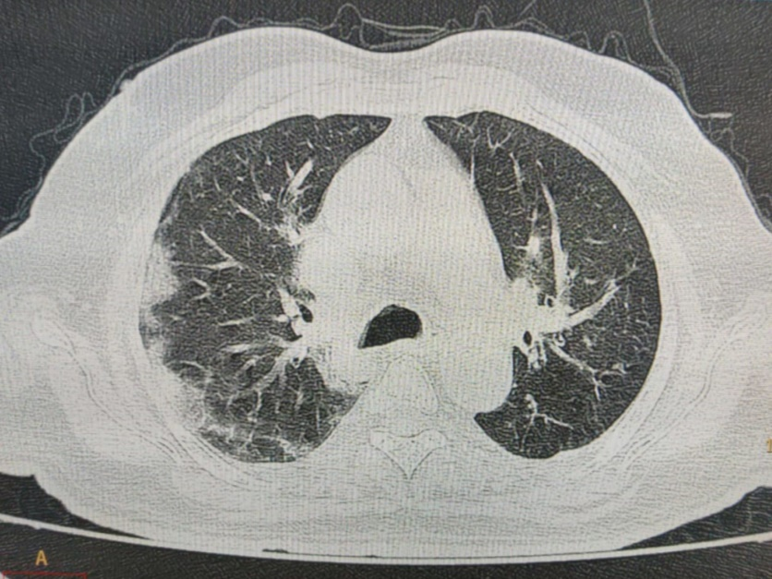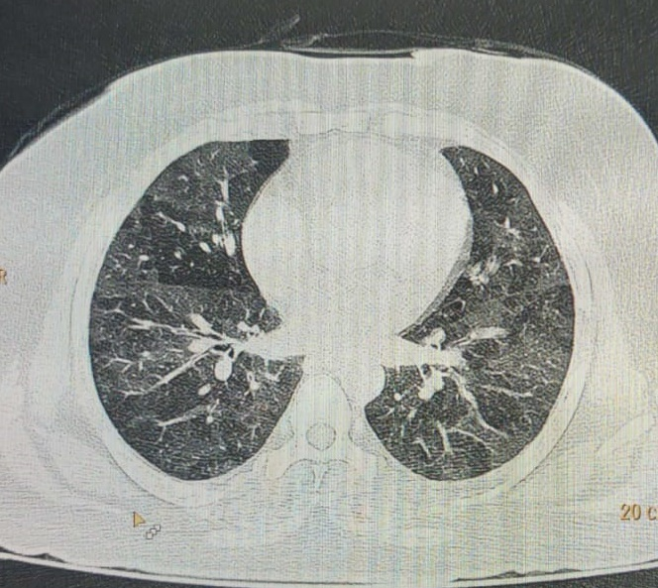
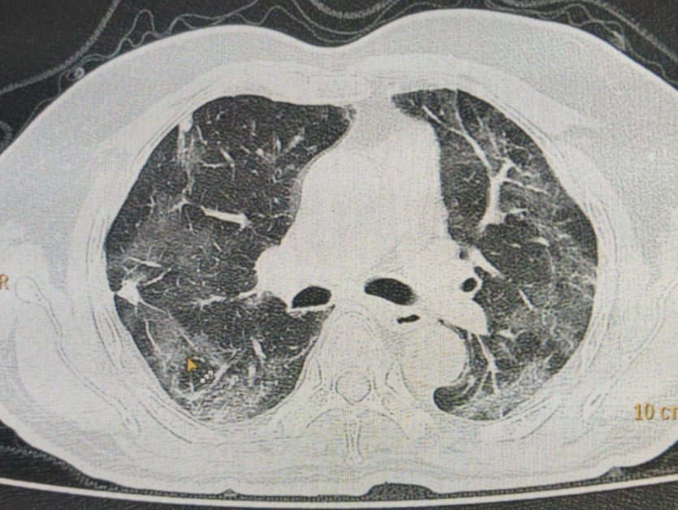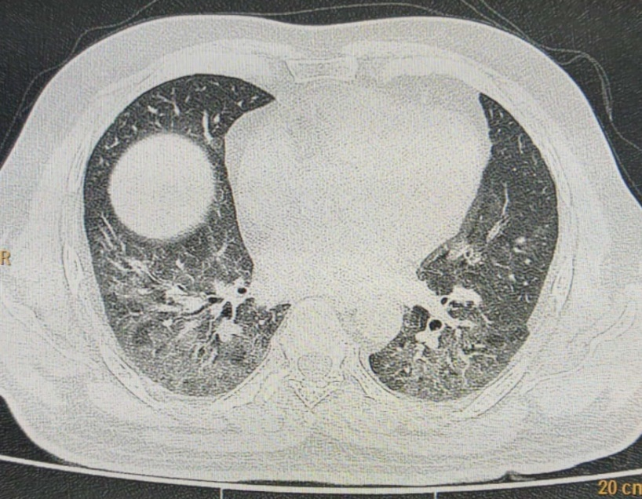

Figures above depict CT chest findings of Covid patients. These patients’ shows high chest CT severity scores with common lung lesions like Ground glass opacities (GGO) admixed with consolidation and interlobular septal thickening in bilateral lung fields.

DISCUSSION
The aim of this study was to determine the changes in radiological findings in Covid-19 patients as the course of the disease progresses from its initial stage. Community spread of respiratory infection caused by the novel corona virus (COVID-19) is occurring globally. Majority of the patients presented with complaints like dry cough (76.3%), fever (61.8%), body ache (39%), and anosmia (31.8%). Chronic diseases have become a global economic burden ⁽¹⁰⁾. Results revealed that 76.3% cases had one or more associated co-morbidities such as diabetes, hypertension, Chronic obstructive pulmonary disease, Coronary artery disease, Chronic kidney disease. Those patients who had associated Co-morbidities has more critical clinical course as well as length of hospital stay similar to the previous studies^{(11,12)}. Like other viral infuenza cases, patients with associated co-morbidities like obesity, cardiovascular diseases, and hypertension has poor prognosis as compare to patients with no significant co-morbidities⁽¹³⁾.
In the present study CT findings clearly shows that major lung lesions like GGO, consolidation, per lobular opacities and other associated lesions are predominately seen in later stages of disease usually after one week from its onset, similar picture is seen in the study done by Pan et al ⁽¹⁴⁾Only two patients in the present study were initially negative in RT PCR result but showing positive radiological findings in their chest CT suggesting that it is positive even in patients with negative RT PCR values, therefore from present study it reveals that CT chest can be used as standalonetooltoruleoutCOVID-19infection.
Analysis of CT chest of Covid-19 patients showed that lesions were mainly confined to right and left lower lobes, suggesting that the virus is most abundant in the more active parts of the lung which is consistent with the findings in the study done by Pan et al ⁽¹⁴⁾. The CT chest findings in Covid-19 patients vary at different stages of the disease which helps to differentiate Covid-19 pneumonia from other types of pneumonia ^{(15,16,17)}.The CT chest findings of SARS and MERS shows unifocal involvement of lung lesions which is also similar to the CT chest findings of Covid-19 patients ⁽¹⁸⁾. In MERS pneumonitis, the GGOs are mainly distributed in the sub pleural and basilar lung regions in contrast to the SARS pneumonitis which shows multiple GGOs in the periphery of the lung, which are somewhat similar to the CT chest findings of Covid-19 patients ⁽¹⁶⁾. With the progression of Covid-19 pneumonitis, the number of GGOs increases and the consolidations become denser ⁽¹⁸⁾. Present data closely resembles with the study done by Pan et al ⁽¹⁴⁾that shows mainly GGOs in early phase of disease, followed by increasing consolidation in the later phase of disease. Previous studies found that patients who had viral pneumonitis with consolidations had more severe clinical outcomes than those presented with GGOs ^{(19.20)}. Covid-19 patients with bilateral pneumonitis tend to have severe systemic inflammatory response. These findings are similar to the study done by Sverzellati et al ⁽²¹⁾ who also pointed out that CT chest findings can be used for classifying Covid -19 patients from other non- Covid-19 pneumonias which has important significance in the outpatient and emergency settings. Present study shows CT chest findings in early, intermediate and later stages of disease. Predominately later stages shows different outcome from complete recovery (healed focus) to progression of disease in chronic phase. It helps the researcher to study the long term complications associated with disease.
CONCLUSION
From present study it can conclude that the constancy of CT chest findings is related to duration of illness. It also shows that time course of infection is of utmost importance not only to understand the pathophysiologic features and natural history of disease, but also help to predict the disease in its early stages and to prevent potential complications. As the disease is very virulent and potentially fatal, the risk stratification through CT chest is necessary so during triage, CT should be done as early as possible along with RT-PCR so that early detection of disease provides window for early initiation of treatment thus avoiding complications especially in co-morbid patients.

REFERENCES

- WMHC. Wuhan Municipal Health and Health Commission’s Briefing on the Current Pneumonia Epidemic Situation in Our City. 2020.
http://wjw.wuhan. gov.cn/front/web/showDetail/2019123108989. (Retrieved on 16 dec2020).
- C. Wang, P.W. Horby, F.G. Hayden, G.F. Gao, A novel coronavirus outbreak of global health concern, Lancet (2020).
- Coronavirus (COVID-19) events as they happenhttps://www.who.int/emergencies/...coronavirus.../events-as-they-happen(Retrieved on 16 dec2020).
- Reid D. India confirms its first coronavirus case. CNBC; 2020. Available from: https://www.cnbc.com/2020/01/30/indiaconfirms-first-case-of-the-coronavirus.html,(Retrieved on6 june 2020).
- Huang C, Wang Y, Li X, Ren L, Zhao J, Hu Y, et al. (2020). Clinical features of patients infected with 2019 novel coronavirus in Wuhan, China. LANCET.
- Alipio, M. M. (2020). Chest Radiographic Findings of Patients Infected with 2019-nCOV. Chest.
- Wang D, Hu B, Hu C et al (2020) Clinical Characteristics of 138Hospitalized Patients With 2019 Novel Coronavirus-Infected Pneumonia in Wuhan. China. JAMA 323:1061
- Kobayashi T, Jung SM, Linton NM, Kinoshita R, Hayashi K, Miyama T, Anzai A, Yang Y, Yuan B, Akhmetzhanov AR, Suzuki A. Communicating the risk of death from novel coronavirus disease (COVID-19)
- *Lee EY, Ng MY, Khong PL. COVID-19 pneumonia: what has CT taught us?. The Lancet Infectious Diseases. 2020 Apr 1;20(4):384-5.
- Zhu Y, Liu C, Zhang L et al (2020) How to control the economic burden of treating cardio-cerebrovascular diseases in China? Assessment based on system of health accounts 2011. J Glob Health 10:010802
- Guan, W. J., Liang, W. H., Zhao, Y., Liang, H. R., Chen, Z. S., Li, Y. M., ... & Ou, C. Q. (2020). Comorbidity and its impact on 1590 patients with Covid-19 in China: A Nationwide Analysis. European Respiratory Journal.
- Lippi G, Wong J, Henry BM (2020) Hypertension and its severity or mortality in Coronavirus Disease 2019 (COVID-19): a pooled analysis. Pol Arch Intern Med 130:304
- Mertz D, Kim TH, Johnstone J et al (2013) Populations at risk for severe or complicated infuenza illness: systematic review and meta-analysis. BMJ 347:f5061
- Pan F, Ye T, Sun P, Gui S, Liang B, Li L, Zheng D, Wang J, Hesketh RL, Yang L, Zheng C. Time course of lung changes on chest CT during recovery from 2019 novel coronavirus (COVID-19) pneumonia. Radiology.
- Wang K, Kang S, Tian R, Zhang X, Zhang X, Wang Y. Imaging manifestations and diagnostic value of chest CT of coronavirus disease 201 (COVID-19) in the Xiaogan area. Clin Radiol 2020 May;75(5):341-347
- Zhou Z, Guo D, Li C, Fang Z, Chen L, Yang R, et al. Coronavirus disease 2019: initial chest CT findings. Eur Radiol 2020 Aug;30(8):4398-4406
- Jin Y, Cai L, Cheng Z, Cheng H, Deng T, Fan YP, for the Zhongnan Hospital of Wuhan University Novel Coronavirus Management and Research Team‚ Evidence-Based Medicine Chapter of China International Exchange and Promotive Association for Medical and Health Care (CPAM). A rapid advice guideline for the diagnosis and treatment of 2019 novel coronavirus (2019-nCoV) infected pneumonia (standard version). Mil Med Res 2020 Feb 06;7(1):4
- Li Y, Xia L. Coronavirus Disease 2019 (COVID-19): Role of Chest CT in Diagnosis and Management. AJR Am J Roentgenol 2020 Jun;214(6):1280-1286.
- Grinblat L, Shulman H, Glickman A, Matukas L, Paul N. Severe acute respiratorysyndrome:radiographicreviewof40probablecasesinToronto, Canada. Radiology.2003;228:802–9.
- GattinoniL,CaironiP,CressoniM,ChiumelloD,RanieriVM,QuintelM,Russo S,PatronitiN,CornejoR,BugedoG.Lungrecruitmentinpatientswiththe acuterespiratorydistresssyndrome.NEnglJMed.2006;354:1775–86.
- Sverzellati N, Milanese G, Milone F, et al. Integrated radiologic algorithm for COVID-19 pandemic. J Thorac Imaging. 2020. Apr 7,

Date of Publishing: 05 March 2021 Author Declaration: Source of support: Nil, Conflict of interest: Nil
Ethics Committee Approval obtained for this study? YES
Was informed consent obtained from the subjects involved in the study? YES
For any images presented appropriate consent has been obtained from the subjects: YES
Plagiarism Checked: Urkund Software
Author work published under a Creative Commons Attribution 4.0 International License

DOI: 10.36848/IJBAMR/2020/26215.55590

