Original article:
Histopathological overview of CNS tumors at a tertiary care hospital
*Dr Ratnaprabha Anil Gunge¹, Dr Anil Munemane² , Dr Ravindra R Karle³

Department of Pathology, Rural Medical College, PIMS (DU) Loni
Corresponding author *; Email : ratnaprabha_tdy@yahoo.co.in

Abstract:
Background: CNS tumors are known to mankind since 1774, when Louis first reported fungal tumor of the Dura mater. Previously it was stated that incidence of brain tumor in India was uncommon, but over the time with evolution of newer investigative neuroimaging techniques in India during the past two decades, it has become obvious that brain tumors are as common in this country as elsewhere in the world.
Material and methods - Retrospective study was done in the Department of Pathology from January 2016 to December 2017.Thirty eight biopsies of CNS tumors were reviewed. Gross features of all the specimens assessed & sections are processed by routine paraffin techniques. Sections were stained using Haematoxylin & Eosin, whenever needed various immunohistochemistry markers were used to classify & grade the lesions according to recent WHO classification. Patient’s clinical details, neuroimaging & other investigations were obtained and analysed in all the cases.
Results : Thirty eight cases of CNS tumors were found among the total 8000 specimens received in the department of pathology. Amongst them primary CNS tumors were 36 cases (94.7%) and 02 (5.3%) were metastatic. In the primary CNS tumors on the basis of cell of origin, tumors of neuroepithelial origin (52%) were the commonest followed by tumors of meningothlial cells (18%) and cranial & peripheral nerve sheath tumors (8%) & tumors of embryonal origin (8%). Amongst the metastatic lesions, the most common histological type was adenocarcinoma.
Conclusion : Primary CNS tumors are the heterogeneous, comprising a large spectrum of different tumour entities associated with distinct biological background and disease course. Histopathological study using immunohistochemistry helps in knowing their epidemiology and burden of disease in community.
Key words : CNS tumors, Histopathology, Immunohistochemistry, Neuroepithelial origin.

Introduction
CNS tumors are known to mankind since 1774, when Louis first reported fungal tumor of the Dura mater. Previously it was stated that incidence of brain tumor in India was uncommon, but over the time with evolution of newer investigative neuroimaging techniques in India during the past two decades, it has become obvious that brain tumors are as common in this country as elsewhere in the world (1).
The majority of brain tumors are sporadic lesion, to date genetic syndromes, prior ionizing radiation exposure like CT scans, X-rays are only known risk factors accounting for <10% of all brain tumors. Recently IARC also classified over exposure to low frequency, non-ionizing electromagnetic waves via mobile phones are possibly carcinogenic to human beings, and a potential risk factor for brain tumors such as Glioma, meningioma, and acoustic neuromas (2).
Tumors of the nervous system are histologically typed by WHO as tumors of neuroepithelial tissue, peripheral nerves, meninges, mesenchymal non-meningothelial tumors, lymphomas, germ cell tumors and metastatic tumors(3). The exact histopathological diagnosis of CNS tumors using newer diagnostic criteria, techniques like use of histochemical stain and immunohistochemistry (IHC) has played major role in differential diagnosis and improving diagnostic accuracy which is essential to predict the grading and prognosis. However this newer diagnostic criteria and techniques have affected the relative frequencies of CNS tumors (4,5).
In malice of these newer advances, there is ample increase in incidence of CNS tumors seen among children under 14 years, and in adults 70 years and older. Incidence rate is higher from 1991 to 1995 in comparison to what was seen from 1975 to 1979 (6, 7).
The CNS tumors that outweigh in adults differ from those seen in children. The annual incidence of CNS tumors ranges according to published Western data from 10 to 17/100,000 persons for intracranial tumors and from 1 to 2 /100,000 persons for intra spinal tumors. Of these about half are primary tumors and the rest are metastatic. Tumors of the CNS account for 20% of all cancers of childhood. Malignant CNS tumors are the second most commonest cause of death under 15 year age group in both males and females (8).
The present study was conducted with the aim to provide current histological overview of CNS tumors in our hospital setup and study these lesions by using revised WHO classification and compare with published literature in India and worldwide.
Aims & objectives:
1. To study the incidence & various histological subtypes of CNS tumors according to age & sex using H&E staining & whenever needed immunohistochemistry.
2. To classify & grade the CNS lesions using recent WHO classification & compare them with previous published literature.
Material and Methods :
Retrospective study was done in the department of pathology from January 2016 to December 2017.Thirty eight biopsies of CNS tumors were reviewed. Gross features of all the specimens assessed & sections werer processed by routine paraffin techniques. Sections were stained using Haematoxylin & Eosin, whenever needed various immunohistochemistry markers are used to classify & grade the lesions according to recent WHO classification. Patient’s clinical details, neuroimaging & other investigations were obtained and analysed in all the cases.
Results :
During the study period, 38 cases of CNS tumors were found among the total 8000 specimens received in the department of pathology. Amongst them primary CNS tumors were 36 cases (94.7%), and 02 (5.3%) were metastatic.
In the primary CNS tumors on the basis of cell of origin, tumors of Neuroepithelial origin (52%) were the commonest followed by tumors of meningothlial cells (18%) and cranial & peripheral nerve sheath tumors (08%) & tumors of embryonal origin (08%) (Table 1). Amongst the metastatic lesions the most common histological type was adenocarcinoma.
Graph 1. Histological spectrum of CNS tumors

Table 1. Histological spectrum of CNS tumors
Types of tumor | No of cases (38) | % of total cases
Neuroepithelial tumors (Astrocytic & Ependymal tumors) | 20 | 52%
Meningothelial tumors | 07 | 18%
Cranial & Peripheral nerve sheath tumors | 03 | 08%
Embryonal tumors  ( Medulloblastoma) | 03 | 08%
Tumors of sellar region  (Pituitary adenoma) | 01 | 03%
Mesenchymal tumors  (Hemangioblastoma) | 01 | 03%
Tumors of hematopoietic system  ( Non-Hodgkin’s lymphoma) | 01 | 03%
Metastasis | 02 | 05%

Graph 2. Age wise distribution of CNS tumors

Graph 3. Sex wise distribution of CNS tumors

In present study, maximum number of CNS tumors were found in more than 40 years of age, amongst them 51-60 years of age group showed highest number of cases. Only single case was found under the age of 10yrs. Comparatively lower incidence is seen in younger age groups.
Out of 38 cases, Astrocytomas were most commonly found followed by meningiomas and shwannomas, Amongst them incidence of CNS tumors were more in male patients than female with male to female ratio was 1.2:1, except in meningiomas were female predominance is noted.

Table 2. Relative frequency of astrocytomas according to WHO grading
Grade | No of cases | Percentage(%)
I | 02 | 10%
II | 05 | 30%
III | 03 | 18%
IV | 07 | 42%

Tumors of neuroepithelial tissue
Out of 38 cases, the commonest were tumors of neuroepithelial tissue accounting for 20 cases. Amongst them astrocytic tumors were the most common (17cases) & ependymal tumors constitutes 3 cases. Amongst them Glioblastoma multiforme WHO grade IV astrocytic tumor were maximum cases reported (7 cases) with dense cellularity, nuclear palisadation, microvascular proliferation & areas of serpentine necrosis (Figure 1), followed by WHO grade II Diffuse astrocytomas having diffuse morphology with mild nuclear pleomorphism and hyperchromasia (Figure 2) & grade III Anaplastic astrocytomas. Immunohistochemistry (IHC) was done to conform the higher grade of tumors like Glioblatoma multiforme which showed diffuse positivity for GFAP & increased mitotic activity which was highlighted by Ki-67.We found 2 cases of grade 1 astrocytomas in younger age group.
Table 3 Tumors of meningothelial origin
Sr No | Age/sex | Site | Diagnosis | WHO grade
1. | 65/F | Lt frontal lobe | Angiomatous meningioma (figure 3) | Grade I
2. | 55/M | Olfactory groove meningioma | Clear cell meningioma | Grade II
3. | 43/F | Orbital mass | Meningothelial meningioma | Grade I
4. | 40/M | Anterior cranial fossa SOL | Meningothelial meningioma | Grade I
5. | 43/M | Orbital mass | Meningothelial meningioma | Grade I
6. | 58/F | Brain SOL | Atypical meningioma | Grade III
7. | 83/F | Spine D8 level | Psammomatous meningioma (Figure 4) | Grade I

Amongst meningothelial tumors, female predilection noted with with M :F ratio 1:1.3. Cases of meningothelial, psammomatous & angiomatous meningiomas belonging to WHO grade1 were found in the study, while recurrent lesions found to be grade II clear cell meningioma & grade III atypical meningioma.
Tumors of peripheral nerve sheath
C4-C5 spinal mass in a 49yr old male diagnosed as neurofibroma, while a rare case of intramedullary schwannoma was reported in a 12 years old boy complaining of occipital headache with neck pain and neck movement restriction from 6 months. He developed gradually progressive quadriparesis. There were no clinical features of Neurofibromatosis.
MRI spine showed a well-defined, T1 hypointense, T2 hyperintense and contrast enhancing intramedullary lesion extending from lower medulla to mid C3 level with slight eccentric location to right on axial section (Figure 5). There were no other lesions found and Neurofibromatosis was ruled out. Patient underwent suboccipital craniotomy with C1 and C3 laminectomy with C2 laminoplasty. Midline myelotomy done and complete tumour excision done.
Histopathological examination showed a variably cellular myxoid tumor composed of spindle cells & short oval cells, which at places showed nuclear palisadation forming verocay bodies. Areas of hemorrhage & congestion noted. Perivascular cuffing by tumor cells seen focally. Tumor is seen within the substance of spinal cord albeit near the surface. IHC performed on tumor sections. Tumor cells expressed strong & diffuse positivity for S100, while GFAP & EMA were focally expressed. Mib - 1 labelling index is low (Figure 6). On the basis of histopathological examination & IHC, diagnosis of intramedullary schwannoma with extensive myxoid changes is favoured, though very rare.
Embryonal tumors
3 cases of medulloblastomas (WHO grade IV) reported in less than 20yrs of age groups with female predominance.
18 yr old female presented with complains of headache, vomiting with cerebellar signs. On MRI well defined lesion in the vermis of cerebellum compressing 4th ventricle, with dialatation of lateral & 3rd ventricle causing obstructive hydrocephalus. On histopathological examination closely packed small blue round cells in sheets & forming nodules with proliferating blood vessels, diagnosed as medulloblastoma (Figure 7). On IHC tumor cells were positive for synaptophysin, negative for CD 20 &CK.

Table 4. Tumors of embryonal cell origin
Sr no. | Age/Sex | Site of involvement | Diagnosis ( WHO grade )
1 | 6/F | 4th ventricular SOL | Medulloblastoma ( Grade IV )
2 | 12/M | 4th ventricular SOL | Medulloblastoma ( Grade IV )
3 | 18/F | Cerebellar SOL | Medulloblastoma ( Grade IV )

Mesenchymal tumors
45yr old female presented with 4th ventricular mass, diagnosed as Hemangioblastoma on histopathology. On IHC stromal cells are positive for vimentine, while CD34 stained endothelial cells conformed the diagnosis of Hemangioblastoma.
Tumors of sellar region
52yr old male presented with complaints of headache, giddiness, on imaging diagnosed with sellar mass. Postoperatively histopathology showed an encapsulated tumor composed of mixture of acidophills, basophills and non-staining cells. The cells are arranged in nests, groups and viable adjacent capillaries. Slight variation in nuclei and sparse mitotic activity seen. Ki 67< 1%,diagnosed as pituitary adenoma.
Tumors of hematopoetic system
57yr old male patient presented with complaints of imbalance suggestive of cerebellar signs. On MRI well defined lobulated extra axial enhancing lesion in right cerebellar lobe. Histopathology examination showed diffuse sheets of medium sized cells with pleomorphic nuclei, prominent nucleoli and scant cytoplasm, diagnosed as high grade Non Hogdkin lymphoma, On IHC tumor cells were positive for CD20, high ki67 30%, GFAP negative(Figure 8).
Metastatic tumors
Two cases of metastatic lesions were found in 38 cases studied.
36yr old female complained of headache, dizziness, vomiting since 20 days. On examination right sided hemiparesis with right facial palsy. MRI showed multiple focal altered signal intensity lesions in the bilateral frontal, parietal & temporal lobes. Intraoperatively ill defined blackish tumor with thick motor oil content. Histopathological examination showed scanty brain parenchyma infiltrated by a tumor composed of papillary structures and glands lined by hyperchromatic pleomorphic nuclei, numerous mitotic figures with mucinous secretions focal areas of necrosis seen(Figure 9). On IHC tumor cells were positive foe CK7, CK20 & EMA, diagnosed as metastatic mucinous adenocarcinoma probably of ovarian origin.
37 yr old male presented with well defined lobulated heterogeneously enhancing solid lesion in right paramedian cerebellum with surrounding vasogenic edema resulting into obstructive hydrocephalus, on histopathological examination diagnosed as metastatic adenocarcinoma, immunohistochemistry showd positivity for TTF-1 & CK7 & negative for PAX 8, suggestive of primary origin in the lung.

DISCUSSION
CNS is the host of the greatest variety of tumors, accounting for less than 2% of all malignancies and because of their location they have a guarded prognosis.(9,10) However the pathogenesis of spontaneously occurring CNS neoplasms in humans is unknown, but recently there is increase in cases of CNS lymphoma observed due to AIDS pandemic. In present study during the study period, 38 cases of CNS tumors were found among the total 8000 specimens received in the Department of pathology. Amongst them primary CNS tumors were 36 cases (94.7%), and 02 (5.3%) were metastatic, which is similar to study done by shivraj et al 2017( (11) in which metastatic tumors were 2%.
In present study amongst the primary CNS tumors on the basis of cell of origin, tumors of Neuroepithelial origin (52%) were the commonest followed by tumors of meningothlial cells (18%) and cranial & peripheral nerve sheath tumors (08%) & tumors of embryonal origin (08%), while meningioma (39.4%) was the most common tumor followed by astrocytoma (34.2%), seen in studies conducted by Shivraj et al 2017 (11), Surawicz et al 1999,(12) Lee et al 2010 (31.2%)(13) and recently in India study by Ghanghoria et al 2014 (41.5%)(14).
Table 5: Showing the incidence of CNS tumours in comparison with other studies from India and worldwide Histological type
Histological type | Present study | Verma et al (15) | Shivraj et al (11) | Lee et al (13) | Ghanghoria  et al (14)
Neuroepithelial tumour | 52% | 62% | 34% | 18% | 25%
Meningeal tumour | 18% | 14% | 40% | 31% | 42%
Cranial nerve tumour | 08% | 05% | 18% | 19% | 06%
Pituitary tumour | 03% | 04% | 03% | 03% | -
Metastatic tumours | 05% | 08% | 05% | - | -

Incidence of neuroepithelial tumors is higher in present study which is comparable with study done by Verma et al (15), while all other studies showed more number of meningothelial tumors which is 2nd most common tumor in present study.
In present study, incidence of CNS tumors were more in male patients than female with male to female ratio was 1.2:1, except in meningiomas were female predominance is noted, this is similar to various previous studies published by indian and foreign studies (9, 12, 14), while overall female predominance is noted in study done by shivraj et al 2017 (11) as more cases of meningeal tumors are seen in the study.
In present study, out of 17 cases of astrocytomas, grade IV astrocytomas (42%) & grade III ( 18%) were more common than grade I & II, which is similar to study done by Monga et al 2015 (16), Rajasthan India were grade III (43.8%) & grade IV ( 25%) were more common than grade II (12.5%).Neuroepithelal tumors could be found in any age group from infancy to over 70 years with most of them occurring in first decade of life (17).
Intraparenchymal schwannomas of the central nervous system are extremely rare when no relationship with neurofibromatosis is present. Several parts of CNS can be affected, such as the spinal cord, cerebellum and brain stem. Spinal canal schwannomas account for 30% of spinal tumors most of which are generally associated with neurofibromatosis, type 1 and type 2. Intramedullary schwannomas not associated with neurofibromatosis are rarely reported, which account for 0.3% of all medullary tumors and 1.1% of spinal schwannomas(18).
In present study 12 year old boy is diagnosed with cervical intramedullary schwannoma unrelated to neurofibromatosis is a rare case, similar case has been reported by Binatli O et al 1999 (19), reported intramedullary schwannoma at C6-T1 level in a 9yr old male child.

Conclusion
Primary CNS tumours are the heterogeneous, comprising a large spectrum of different tumour entities associated with distinct biological background and disease course. Histopathological study helps in knowing their epidemiology and burden of disease in community. From practical point of view, an accurate diagnosis of brain tumour is possible after careful assessment of histomorphological features along with clinical and radiological imaging information. Though the conventional H and E staining is the mainstay for pathologic diagnosis, IHC has played a major role in improving diagnostic accuracy & grading the CNS lesions according to WHO, which helps in predicting tumor behavior & prognosis in patients suffering with CNS lesions..

Figure 1. Malignant astrocytes surrounding serpentine necrosis, microvascular proliferation in a case of Glioblastoma multiformis (WHO grade IV) (H&E 40x).
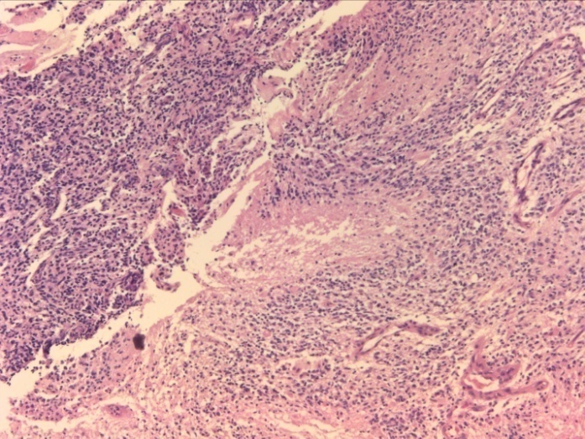

Figure 2 - Proliferating germistocytic astrocytes with abundant eosinophillic cytoplasm and eccentrically placed nucleus against fibrillary background – Germistocytic Astrocytoma (WHO grade II) (H&E 40x).
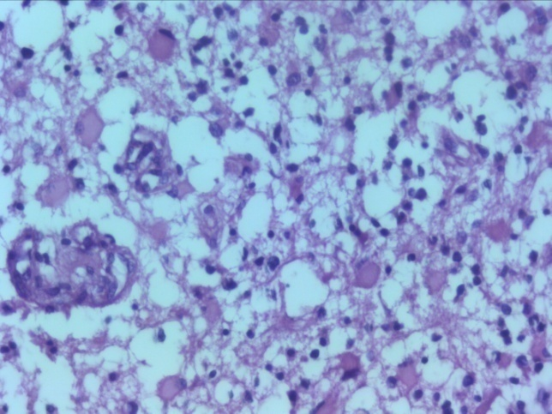

Figure 3 – Proliferating vasculature with meningothelial cells – Angiomatous meningioma ( WHO grade I) (H&E 40x).
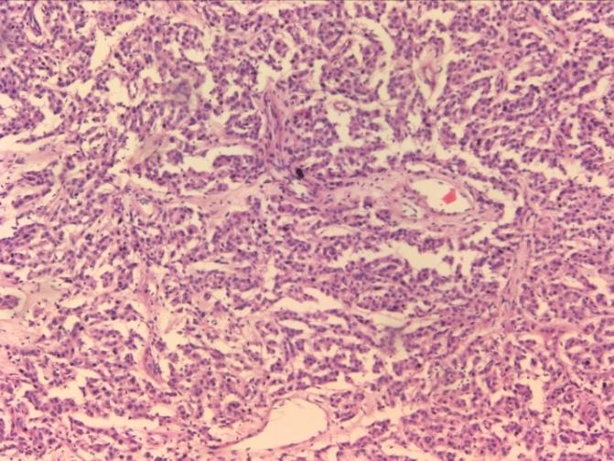

Figure 4 – Numerous calcified psammomatous bodies with inconspicuous meningothelial whorls – Psammomatous meningioma (WHO grade I) (H&E 40x).
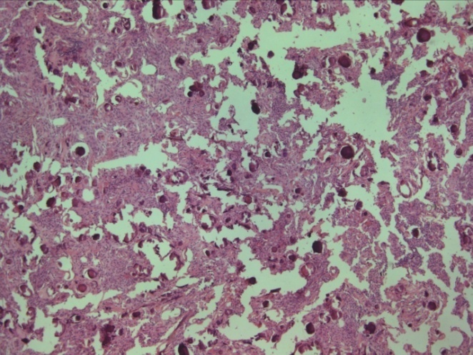

Figure 5 – MRI spine showed a well-defined, T1 hypointense, T2 hyperintense and contrast enhancing intramedullary lesion extending from lower medulla to mid C3 level with slight eccentric location to right on axial section.
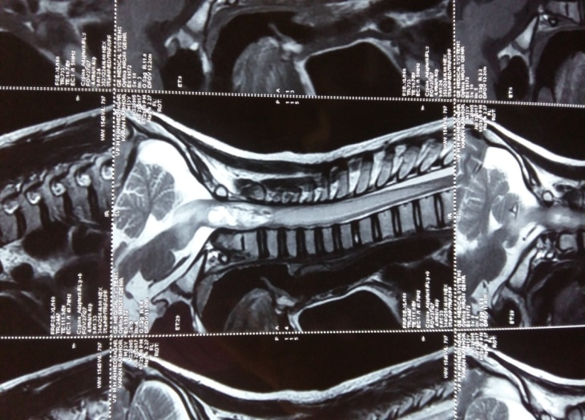

Figure 6 – Intramedullary schwannoma - cellular myxoid tumor composed of spindle cells & short oval cells, at places showed nuclear palisadation forming verocay bodies. On IHC tumor cells expressed strong & diffuse positivity for S100, while GFAP & EMA were focally expressed, low Mib - 1 labelling index.(WHO grade I) (H&E 40x).
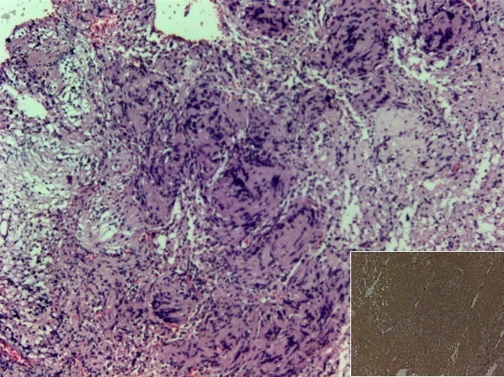

Figure 7 – 4th ventrivular mass showing dencely packed round pleomorphic cells with hyperchromatic nuclei, scant cytoplasm with increased mitotic activity – Medulloblastoma WHO grade IV (H&E 40x).
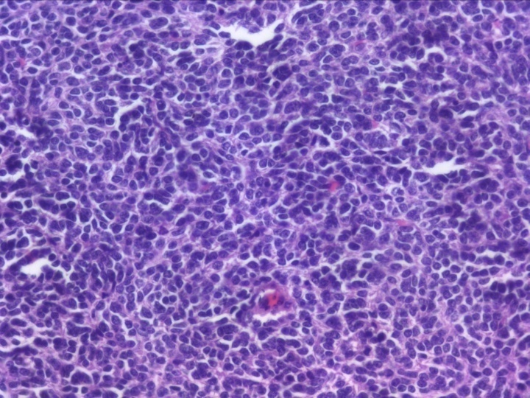

Figure 8 - Cerebellar SOL - diffuse sheets of medium sized cells with pleomorphic nuclei, prominent nucleoli and scant cytoplasm, diagnosed as high grade Non hogdkin lymphoma, On IHC tumor cells were positive for CD20, high ki67 30%, GFAP negative. (H&E 40x).
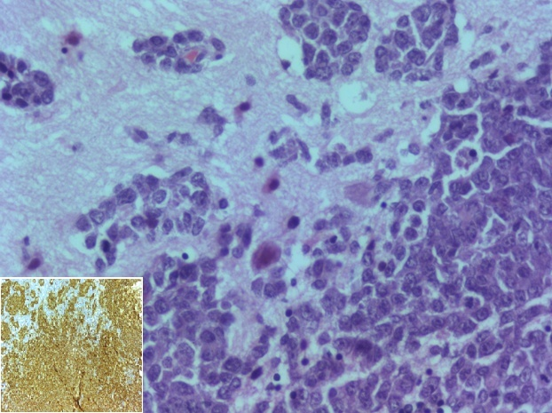

Figure 9 – Multiple frontal, parietal, temporal lesions - papillary structures and glands lined by hyperchromatic pleomorphic nuclei, numerous mitotic figures with mucinous secretions focal areas of necrosis, On IHC tumor cells positive for CK7, CK20 & EMA, diagnosed as metastatic mucinous adenocarcinoma probably of ovarian origin (H&E 40x).
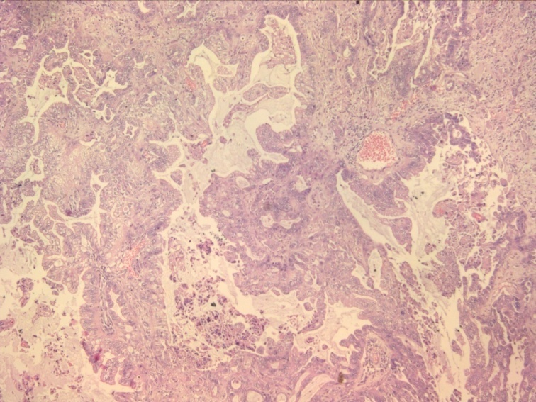

References
1. V Rathod, ABhole, M Chauhan, H Ramteke, B Wani Citation V Rathod, A Bhole, M Chauhan, H Ramteke, B Wani. /Study of clinico-radiological and clinico-pathological correlation of intracranial space occupying lesion at rural center/. The Internet Journal of Neurosurgery. 2009 Volume 7 Number 1.
2. Wohrer A. Epidemiology and Brain Tumours: Practical Usefulness. Eur Assoc Neurooncol Mag 2013;3(2):56-60.
3. Louis D N, Ohgaki H, Wiestler O D, Cavenee W K.WHO classification of tumours of the Central Nervous System.4th Ed, Lyon; IARC press:2007.
4. Aryal G. Histopathological pattern of central nervous system tumor: A three year retrospective study. Journal of Pathology of Nepal 2011;1:22 -25.
5.Hidehiro Takei, Bhattacharjee MB, Andreanna Rivera, Yeongju Dancer, Suzanne Z Powell. New Immunohistochemical markers in the evaluation of Central Nervous system Tumors. Arch Pathol Lab Med 2007;131:234-41.
6. Legler JM, Ries LA, Smith MA, Warren JL, Heineman EF, Kaplan RS, et al. Cancer surveillance series[corrected]: Brain and other central nervous system cancers: Recent trends in incidence and mortality. J Natl Cancer Inst 1999;91:1382-90.
7.Yeole BB. Trends in the Brain cancer incidence in India. Asian Pac J Cancer Prev 2008;9:267-70.
8. Ahmed Z, Muzaffar S, Kayani N, et al. Histological pattern of Central Nervous system neoplasms. Journal of Pakistan Med Association 2001;51(4):154-57.
9.Yeole BB. Trends in the Brain cancer incidence in India. Asian Pac J Cancer Prev 2008;9:267-70.
10.Madabhushi V, Venkata RI, Garikaparthi S, Kakarala SV, Duttaluru SS. Role of immunohistochemistry in diagnosis of brain tumours: A single institutional experience. J NTR Univ Health Sci 2015;4:103-11.
11. Shivraj Nagnath Kanthikar, Dhiraj B. Nikumbh, Nadkumar V. Dravid, Histopathological overview of central nervous system tumours in North Maharashtra, India: a single center study, Indian Journal of Pathology and Oncology, January-March 2017;4(1):80-84.
12.Surawicz TS, McCarthy BJ, Kupelian V, Jukich PJ, Bruner JM, Davis FG. Descriptive epidemiology of primary brain and CNS tumors: Results from the Central Brain Tumor Registry of the United States, 1990-1994. Neuro Oncol 1999;1:14-25.
13. Lee CH, Jung KW, Yoo H, Park S, Lee SH. Epidemiology of primary brain and central nervous system tumors in Korea. J Korean Neurosurg Soc 2010;48:145-52.
14. Ghanghoria S, Mehar R, Kulkarni CV, Mittal M, Yadav A, Patidar H. Retrospective histological analysis of CNS tumors – A 5 year study. Int J Med Sci Public Health 2014;3:1205-07.
15. Verma RN, Subramanyam CSV, Banerjee AK. Intracranial neoplasms- pathological review of 283 cases. Indian J Pathol Microbiol 1983;26(4):289-97.
16.Monga K, Gupta VK, Gupta S, Marwah K. Clinicopathological study and epidemiological spectrum of brain tumours in Rajasthan. Indian Journal of Basic and Applied Medical Research 2015;5(1):728-34.
17.Masoodi T, Gupta RK, Singh JP, Khajuria A. Pattern of Central Nervous System Neoplasms: A Study of 106 Cases. JK-Practitioner 2012;17(4):42-46.
18. Brown KM, Dean A, Sharr MM. Thoracic intramedullary schwannoma. NeuropatholApplNeurobiol. 2002;28:421–4.
19. Binatli O, Ersahin Y, Korkmaz O, Bayol U. Intramedullary schwannoma of the spinal cord. A case report and review of literature. J Neurosurg sci 1999 Jun; 43(2):163-7

