Original article
Study Of Bispectral Indices And Observer Assessment Of Alertness/Sedation (OAA/S) Scale For Monitoring Loss Of Consciousness During Induction Of Anaesthesia With Propofol In Patients Of Age Group Between 40 Years To 65 Years
¹Dr Stephan Jebaraj , ²Dr Surekha S Chavan , ³ Dr Priya Chavre

¹Assistant Professor , Dept of Anesthesiology BJ Government Medical College & Sassoon General Hospitals, Pune India.
²Associate Professor, Dept of Anesthesiology BJ Government Medical College& Sassoon General Hospitals, Pune India.
³Junior Resident, Dept of Anesthesiology BJ Government Medical College& Sassoon General Hospitals, Pune India
Corresponding author : Dr Surekha Sudhir Chavan

ABSTRACT
Introduction: Anesthetic technique is important in the pathogenesis of awareness during anesthesia. Several case reports and clinical studies have suggested that intra-operative awareness during general anesthesia is a frightening experience and has many postoperative adverse consequences. There are limitations for use of clinical signs to measure the hypnotic component of anesthesia as compared to bispectral indices (BIS) monitoring.
AIM- to study and compare BIS indices and 0bserver assessment of alertness/sedation (OAA/S) scale for loss of consciousness during induction of anesthesia with two different doses of propofol (2mg/kg & 1.5 mg/kg) in 40–65 years age group.
Methods- This was randomized, prospective, single blinded, single centre study conducted in a tertiary care institute. Total 100 patients of age group 40-65 years undergoing elective surgeries under general anesthesia were randomly divided into GroupB1(propofol 2mg/kg) and GroupB2 (propofol 1.5mg/kg) of 50 each. BIS values, OAA/S score, PR and BP were recorded during preoperative (baseline) and at 15 seconds, 30 seconds, 45 seconds, 1 minute, 2 minutes after induction.
Results/Conclusion- Injection propofol 2mg/kg was safe and effective to provide adequate depth of anesthesia during induction of anesthesia in patients of age 40 – 65 years. BIS monitoring is a better method to monitor depth of anesthesia and for deciding dose of propofol during induction of anesthesia compared to clinical method (OAA/S score) in 40-65 years age groups.
Key words – General Anesthesia, Propofol, Monitoring, Bispectral Index, OAA/S score

INTRODUCTION-
Anesthetic technique is important in the pathogenesis of awareness during anesthesia. Several case reports and clinical studies have suggested that intra-operative awareness during general anesthesia is a frightening experience and has many postoperative adverse consequences¹.
Loss of consciousness can be assessed clinically by 0bserver assessment of alertness/sedation (OAA/S) scale which has scoring range from 0 to 5 .According to OAA/S scale, Loss of consciousness is defined if OAA/S score<2, corresponding to absence of response to mild probing or shaking² . Advantages of OAA/S scale are- it is a simple clinical method which do not require any special equipment or monitor. Limitation of OAA/S scale is that it doesn’t differentiate between lighter and deeper planes of anesthesia because noxious stimulus like trapezius squeeze is used to assess level of consciousness³. Hence clinical signs monitoring may not be reliable for measuring the hypnotic component of anesthesia.
Bispectral index (BIS) has steadily gained clinical acceptance as a reliable measure to monitor the depth of anesthesia. BIS monitors are noninvasive devices that reflect a signal processed EEG, measures cerebral electrical activity and allows continuous measurement of patient’s hypnotic state. The BIS Index is a scale ranges from 100 (awake, responsive to normal voice) to 0 (Representing as iso-electric, flat line EEG). A BIS value between 40 and 60 indicates an appropriate level for general anesthesia¹. Advantages of BIS monitored anesthesia are, it decreases the requirement of intravenous inducing agents and inhalational agents with adequate depth of anesthesia intra-operatively, which helps to fasten the recovery from anesthesia, early discharge and decreases incidence of post operative cognitive dysfunction (POCD) .
Propofol is commonly used for induction/maintenance of anesthesia and for sedation⁴. The equilibrium constant for propofol based on suppression of the electroencephalogram (which is strongly correlated with loss of consciousness) is about 0.3 min. Awakening is more rapid with minimal residual central nervous system effects is an important advantage of propofol compared to other inducing agents⁵. Our ultimate anesthetic management goal is to facilitate early recovery from anesthesia, to prevent any functional decline, early mobilization, to minimize post operative complications, to minimize the duration of hospital stay.
So, we have designed a comparative study of BIS values and OAA/S scale for monitoring loss of consciousness during induction of anesthesia with propofol.

AIMS- to study and compare BIS values and OAA/S score for monitoring loss of consciousness during induction of anesthesia with two different doses of propofol (2mg/kg & 1.5 mg/kg) in patients of age group 40–65 yrs.

OBJECTIVES –to study and compare,
- time taken to achieve BIS values 40-60 after induction with injection Propofol 2mg/kg IV
- time taken to achieve BIS values 40-60 after induction with injection Propofol 1.5mg/kg IV
- time taken for loss of consciousness after induction with injection Propofol 2 mg/kg IV by using OAA/S score
- time taken for loss consciousness after induction with injection Propofol 1.5 mg/kg IV by using OAA/S score
- Hemodynamic and adverse effects i.e. hypotension, bradycardia, myoclonus, nausea, vomiting.

MATERIALS AND METHODS-

Study design- This was a randomized, prospective, single blinded, single centre study, conducted in tertiary care hospital. The approval from Institutional Review Board/Ethics Committee was obtained.
Sample size- By using following formula we calculated the sample size
2*(Zα +Z(1-β))² * Sd ²
n = -----------------------------
d²
n = sample size per group
Za = Standard normal variate for a=0.05 (95%CI) =1.96
Z1-β = standard normal variate for 1-β=0.80 (80%) =0.84
Assumed sd = 3.12, Effective size = d = 1.75
By using pilot study the SD is 49.84 and effect size is 50 per sub group. Total sample size is 100.

Selection of cases- Inclusion criteria: total 100, Age 40-65 years, ASA grading I/II, male/female, undergoing elective surgery (cholecystectomy, hernia surgeries, modified radical mastiodectomy, modified radical mastectomy etc.) of 2 hours duration under general anesthesia. Exclusion criteria: Patient refusal, Age <40years & >65yrs, H/o allergy and hypersensitivity to propofol , Patients taking anti-depressants, sedatives/opioids, major systemic illness, Psychiatric and Neurological disorders, Alcoholic/drug abuse, Obese [BMI >30]. All patients in this study underwent thorough preoperative assessment. A written informed consent was obtained.
Anesthesia Technique- Patients satisfying inclusion criteria were randomly assigned into Group B1 (Propofol 2mg/kg IV) and Group B2 (Propofol 1.5mg/kg IV). Randomization was done by computer generated random numbers. Blinding: The syringes in which propofol was loaded were wrapped using micropore and was loaded by different anesthetist other than the one who conducted the study. Nil by mouth for 8 hours was confirmed pre-operatively. Intravenous line by intracath 20G in either of the upper limb was secured preoperatively. Monitors Electrocardiogram (ECG), Noninvasive blood pressure (NIBP), Spo2 attached. All were given premedications Inj Glycopyrolate 5 ug/kg iv, half hour prior to induction followed by Inj Ondansetron 0.08 mg/kg IV, Inj Midazolam 0.03 mg/kg IV, Inj pentazocine 0.3 mg/kg IV were given IV slowly. Special composite BIS electrode was applied to the forehead i.e. over the frontal lobe of dominant hemisphere in accordance with manufacturer’s instruction and connected to the BIS monitor were attached after skin preparation with disinfectant and slight rubbing. BIS values before induction were noted. Preoxygenation with 100% Oxygen was done for 3 minutes.
Induction of anesthesia: Propofol was used as single dose intravenous inducing agent in both groups Group B1-2mg/kg, Group B2- 1.5mg/kg. BIS value of patients during pre induction and after induction (15seconds, 30seconds, 45seconds, 1 minute, 2minutes) was recorded. Followed by Inj Suxamethonium 2 mg/kg IV, Bag and mask ventilation with 100 % Oxygen was done and then direct laryngoscopy and intubation was done with portex endotracheal cuffed tube. Patient was maintained on 50% O2 + 50% N2O, Isoflurane as inhalational agents and Injection vecuronium 0.08 mg/kg as skeletal muscle relaxant. Intra-operative monitoring BIS value, Pulse rate (PR), Systolic (SBP) and diastolic blood pressure (DBP), ECG, SpO2, End tidal carbon dioxide concentration (EtCO2), any complication like hypotension ,bradycardia, hypoxia ,myoclonus, nausea, vomiting, if any was done. After completion of surgery, reversal was done with -Inj glycopyrolate 10 ug/kg iv and Inj neostigmine 0.05 mg/kg iv. Patients were extubated.
Monitoring chart was recorded for data analysis- PR, SBP, DBP, BIS values and OAA/S score were recorded during preoperatively (baseline) and 15 seconds, 30 seconds, 45 seconds, 1 minute, 2 minutes after induction.
Statistical Analysis was done using Unpaired t test for comparison of age, weight, PR, SBP, DBP, BIS values, OAA/S scores. Statistical analysis for comparison of sex and ASA Grade was done by Chi square test. P value < 0.05 was considered as statistically significant.

OBSERVATIONS AND RESULTS:

Table1- Demographic Data
Variable | GROUP B1 (n=50) | GROUP B2 (n=50) | Statistical Test | P Value | Statistical Significance
AGE (Year)  Mean+SD | 53.26±7.631 | 53.14±7.902 | Unpaired t Test | 0.939 | Not significant
WEIGHT(Kg)  Mean+SD | 65.78±7.747 | 66.26±7.793 | Unpaired t Test | 0.758 | Not significant
SEX (M/F) | 32/18 | 29/21 | Chi Square Test | 0.900 | Not significant
ASA GRADE  I/II | 27/23 | 29/21 | Chi Square Test | 0.201 | Not significant

Table 2- Comparison of BIS Values in Group B1 and B2
Variable | GROUP B1 n=50 | GROUP B2 n=50 | Statistical Test | P Value | Statistical Significance
Pre-induction BIS | 97.24±0.981 | 97.58±1.416 | Unpaired t Test | 0.166 | Not significant
BIS at 15 Sec | 93.42±2.001 | 92.94±1.766 | Unpaired t Test | 0.207 | Not significant
BIS at 30 sec | 85.28±3.156 | 86.14±1.885 | Unpaired t Test | 0.102 | Not significant
BIS at 45 Sec | 75.08±3.675 | 76.32±2.015 | Unpaired t Test | 0.040 | Stat. significant
BIS at 1 min | 64.54±4.367 | 66.24±2.767 | Unpaired t Test | 0.023 | Stat. significant
BIS at 2 min | 42.82±4.154 | 49.34±3.634 | Unpaired t Test | <0.001 | Stat. significant

Graph no.1 – Comparison of Bispectral Index (BIS) values in group B1 and B2
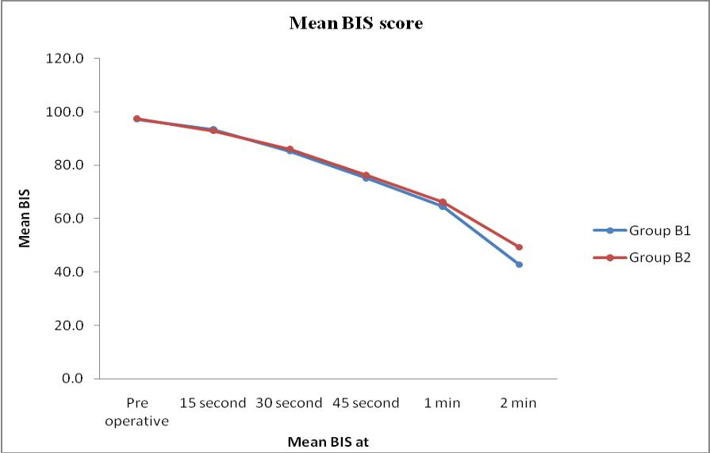

Table 3- Comparison of OAA/S SCORE in Group B1 and B2
Variable | GROUP B1  N=50 | GROUP B2  N=50 | Statistical test | P Value | Statistical Significance
Pre-induction  OAA/S Score | 5.00+0.000a | 5.00+0.000a | - | - | NS
OAA/S Score at 15 sec | 4.00+0.000a | 4.00+0.000a | - | - | NS
OAA/S Score at 30 sec | 2.60+0.495 | 2.66+0.479 | Unpaired t Test | 0.539 | NS
OAA/S Score at 45 sec | 1.64+0.485 | 1.56+0.501 | Unpaired t Test | 0.419 | NS
OAA/S Score at 1min | 0.76+0.476 | 0.74+0.443 | Unpaired t Test | 0.828 | NS
OAA/S Score at 2 min | 0.00+0.000a | 0.00+0.000a | - | - | NS
NS= not significant

Graph no.2 – comparison of OAA/S score in group B1 and B2
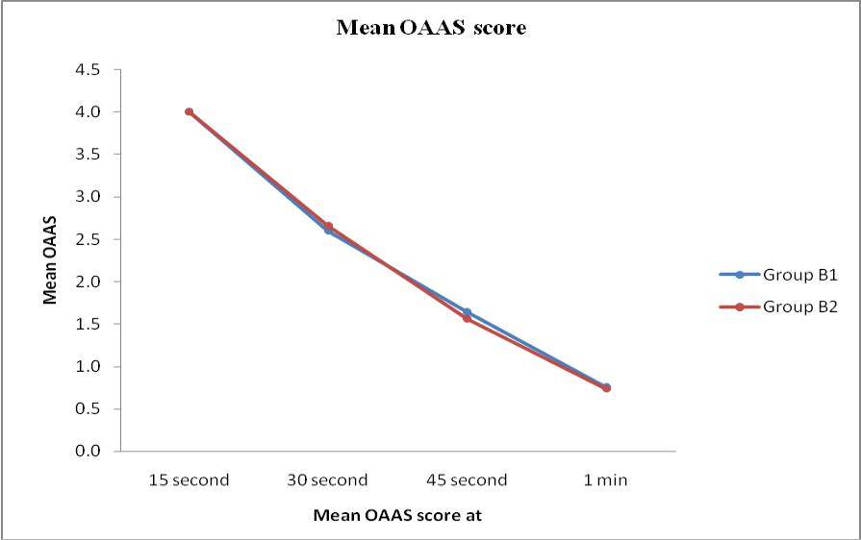

Table no.4- Comparison of PR, SBP AND DBP IN GROUP B1 & GROUP B2
VARIABLE | GROUP B1 | GROUP B2 | P Value
Pre-induction PR | 85.86+8.878 | 86.02+8.057 | 0.925
PR 2 MIN | 94.38+6.509 | 95.62+7.197 | 0.368
PR 5 MIN | 97.28+5.969 | 99.28+7.404 | 0.140
PR 10 MIN | 87.50+5.926 | 91.96+5.876 | <0.001
Preinduction SBP | 128.88+8.927 | 128.24+8.138 | 0.709
SBP 2MIN | 109.44+8.853 | 108.96+7.343 | 0.769
SBP 5 MIN | 108.36+8.208 | 110.04+6.227 | 0.252
SBP 10 MIN | 113.80+8.064 | 117.02+8.600 | 0.015
Preinduction DBP | 86.24+5.564 | 84.08+6.154 | 0.069
DBP 2 MIN | 73.76+5.934 | 70.28+6.917 | 0.008
DBP 5 MIN | 71.96+7.211 | 67.76+5.637 | 0.002
DBP 10 MIN | 73.24+6.219 | 72.80+6.312 | 0.726

Graph no.3: Comparison of pulse rate in group B1 and group B2
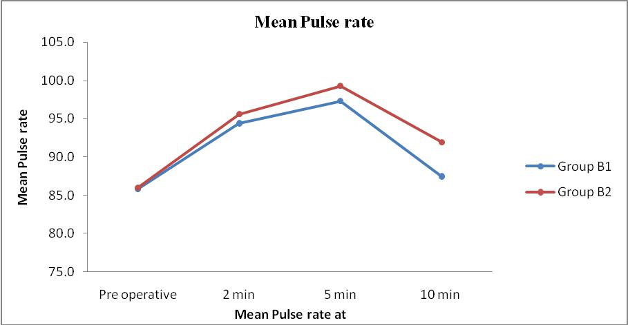

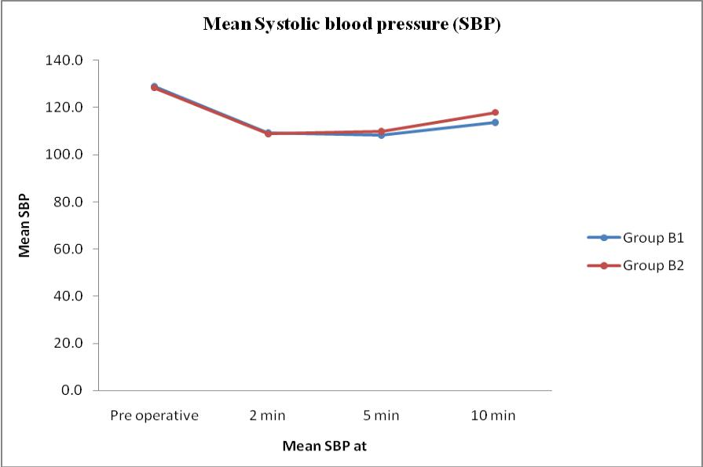
Graph no. 4 – Comparison of Systolic Blood Pressure in group B1 and group B2

Graph no. 5: Comparison of diastolic blood pressure in group B1 and group B2
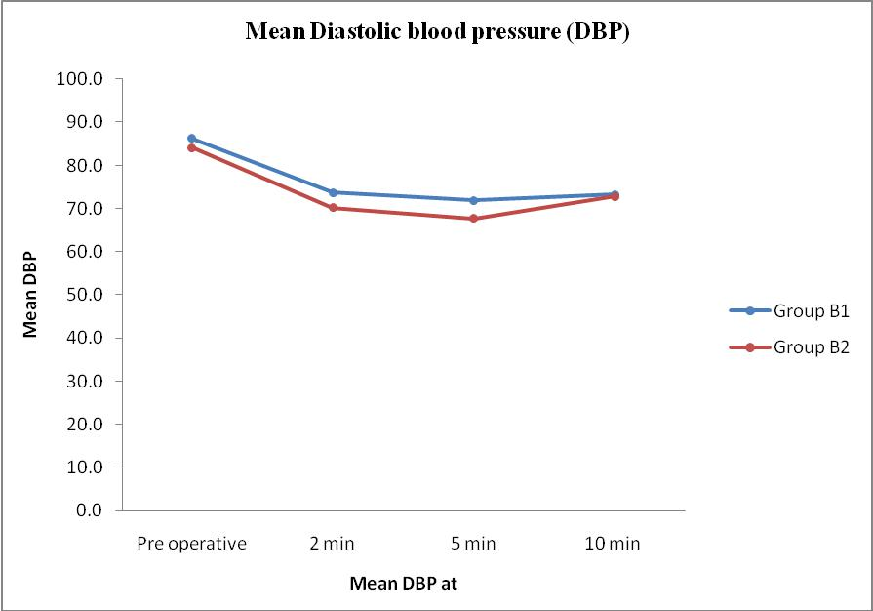

DISCUSSION -
Anesthetic technique is important in the pathogenesis of awareness during anesthesia. Several case reports and clinical studies have suggested that intra-operative awareness during general anesthesia is a frightening experience, which may result in serious emotional injury and posttraumatic stress disorder⁶.
Monitoring Depth of anesthesia –1) Clinical Method- Loss of consciousness can be assessed by an independent observer, clinically by using observer assessment of alertness/sedation scale² which has score ranging from 0 to 5. According to OAA/S scale, Loss of consciousness is defined if score<2, which is corresponding to absence of response to mild probing or shaking.
OAA/S SCORE²
0 -Do Not Respond To Painful Trepezius Squeeze
1- Responds Only After Painful Trepezius Squeeze
2 – Responds Only After Mild Probing/ Shaking
3 –Responds Only After Name Is Called Loudly / Repeatedly/Both
4 –Responds Lethargically To Name Spoken In Normal Tone
5 –Responds Readily To Name Spoken In Normal Tone
2) BIS Monitoring- The BIS correlates with the level of the responsiveness (responsiveness scores of modified observer’s assessment of alertness / sedation level) and provide an excellent prediction of the level of consciousness with propofol. BIS values of 40-60 reflect adequate hypnotic effect for general anesthesia with reasonably rapid recovery to consciousness⁸. Various studies have shown that BIS also correlates with the hemodynamic response to intubation, patient’s response to skin incision and verbal command during inhalational as well as total intravenous anesthesia⁹.
The use of clinical signs (OAA/S score ) may not be reliable for measuring the hypnotic component of anesthesia as limitations of OAA/S scale is that it doesnot differentiate the higher/deeper levels of anesthesia as noxious stimulus like trepezius squeeze is used to assess level of consciousness⁴ The use of bispectral indices monitoring in routine clinical practice is useful on achieving safe, adequate anesthesia and in obtaining stable hemodynamic intra-operatively and satisfactory recovery post-operatively.
Hence, we conducted a comparative study of bispectral indices values and OAA/S score for assessment of loss of consciousness during induction of anesthesia with two different doses of propofol (GroupB1-2mg/kg & GroupB2-1.5 mg/kg) in age group 40-65 years.
Demographic data-
Both groups were comparable in terms of age, sex, weight and ASA grading (table no.1).
Bispectral index (BIS) in Group B1 & B2-
Time taken to achieve BIS value of 40 – 60 after induction with injection propofol was studied. By using Unpaired t test p-value > 0.05 during pre induction and 30 seconds, 45 seconds after induction, therefore there was no significant difference between BIS score in group B1and groupB2. But p value <0.05 during 15 seconds, 1 minutes and 2 minutes after induction therefore there was significant difference between BIS scores in groupB1and groupB2 (table no.2, graph no.1)
Hascilowicz, T et al¹⁰ in 2011 Studied, how much propofol should be given to the elderly for induction of anesthesia, A prospective study based on change of BIS values was conducted in 72 patients ≤60yrs or ≥ 60 years of age (younger and older group). They were randomly allocated into three subgroups depending on dose of propofol: 1.5, 2.0 or 2.5 mg/kg (younger group) or 1.0, 1.5 or 2.0 mg/kg group (older groups). The difference between the baseline and minimum BIS value during the first 5 minutes after injection propofol was compared between the two age groups. A dose dependent relationship between propofol dose and BIS showed significant difference in both younger and older age groups. In our study also, we found a statistical significant difference in BIS values between group B1and B2 at 1, 2 minutes after induction with injection propofol 2mg/kg and 1.5 mg/kg (table no.2, graph no.1).
We studied, time taken to achieve BIS value of 40–60 after induction with injection propofol, was 1-2 minutes(Table no.2).Though there is statistically significant difference in BIS values in patient who received inj. propofol 2 mg/kg (Group B1) : mean BIS values were 42.82 ± 4.15 when compared to patients receiving inj. propofol 1.5 mg/kg (Group B2) : mean BIS values were 49.34 ± 3.63 in 2 minutes, but there was no clinically significant difference between the groups as mean BIS values in both groups were within the desired level i.e. BIS values 40-60 (table no.2, graph no.1).
OAA/S score In Group B1 & B2-
Time taken for loss of consciousness using OAA/S score after induction with injection propofol was studied. In our study, OAA/S score during pre-induction were 5 in all patients so it was not necessary to compare and OAA/S score at 2 minutes after induction, were 0 in all patients so it was not necessary to compare in the study (table no.3, graph no.2). Also by using Unpaired t test, p-value > 0.05 during 30 seconds, 45 seconds and 1 minute after induction therefore we concluded that there was no significant difference between OAA/S score in groupB1and groupB2(table no.3, graph no.2). .
On literature search there was no study reports comparing OAA/S score with two different doses of propofol for induction of anesthesia.
Pulse rate, systolic blood pressure and diastolic blood pressure in Group B1 & B2
By using Unpaired t test, p-value > 0.05 during pre induction and 2 minutes , 5 minutes after induction and there was no significant difference in PR between groupB1 and B2 , but at 10minutes after induction p-value <0.05 , there was significant difference in PR between group B1 and B2 (table no.4, graph no.3).
By using Unpaired t test, p-value >0.05 during pre induction and 2 minutes , 5 minutes after induction , there is no significant difference in SBP in groupB1 and B2 , but at 10minutes after induction p-value <0.05 , there is significant difference in SBP between group B1 and B2 (table no.4, graph no.4).
By using Unpaired t test, p-value > 0.05 during pre induction and 2 , 5, 10 minutes after induction , there is no significant difference in DBP in both group B1 and B2(table no.4, graph no.5)..
Jagdish.Sharma et al⁷ studied Clinical vs bispectral index guided propofol induction of anesthesia. Seventy patients were randomized into two groups of age group 20-60 years. The mean dose of propofol for induction was 1.85±0.48mg/kg (groupA) and 1.79±0.41mg/kg (group B). HR, SBP, DBP were comparable between the groups at the time of induction, post-induction, and intubation. A significant increase in HR, SBP was observed during post-intubation.
In our study, there was no significant difference in PR, SBP and DBP between group B1 and B2 during pre-induction and at 2, 5 minutes after induction with injection propofol 2 mg/kg and 1.5 mg/kg respectively, but there was significant difference in PR and SBP in group B2 compared to group B1 at 10 minutes after induction (table no.4, graph no.3, 4, 5). This response may be due to increased sympathetic activity while start of surgery in Group B2 (inj. propofol 1.5 mg/kg).
Adverse Effects- Adverse side effects like bradycardia, hypotension, myoclonus, hypoxia, nausea, vomiting was not observed in any group.
CONCLUSION-
- Time taken to achieve BIS values 40 -60 in Group B1 (inj. propofol 2mg/kg) and Group B2 (inj. propofol1.5 mg/kg) was 1- 2minutes and BIS values were comparable in both groups.
- Time taken for loss of consciousness using OAA/S score in Group B1 and B2 was 45 seconds and there was no significant difference between OAA/S score in both groups.
- Injection propofol 2mg/kg provided stable hemodynamic in GroupB1 than GroupB2.
- Adverse side effects were not observed in any groups.
From this study we can suggest that, Injection propofol 2mg/kg is safe and effective to provide adequate depth of anesthesia for induction of anesthesia in patients of age 40 – 65 years. BIS monitoring is better method compared to clinical method (OAA/S score) to monitor depth of anesthesia and for deciding dose of propofol during induction of anesthesia in patients of 40-65 years age group.
BIBLIOGRAPHY
[1] C. Balci, H. S. Karabekir, M. Yigit “Comparison of entropy and bispectral index values during propofol induction,” Neurosciences, vol. 13, no. 2, pp. 122–126, 2008.
[2] C. Lysakowski et al.,“Bispectral and spectral entropy indices at propofol-induced loss of consciousness in young and elderly patients,” Br. J. Anaesth., v103;issue3,pg 387-393, sept. 2009.
[3] T. K. Kim, P. J. Niklewski, J. F. Martin, S. Obara, T. D. Egan, “Enhancing a sedation score to include truly noxious stimulation: The Extended Observer’s Assessment of Alertness and Sedation (EOAA/S),” Br. J. Anaesth., vol. 115, no. 4, pp. 569–577, 2015.
[4] B. Kay, G. Rolly, “I.C.I. 35868, a new intravenous induction agent.” Acta Anaesthesiol Belg, 28(4), p303-316, jan 1977.
[5] N. H. Kay, J. W. Sear, J. Uppington, I. D. Cockshott, E. J. Douglas, “Disposition of propofol in patients undergoing surgery: A comparison in men and women,” Br. J. Anaesth., vol. 58, no. 10, pp. 1075–1079, 1986.
[6] K. B. M. Domino, C. D. M. Kent, “Medicolegal consequences of intraoperative awareness,” in Consciousness, Awareness, and Anesthesia, G. A. Mashour, Ed. Cambridge: Cambridge University Press, 2010, pp. 204–220.
[7] V. Asthana, J. Sharma, S. Arya, “Clinical vs. bispectral index-guided propofol induction of anesthesia: A comparative study,” Saudi J. Anaesth., vol. 7, no. 1, p. 75, 2013.
[8] S. Kelley, “Monitoring Consciousness - Using the bispectral index (BIS) during anesthesia,” second edition, p. 48, 2012.
[9] D. M. Mathews, “Effects of Bispectral Index Monitoring on Ambulatory Anesthesia, ”Surv. Anesthesiol. vol. 49, no. 4, p. 177–178, 2005.
[10] Hascilowicz T., Hamaguchi T., Nakata S., Yamamoto Y., Kiyama S., Uezono S: How much propofol should be given to the elderly for induction of anesthesia , A prospective study based on change of bispectral index (BIS) values: European Journal Anesthesiology: June 2011: 28:222

Date of Submission: 22 September 2020
Date of Publishing: 05 December 2020
Author Declaration: Source of support: Nil, Conflict of interest: Nil
Ethics Committee Approval obtained for this study? NA
Was informed consent obtained from the subjects involved in the study? YES
For any images presented appropriate consent has been obtained from the subjects: NA
Plagiarism Checked: Urkund Software
Author work published under a Creative Commons Attribution 4.0 International License
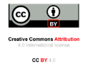
DOI: 10.36848/IJBAMR/2020/16215.55570

