**Original Article**

**Correlating upper cervical spine to craniofacial morphology in growing subjects with Class II and Class II div. 1 malocclusion: A cephalometric study**

**Dr. Uday Kumar Jain, Dr. Falguni Mehta, Dr. Renuka Patel, Dr. Harshik Parekh,**

**Dr. Purnima Bhave**

Name of the Institute/college: Government Dental College and Hospital, Ahmedabad

Corresponding author: Dr. Uday Kumar Jain

**ABSTRACT:**

Introduction: The development of spine and craniofacial structures are embryologically associated. Thus, there is close functional, morphological and developmental relationship between stomatognathic system and vertebral column.

Aim and Objectives: the study was carried to correlate the morphology of ‘Atlas’ vertebrae to craniofacial morphology in growing subjects with Class I and Class II Div 1 malocclusion. The objectives are (1) To study the differences in posterior cranial fossa morphology and to analyse the differences in the Atlas morphology between Class I and Class II Div 1. (2) To find the gender differences if exists for the various parameters (3) To associate dimensions of Atlas to various craniofacial patterns.

Materials and method: the data for the present study was selected according to specified inclusion and exclusion criteria from the pretreatment cephalometric radiographs of growing subjects (CVMI Stage 3). The cephalograms were divided into Skeletal Class I and Class II Div 1 based on ANB angle and Overjet. The radiographs were digitalised and Atlas dimensions, craniofacial morphology & posterior cranial fossa were assessed.

Results: significant differences were found in parameter of posterior cranial fossa, in overall skeletal parameters, dental parameters. Also, significant correlations were observed between Atlas parameters and craniofacial parameters for both the groups.

Conclusion: Dimensions of posterior cranial fossa were greater in Class II Div 1 patients. There was no statistically significant variation in the cervical vertebrae dimensions between Class I and Class II patients. Significant correlations were found between Atlas dimension to cranial morphology and facial morphology for both Class I and Class II Div 1 subjects

Keywords: Craniofacial morphology, Atlas morphology, Malocclusion

**INTRODUCTION:**

Spinal column is the portion of axial skeleton. It comprises of 7 cervical, 12 thoracic, 5 lumbar, the sacrum and the coccyx vertebrae. Embryologically, development of spine and growth of craniofacial structures are associated to each other1. The cause of such association is hypothesised as development of the mesenchymal areas that might be on the same para-axial mesoderm as the maxilla or mandible2. Also, the posterior cranial fossa is shown to be the extension of the notochord in the early body axis from the spine to the Sella turcica3, which shows the developmental association between the vertebral column and the posterior part of the occipital bone. Thus, there is a close correlation of functional, morphological and developmental relationship between the stomatognathic system and vertebral column4.

Atlas, the first cervical vertebra, is the connecting element between the head and the vertebral column proper and forms the craniocervical junction5. Atlas is shown to be dimensionally associated with craniofacial morphology6, cranial base7, upper airway and occlusion. Morphological variations are observed in patients with syndromes (Treacher Collins, Pierre Robin, or hemifacial microsomia), cleft lip and/or palate8, hypophostemic rickets9, obstructive sleep apnoea10, in patients with malformed condyle11 and in children with enlarged adenoids12. It was also observed that position of Atlas and vertical dimension of posterior of Atlas is associated with sagittal jaw position and head posture6,13,14. Thus, it can be said that a relationship also exists between the anatomy of the dorsal arch and dentofacial build.

Many studies have been carried out to find the association between morphology of upper cervical spine and craniofacial morphology between the subjects with ethnic variation & with similar skeletal Classification15,16. Only fewer studies17–19, have been conducted to find the association of Atlas with different craniofacial patterns. Therefore, this study was carried out to find the correlation between upper cervical spine and craniofacial morphology among growing subjects with different anteroposterior jaw relationship i.e., Class I and Class II Div. 1 This study also aims to (1) study the differences in posterior cranial fossa morphology between the Class I and Class II Div. 1 group. (2) To analyse the differences in the Atlas morphology between Class I and Class II Div. 1 and (3) To associate dimensions of Atlas to various craniofacial patterns.

**MATERIALS AND METHOD:**

Present study was carried out in the Department of Orthodontics and Dentofacial Orthopaedics, Government Dental College & Hospital, Ahmedabad. It was approved by the Institutional Ethical Committee (IEC). For this study 120 growing subjects were chosen who visited Department of Orthodontics. They were classified into Class I and Class II Div. 1 based on Angle’s classification and CVMI stage III.

Inclusion criteria:

• No previous H/o orthodontic treatment.

• Lateral cephalogram with posterior cranial fossa seen on it.

• Before the pubertal growth spurt (CVMI stage 3).

Exclusion criteria:

• Patients with craniofacial syndromes and other general diseases.

• Class III malocclusion.

• Previous H/o facial injury.

• Patients who did not give consent.

Standardized cephalometric radiographs of these subjects, were taken in centric occlusion with lips relaxed and horizontally oriented Frankfort horizontal plane. These subjects were divided in skeletal Class I and Class II Div. 1 based on ANB angle (ss-n-sm) and overjet (Table 1).

All lateral cephalograms were taken with Vatech PHT 30LFO smart machine with a film to focus distance of 150 cm and a film to median plane distance of 15 cm and following parameters were digitally analysed (Figure 1).

Cranial fossa morphology:

Posterior Cranial Fossa dimensions were evaluated using the measurements (Table 2) as described by Caspersen et al.20 and Cranial Base Angle was measured as the angle between the N-S and the S-Ba lines (N-S-Ba).

Facial morphology:

For Sagittal dimensions: angles SNA, SNB, ANB, SNPg and ANPg. & for vertical dimensions: Nasal plane angle (NSL/NL), mandibular plane angle (NSL/ML), base plane angle (NL/ML) and LAFH (mm) were measured.

Mandibular morphology:

Was assessed using angle ML/MBL and gonial angle (ML/RL).

Dentoalveolar morphology:

was assessed using parameters Overjet, Overbite, pr-N-A (°), ILs/NL (°), IMPA (Ili/ML), chin angle (CL/ML), occlusal plane to nasal plane (OL/NL), occlusal plane to mandibular plane (OL/ML) and inter-incisal angle (ILs/Ili).

Atlas dimensions:

The dimensions of atlas were evaluated by using the various measurements given by Huggare J21 (Figure 2).

1. Anterior- Posterior dimension: distance between extreme anterior point on the anterior tubercle and extreme posterior point on the dorsal arch of atlas.
2. Height of dorsal arch.
3. Height of slimmest part of the posterior neural arch.

Statistical analysis:

The *independent sample t test* was used to do both intergroup comparison between Class and Class II Div. 1 subjects and for intragroup comparison & *Pearson’s correlation coefficient* was used to analyse the correlation between Atlas dimension to Cranial and facial morphology. Statistical analysis was performed using SPSS version 23.

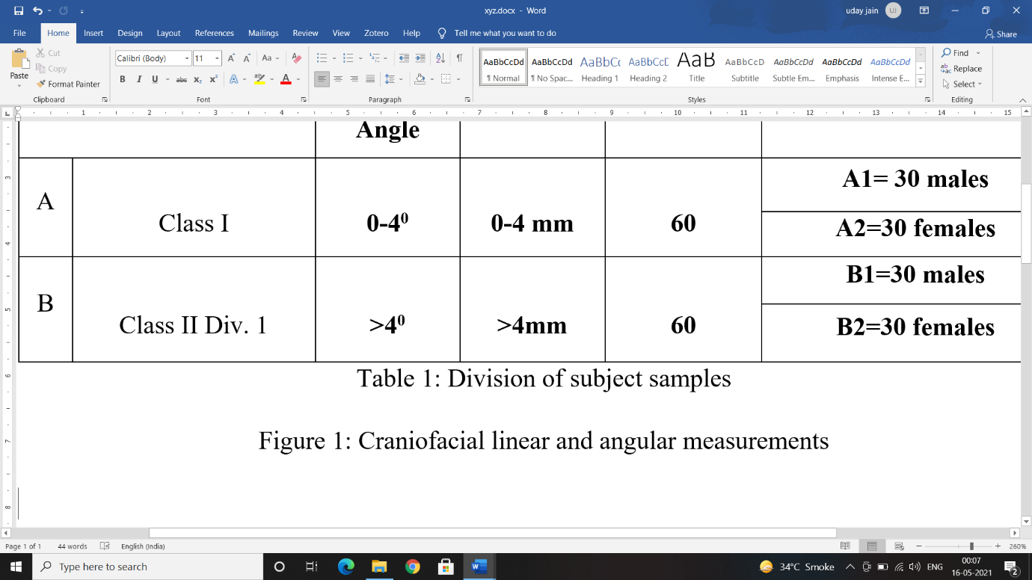

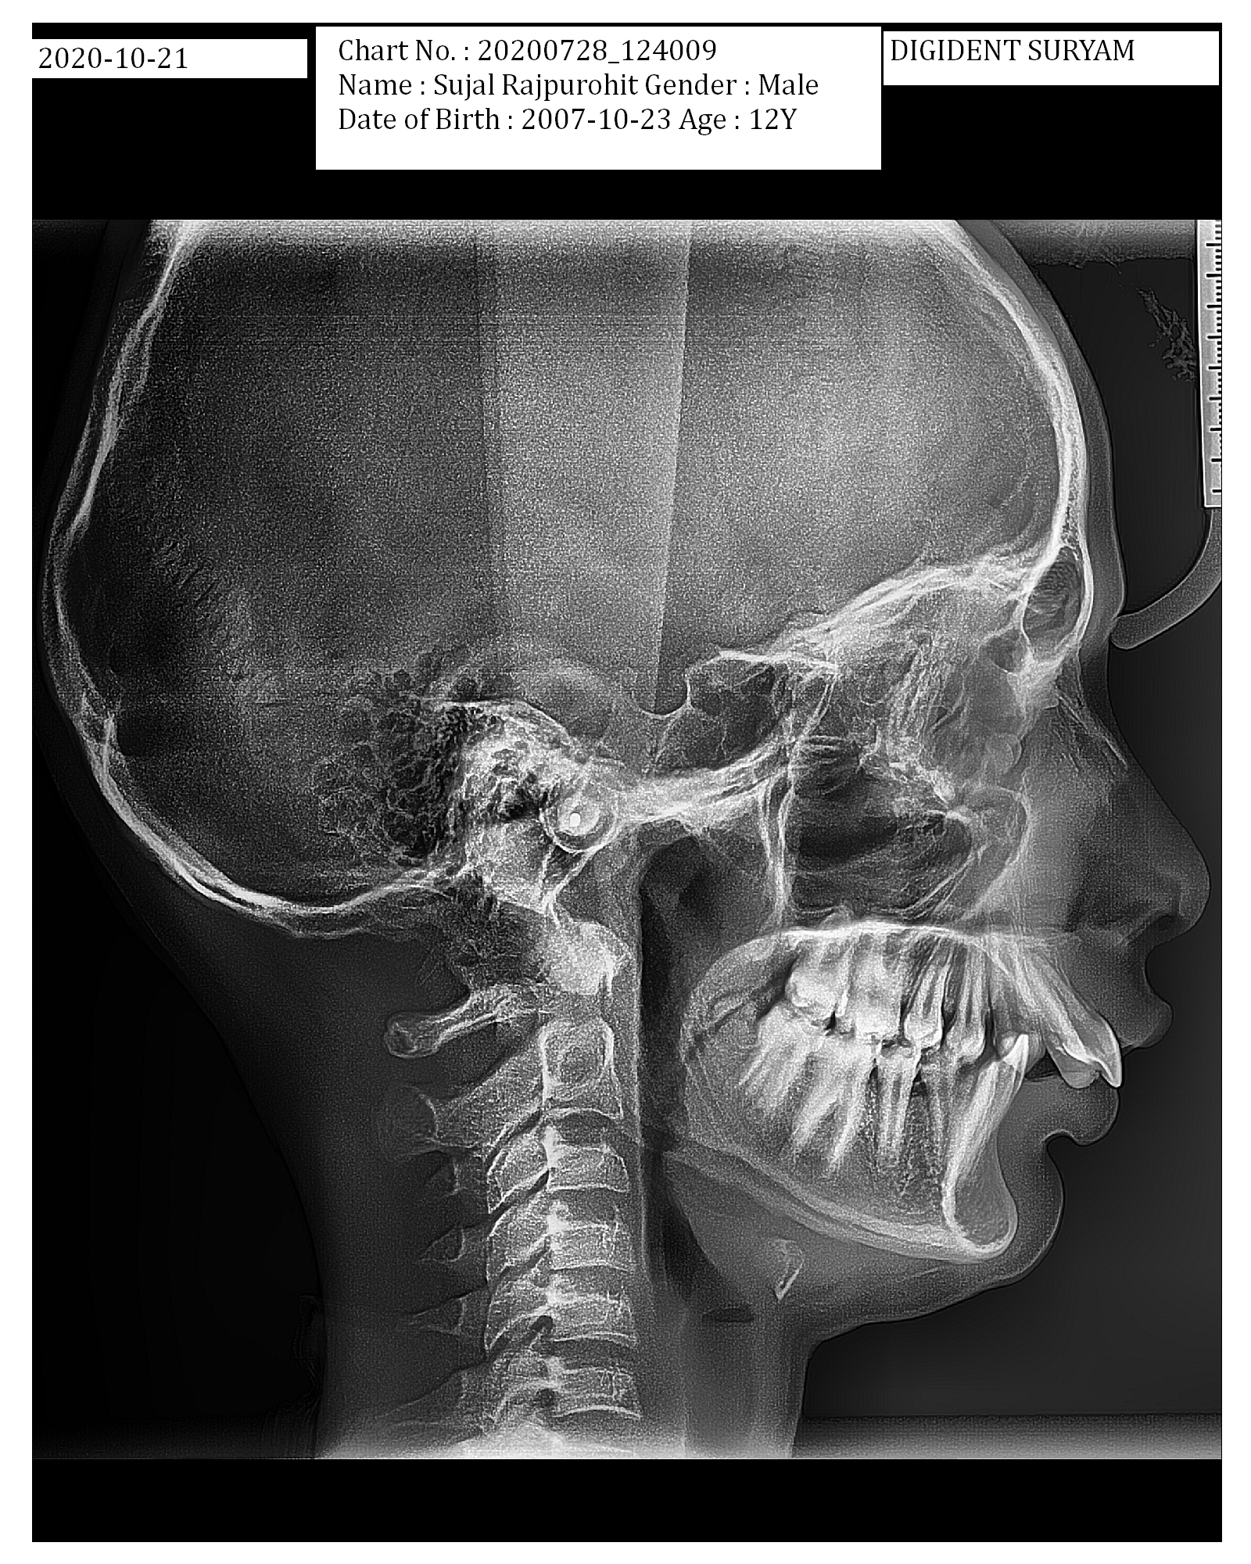

a

b

c

Figure 2: The dimensions of atlas

|  |  |  |  |  |  |
| --- | --- | --- | --- | --- | --- |
| **GROUP** | | **ANB Angle** | **Overjet** | **TOTAL** | **SUBGROUPS** |
| A | Class I | **0-40** | **0-4 mm** | **60** | **A1= 30 males** |
| **A2=30 females** |
| B | Class II Div. 1 | **>40** | **>4mm** | **60** | **B1=30 males** |
| **B2=30 females** |

Table 1: Division of subjects

|  |  |  |
| --- | --- | --- |
| S-d (mm) | the length from the Sella turcica to the deepest point in posterior cranial fossa. |  |
| S-iop (mm) | the length from the Sella turcica to the internal occipital protuberance. | length of posterior cranial fossa |
| d-p (mm) | the length from the deepest point in the posterior cranial fossa (d) perpendicular to S-iop (p). | the height of posterior cranial fossa |
| iop-S-d (°) | the angle between the S-d and the S-iop lines. | the depth of posterior cranial fossa |

Table 2: Posterior Cranial Fossa dimensions

|  |  |  |  |  |  |  |
| --- | --- | --- | --- | --- | --- | --- |
|  |  | Class I | | Class II Div 1 | |  |
| Parameter | N | Mean | SD | Mean | SD | P value |
| S-d (mm) | 60 | 68.62 | 5.11 | 71.46 | 4.43 | 0.035* |
| S-iop (mm) | 60 | 87.01 | 6.11 | 88.21 | 3.51 | 0.385 NS |
| d-p (mm) | 60 | 30.46 | 2.84 | 31.19 | 3.26 | 0.618 NS |
| Iop-S-d (°) | 60 | 27.80 | 3.40 | 28.61 | 3.87 | 0.221 NS |
| N-S-Ba (°) | 60 | 131.40 | 4.59 | 132.75 | 4.64 | 0.113 NS |

**- Highly significant (p<0.001), *-Significant (p<0.05), NS – Not significant (p>0.05)

Table 3: Overall Comparison posterior cranial fossa morphology

|  |  |  |  |  |  |  |
| --- | --- | --- | --- | --- | --- | --- |
|  |  | Class I | | Class II Div 1 | |  |
| Parameter | N | Mean | SD | Mean | SD | P value |
| SNA (°) | 60 | 81.79 | 3.24 | 81.39 | 3.62 | 0.529 NS |
| SNB (°) | 60 | 78.97 | 3.06 | 74.39 | 3.42 | <0.001** |
| ANB (°) | 60 | 2.80 | 0.92 | 7.00 | 1.56 | <0.001** |
| SNPg (°) | 60 | 79.01 | 3.54 | 75.36 | 3.31 | <0.001** |
| ANPg (°) | 60 | 2.82 | 2.62 | 5.87 | 2.53 | <0.001** |
| NSL/ML (°) | 60 | 30.71 | 5.30 | 31.98 | 5.66 | 0.206 NS |
| NL/ML (°) | 60 | 25.43 | 5.32 | 26.16 | 6.07 | 0.489 NS |
| NSL/NL (°) | 60 | 5.26 | 3.84 | 6.27 | 2.97 | 0.110 NS |
| LAFH (mm) | 60 | 59.25 | 5.82 | 58.14 | 5.52 | 0.286 NS |
| ML/MBL (°) | 60 | 25.11 | 1.21 | 26.07 | 1.38 | <0.001** |
| ML/RL (°) | 60 | 123.54 | 5.38 | 125.00 | 5.45 | 0.261NS |

**- Highly significant (p<0.001), *-Significant (p<0.05), NS – Not significant (p>0.05)

Table 4: Overall comparison of skeletal parameters

|  |  |  |  |  |  |  |
| --- | --- | --- | --- | --- | --- | --- |
|  |  | Class I | | Class II Div 1 | |  |
| Overjet (mm) | 60 | 3.98 | 2.06 | 7.17 | 2.15 | <0.001** |
| Overbite (mm) | 60 | 3.30 | 1.28 | 5.14 | 1.67 | <0.001** |
| pr-N-A (°) | 60 | 4.67 | 1.22 | 3.99 | 1.16 | 0.002* |
| ILs/ NL (°) | 60 | 119.92 | 7.54 | 120.81 | 7.40 | 0.059 NS |
| Ili/ ML (°) | 60 | 102.11 | 7.90 | 102.45 | 6.39 | 0.729 NS |
| CL/ML (°) | 60 | 77.65 | 5.26 | 78.80 | 5.96 | 0.261 NS |
| OLs/ NL (°) | 60 | 11.61 | 3.90 | 14.35 | 2.57 | 0.177 NS |
| Oli/ ML (°) | 60 | 13.71 | 4.00 | 14.03 | 5.27 | 0.707 NS |
| ILs/ Ili (°) | 60 | 114.35 | 6.54 | 112.49 | 9.34 | 0.403 NS |

**- Highly significant (p<0.001), *-Significant (p<0.05), NS – Not significant (p>0.05)

Table 5: Overall comparison of Dentoalveolar parameters.

|  |  |  |  |  |  |  |
| --- | --- | --- | --- | --- | --- | --- |
|  |  | Class I | | Class II Div 1 | |  |
| Parameter | N | mean | SD | mean | SD | P value |
| Antero-posterior (mm) | 60 | 40.20 | 7.19 | 39.17 | 2.69 | 0.300 NS |
| Dorsal arch ht. (mm)7 | 60 | 7.28 | 1.49 | 7.23 | 1.77 | 0.880 NS |
| Neural height at slimmest (mm)7 | 60 | 2.57 | 0.94 | 2.77 | 0.86 | 0.212 NS |

**- Highly significant (p<0.001), *-Significant (p<0.05), NS – Not significant (p>0.05)

Table 6: Overall comparison of Atlas parameters

| Parameter | Statistics | Antero-posterior (mm) | Dorsal arch ht. (mm) | Neural height at slimmest (mm) |
| --- | --- | --- | --- | --- |
| S-d (mm) | Pearson Correlation | .18 | **0.20\*** | .30 |
| P value | .36 | **.02** | .17 |
| S-iop (mm) | Pearson Correlation | -.25 | **-.35\*** | .369 |
| P value | .39 | **.03** | .204 |
| d-p (mm) | Pearson Correlation | .049 | .057 | .252 |
| P value | .71 | .665 | .052 |
| Iop-S-d (°) | Pearson Correlation | .07 | .099 | .050 |
| P value | .56 | .449 | .704 |
| N-S-Ba (°) | Pearson Correlation | **-.92\*** | **-.25\*** | -.020 |
| P value | **.02** | **.04** | .879 |
| SNA (°) | Pearson Correlation | -.06 | **-.26\*** | .062 |
| P value | .61 | **.04** | .636 |
| SNB (°) | Pearson Correlation | -.09 | **-.28\*** | .081 |
| P value | .49 | **.03** | .539 |
| ANB (°) | Pearson Correlation | -.056 | -.045 | -.027 |
| P value | .669 | .731 | .840 |
| SNPg (°) | Pearson Correlation | .052 | **-.14** | -.046 |
| P value | .692 | **.02** | .726 |
| ANPg (°) | Pearson Correlation | .006 | .148 | .120 |
| P value | .964 | .258 | .361 |
| NSL/ML (°) | Pearson Correlation | .005 | -.025 | -.004 |
| P value | .968 | .849 | .977 |
| NL/ML (°) | Pearson Correlation | -.097 | .007 | .003 |
| P value | .460 | .957 | .984 |
| NSL/NL (°) | Pearson Correlation | .142 | .045 | -.011 |
| P value | .278 | .733 | .931 |
| LAFH (mm) | Pearson Correlation | .134 | .189 | .205 |
| P value | .308 | .148 | .116 |
| ML/MBL (°) | Pearson Correlation | -.050 | -.051 | .132 |
| P value | .702 | .701 | .316 |
| ML/RL (°) | Pearson Correlation | -.018 | .143 | -.051 |
| P value | .894 | .275 | .698 |

**- Highly significant (p<0.001), *-Significant (p<0.05), NS – Not significant (p>0.05)

Table 7: Correlation of Atlas with posterior cranial morphology and facial parameters in Class I subjects.

| Parameter | Statistics | Antero-posterior (mm) | Dorsal arch ht. (mm) | Neural height at slimmest (mm) |
| --- | --- | --- | --- | --- |
| S-d (mm) | Pearson Correlation | **.14\*** | **.099\*** | **.007** |
| P value | **.01** | **.04** | **.04** |
| S-iop (mm) | Pearson Correlation | .222 | -.060 | .041 |
| P value | .089 | .64 | .754 |
| d-p (mm) | Pearson Correlation | **.181\*** | .099 | .159 |
| P value | **.01** | .454 | .224 |
| Iop-S-d (°) | Pearson Correlation | .036 | .107 | .095 |
| P value | .785 | .416 | .470 |
| N-S-Ba (°) | Pearson Correlation | **-.143** | **-.122\*** | .192 |
| P value | **.027** | **.019** | .141 |
| SNA (°) | Pearson Correlation | -.042 | .114 | -.187 |
| P value | .749 | .385 | .153 |
| SNB (°) | Pearson Correlation | **-.104\*** | .151 | -.102 |
| P value | **.024** | .74 | .439 |
| ANB (°) | Pearson Correlation | **-.490\*** | -.03* | -.210 |
| P value | **.04** | .06 | .107 |
| SNPg (°) | Pearson Correlation | .042 | -.118 | -.011 |
| P value | .07 | .066 | .936 |
| ANPg (°) | Pearson Correlation | -.149 | .072 | -.223 |
| P value | .256 | .587 | .087 |
| NSL/ML (°) | Pearson Correlation | **.163\*** | -.035 | -.114 |
| P value | **.02** | .789 | .386 |
| NL/ML (°) | Pearson Correlation | -.184* | **-.012\*** | -.151 |
| P value | .13 | **.009** | .248 |
| NSL/NL (°) | Pearson Correlation | **.386\*** | -.177 | .037 |
| P value | **.01** | .177 | .778 |
| LAFH (mm) | Pearson Correlation | **.119\*** | .020 | -.112 |
| P value | **.03** | .881 | .392 |
| ML/MBL (°) | Pearson Correlation | .251 | .203 | .138 |
| P value | .054 | .119 | .293 |
| ML/RL (°) | Pearson Correlation | -.141 | -.194 | -.092 |
| P value | .283 | .137 | .484 |

**- Highly significant (p<0.001), *-Significant (p<0.05), NS – Not significant (p>0.05)

Table 8: Correlation of Atlas with posterior cranial morphology and facial parameters in Class II Div. 1 subjects.

**RESULTS & DISCUSSION:**

In overall comparison between the groups the Posterior cranial fossa parameters i.e. S-d, S-Iop, d-p, Iop-S-d and N-S-Ba shows the larger values for Class II Div. 1 subjects. However, only S-d showed a statistically significant higher value (p < 0.05*) (Table 3). Caspersen et al20 carried out similar study in skulls with normo occlusion in Danish population and observed S-d was 66.1± 4.4mm and S-iop 89.1 ±3.5mm. The depth of posterior cranial fossa (Iop-S-d) in Class II Div. 1 group subjects was found to be more than in Class I group subjects but was statistically non- significant. Cranial base angle (N-S-Ba) in Class II Div. 1 group subjects was larger than Class I group subjects. Sonnesen et al22 and Kasai et al23 also observed the same.

On comparing skeletal parameters (Table 4) no significant difference was found in SNA. SNB was smaller in Class II Div. 2 subjects which was highly significant (p< 0.001**). These findings were in accordance with the previous studies22,24–31 which suggested that Class II skeletal pattern was due to retruded mandible rather than due to protruded maxilla. This was further confirmed by highly significantly (p< 0.001**) smaller SNPg i.e. retruded chin position. Various studies22,27,29,32–34 also observed the same. These studies also supported the findings of the present study of highly significant (p< 0.001**) larger ANB and ANPg in Class II Div. 1 subjects. Bjork’s mandibular base angle (ML/MBL) was also found to be statistically highly significant (p< 0.001**) larger in Class II Div. 1 which was supported by Sonnesen et al23. Mandibular angle, mandibular base angle, nasal plane angle and gonial angle was larger in Class II Div. 1 subjects than in Class I subjects but difference was not significant. This was supported by other studies22–24,28,29,31–33,35–37.

Table 5 shows that overjet and overbite was highly significantly (p <0.001**) larger in Class II than in Class I. These findings were supported by the various studies22,25,26,30,31,35,38,39. Maxillary alveolus was found to be significantly more protruded in Class I subjects, which was also found in study by Haavikko et al.33, it may be due to inclusion of more bimaxillary protrusion subjects in Class I group. The maxillary incisor proclination, IMPA, interincisal angle and chin angle were found to be non-significantly different in Class I and Class II subjects. These findings were supported by Sonnesen et al22 and others23,35,36,40–42. This also suggested the inclusion bimaxillary protrusion cases. Which was in contrast to the studies by Prakash et al24, which suggested significantly more maxillary protrusion in Class I subjects; many studies26,27,31,36,40,43 observed IMPA to be significantly more in Class II & Haavikko et al33 observed chin angle to be significantly more in Class II subjects.

Overall comparison of Atlas (Table 6) shown that anterior -posterior length and dorsal arch height was more in Class I subjects as compared to Class II subjects but was non-significant. This was found in association with the study by Arslan et al.19 However, Nambiar et al.18 observed it to be more in Class II but was non-significant. Neural height at slimmest part of Atlas was non-significantly more in Class II subjects.

Various parameters of posterior cranial fossa and total cranial fossa (N-S-Ba) shows no significant difference between males and female subjects which indicates that no gender discrimination exists in posterior cranial fossa dimensions (Table 7). This is in accordance of Gjorup et al.9, Obaidi et al.44 and Axelsson et al.45 who observed a non-significant difference between males and females in posterior cranial base parameters.

When intragroup comparison i.e. male and female, was made in Class I and Class II Div. 1 groups (Table 8 & Table 9). No statistically significant difference is observed in various skeletal & dental parameters. These findings are in accordance with the most studies22,27,30,31,34–37,43,46–48 conducted. Whereas, Uzuner et al30 observed SN/ML to be significantly greater in females than in male for both Class I and Class II subjects and LAFH to be significantly more in males as compared to females for both Class I and Class II Div. 1 subjects. Also, Gasgoos et al.27 observed that LAFH is significantly more in males as compared to females in Class II Div. 1 subjects. Study conducted by Saltaji et al.46 observed ILs/NL to be significantly more in male than in females for Class I subjects.

For Class I subjects the mean value of antero-posterior dimension and dorsal arch height of Atlas in male subjects was found to be larger than female group subjects and the difference between them is statistically significant (p <0.05*). These findings are in accordance with study conducted by Arslan et al who observed the same (Table 10). In Class II Div. 1 subjects (Table 10) the mean values for antero-posterior dimension, dorsal arch height and neural height at slimmest of Atlas in males and females, the difference between them was statistically non-significant. These findings are in accordance with study conducted by Arslan et al.19 who observed a non-significant difference.

Posterior cranial fossa length showed significant difference when Class I and Class II Div 1 subjects were compared. However, no significant difference was observed in various Atlas parameters between them. No sexual dimorphism was also observed. Pearson’s correlation test was done to correlate craniofacial morphology to dimensions of ‘Atlas.’

On correlating Atlas dimension to cranial morphology and facial morphology in Class I subjects (Table 11). The statistically significant correlation was found for s-d, s-iop, N-S-Ba, SNA, SNB & SNPg. S-d, had a weakly positive correlation with the dorsal arch height of Atlas (s-d: r= 0.20; p= 0.02*). This was observed in studies by Gjorup et al.9 and Sandikcioglu et al.49, which showed weakly positive correlation (s-d: co= 0.16; p= 0.009*; co= 0.30; p< 0.01*), S-iop had a moderately negative correlation with the dorsal arch height of Atlas (s-iop: r= -0.35; p= 0.03*).. Cranial base angle (N-S-Ba) had a strongly negative correlation with the anterior- posterior length of Atlas (N-S-Ba: r= -0.92; p= 0.02*) & weakly negative correlation with the dorsal arch height of Atlas (N-S-Ba: r= -0.25; p= 0.04*). Gjorup et al9 also observed that N-S-Ba had a weakly negative correlation with antero-posterior length of the Atlas and also with dorsal arch length of Atlas (N-S-Ba: length A-P, co= -0.14, p= 0.008*, dorsal arch height, co= -0.06, p= 0.017*).

SNA and SNB has a weakly negative correlation with the dorsal arch height of Atlas (SNA:r= -0.26; p= 0.04* & SNB: r= -0.26; p= 0.03*). The significant finding was supported by Nambiar et al18, who obtained a moderately negative correlation of SNA and SNB with dorsal arch length of Atlas (SNA: r= -0.619, p< 0.01*) (SNB: r= -0.547, p< 0.05*). SNPg has a weakly negative correlation with the dorsal arch height of Atlas (SNPg: r= -0.14; p= 0.02*). Huggare et al50 observed a moderately negative correlation of SNPg with dorsal arch height of Atlas in both boys and girls (SNPg: boys r= -0.54; girls r=-0.62, p<0.01).

Correlating Atlas dimension to posterior cranial morphology and facial morphology in Class II Div 1 subject significant correlation was observed for s-d, d-p, N-S-Ba, SNB, ANB, SNPg, SN/ML, NL/ML & LAFH (Table 12).

s-d and d-p, has a weakly positive correlation with the anterior-posterior length of the Atlas (s-d: r=0.14; p= 0.01*) (d-p: r= 0.181, p= 0.01), with dorsal arch height of Atlas (s-d: r=0.09; p= 0.04*) and with posterior neural arch height (s-d: r= 0.007, p= 0.04). Cranial base angle (N-S-Ba) has a weakly negative correlation with the anterior- posterior length of Atlas (N-S-Ba: r= -0.143; p= 0.027*) & dorsal arch height of Atlas (N-S-Ba: r= -0.122; p= 0.019*) The study by Oh et al15 also observed s-d and d-p to be weakly positive correlated with the anterior-posterior length of the Atlas (s-d: co= 0.108; p< 0.01**) (d-p: co= 0.211; p< 0.01**), with dorsal height of Atlas (s-d: co= 0.057; p< 0.5*) and with posterior neural arch height (s-d: co= 0.026, p< 0.05*) and weakly negative correlation of N-S-Ba with antero-posterior dimension and with dorsal arch height of Atlas (N-S-Ba: co= -0.131; p< 0.01**) (N-S-Ba: co= -0.034; p< 0.05*).

SNB and SNPg has a weakly positive correlation & ANB has a moderately negative correlation with the antero-posterior dimension of Atlas (SNB: r= 0.151; p= 0.024*) (SNPg: r=0.042, p=0.007*) (ANB: r= -0.490; p= 0.04*). Oh et al15 observed a significant correlation with antero-posterior length of Atlas which was weakly positive (SNB: co= 0.196, p< 0.05*) (SNPg: co= 0.252, p< 0.001***) and highly negative for ANB (ANB: co= -0.712, p< 0.0001****). Whereas, study conducted by Nambiar et al18 observed a non-significant correlation between SNB and antero- posterior dimension of Atlas.

SN/ML, SN/NL and LAFH had a weakly positive correlation with the anterior-posterior dimension of Atlas (SN/ML: r=0.163, p=0.02*) (SN/NL: r=0.386, p=0.01*) (LAFH: r=0.119, p=0.03*). Nambiar et al18 also observed a moderately positive with antero-posterior dimension of Atlas (SN/ML: r= 0.466, p< 0.01**) (SN/ML: r= 0.389, p< 0.05) and Oh et al15 observed a weakly positive correlation of LAFH (LAFH: co= 0.115, p< 0.05*).

**CONCLUSION:**

Cervical spine, posterior cranial fossa and facial structures are shown to embryologically associated. Functionally, Cervical spine connects the head with the rest of vertebrae and provides the movement of head in all planes. The present study concluded that

* Dimensions of posterior cranial fossa was found to be greater in Class II Div 1 subjects than in Class I subjects. However, the difference was non-significant. Only distance from the Sella to most inferior point in the posterior cranial fossa is significantly more in Class II Div 1.
* Class II Div 1 was found to be due to retruded mandible rather than that of prognathic maxilla. And has significantly more overbite than that of Class I subjects.
* There was no sexual dimorphism found in both groups. Only, Males in Class I group of Subjects had significantly increased anteroposterior dimension and dorsal arch height of Atlas whereas Class II Div 1 group subjects did not show significant variation in dimensions of Atlas.
* For Class II Div 1 subjects Antero-posterior length of Atlas is negatively correlated with skeletal parameters such as SNB and ANB suggesting that with increase in length of Atlas, mandible may be positioned posteriorly.
* Larger sample size and samples with variable growth status may be more conclusive.

**REFERENCES:**

1. Kjær I. Neuro-Osteology. Critical Reviews in Oral Biology & Medicine. 1998 Apr;9(2):224–44.

2. Noden DM, Trainor PA. Relations and interactions between cranial mesoderm and neural crest populations. J Anat. 2005 Nov;207(5):575–601.

3. Kjær I. Sella turcica morphology and the pituitary gland—a new contribution to craniofacial diagnostics based on histology and neuroradiology. European Journal of Orthodontics. 2015 Feb 1;37(1):28–36.

4. Cuccia A, Caradonna C. The Relationship Between the Stomatognathic System and Body Posture. Clinics (Sao Paulo). 2009 Jan;64(1):61–6.

5. Farman AG, Nortjé CJ, Joubert JJ. Radiographic profile of the first cervical vertebra. J Anat. 1979 May;128(Pt 3):595–600.

6. Huggare J, Houghton P. Associations between atlantoaxial and craniomandibular anatomy. Growth Dev Aging. 1996;60(1):21–30.

7. Solow B, Tallgren A. Head posture and craniofacial morphology. Am J Phys Anthropol. 1976 May;44(3):417–35.

8. Sandham A. Cervical Vertebral Anomalies in Cleft Lip and Palate. The Cleft Palate Journal. 1986 Jul 1;23(3):206–14.

9. Gjorup H, Sonnesen L, Beck-Nielsen SS, Haubek D. Upper spine morphology in hypophosphatemic rickets and healthy controls: a radiographic study. The European Journal of Orthodontics. 2014 Apr 1;36(2):217–25.

10. Sonnesen L, Jensen K, Petersson A, Petri N, Berg S, Svanholt P. Cervical vertebral column morphology in patients with obstructive sleep apnoea assessed using lateral cephalograms and cone beam CT. A comparative study. Dentomaxillofac Radiol [Internet]. 2013 Jun [cited 2020 Jul 8];42(6). Available from: https://www.ncbi.nlm.nih.gov/pmc/articles/PMC3667528/

11. Sonnesen L. Temporomandibular disorders in relation to craniofacial dimensions, head posture and bite force in children selected for orthodontic treatment. The European Journal of Orthodontics. 2001 Apr 1;23(2):179–92.

12. Huggare J, Kyl markula S. Morphology of the first cervical vertebra in children with enlarged adenoids. The European Journal of Orthodontics. 1985 May 1;7(2):93–6.

13. Huggare J. The first cervical vertebra as an indicator of mandibular growth. European Journal of Orthodontics. 1989 Feb;11(1):10–6.

14. Huggare J. Population differences in the morphology of the first cervical vertebra. Am J Phys Anthropol. 1992 Jun;88(2):197–201.

15. Oh E, Ahn S-J, Sonnesen L. Ethnic differences in craniofacial and upper spine morphology in children with skeletal Class II malocclusion. The Angle Orthodontist. 2018 May 1;88(3):283–91.

16. Oh E, Ahn S-J, Sonnesen L. Ethnic differences in craniofacial and upper spine morphology between European and Asian children with skeletal Class III malocclusion. Am J Orthod Dentofacial Orthop. 2019 Oct;156(4):502–11.

17. Baydas B. An investigation of cervicovertebral morphology in different sagittal skeletal growth patterns. The European Journal of Orthodontics. 2004 Feb 1;26(1):43–9.

18. Nambiar S, Mogra S, Nair BU, Menon A, Babu CS. Morphometric analysis of cervical vertebrae morphology and correlation of cervical vertebrae morphometry, cervical spine inclination and cranial base angle to craniofacial morphology and stature in an adult skeletal class I and class II population. Contemp Clin Dent. 2014;5(4):456–60.

19. Gündüz Arslan S, Dildeş N, Devecioglu Kama J. Cephalometric Investigation of First Cervical Vertebrae Morphology and Hyoid Position in Young Adults with Different Sagittal Skeletal Patterns [Internet]. Vol. 2014, The Scientific World Journal. Hindawi; 2014 [cited 2020 Dec 13]. p. e159784. Available from: https://www.hindawi.com/journals/tswj/2014/159784/

20. Caspersen L, Kjaer I, Sonnesen L. How does occipitalization influence the dimensions of the cranium?: Occipitalization and cranial dimensions. Orthodontics & Craniofacial Research. 2010 Jul 6;13(3):162–8.

21. Huggare J. Association between morphology of the first cervical vertebra, head posture, and craniofacial structures. The European Journal of Orthodontics. 1991 Dec 1;13(6):435–40.

22. Sonnesen L, Kjær I. Anomalies of the cervical vertebrae in patients with skeletal Class II malocclusion and horizontal maxillary overjet. American Journal of Orthodontics and Dentofacial Orthopedics. 2008 Feb;133(2):188.e15-188.e20.

23. Kasai K, Moro T, Kanazawa E, Iwasawa T. Relationship between cranial base and maxillofacial morphology. Eur J Orthod. 1995 Oct;17(5):403–10.

24. Prakash AT, Shetty KS, Sudhakar P. Dental and Skeletal Characteristics of Individuals with Normal, Class II and Class III Occulsions - A Cephalometric Evaluation using Tetragon Analysis. J Indian Orthod Soc. 2010 Dec 1;44(4):63–71.

25. Baccetti T, Franchi L, McNamara JA, Tollaro I. Early dentofacial features of Class II malocclusion: a longitudinal study from the deciduous through the mixed dentition. Am J Orthod Dentofacial Orthop. 1997 May;111(5):502–9.

26. Celar A, fredenthaler J. The denture frame analysis: an additional diagnostic tool. European Journal of Orthodontics. 1998;20:579–87.

27. Gasgoos S, Al-Saleem N, Awni K. Cephalometric features of skeletal Class I, II and III (A comparative study). RDENTJ. 2007 Jun 1;7(2):122–30.

28. Jacob HB, Buschang PH. Mandibular growth comparisons of Class I and Class II division 1 skeletofacial patterns. The Angle Orthodontist. 2014 Feb 13;84(5):755–61.

29. Karlsen AT. Craniofacial characteristics in children with Angle Class II div. 2 malocclusion combined with extreme deep bite. The Angle Orthodontist. 1994 Apr 1;64(2):123–30.

30. Uzuner FD, Aslan BI, Dinçer M. Dentoskeletal morphology in adults with Class I, Class II Division 1, or Class II Division 2 malocclusion with increased overbite. American Journal of Orthodontics and Dentofacial Orthopedics. 2019 Aug 1;156(2):248-256.e2.

31. Lee Y-J, Park J-T, Cha J-Y. Perioral soft tissue evaluation of skeletal Class II Division 1: A lateral cephalometric study. Am J Orthod Dentofacial Orthop. 2015 Sep;148(3):405–13.

32. Ngan PW, Byczek E, Scheick J. Longitudinal evaluation of growth changes in Class II division 1 subjects. Semin Orthod. 1997 Dec;3(4):222–31.

33. Haavikko K, Rahkamo A. Age and skeletal type-related changes of some cephalometric parameters in Finnish girls. Eur J Orthod. 1989 Aug;11(3):283–9.

34. Pancherz H, Zieber K, Hoyer B. Cephalometric characteristics of Class II division 1 and Class II division 2 malocclusions: a comparative study in children. Angle Orthod. 1997;67(2):111–20.

35. Baccetti T, Stahl F, McNamara JA. Dentofacial growth changes in subjects with untreated Class II malocclusion from late puberty through young adulthood. Am J Orthod Dentofacial Orthop. 2009 Feb;135(2):148–54.

36. Al-Khateeb EAA, Al-Khateeb SN. Anteroposterior and vertical components of class II division 1 and division 2 malocclusion. Angle Orthod. 2009 Sep;79(5):859–66.

37. Tanaka EM, Sato S. Longitudinal alteration of the occlusal plane and development of different dentoskeletal frames during growth. American Journal of Orthodontics and Dentofacial Orthopedics. 2008 Nov;134(5):602.e1-602.e11.

38. Hitchcock HP. A cephalometric description of Class II, Division 1 malocclusion. Am J Orthod. 1973 Apr;63(4):414–23.

39. Jabbar A, Mahmood A. Correlation of overjet, ANB and wits appraisal for assessment of sagittal skeletal relationship. :7.

40. Fushima K, Kitamura Y, Mita H, Sato S, Suzuki Y, Kim YH. Significance of the cant of the posterior occlusal plane in class II division 1 malocclusions. Eur J Orthod. 1996 Feb;18(1):27–40.

41. Sukhia R, Bashir M, Ghandhi D. SKELETAL CLASS 1 & 2 MALOCCLUSION EVALUATION IN JMDC ORTHODONTIC PATIENTS. :6.

42. Hassan AH. Cephalometric characteristics of Class II division 1 malocclusion in a Saudi population living in the western region. The Saudi Dental Journal. 2011 Jan 1;23(1):23–7.

43. Comparative evaluation of perioral soft tissue of skeletal normal Class I and Class II Division 1 subjects: A lateral cephalometric study Khatri JM, Sanap NB - Int J Orthod Rehabil [Internet]. [cited 2020 Dec 19]. Available from: https://www.orthodrehab.org/article.asp?issn=2349-5243;year=2020;volume=11;issue=1;spage=1;epage=8;aulast=Khatri

44. Obaidi H. Variation of facial heights among the Class I, II and III dentoskeletal relationships (Cephalometric study). RDENTJ. 2006 Jun 1;6(2):98–105.

45. Axelsson S. Longitudinal cephalometric standards for the neurocranium in Norwegians from 6 to 21 years of age. The European Journal of Orthodontics. 2003 Apr 1;25(2):185–98.

46. Saltaji H, Flores-Mir C, Major PW, Youssef M. The relationship between vertical facial morphology and overjet in untreated Class II subjects. The Angle Orthodontist. 2011 Sep 14;82(3):432–40.

47. Alhammadi M-S. Dentoalveolar compensation in different anterioposterior and vertical skeletal malocclusions. J Clin Exp Dent. 2019 Aug 1;11(8):e745–53.

48. Maskey S, Shrestha R. Cephalometric Approach to Vertical Facial Height. Orthodontic Journal of Nepal. 2019 Sep 20;9(1):54–8.

49. Sandikcioglu M, Skov S, Solow B. Atlas morphology in relation to craniofacial morphology and head posture. The European Journal of Orthodontics. 1994 Apr 1;16(2):96–103.

50. V. Huggare JA, Michael S. C. Head posture and cervicovertebral anatomy as mandibular growth predictors. The European Journal of Orthodontics. 1994 Jun 1;16(3):175–80.

Date of Publishing: 05 September 2021

Author Declaration: Source of support: Nil, Conflict of interest: Nil

Ethics Committee Approval obtained for this study?  YES

Was informed consent obtained from the subjects involved in the study?  YES

For any images presented appropriate consent has been obtained from the subjects: NA

Plagiarism Checked: Urkund Software

Author work published under a Creative Commons Attribution 4.0 International License

