Letter to Editor
A cross-sectional study to analyze the etiological profiles of interstitial lung disease at a tertiary care hospital
A.Varghese¹, *N. Mittal²

¹Department of General Medicine, Sree Narayana Institute Of Medical Sciences, Chalakka, Kochi, Kerala , India,
²Department Of Pulmonary Medicine, Christian Medical College Ludhiana.
Corresponding author*

ABSTRACT:
Background: Interstitial lung disease (ILD) is a group of disorders that are characterized by inflammation and fibrosis of the space between the epithelial and endothelial basement membranes. There is no gold standard investigation, and management is based on an accurate and specific diagnosis. HRCT has emerged as an invaluable investigative tool.
Aim – To study the etiological profile of ILD and add to the literature on the pattern, determinants, distribution and response of treatment of ILD in India.
Materials and methods - A cross sectional study was conducted in the Department of Medicine at a tertiary level healthcare in North India over a period of 18 months. Patients presenting to OPD and admitted in Medicine wards and specialties with a diagnosis of ILD on HRCT were included. Radiological features were studied in detail with the help of radiologist. Patients diagnosed as a case of ILD on HRCT would undergo clinical assessment, relevant investigations to find out underlying disease. Diagnosis of different diseases was made with the help of diagnostic criteria for that particular disease. In the analysis, continuous variables were expressed as a mean, and categorical variables were expressed as percentages. Univariate and multivariate analysis were performed as required.
Results - Majority of the patients, were in the 50-70 age group. A Large proportion (59.6%) were diagnosed to have Idiopathic Interstitial Pneumonia (IIP). The predominant pattern on HRCT was usual interstitial pneumonia (UIP). Of IIP cases, few were ANA positive, but a large proportion had elevated ESR, CRP which could be an indicator of latent autoimmune disease.
Conclusion – Even though many ILD cases were associated with Connective Tissue Disease, many IIP cases were also found to have indicators of possible latent autoimmunity. ILD could be the first manifestation of an autoimmune disease.
Keywords: Non-Specific Interstitial Pneumonia, Usual Interstitial Pneumonia, Comparison, India, Autoimmune.

Dear Editor,
Interstitial lung disease (ILD) are a group of disorders that are characterized by a varying combination of inflammation and fibrosis involving the space between the epithelial and endothelial basement membranes.^{1,2} These disorders share common radiologic, pathologic, and clinical manifestations. A gold standard in detection and diagnosis of ILD does not exist as different cases can have different presentations and different histological findings. They mimic diseases such as pulmonary edema, infection, and neoplastic disease. Therefore, a multidisciplinary approach is needed.³ Though the clinician has a greater role to play as clinical findings correlate more to diagnosis; ILD is a disease that would ideally require the clinician, radiologist, and pathologist to work together to establish a diagnosis.⁴
Management of patients with ILD is dependent upon establishing an accurate and specific diagnosis and needs extensive evaluation, as treatment is diagnosis-specific.³ In patients for whom the diagnosis is uncertain after clinical examination, biochemical investigation and chest radiography, HRCT has emerged as an invaluable tool for the assessment of patients with ILD.⁵ Various common findings of ILD in a HRCT are enumerated in table 4. Causative factors of ILD vary from place to place. ⁶ In published Indian literature, connective tissue disorder (CTD) associated ILD, hypersensitivity pneumonitis and sarcoidosis are present in significant proportions. However, data from Indian studies remains sparse. Hence, there is great potential to add to the literature on the pattern, determinants, distribution and response of treatment of ILD in India.⁷

Materials and methods
  - Settings and design and Study population
A cross sectional study was conducted in the Department of Medicine at a tertiary level healthcare setup in North India over a period of 18 months from January 2016 to August 2017.
Patients presenting to OPD and admitted in Medicine wards and medicine specialties with a diagnosis of ILD on HRCT were included. HRCT was performed on a Philips Ingenuity 128 Slice CT Scanner. 2mm slices were taken with window level -600 and window width of 1600. Radiological features were studied in detail with the help of radiologist.
The participants in the study gave informed consent, approval for the study was obtained from the ethics committee of Christian Medical College , Ludhiana.
  - Algorithm of the study
Any patient diagnosed as a case of ILD on HRCT would undergo clinical assessment, relevant investigations to delineate underlying disease and information was then recorded on structured case reporting form. Diagnosis of different diseases as enumerated in Table 1 were made with the help of diagnostic/classification criteria for that particular disease. In cases of doubt about etiology, experts in the field were consulted.
  - Statistical analysis
In the descriptive analysis, continuous variables were expressed as a mean, and categorical variables were expressed as count (percentages). Univariate and multivariate analysis were performed as required.

Results and Discussion
The total number of patients included were 57.
  - Demographic profile
Majority of the patients, 57.63% (30 of 57) were in the 50-70 age group. Average age in years was found to be 58 for ILD, Female to male ratio was 14:5. In the study conducted by Moua et al, the mean age was 67.5 whereas in the study conducted by Rajkumar et al, mean age for male participants was 44 years. ^{8,9} In comparison, the study conducted by Moua et al, 66% was male and 34% was female whereas in another study by Rajkumar et al, 45.32% were males and 54.68% were females.^{8,9}

  - Etiology of ILD
Thirty-four (59.6%) were diagnosed to have Idiopathic Interstitial Pneumonia (IIP), which is similar to the study by Rajkumar et al where 55% of patients studied were IIP. ⁹ However, this number is much more than the ILD India registry where only 25.8% were IIP.⁷
A total of 16 patients (28%) of all ILDs had CTD. Rheumatoid arthritis was the most common CTD associated with ILD with 7 out of 16 patients (43.7%). Second most common CTD was systemic sclerosis (31.2%). A total of 16 patients (28%) of all ILDs in our study had CTD which is similar to the number reported by Kundu et al study (31.5%) but higher than the number reported by ILD India registry (13.9%). ^{7,10}
  - Symptoms and physical signs
In present study the most common symptoms noted were cough followed by breathlessness.
Symptoms and physical signs have been detailed in table 2 and 3 respectively.
  - HRCT findings and patterns
Etiology wise HRCT findings have been listed in table 4. A comparison of the prevalence of different HRCT patterns has been illustrated in figure 2. In the 57 patients, the predominant pattern on HRCT was usual interstitial pneumonia (UIP) , seen in 30/57 patients (52.6%). In comparison , In the study conducted by Lee et al, among 154 patients, 101 had UIP and 53 had fibrotic NSIP.¹¹ Out of 16 patients of CTD ILD, 10 (62.5%) had a UIP pattern, 4 (25%) had non-specific interstitial pneumonia (NSIP) pattern. Autoimmune diseases (CTD excluding RA) which were a total of 9 patients, 6 (66.6%) had the UIP pattern and 3 (33.3%) had NSIP pattern. In comparison, a study conducted by Bouros et al showed NSIP being much more prevalent in systemic sclerosis associated ILD(66/80 patients).¹² This is a peculiar finding that was present in our study where despite most of the autoimmune disease patients having systemic sclerosis, UIP was the predominant pattern in autoimmune diseases.
  - Laboratory findings
Out of 33 patients with IIP, 7 were found to have ANA positive. It has been demonstrated that in certain patients of CTD, ILD may be the first presentation. ANA may come positive even years before the actual symptoms of the disease are unmasked.¹³ This plays an important role as it can help in predicting the onset of CTD in advance.
According to Lee et al, 26% patients of IIP were found to be ANA positive.¹⁴ Fischer et al reported ANA positivity 34% patients. ¹⁵
Out of 57 cases, 96.8% of them had elevated ESR, CRP was positive for 78.3% which could be an indicator of latent CTD.
ECHO was done for 12 patients and 5 of them had a RVSP more than 40mmHg which signifies the presence of pulmonary artery hypertension and a poor prognosis. The mean RVSP observed by Moua et al was 56.8mmHg.⁸
Strengths of this study include a fair representation of various etiologies and a detailed analysis of HRCT findings. Limitations of the study include fewer number of patients evaluated in the present study were less, the prognosis and mortality could not be assessed because this was not a follow up study and lung biopsy could not be done for patients who were evaluated.

Table 1: Etiology-wise distribution of the study participants

Etiology | Number (n) | Percentage (%)
Idiopathic Interstitial  Pneumonia (IPF+UIP+NSIP) | 34 | 58.93
Hypersensitivity Pneumonitis | 5 | 8.93
Systemic Sclerosis | 5 | 8.93
Rheumatoid Arthritis | 7 | 12.5
Overlap Syndromes | 2 | 3.57
Sjogrens | 1 | 1.79
SLE | 1 | 1.79
Sarcoidosis | 1 | 1.79
Polymyositis | 0 | 0
Lymphangiomyomatosis | 0 | 0
Pulmonary Alveolar  Proteinosis | 0 | 0
Pulmonary Histiocytosis | 0 | 0
Eosinophilic Pulmonary  Diseases | 1 | 1.79
Idiopathic Pulmonary  Haemosiderosis | 0 | 0
Drug Induced ILD | 0 | 0
Wegeners Granumatosis | 0 | 0
Total | 57 | 100

Table 2: Symptoms observed in different etiologies of ILD

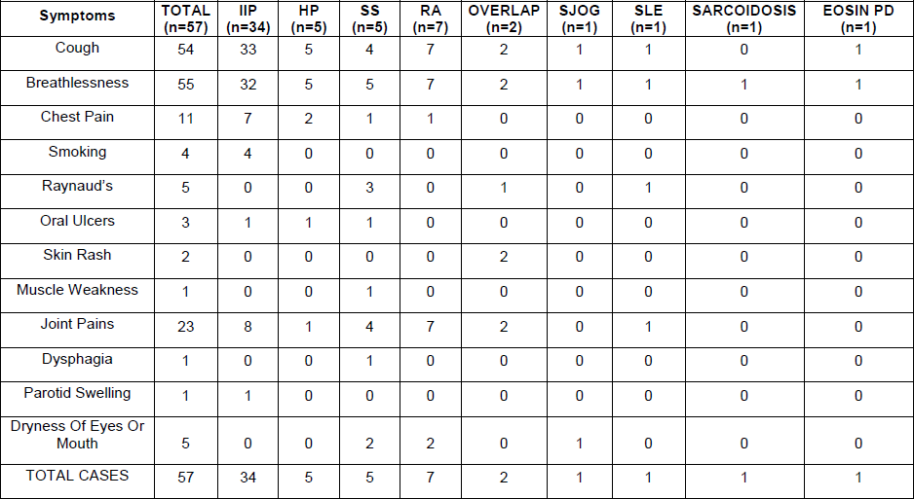

Table 3: Physical signs observed in different etiologies of ILD
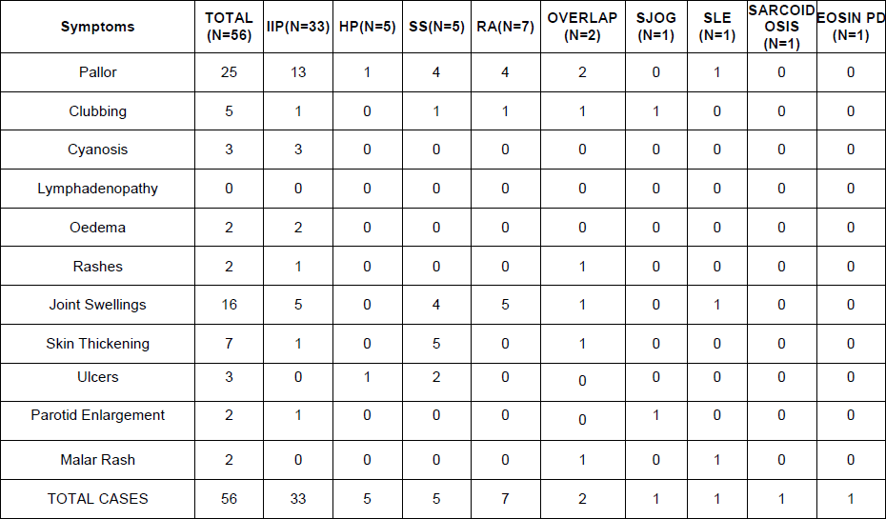

Table 4: HRCT findings in different etiologies of ILD
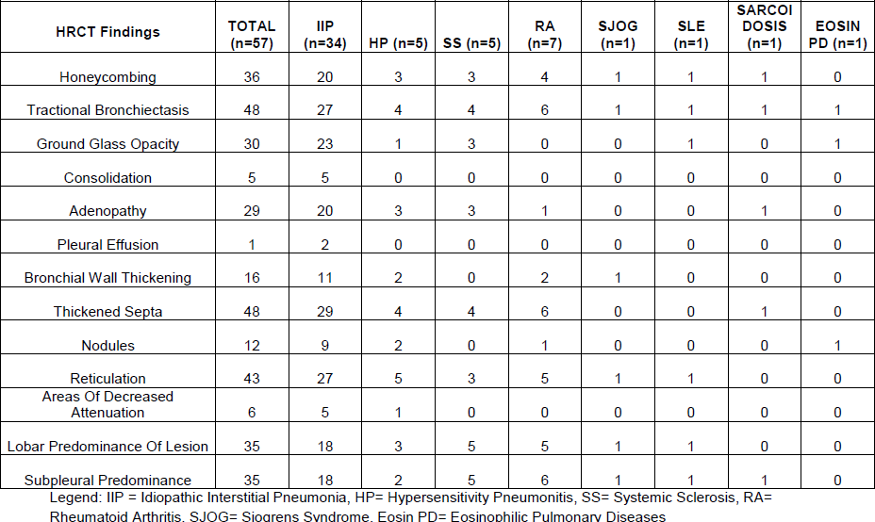

Figure 1: Prevalence of different HRCT patterns of [a] Interstitial Lung Disease (ILD) (n=57) [b] Idiopathic Interstitial Pneumonitis (IIP) (n=34) [c] ILD in Connective Tissue Disorders (CTD) (n=16)
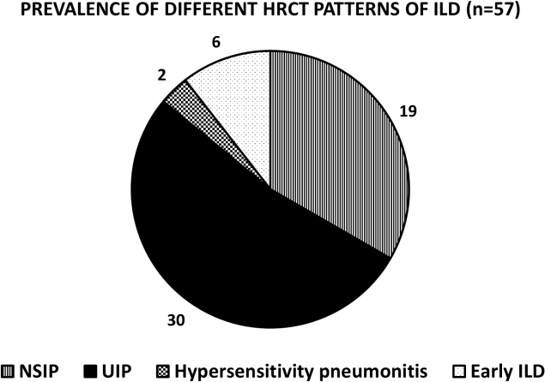

[a]

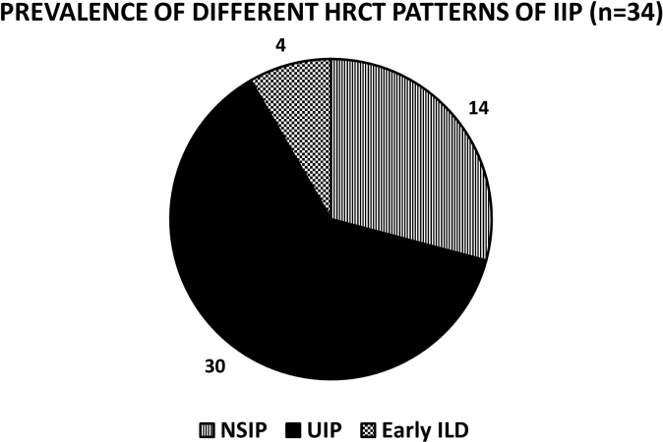

[b]

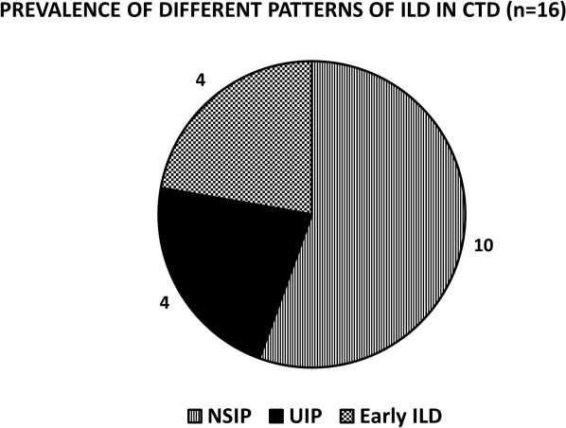

[c]

Acknowledgements: The authors would like to thank all the study participants.

References

1. Deconinck B, Verschakelen J, Coolen J, Verbeken E, Verleden G, Wuyts W. Diagnostic workup for diffuse parenchymal lung disease: schematic flowchart, literature review, and pitfalls. Lung. 2013 Feb;191(1):19–25.
2. Martinez FJ, Flaherty K. Pulmonary function testing in idiopathic interstitial pneumonias. Proc Am Thorac Soc. 2006 Jun;3(4):315–21.
3. Bourke SJ. Interstitial lung disease: progress and problems. Postgrad Med J. 2006 Aug;82(970):494–9.
4. Flaherty KR, King TE, Raghu G, Lynch JP, Colby TV, Travis WD, et al. Idiopathic interstitial pneumonia: what is the effect of a multidisciplinary approach to diagnosis? Am J Respir Crit Care Med. 2004 Oct 15;170(8):904–10.
5. Troy L, Corte T. Interstitial lung disease in 2015: where are we now? Aust Fam Physician. 2015 Aug;44(8):546–52.
6. Demedts M, Wells AU, Antó JM, Costabel U, Hubbard R, Cullinan P, et al. Interstitial lung diseases: an epidemiological overview. Eur Respir J Suppl. 2001 Sep;32:2s–16s.
7. Singh S, Collins BF, Sharma BB, Joshi JM, Talwar D, Katiyar S, et al. Interstitial Lung Disease in India. Results of a Prospective Registry. Am J Respir Crit Care Med. 2017 15;195(6):801–13.
8. Moua T, Westerly BD, Dulohery MM, Daniels CE, Ryu JH, Lim KG. Patients With Fibrotic Interstitial Lung Disease Hospitalized for Acute Respiratory Worsening: A Large Cohort Analysis. Chest. 2016;149(5):1205–14.
9. Kumar R, Gupta N, Goel N. Spectrum of interstitial lung disease at a tertiary care centre in India. Pneumonol Alergol Pol. 2014;82(3):218–26.
10. Kundu S, Mitra S, Ganguly J, Mukherjee S, Ray S, Mitra R. Spectrum of diffuse parenchymal lung diseases with special reference to idiopathic pulmonary fibrosis and connective tissue disease: An eastern India experience. Lung India. 2014 Oct 1;31(4):354.
11. Lee HY, Lee KS, Jeong YJ, Hwang JH, Kim HJ, Chung MP, et al. High-resolution CT findings in fibrotic idiopathic interstitial pneumonias with little honeycombing: serial changes and prognostic implications. AJR Am J Roentgenol. 2012 Nov;199(5):982–9.
12. Bouros D, Wells AU, Nicholson AG, Colby TV, Polychronopoulos V, Pantelidis P, et al. Histopathologic subsets of fibrosing alveolitis in patients with systemic sclerosis and their relationship to outcome. Am J Respir Crit Care Med. 2002 Jun 15;165(12):1581–6.
13. Vij R, Strek ME. Diagnosis and treatment of connective tissue disease-associated interstitial lung disease. Chest. 2013 Mar;143(3):814–24.
14. Lee JS, Kim EJ, Lynch KL, Elicker B, Ryerson CJ, Katsumoto TR, et al. Prevalence and clinical significance of circulating autoantibodies in idiopathic pulmonary fibrosis. Respir Med. 2013 Feb;107(2):249–55.
15. Fischer A, Pfalzgraf FJ, Feghali-Bostwick CA, Wright TM, Curran-Everett D, West SG, et al. Anti-th/to-positivity in a cohort of patients with idiopathic pulmonary fibrosis. J Rheumatol. 2006 Aug;33(8):1600–5.

Date of Submission: 07 November 2020
Date of Publishing: 15 December 2020
Author Declaration: Source of support: Nil, Conflict of interest: Nil
Ethics Committee Approval obtained for this study? YES
Was informed consent obtained from the subjects involved in the study? YES
Plagiarism Checked: Urkund Software
Author work published under a Creative Commons Attribution 4.0 International License

DOI: 10.36848/IJBAMR/2020/16215.55770
www.ijbamr.com P ISSN: 2250-284X, E ISSN: 2250-2858 | 306

