Case Report:
Obstetric Anesthesia Management of Multigravida with Paroxysmal Supra-ventricular Tachycardia during Elective Caesarean Section
¹Dr Ishaa Pradhan , ²r Surekha S Chavan, ³Dr Payal Kankal , ⁴ Dr Stephan Jebaraj

¹Senior Resident Dept of Anesthesiology BJGMC & Sassoon General Hospitals Pune India
² Associate Professor, MD PGDGM, Dept of Anesthesiology BJGMC & Sassoon General Hospitals Pune India
^{3, 4} Senior Resident Dept of Anesthesiology BJGMC & Sassoon General Hospitals Pune India
Corresponding author: Dr Surekha S Chavan

ABSTRACT
Paroxysmal supraventricular tachycardia (PSVT) is the most common symptomatic arrhythmia during pregnancy. Pregnancy is a risk factor for PSVT. Obstetricians often find caesarean section as safest mode of delivery for female having PSVT. However this can predispose patients to arrhythmias due to the complex electrophysiological effect of anesthetics, particularly volatile agents. The safe management of pregnant patient with PSVT depends on the understanding of pathophysiology of PSVT and effects of anesthetic agents on cardiac electrophysiology. We describe the perioperative management of a patient with PSVT undergoing an elective caesarean section.
Key Words- Paroxysmal supraventricular tachycardia, obstetric anesthesia, caesarean section

INTRODUCTION
Paroxysmal supraventricular tachycardia (PSVT) is defined as any tachyarrhythmia with a heart rate more than 120 beats per minute requiring atrial or atrioventricular junctional tissue for its initiation and maintenance. PSVT refers to intermittent pathological tachycardia that includes atrial fibrillation and flutter as well as atrial tachycardia. Pregnancy is a risk factor for PSVT. The increase in risk of development of PSVT in pregnancy may be due to the hemodynamic, hormonal, autonomic and emotional changes. Anesthetic management is considered as a challenge in these patients as many anesthetic drugs and the physiological changes associated with administration of anesthesia may act as a trigger for inducing PSVT. Here, we have described perioperative management of a case of PSVT undergoing an elective caesarean section.
CASE REPORT
A 26 year old patient (gravida 3, para 1 with 1 abortion and 1 intrauterine death at 7 months of gestation) presented with complaints of shortness of breath and palpitations during her 37th week of pregnancy. She was a diagnosed case of PSVT since 2 years. She had experienced similar symptoms for first time during her first pregnancy which was treated with electrocardioversion, followed by normal vaginal delivery of intrauterine dead fetus. She reported one spontaneous abortion after this. Then she was diagnosed of PSVT after electrophysiological studies followed by radiofrequency ablation. Current pregnancy was diagnosed after 3 months gestation when she developed similar complaints necessitating ICU admission with treatment of tablet Amiodarone and tablet Bisoprolol.
Clinical examination revealed heart rate 124/minute and blood pressure 90/60 mmHg. Respiratory and Cardiovascular examination was normal. Preoperative investigations showed ECG suggestive of atrial tachycardia and echocardiography findings of global left ventricular hypokinesia with ejection fraction of 40% and dilated all cardiac chambers.
Elective caesarean section under general anaesthesia was planned to avoid any overt hemodynamic changes in presence of cardiac compromise. Anti-arrhythmic medications continued preoperatively. Consent for general anaesthesia recorded along with preoperative counseling. Intravenous access was secured and routine standard monitoring NIBP, spO2 and 12 lead ECG were attached. Catecholamine release associated with emotional, physical and pharmacological stresses increase the likelihood of arrhythmias. Hence, anti-arrhythmic drugs like adenosine, lignocaine, amiodarone and defibrillator were kept ready.
Premedication was done with injection Glycopyrollate 5 mcgs/kg intramuscularly to prevent tachycardia which occurs more with intravenous injection. Anti-aspiration prophylaxis was given. Opioids were avoided at induction to prevent fetal respiratory depression. Obtundation of laryngoscopy response was done with intravenous lignocaine 1.5mg/kg. Rapid Sequence Induction was done with titrated doses of Thiopentone 5mg/kg and Rocuronium 1mg/kg. Intubation was done by expert anesthetist in less than 15 seconds. Anesthesia was maintained with 100% oxygen, Sevoflurane and intermittent doses of Atracurium.
Judicious fluid administration was adopted to prevent fluid overload. Single episode of hypotension occurred post-induction which was successfully treated with single bolus dose of Phenylephrine (100 mcgs). After delivery of the baby, injection Furosemide 40mg was administered intravenously to prevent cardiac overload. A 5 unit bolus of oxytocin was given followed by a slow infusion of 15 unit oxytocin in 100 ml normal saline. 50 mcgs Fentanyl was given to decrease the catecholamine release associated with surgical stress. Shortly after this, a run of PSVT was noted on the ECG. Oxytocin infusion was discontinued and Valsalva maneuver was done which terminated the arrhythmia. Surgery was completed successfully with delivery of a healthy baby in 30 minutes with intraoperative 400ml blood loss. Anesthesia was reversed with neostigmine (0.05 mg/kg) and glycopyrrolate (10 mcgs/kg) and trachea extubated. Patient was observed in intensive care unit(ICU) for anticipated risk of PSVT and cardiac failure. Immediately in the postoperative period, patient started complaining of shortness of breath and palpitations with ECG suggestive of atrial tachycardia. She was started on Amiodarone infusion and Fentanyl transdermal patch for postoperative analgesia which led to the abolishment of the symptoms and arrhythmias. The patient was discharged on the 10th postoperative day with advice of cardiology follow-up.

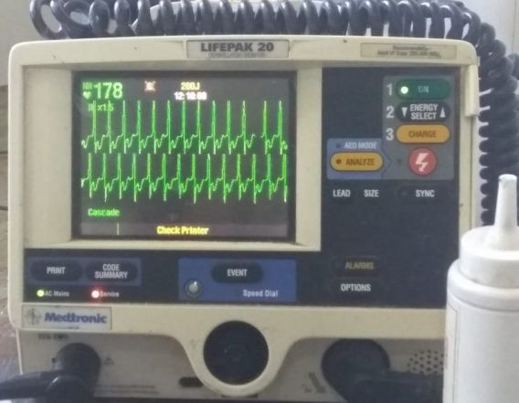  Intraoperative ECG | 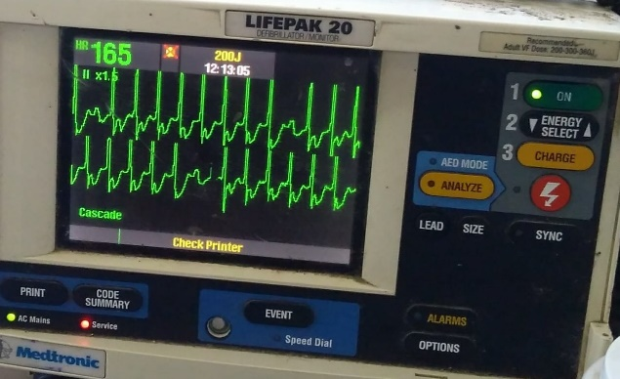  INTRAOPERATIVE ECG

DISCUSSION
The commonest arrhythmia in women of reproductive age is PSVT. The term paroxysmal refers to an arrhythmia that begins and ends abruptly. Atrioventricular nodal re-entry and Wolf-Parkinson-White syndrome account for the majority of SVT in this population, with an incidence of 1.2 per 1000 individuals¹.
Pregnancy has been considered a risk factor for PSVT. The increase in frequency of arrhythmias and in symptoms during pregnancy may be due to the associated hemodynamic, hormonal, autonomic and emotional changes. An expanded plasma volume may cause atrial stretch and a faster sinus heart rate may alter tissue excitability, causing a reentry circuit. It has been postulated that oestrogens may lead to cardiac excitability as they have this effect on uterine muscle. Also, oestrogens sensitize the myocardium to catecholamines by increasing the number of alpha-adrenergic receptors. Peripartum oxytocic, tocolytic and anesthetic drugs have also been suggested as triggers for inducing SVT².
Although PSVT is considered harmless, its association with maternal and fetal outcomes is unknown. Episodes of SVT occur during pregnancy particularly in the third trimester. Potential risk factor is any underlying congenital or structural heart disease. Patients present with palpitations, shortness of breath and syncope. PSVT is a cardiac emergency which causes hemodynamic compromise leading to fetal hypoxia. Hence, it is important to recognize and evaluate this condition preoperatively to avoid unfavorable fetal and maternal outcome.
Acute treatment of PSVT in pregnancy is similar to that of non-pregnant women. Several pharmacological and non-pharmacological treatments have been described. Valsalva maneuver and Carotid massage should be tried first to terminate the arrhythmia. When it fails, pharmacological treatment should be initiated. Adenosine is the first choice drug because of its rapid onset, high efficacy and short half life. Calcium channel blockers may cause hypotension which is more common with the use of Diltiazem than Verapamil. Synchronized electrical cardioversion may become necessary for PSVT that is resistant to pharmacological treatment or if the patient is haemodynamically unstable³. Close collaboration between the cardiologist, obstetrician and anesthesiologist is important in the perioperative period to develop strategies and care for the diagnosis and control of PSVT.
In addition to the arrhythmia, cardiovascular and functional status of the patient should be assessed as the patient may have other structural heart diseases. Anti-platelet agents and Anticoagulants use should be noted. Catheter ablation should be recommended in symptomatic women before they contemplate pregnancy. PSVT or arrhythmia lasting longer than 6 hours has been associated with heart failure⁴. Hence, considering the patient’s gestational age and findings on echocardiography, cesarean delivery under general anaesthesia was the best course of action for the mother and the baby.
Anesthetic management should focus on avoiding factors known to cause tachycardia and cardiac ectopy such as electrolyte imbalances and catecholamine release. Volatile agents reduce the incidence of perioperative arrhythmias because they increase the refractoriness of the accessory pathways. Also administering general anaesthesia avoids precipitous hypotension associated with spinal anaesthesia which may be difficult to correct in such patients with dilated cardiac chambers and moderately low ejection fraction. Sympathomimmetics which are frequently used to treat hypotension may initiate tachycardia. Tocolytics and oxytocin have been implicated to precipitate PSVT. Recommendations are that oxytocin should be given as bolus of 5 units maximum and administered slowly⁵.
There is a risk of post-operative arrhythmias in these patients due to pain or surgical stress. Early identification and administration of antiarrhythmic agents and analgesics is essential in order to avoid deterioration in cardiac function. Antiarrhythmics were administered vigilantly with continuous cardiac monitoring in ICU in our case.
CONCLUSION
Even though PSVT is the commonest arrhythmia in pregnancy, the mode of conduct of anaesthesia is critical for safe patient management.
Reported multigravida had past history of bad obstetric outcomes due to PSVT with one intrauterine death at 7 months and one spontaneous abortion, and in first pregnancy mother needed cardioversion and ICU admission for treatment of PSVT. Elective caesarean section was done under general anesthesia with safe fetomaternal outcomes. The episodes of intraoperative and perioperative hypotension and arrhythmias were managed vigilantly.

REFERENCES
1) K. Robins, G. Lyons, Supraventricular tachycardia in pregnancy, BJA: British Journal of Anaesthesia, Volume 92, Issue 1, January 2004, Pages 140–143
2) Agrawal R, Shintre H, Rani B. A rare case of supraventricular tachycardia during pregnancy and successful management in crisis situation with electrical cardioversion and radiofrequency ablation. J Obstet Gynaecol India. 2016; 66 (Suppl 2):594–597.
3) Kumare B.D, Kawathalkar A, Vijay N R Paroxysmal Supraventricular Tachycardia- A Complex Dilemma during Pregnancy. J South Asian Feder Obst Gynae 2015; 7(1):44-47.
4) Jones, R. M., Broadbent, M. P. and Adams, A. P. Anesthetic considerations in patients with paroxysmal supraventricular tachycardia. Anaesthesia.1984; 39: 307-313.
5) Kim KO, Chang EJ, Han J, Cho H. Emergency cesarean delivery in a parturient who had an intractable paroxysmal supraventricular tachycardia -A case report-. Korean J Anesthesiol 2012; 63(4):360–362.

Date of Submission: 21 September 2020
Date of Publishing: 05 December 2020
Author Declaration: Source of support: Nil, Conflict of interest: Nil
Ethics Committee Approval obtained for this study? NA
Was informed consent obtained from the subjects involved in the study? YES
For any images presented appropriate consent has been obtained from the subjects: NA
Plagiarism Checked: Urkund Software
Author work published under a Creative Commons Attribution 4.0 International License
DOI: 10.36848/IJBAMR/2020/16215.55550

