Case Report
A Case of Mesentric Fibromatosis Masquerading as Small Intestine GIST
Dr.Bellala Prithvi Raj, Prof Dr.Ramesh Reddy G , Dr.Tinnu George, Dr.Keerthi K

Department of General Surgery, Vydehi Institute of Medical Sciences and Research Centre, Bangalore, India-560066.
Corresponding author: Dr.Bellala Prithvi Raj

This work is licensed under a Creative Commons Attribution-NonCommercial 4.0 International License

Date of submission: 11 January 2023
Date of Final acceptance: 12 February 2023
Date of Publication: 15 March 2023
Source of support: Nil
Conflict of interest: Nil

Abstract:
Mesenteric fibromatosis, also known as desmoid tumor of mesentery is a rare benign soft tissue proliferative tumor having its origin in the mesenteric tissue. It is a locally aggressive tumor. Desmoid tumor accounted for 0.03% of all tumors, and less than 3% of all soft tissue tumors. Mesenteric fibromatosis accounts for about 8% of all cases of desmoid tumor. Though it lacks malignant potential, recurrences have been documented in the literature. It is important to differentiate mesenteric fibromatosis from GIST (gastrointestinal stromal tumor) as it is its closest differential on radiology as well as on histopathology. Misdiagnosis can lead to hazardous therapeutic management. Here we present an unusual case of mesenteric fibromatosis. A twenty five years old female presenting with abdominal distension and discomfort. CT suggestive of small intestinal tumor preoperatively suspected as GIST and Post-operatively histopathology reveals it to be Mesentric fibromatosis. IHC-proven histopathological diagnosis is mandatory for mesenteric fibromatosis as other closest differentials have a completely different surgical and therapeutic management. Usually, mesenteric fibromatosis is diagnosed as GIST on radiology and tissue diagnosis followed by IHC is mandatory.
Keywords: Desmoid tumour, GIST, Histopathology, IHC.
Keynotes: Mesenteric fibromatosis is usually misdiagnosed as GIST on radiology and tissue diagnosis followed by IHC is mandatory.

INTRODUCTION:
Mesenteric fibromatosis, also known as desmoid tumor is myofibroblastic proliferation of the mesentery. The fibromatosis comprises a broad group of myofibroblastic proliferations. It is classified into deep-seated and superficial, and the former is also called desmoid tumor ^{[1,2]}. The most occurring locations of desmoid tumor are the extremities, the abdominal wall, and intra-abdominal or mesenteric ^{[3]}.It was first described by John Macfarlane more than 150 years ago^{[4]}. Desmoid tumor accounted for 0.03% of all tumors, and less than 3% of all soft tissue tumors ^{[5]}. Mesenteric fibromatosis accounts for about 8% of all cases of desmoid tumor^{[5]}. Most reported cases have been in association with Gardner’s Syndrome, previous trauma and prolonged intake of estrogen^{[6]}, but mesenteric fibromatosis can occur as a primary condition in the absence of any predisposing condition. The tumor presents either due to its mass effect or due to obstruction of the surrounding structures, including ureters and small bowel.
CASE PRESENTATION:
A 25 year old female patient presented to the General Surgery OPD with complaints of abdominal distension and discomfort since 3 months. She was married and home maker by occupation, no history of previous surgical procedures and patient was not a known case Tuberculosis, Diabetes, Hypertension. There was no family history of malignancy. On radiological evaluation soft tissue lesion of small intestine was noted on ultrasonography of abdomen and pelvis. Patient underwent abdominal contrast enhanced CT scan and revealed 12x11x6 cm heterogeneous enhancing mass lesion in mesenteric in right lumbar region extending into right iliac fossa, the lesion was noted compressing the caecum and ascending colon and adherent to ileal loops. Findings are suggestive of neoplastic etiology – possibilities of mesenteric sarcoma/ GIST were considered and advised for tissue biopsy for confirmation. Patient underwent CT guided core biopsy which reported as Benign mesenchymal tumor of probable neural origin.
Patient underwent exploratory laparotomy. Intra-operatively surprisingly, there was soft tissue mass, spherical-shaped mass measuring approximately 15 × 12 × 8 cm arising from the mesentry and adherent to the ileum. A large segment of small intestine (20cm proximal to ileo-caecal junction) measuring approximately 40 cm was resected. There was no gross invasion into large intestine and other organs. Intraoperative period was uneventful and postoperatively patient was monitored, drain was removed on post-operative day 2 and discharged after 4 days, and the mesentric mass with small bowel segment specimen was sent to pathologist for histopathological examination.
On gross examination(Figure 1 &2) the intestinal segment measured approximately 40 cm in length, with a spherical-shaped gray tan to gray brown tumor measuring approximately 15 × 12 × 8 cm arising from the mesentry and adherent to the small intestine. The tumor was well circumscribed and the cut surface showed a solid-homogenous mass with whirling pattern without areas of hemorrhage or necrosis.

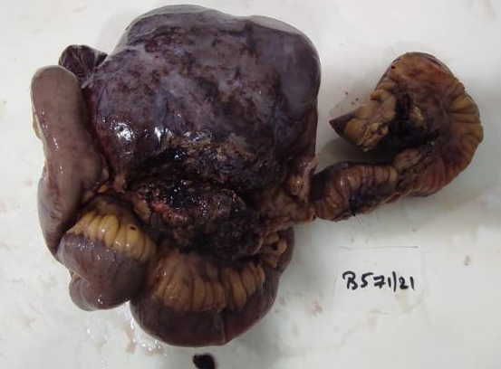
Figure 1: Gross Specimen
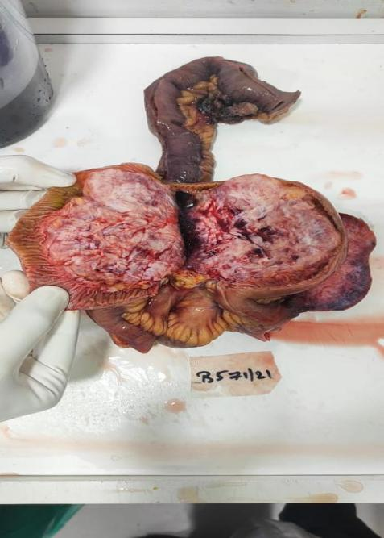
Figure 2: Cut section of the Gross Specimen.
On microscopy(Figure 3&4), the sections showed spindle cells to elongated cells arranged in fascicles and bundles, thin walled dialated blood vessels with focal perivascular microhaemorrhages and tentacular insinuation of tumor cells into muscularis propria of small intestine. Features suggestive of Spindle cell tumor, probably Mesentric fibromatosis and further confirmation was done by IHC.
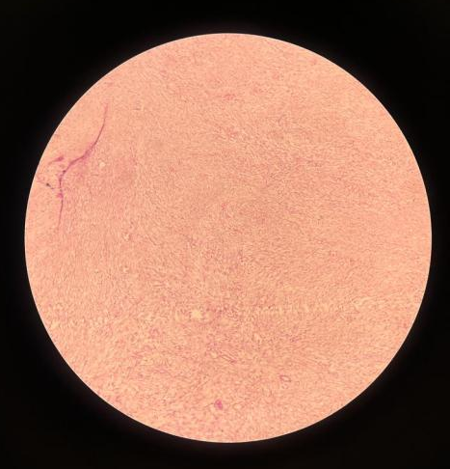
Figure 3:Fascicles of spindle cells
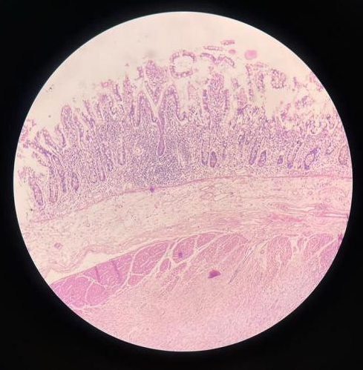
Figure 4:Infiltration of spindle cells into muscularis propria
For confirmation of diagnosis, IHC was performed which showed(Table 1)
IHC MARKERS | RESULTS
Vimentin | Positive
Nuclear beta catenin | Positive
SMA | Positive
MIB 1 labeling index | 2-5%
CD-117,  DOG-1,  CD-34 | Negative
Table :1 Showing IHC test reports
Patient was followed-up in our OPD after 3 months and patient was doing well and she was adviced for regular follow-up.
DISCUSSION:
Mesenteric fibromatosis is a benign tumor arising from the fibroblasts of mesentery. Its occurrence may be due to previous surgical trauma, handling of the intestine and also is often related to hormonal influence. Familial adenomatous polyposis (FAP) and Gardner syndrome, estrogen and pregnancy patients are often at risk of developing mesenteric fibromatosis ^{[7]}. It is the most common primary tumor of the mesentery, and these tumors may occur in all age groups, but they are usually peaking in the 3rd and 4th decades of life. It is more common in females than males ^{[8]}.
Both MRI and CT are effective methods for pre-operative diagnosis. However, when the lesion involves the stomach or the intestine, it may appear to originate from these sites, and thereby mimic primary gastrointestinal tumor (GIST). Generally mesenteric fibromatosis is easy to be confused with GIST. Large tumors can cause intestinal obstruction or can lead to mesenteric ischemia.
Treatment modality of mesenteric desmoids is surgical resection done in well circumscribed tumors and tumors which do not invade the root of mesentery. In spite of total resection and R0 margin of mesenteric fibromatosis, some researchers have suggested that the risk of local recurrence still remained, and ranged from 25 to 50% in most studies of complete surgical resections ^{[9]}. Usually Radiotherapy and Chemotherapy was noted to be futile in case of R0 resection but in cases of recurrence and R1 resection the above specifed is a modality of treatment. Doxorubicin is given in cases of recurrent tumors and tumors with genetic mutation. Further, radiotherapy is an optional choice for recurrent or advanced mesenteric fibromatosis. In addition, tyrosine kinase inhibitors such as Imatinib in treating locally advanced mesenteric fibromatosis showed a positive response in some of the cases ^{[10]} .
In some cases where surgery and radiotherapy are not rewarded because of guarded success, systemic therapy with pharmacological agents (antiproliferative and cytotoxic drugs) can be well considered, including estrogen receptor antagonist tamoxifen, nonsteroidal anti-inflammatory drugs agent sulindac and chemotherapy with dactinomycin, vincristine and cyclophosphamide, singly or in combination, with varying success ^{[11]}.
CONCLUSION:
Mesentric Fibromatosis is a rare condition with insidious growth and locally aggressive behavior. Complications such as bowel perforation, obstruction and compression symptoms are usually uncommon. Complete surgical resection is the first-line treatment but high recurrence rate remains dubious. Multidisciplinary care is always necessary. Mesenteric fibromatosis is usually misdiagnosed as GIST on radiology and tissue diagnosis followed by IHC is mandatory. IHC-proven histopathological diagnosis is mandatory for mesenteric fibromatosis as other closest differentials have a completely different surgical and therapeutic management.

REFERENCES
- Stout AP. Fibrosarcoma the malignant tumor of fibroblasts. Cancer 1948;1:30-63.
- Molnar PP. Enzinger and Weiss's Soft Tissue Tumors (ed 4). Hum Pathol 2002;32:1414.
- Lev D, Kotilingam D, Wei C, et al. Optimizing Treatment of Desmoid Tumors. J Clin Oncol 2007;25:1785.
- Macfarlane J. Clinical Reports on the Surgical Practice of the Glasgow Royal Infirmary. Glasgow: D. Robertson, 1832;63–6.
- Micke O, Seegenschmiedt MH. Radiation therapy for aggressive fibromatosis (desmoid tumors): results of a national Patterns of Care Study. Int J Radiat Oncol Biol Phys 2005;61:882-91.
- Karakousis CP, Berjian RA, Lopez R, Rao U. Mesenteric fibromatosis in Gardner’s syndrome. Arch Surg 1978; 113: 998-1000
- Gurbuz AK, Giardiello FM, Petersen GM, Krush AJ, Offerhaus GJ, Booker SV, Kerr MC, Hamilton SR (1994) Desmoid tumours in familial adenomatous polyposis. Gut 35:377–381
- Shields CJ, Winter DC, Kirwan WO, et al. Desmoid tumours. Eur J Surg Oncol 2001;27:701–6.
- Cruz RP, Guerra EE, Cambruzzi E, et al. Mesenteric fifibromatosis affecting duodenum and jejunum. Int J Colorectal Dis 2016;31:715.
- Chu Y, Guo Q, Wu D (2017) Mesenteric fibromatosis after resection for gastrointestinal stromal tumor of stomach. Medicine (Baltimore) 96(48):e8792
- Yantiss RK, Spiro IJ, Compton CC, Rosenberg AE. Gastrointestinal stromal tumor versus intra-abdominal fibromatosis of the bowel wall: a clinically important differential diagnosis. Am J Surg Pathol 2000; 24: 947-957

