Case Report
Rare case of metastasis to pancreas from uterine leiomyosarcoma
Jude Rodrigues¹, Bhagyashree Sukhthanker², Frazer Rodrigues³

¹MS General Surgery , Professor, Department of Surgery, Goa Medical College, Bambolim,Goa.
^{2, 3} MBBS , Junior Resident, Department of Surgery, Goa Medical College, Bambolim, Goa.
Name of Institute/College: Goa Medical College and Hospital
Corresponding author: Dr Bhagyashree Sukhthanker , Email id: sukhthankerbhagyashree@gmail.com

ABSTRACT:
Metastatic lesions of the pancreas are rare and form approximately 2% of pancreatic malignancies. Most common extra pancreatic tumors involving the pancreas are lung cancer, breast cancer, renal cell cancer and prostate cancer. Rarely metastasis from osteosarcoma, leiomyosarcoma, chondrosarcoma has been reported.
KEYWORDS: Uterine leiomyosarcoma, Metastasis to Pancreas.

CASE REPORT:
In this report, we describe a case of a 42 year old lady who presented to our tertiary care centre 4 years back with a uterine mass. After a negative metastatic workup and preoperative optimization, she underwent total abdominal hysterectomy with bilateral salpingo oophorectomy. Final histopathology report of the resected specimen confirmed it to be uterine leiomyosarcoma. She underwent 6 cycles of adjuvant chemotherapy. Metastatic workup at 1 year follow up revealed a metastatic nodule in upper lobe of right lung for which she underwent lobectomy followed by 6 cycles of adjuvant chemotherapy. Patient presented with bilateral pleural effusion at second year followup. Computed Tomography [CT] thorax revealed multiple metastatic nodules in both lungs with pleural effusion for which pleurodesis followed by 6 cycles of adjuvant chemotherapy was administered.
Patient presented again at 3 years post primary surgery with acute abdomen. CT scan of abdomen revealed mass in the head of pancreas invading the duodenum with enlarged peri pancreatic lymph nodes. Upper gastrointestinal scopy revealed an ulcero-proliferative growth infiltrating the duodenum, which was biopsied. Histopathology showed metastasis from uterine leiomyosarcoma. Best supportive care was given, however patient expired in a few days.

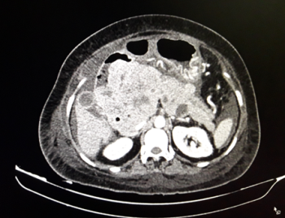
Image 1 : Computed Tomography picture showing pancreatic mass infiltrating the duodenum.
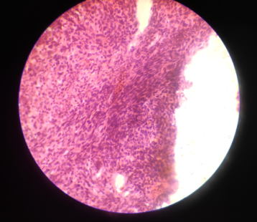
Image 2 : Histopathology picture of endoscopic biopsy of growth showing pattern similar to uterine leiomyosarcoma.

DISCUSSION:
Pancreatic metastasis accounts for around 2% of all pancreatic malignancies [1,3]. Common sites of primary being lung, kidney and gastrointestinal tract [8]. Primary sites of leiomyosarcoma includes the uterus, ovary, veins, spermatic cord, intestine, retroperitoneum and soft tissue [2]. Symptoms of pancreatic metastasis are nonspecific and include obstructive jaundice, pain and weight loss which are similar to the symptoms of primary pancreatic cancer [1,7]. Asymptomatic pancreatic metastasis is common and detected during routine follow up [1]. Majority of the patients have widespread disease and isolated metastasis to pancreas is rare [1]. Accurate preoperative staging must be done so as to avoid major surgery in patients with widespread disease. Ultrasound guided fine needle aspiration cytology is useful to establish correct diagnosis, especially in patients with widespread disease[2]. Surgical options include pancreaticoduodenectomy, distal pancreatectomy, segmental resection and in some cases total pancreatectomy depending on the location of the lesion in the pancreas [5]. Currently no established guidelines exist regarding appropriate management of such lesions. The presence of extra pancreatic disease together with pancreatic metastasis is not always a contraindication to resection, if it is technically possible [6].
CONCLUSION:
In patients who present with pancreatic malignancies it has to be kept in mind that secondaries from organs like lung, breast, kidney, prostate and rarely leiomyosarcoma from the uterus may be the primary.
Solitary metastasis in pancreas from uterine leiomyosarcoma can benefit from pancreatic surgery depending upon the site, wherein literature mentions prolonged survival.

REFERENCES:
1)Falconi M.,Crippa S.,Saegenti M.,Capelli P.,Pederzoli P.Pancreatic metastasis from leiomyosarcoma of the broad ligament of the uterus.Lancet Oncol.2006;7:94-95.
2)Koh Y.S.,Kim J.C.,Cho C.K.,Kim H.J.Pancreatic metastasis of leiomyosarcoma in the right thigh:a case report.World J Gastroenterology 2007;13(7):1135-1137.
3)You D.D.,Choi D.W.,Choi S.H.Surgical resection of metastasis to the pancreas.J Korean Surg Soc.2011;80:278-282.
4)Iwamoto I.,Fujino T.,Higashi Y.Metastasis of uterine leiomyosarcoma to the pancreas.J Obstet Gynaecol Res.2005;6:531-534
5)Gomez J.A.,Sanchez A.A.,Cecilia D.M.Uterine leiomyosarcoma metastasis to the pancreas:report of acase and review of the literature.J Gastrointest Cancer.212;43(2):361-363
6)Sperti C.,Pasquali C.,Liessi G.,Pinciroli L.,Decet G.,Pedrazzoli S.Pancreatic resection for metastatic tumors to the pancreas.J Surg Oncol.23;83:161-166
7)Deveaux P.G.,Aranha G.V.,Yong S.Leiomyosarcoma of the pancreas.HPB.2001;3(2):175-177

Date of Submission: 21 Aug 2020 Date of Publishing: 30 September 2020
Author Declaration: Source of support: Nil, Conflict of interest: Nil
Ethics Committee Approval obtained for this study? NA
Was informed consent obtained from the subjects involved in the study? YES
For any images presented appropriate consent has been obtained from the subjects: YES
Plagiarism Checked: YES
Author work published under a Creative Commons Attribution 4.0 International License

DOI: 10.36848/IJBAMR/2020/18215.56115

