Case Report:
UNUSUAL ACRAL PRESENTATION OF TUBERCULOSIS VERRUCOSA CUTIS
Dr Rishab Rampradeep*, Dr Prasanth G, Dr V Gangadharan

Department of Respiratory Medicine , Saveetha Medical College and Hospital, Chennai
Corresponding author*

Abstract:
Cutaneous lesions and manifestations of tuberculosis have been described long before Koch’s identification of the Mycobacterium. Tuberculosis verrucosa cutis refers to a paucibacillary form caused by an exogenous re-infection in sensitized individuals. Starting out as erythematous papules with surrounding purplish inflammatory halo, the lesion gradually evolves to an asymptomatic verrucous and scaly plaque, rarely ulcerating.
Histopathological examination usually reveals a thickened epidermis with small epitheloid granulomas amidst an infiltrate of lymphocytes and plasma cells in the upper and mid dermis, while characteristic foci of caseating necrosis are uncommon if not absent. We report one such case of histopathologically confirmed tuberculosis verrucosa cutis of the small toe, in a 23-year-old male with a strong contact history.
Keywords: Tuberculosis verrucosa cutis,cutaneous,tuberculosis,extrapulmonary

Introduction
Tuberculosis verrucosa cutis refers to a paucibacillary form caused by an exogenous re-infection in sensitized individuals with a moderate to high degree of slowly evolving cell-mediated immunity (1,2)
It may result from direct inoculation of the micro-organism into the skin of a previously sensitized person with a moderate to high degree of immunity by accidental exposure from an extraneous source, auto-inoculation from sputum in patient with active pulmonary tuberculosis or following an injury.(1)
Also called warty tuberculosis, the lesion is characterized by a verrucous plaque like appearance. Lesions are mostly solitary, painless and usually located in anatomical areas that are prone to traumas, such as fingers and toes(3,4,5,6)
We report a case of Tuberculosis verrucosa cutis of a 23-year old male whose diagnosis was confirmed by typical histopathological findings of biopsy specimens.
Case Report:
A 23-year old male with no comorbidities presented with a 3-month history of slowly enlarging papular, warty growth over his left 5th toe. The lesion began as a small pinkish red papule over the left 5th toe following a trivial injury and gradually progressed to attain its current state, eventually ulcerating. The patient complained of a vague discomfort and numbness over the region but gave no history of any pain or discharge associated with the growth. Patient’s neighbor, who he was in close contact with, as well as the neighbor’s father had both been diagnosed with tuberculosis and had completed treatment for the same. Patient was a non-smoker had no other significant personal or family history.
The lesion over the 3 months was managed conservatively with topical ointments obtained from local clinics and pharmacies, as well as home remedies but showed no evidence of regression.
Local examination of the lesion showed an irregular papular ulceroproliferative growth involving the base of left 5th toe circumferentially measuring approximately 4x2cm(Figure 1) Regional lymph nodes were not palpable. Auscultation of the chest revealed no abnormal findings. Remainder of the physical examination was unremarkable. A bacillus Calmette-Guerin vaccination scar was identified on the left deltoid. Routine blood investigations were done and found to be within normal limits.
Purified protein derivative test done was found to be strongly positive (22mm induration with excoriation and ulceration after 72 hours) (Figure 2)
Chest Xray done showed no evidence of pulmonary disease.
Biopsy was taken from the lesion and sent for histopathological examination as well as for MTB CBNAAT.
Xray of the left foot revealed no evidence of underlying bone involvement.
On Ziehl-Neelsen staining acid fast bacilli could not be found.
Cartridge Based Nucleic Acid Amplification Test(CBNAAT) performed at a private lab did not detect the presence of the mycobacterium.
Histopathological examination revealed hyperplastic and acanthotic stratified squamous epithelium with parakeratosis. There was focal pseudoepitheliomatous hyperplasia, microabsesses and occasional clusters of epethelioid histiocytes with multinucleated giant cells in the subdermal region; highly suggestive of Tuberculosis verrucosa cutis. (Figure 3)
Patient was consequently started on oral antituberculous therapy (ATT) (Fixed Dose Combination of Isoniazid,Rifampicin,Pyrazinamide and Ethambutol) 4 tabs/day and reviewed monthly. Serial evaluation showed gradual improvement.
The patient completed 8 months of ATT with complete resolution of the lesion, at the end of the regimen. (Figure 4)

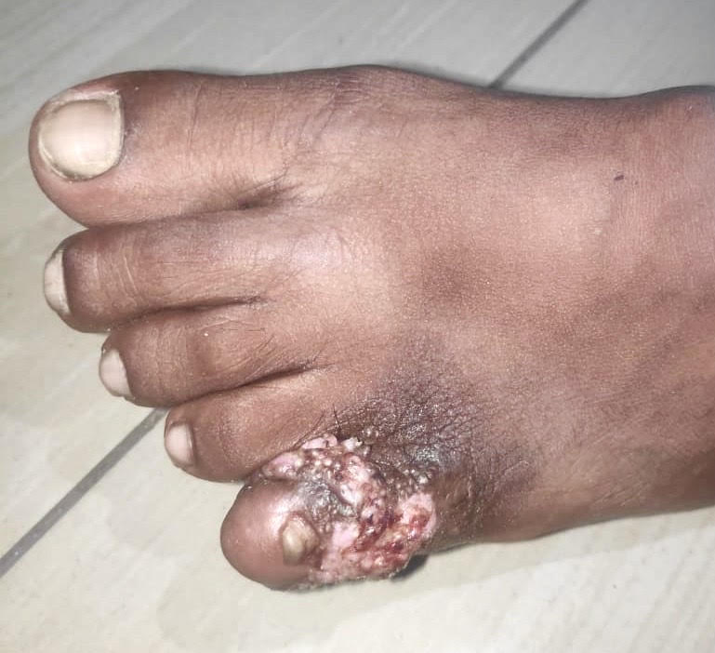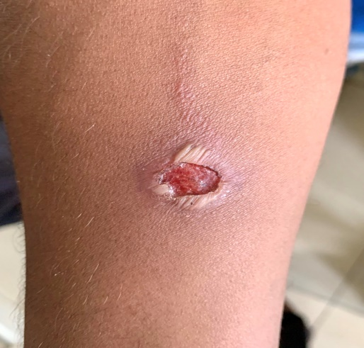

Figure 1 Figure 2

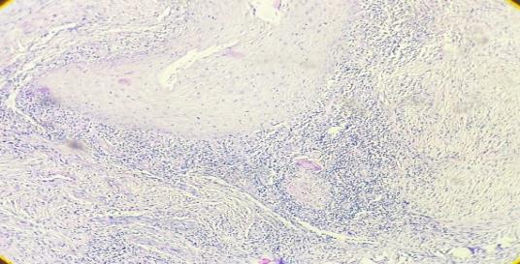
Figure 3

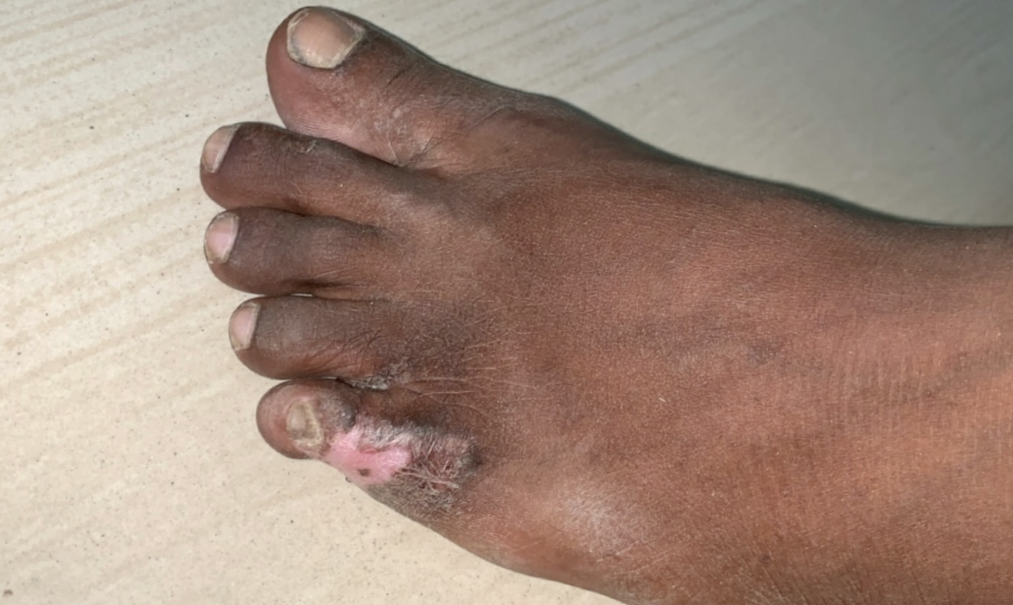
Figure 4

Discussion:
While Tuberculosis is an ancient disease known to affect almost every part of the body, Cutaneous tuberculosis constitutes only a small portion of extra pulmonary tuberculosis.(7)
According to a study conducted in North India in 2011 the commonest clinical variant of cutaneous tuberculosis was lupus vulgaris 55% patients followed by scrofuloderma 25% , orificial tuberculosis, tuberculosis verrucosa cutis,papulonecrotic tuberculid, and erythema induratum seen in 5% each.(8)
Cutaneous tuberculosis is thought to be a continuous spectrum, with lupus vulgaris and tuberculosis verruca cutis at one end, and scrofuloderma and tuberculosis cutis orificialis at the other, with the cell mediated immunity declining from one end to the other.(7)
Tuberculosis verrucosa cutis, a paucibacillary form is caused by an exogenous re-infection in sensitized individuals with a moderate to high degree of slowly evolving cell mediated immunity(1,2), following incidental trauma and accidental inoculation of the bacilli(2)
Commonly observed in high risk groups such as physicians, pathologists and laboratory workers (Anatomist’s wart, Prosector’s wart)(9)
While Tuberculosis verrucosa cutis often occurs on the hands, lower extremities are more commonly involved in children.
They begin as erythematous papules with surrounding purplish inflammatory halo that evolve to asymptomatic verrucous plaques (10). They extend peripherally, sometimes accompanied by an atrophic center (4,11) rarely ulcerating (4)
Histopathological examination usually reveals a thickened epidermis (pseudoepitheliomatous hyperplasia) with small epitheloid granulomas amidst an infiltrate of lymphocytes and plasma cells in the upper and mid dermis.
Typical foci with caseating necrosis are uncommon if not absent (12).
Cultures and staining are usually negative due to the absence of bacilli in the lesion.
DNA amplification and polymerase chain reaction (PCR) is found to be useful in cases where histopathology and culture is inconclusive (13)
Antitubercular therapy remains the mainstay of treatment, with most lesions showing near complete resolution.
Surgical excision and Co2 Laser ablation may be used to debulk resistant cases following completion of medical therapy.
Conclusion:
Tuberculosis verrucosa cutis usually presents as a hyperkeratoic lesion and rarely ulcerates. The case here represents an atypical acral presentation with ulceration, possibly due to various topical home remedies applied and/or secondary bacterial infection.
Thus it’s important, particularly in an endemic country like India to consider cutaneous manifestations of tuberculosis in patients with chronic non-healing ulcers, presenting with atypical skin lesions suggestive of an underlying infectious etiology.

References:

1. Aliağaoğlu C, Atasoy M. Tuberculosis Verrucosa Cutis. Vol. 6, European
Journal of General Medicine. 2009
2. Janjua SA, Khachemoune A, Guillen S. Continuing MediCal eduCation
Tuberculosis Verrucosa Cutis Presenting as an Annular Hyperkeratotic
Plaque Continuing MediCal eduCation. Vol. 78, Cutis. 2006.
3. Handog EB, Gabriel TG, Pineda RT. Management of cutaneous
tuberculosis. Dermatol Ther. 2008;21:154–16
4. MacGregor RR. Cutaneous tuberculosis. Clin Dermatol. 1995;13:245–255
5. Sehgal VN, Sehgal R, Bajaj P, Sriviastava G, Bhattacharya S. Tuberculosis
verrucosa cutis (TBVC) J Eur Acad Dermatol Venereol. 2000;14:319–321
6. Gruber PC, Whittam LR, du Vivier A. Tuberculosis verrucosa cutis on the
sole of the foot. Clin Exp Dermatol. 2002;27:188–191

7. Rajan J, Mathai AT. MULTIFOCAL TUBERCULOSIS VERRUCOSA CUTIS. Indian Journal of Dermatology [Internet]. 2011;(May-June):332–4. Available from: http://https://www.ncbi.nlm.nih.gov/pmc/articles/PMC3132919/?report=classic
8. Puri N. A Clinical and Histopathological Profile of Patients with Cutaneous Tuberculosis. Indian Journal Of Dermatology . 2011;(Sept-Oct):550–2.
9. Verma S. Tuberculosis Verrucosa Cutis of Great Toe. The Internet Journal of Orthopedic Surgery. 2012 Jun 28;9(1).
10. Lai-Cheong JE, Perez A, Tang V, Martinez A, Hill V, Menagé Hdu P. Cutaneous manifestations of tuberculosis. Clin Exp Dermatol. 2007;32:461–466
11. Abebe F, Bjune G. The protective role of antibody responses during Mycobacterium tuberculosis infection. Clin Exp Immunol. 2009;157:235–243.
12. Ghosh S, Aggarwal K. Tuberculosis Verrucosa Cutis Presenting as Diffuse Plantar Keratoderma: an Unusual Sight. Indian Journal of Dermatology. 2014;(Jan-Feb):80–1.
13. A B-N, Aznar C, Chureau C. Diagnosis of tuberculosis by DNA amplification in clinical practice evaluation . Lancet. 1991;(Aug):364–6.

