Case Report:
Extramedullary epidural capillary hemangioma of the thoracic spine: a case report and review of literatures

Dr.Rushama Tandon*, Dr. Gajendra Kumar Sharma**, Dr. Ashutosh Kapoor***

* COS (Chief Orthopedic Specialist), Northern Railway Central Hospital, New Delhi.
** Senior Resident, Department of Orthopedics, AIIMS Gorakhpur, Uttar Pradesh.
*** DMO, Department of Orthopaedics, Northern Railway Central Hospital, Basant lane, New Delhi
Corresponding author: Dr. Gajendra Kumar Sharma

Abstract
A 33 year old male presented in January 2018 with 2 months of progressive upper back pain, lower extremities weakness, numbness and altered bladder–bowel habits. In MRI of dorsal spine, there was heterogeneous extra-medullary lesion in posterior epidural space at D5-D6 vertebral level with no bony involvement and displacing the cord anteriorly with severe canal stenosis. The patient showed significant recovery after total tumor excision following a laminectomy at D4-D6. Histopathology explained capillary hemangioma. Epidural capillary hemangioma is a very rare tumor of spinal cord, needs careful workup, clinical and radiological MRI examinations for confirmation. Gross total excision with histopathological examinations of the lesion is recommended.
Keywords: Epidural capillary hemangioma, cavernous hemangioma, posterior epidural space, dorsal spine and laminectomy.

Introduction
Capillary hemangioma is a benign vascular lesion, most often found in the skin and soft tissues of children.³ Within the spine, this tumor is rare and commonly found as inter-osseous lesions.² Epidural capillary hemangioma is exceedingly rare and the most of the spinal epidural hemangioma reported previously were of the cavernous type. In the present case, we report an extra-medullary epidural capillary hemangioma of the thoracic spine, an exceedingly rare presentation with few previously reported cases in the literature.
Case report
A 33 year young male presented with 2 months history of progressive upper back pain, lower extremities weakness and 2 weeks history of inability to stand, numbness and altered bladder – bowel habits. The previous medical history and family history were unremarkable. The baseline deficits of the patient included SLR was ‘0 degree’ bilaterally with spasticity, strength was 0/5 in both lower limbs and sensory loss was >50% below T6. Abdominal reflex was absent, knee and ankle jerks were increased with Babinski reflex was present bilaterally. MRI without contrast and Gadolinium enhanced MRI of dorsal spine, both demonstrated a 5.7 cm × 1.7 cm heterogenous extra-medullary lesion in posterior epidural space at D5-D6 vertebral level displacing the cord anteriorly with severe canal stenosis, measuring canal diameter of 0.3 cm at this level (Figure1&2).
Differential diagnosis included: cavernous hemangioma, capillary hemangioma, schwannoma, nerve sheath tumor, meningioma and ependymoma lesion extending from D5-D6 level. An excisional biopsy was planned. D4 to D7 laminectomies were performed and location of the lesion was confirmed. Tumor was highly vascular, partially encapsulated, cherry-red colour and appeared to arise from anastomosis of posterior spinal artery (Figure 3). Dural adhesions were dissected, involved vessels were coagulated and excised the tumor out and sent for histo-pathological examinations. On histopathology, the gross appearance of tumor was brownish-tan partialy circumscribed. H&E staining showed a hypervascular, hypercellular mass composed of cytologically bland spindled cells with minimal cytoplasm, and dilated vascular spaces explained capillary hemangioma (Figure 4).
Post-operatively, pain decreased and patient gained good functional recovery in subsequent months. Post-operative MRI confirmed no evidence of residual tumor (Figure 5). In follow-up, at the three months, the patient had only minor residual lower limbs dysesthesia was persist. At the six months, the patient had normal function. The patient is stable after 12 months of tumor resection.
Discussion
Capillary hemangiomas are benign vascular lesions often found in soft tissues. Purely epidural hemangiomas of spinal cord have been reported, but very rarely, in different levels starting from cervical cord to the cauda equina. Some of these cases had some nerve involvement and foraminal extension, and one case was even considered and treated as a disk herniation.^{8,11} All reported cases presented with back pain, radicular pain and / or chronic myelopathy due to mass effect, but not with acute or chronic bleeding.⁵ The unexpected intraoperative finding of this tumor is the risk of diffuse bleeding and of an incomplete removal; even reoperation will not guarantee a complete resection.⁷ Therefore, a careful preoperative workup is necessary. Surgical resection with laminectomy or laminotomy should always be performed regardless of the clinical presentation because of the risk of spinal cord compression.¹⁰

Fig.1 (A): T2 sagittal image shows irregular hyper intense (B) lesion after post contrast enhancement
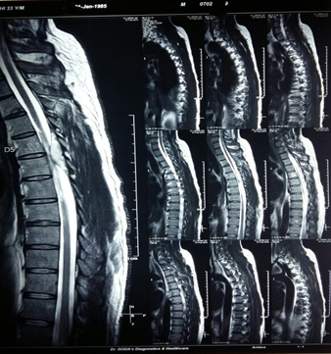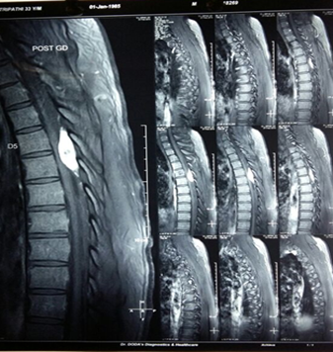

Fig.2: Axial images the lesion is in posterior epidural space compressing cord at D5-D6 level
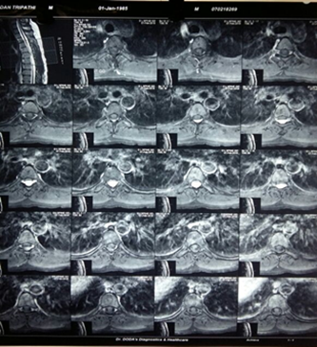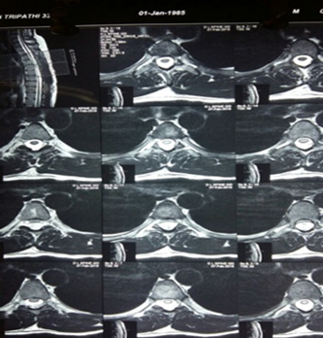

Fig.3: Intra-operatively lesion is visible after lifting the dura
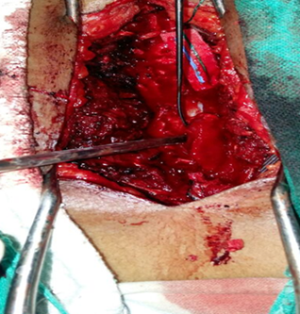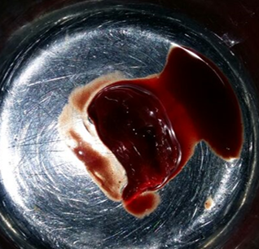

Fig.4: Histopathology
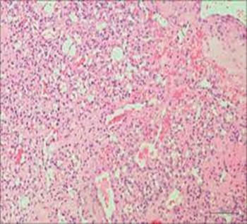

Fig.5: Post-operative MRI
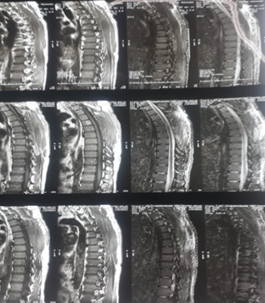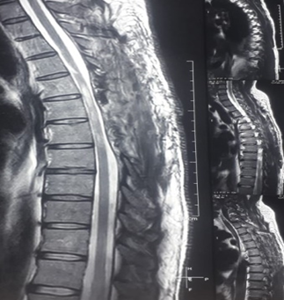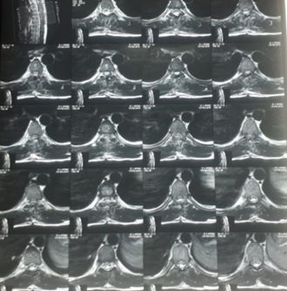

References
- Gupta S et al. Magnetic resonance imaging features of an epidural spinal haemangioma. Australas Radiol 1996;40:342-4.
- Roncaroli F, Scheithauer BW, Krauss WE. Capillary hemangioma of the spinal cord. Repot of four cases. J Neurosurg 2000;93:148-51.
- Nowak DA, Widenka DC. Spinal intradural capillary hemangioma: a review. Eur Spine J 2001;10:464-72.
- Bozkus H at al. Capillary hemangiomas of spinal cord; Report of 2 cases . Minim Invasive Neurosurg 2003;46:41-6.
- Budinand B at al. Dumbbell shaped epidural capillary hemangioma. AJNR Am J Neurodiol 2003;24:190-2.
- Alakandy LM at al. Thoracic intradural extramedullary capillary hemangioma. Br J Neurosurg 2006;20:235-8.
- Lee JW et al. Spinal epidural hemangiomas: various types of MR imaging features with histopathologic correlation. AJNR Am J Neuroradiol 2007;28;1242-1248.
- Tekin T et al. Lumbar epidural capillary hemangioma presenting as lumbar disc herniation disease: case report. Spine 2008;33:E795-E797.
- Chung SK et al. Capillary hemangioma of the thoracic spinal cord. J Korean Neurosurg Soc 2010;48:272-5.
- Hasan A et al. A case report of a spinal epidural capillary haemangioma: Case report. Neurosurgery 2011;68:E850-3.
- Vassal F, Peoc’h M, Nuti C. Epidural capillary hemangioma of the thoracic spine with proximal nerve root involvement and extraforaminal extension. Acta Neurochir (Wien) 2011;153:2279-81.

