Original article:
Study of utility of body fluids cytology in detection of non neoplastic and neoplastic lesion
Pooja Nagarjoge ¹, M. A. Sameer ², Prabha Mulay ³

¹⁻Post Graduate Resident, ²⁻Professor and Head of the Department, ^{3, -}Associate Professor
Department of Pathology, Dr Shakarrao Chavan Government Medical College, Vishnupuri , Nanded
Corresponding author: Dr Prabha Mulay

This work is licensed under a Creative Commons Attribution-NonCommercial 4.0 International License

Date of submission: 22 January 2023
Date of Final acceptance: 18 March 2023
Date of Publication: 30 March 2023
Source of support: Nil
Conflict of interest: Nil

Abstract:
Introduction: Cytological study of body fluids dates back to a long way in the history of pathology for being an inexpensive, simple procedure combined with imbibing significant knowledge in the diagnostic modality of body fluids.
Material and methods: The present study was an observational prospective type of study. Study subjects were selected from patients attending OPD of Department of Pathology. Registration of patients was from 2020 to 2022. The main objective of this study was to determine gross and microscopic features of cytological fluids.
Results: Most common age group affected was 30 to 60 years 69.7%, 6.1% >60 and 24.2% <30 years for ascites. Most common age group affected was 30 to 60 years 55.6%, 22.2% >60 and 22.2% <30 years for CSF. 89.7% had protein >3 and 34.5% had sugar <60 on biochemical investigation of pleural fluid. 27.3% had protein >3 and 36.4% had sugar <60 on biochemical investigation of ascetic fluid. 44.4% had protein >45 and 33.3% had sugar <45 on biochemical investigation of CSF fluid.
Conclusion The present study demonstrated that the most useful test in establishing the diagnosis of effusion is fluid cytology and fluid cell count.
Keywords: Cytology, Body fluids , cell count

Introduction:
Cytological study of body fluids dates back to a long way in the history of pathology for being an inexpensive, simple procedure combined with imbibing significant knowledge in the diagnostic modality of body fluids.^{1,2} The main serosal body cavity fluids comprise of pleural, peritoneal, pericardial and cerebrospinal fluids. ³ Cytological examination of various body fluids like ascitic, pleural, synovial, CSF, urine etc., plays an important role in diagnosing various non- neoplastic and neoplastic conditions. ⁴ Effusions or body cavity fluids are amongst the most commonly submitted samples to the cytology laboratory. Knowledge of proper collection, storage, preservation and processing techniques is essential to ensure proper handling and successful analysis of the sample. ⁵ Malignant effusions are a common presenting sign of malignancy and reflect dissemination. ⁶ Cytological study of body fluid is a complete diagnostic modality. First, it assists the clinician in formulating and pointing out the etiology of effusion and list of differential diagnoses, Secondly it allows one to follow the results of therapy and prognosis. ⁷
Material and methods:
The present study was an observational prospective type of study. Study subjects were selected from patients attending OPD of Department of Pathology. Registration of patients was from 2020 to 2022. The main objective of this study was to determine gross and microscopic features of cytological fluids. At the time of registration, the baseline information was taken especially with respect to sociodemographic factors, clinical findings, and other investigations. The data thus collected was analyzed to study utility of body fluids cytology in detection of non neoplastic and neoplastic lesions,
- INCLUSION CRITERIA:
The effusion samples such as pleural fluid, pericardial fluid, CSF, synovial fluid and peritoneal fluids obtained from both male and female patients of all age groups during the study period.
- EXCLUSION CRITERIA:
  - inadequate sample
  - sample dried
  - bronchoalveolar lavage
  - Gastric lavage
  - Fluid aspirate from cystic lesions
Written informed consent was taken in the language the respondent understands i.e. Marathi/Hindi which was signed/thumb printed by the respondent. Data collection was done with help of detailed examination. Predesigned, pre-tested, structured questionnaire (performa) was used for interview and examination purpose.
Results:
Majority of cases 36.7% had age 61 to70years, followed by 51 to 60 years 25.7% and least were in 21 to 30 years age group. On fluid specimen, most common was pleural 58%, ascetic 33% and 9% CSF

Table 1) Causes of transudative and exudative ascetic fluid, total and differential cell count and biochemical features

Diagnosis | Transudative  N=156 | Percentage | Exudative  N =42 | Percentage
Liver cirrhosis | 64 | 41.0 | 23 | 54.8
Tuberculosis | 27 | 17.3 | 8 | 19.0
CCF (Congestive Cardiac Failure) | 27 | 17.3 | 5 | 11.9
Malignancy | 24 | 15.4 | 4 | 9.5
Pancreatitis | 11 | 7.1 | 1 | 2.4
Hypoproteinemia | 1 | 0.6 | 1 | 2.4
Renal failure | 1 | 0.6 | 0 | 0.0
SFM (Suspicious for Malignancy) | 1 | 0.6 | 0 | 0.0

Table 2) Distribution depending on Clinical diagnosis
Clinical | Frequency | Percentage
Benign | 438 | 73
Suspicious | 90 | 15
Malignant | 72 | 12
Total | 600 | 100

Table 3) Cytological diagnostic distribution of Ascitic fluid neoplastic cases (n=32)
Type of malignancy | Frequency | Percentage
Adenocarcinoma | 21 | 65.6
Suspicious for  malignancy | 11 | 34.4
Total | 32 | 100

Table 4) Diagnostic distribution of CSF cytology (n=54)
Parameter | Frequency | Percentage
S/O bacterial meningitis | 2 | 3.7
S/O non bacterial meningitis | 3 | 5.6
Hemorrhagic smear | 4 | 7.4
Non specific findings | 45 | 83.3

On CSF cytology, only 17% had abnormal finings. Among them 6.4% had hemorrhagic smear, 5.6% had S/O non bacterial meningitis and 3.7% had S/o bacterial meningitis
Table 5) Association between cytology and clinical diagnosis
Cytology | Clinical diagnosis |  | Total
 | Malignant | Benign
Malignant | 42 | 30 | 72
Benign | 12 | 426 | 438
Total | 54 | 456 | 510

Sensitivity | 77.78%
Specificity | 93.42%
Positive Predictive Value | 58.33%
Negative Predictive Value | 97.26%
Diagnostic Accuracy | 91.76%

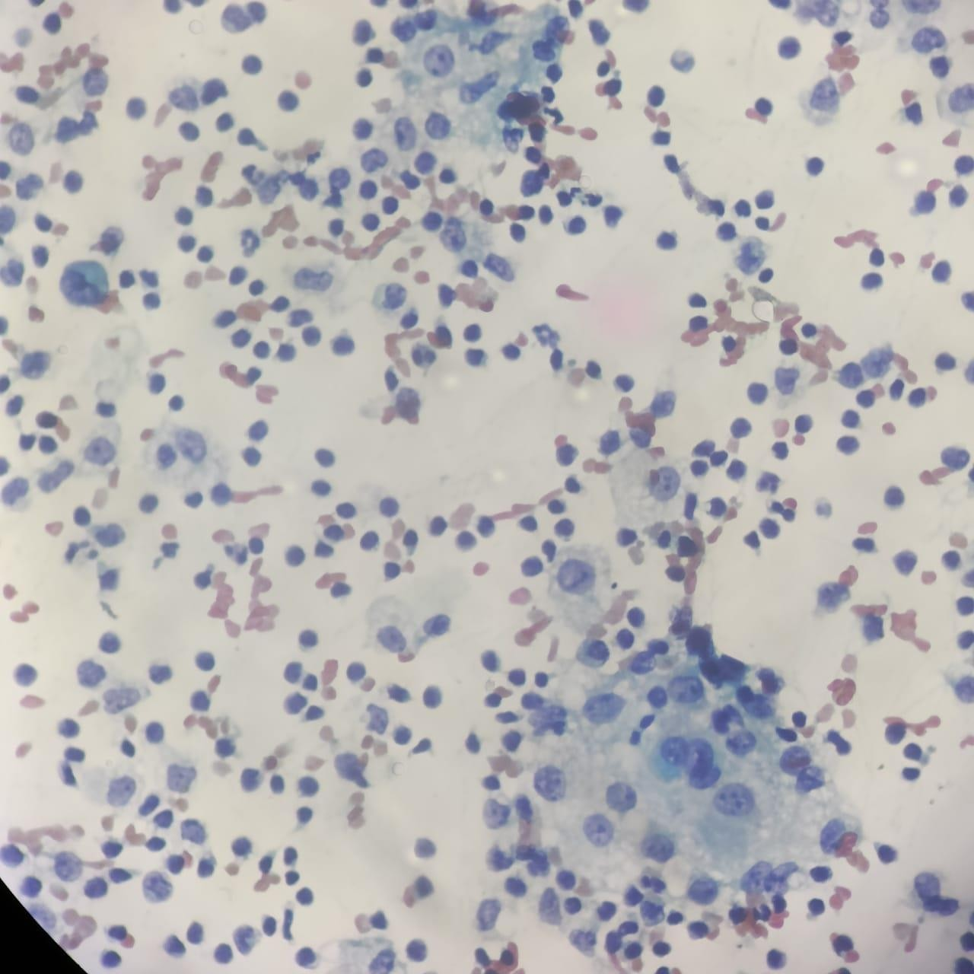
Fig 1: Ascitic fluid cytology showing malignant tumor cells having hyperchromatic pleomorphic nuclei, prominant nucleoli and vacuolated cytoplasm, arranged singly and in clusters in the background of lymphocytes, histiocytes and RBCS (H & E Stain, High Power).
Discussion:
Most common clinical presentation among pleural specimen was cough with expectoration 7.6%, 70.7% had chest pain etc. Most common clinical presentation among asitic specimen was disturbed appetite and abdominal distension 90.9%.^{7,8} Most common clinical presentation among CSF specimen was headache 66.7%, neck stiffness 55.6%. Study by Arpana Dharwadkar et al ⁴ showed that chronic inflammation was most common among pleural fluid 60%. Most common age group affected was 30 to 60 years 43.1%, 29.3% >60 and 27.6% . <30 years for pleural infections. Most common age group affected was 30 to 60 years 69.7%, 6.1% >60 and 24.2% <30 years for ascites. Most common age group affected
was 30 to 60 years 55.6%, 22.2% >60 and 22.2% <30 years for CSF. 89.7% had protein >3 and 34.5% had sugar <60 on biochemical investigation of pleural fluid. 27.3% had protein >3 and 36.4% had sugar <60 on biochemical investigation of ascetic fluid. 44.4% had protein >45 and 33.3% had sugar <45 on biochemical investigation of CSF fluid.
82.8% was exudate and only 17.2% was transudate in pleural fluid. 78.8% was transudate and only 21.2% was exudate in ascitic fluid. Among pleural fluid sample, among Tb 67% were exudative and 66.7% were transudative. Among pneumonia 20.1% were exudative and 16.7% were transudative and so on. Of ascetic fluid sample among liver cirrhosis 54.8% were exudative and 41% were transudative. Among tuberculosis 19% were exudative and 17.3% were transudative. Among CCF 11.9% were exudative and 17.3% were transudative and so on. 89.7% had protein >3 and 34.5% had sugar <60 on biochemical investigation of pleural fluid. 27.3% had protein >3 and 36.4% had sugar <60 on biochemical investigation of ascetic fluid. 44.4% had protein >45 and 33.3% had sugar <45 on biochemical investigation of CSF fluid.
82.8% was exudate and only 17.2% was transudate in pleural fluid. 78.8% was transudate and only 21.2% was exudate in ascitic fluid. Among pleural fluid sample, among Tb 67% were exudative and 66.7% were transudative. Among pneumonia 20.1% were exudative and 16.7% were transudative and so on. Of ascetic fluid sample among liver cirrhosis 54.8% were exudative and 41% were transudative. Among tuberculosis 19% were exudative and 17.3% were transudative. Among CCF 11.9% were exudative and 17.3% were transudative and so on.
Examination of the fluid can narrow the differential diagnosis considerably.⁹⁻¹² The appearance of the fluid and biochemical parameters along with microbiological findings can be key to a direct diagnosis or can indicate the next step. In transudative effusions, the underlying cause should be sought and treated. In exudative effusions in which fluid analysis does not lead to immediate diagnosis, radiological investigations should be performed. If the diagnosis is still not evident after combined cytology, radiology, biochemical and microbiological investigations, pleural biopsy or peritoneal biopsy is recommended. In a few patients, the effusion may begin to improve. In these instances, the patient should be observed; the disease process may be resolving and further invasive investigation may not be warranted.^{13,14}
Conclusion:
The present study demonstrated that the most useful test in establishing the diagnosis of effusion is fluid cytology and fluid cell count.

References:
- Saba H, Prakash C.J, Sharmila P.S, Vinitra. K. Cytological study of body fluids for malignancy. Trop J Path Micro 2019;5(1):43-50
- GiaKhanh Nguyen. Essentials of fluid cytology. 2009:9-71
- Arpana Dharwadkara, Shruti Vimalb, Vidya Viswanathanc, Manoj Sawadkard. Diagnostic Utility of Body Fluid Cytology. Indian Journal of Pathology: Research and Practice. March 2018; Volume 7: Issue 3:Pages 312-316
- Michael CW, Davidson B. Pre-analytical issues in effusion cytology. Pleura Peritoneum. 2016 Mar 1;1(1):45-56.
- Pradhan SB, Pradhan B, Dali S. Cytology of body fluids from different sites: an approach for early diagnosis of malignancy. JNMA J Nepal Med Assoc. 2006 Oct- Dec;45(164):353-6.
- Bhanvadia VM, Santwani PM, Vachhani JH. Analysis of diagnostic value of cytological smear method versus cell block method in body fluid cytology: study of 150 cases. Ethiop J Health Sci. 2014 Apr;24(2):125-31.
- Frable WJ. Fine-needle aspiration biopsy: A review. Hum Pathol. 1983;14:9–28
- Frable WJ. Integration of surgical and cytopathology: A historical perspective. Diagn Cytopathol. 1995;13:375–8.
- Demay RM. The Art and Science of Cytopathology. 1st ed 1996
- Cibas ES, Ducatman BS. Cytology: Diagnostic Principles and Clinical Correlates. 2nd ed 2003.
- Yamamoto T, Nagira K, Marui T, Akisue T, Hitora T, Nakatani T, et al. Fine-needle aspiration biopsy in the initial diagnosis of bone lesions. Anticancer Res. 2003;23:793– 7.
- Edoute Y, Malberger E, Tibon-Fishe O, Assy N. Non-imaging-guided fine-needle aspiration of liver lesions: A retrospective study of 279 patients. World J Gastroenterol. 1999;5:98–102.
- Amedee RG, Dhurandhar NR. Fine-needle aspiration biopsy. Laryngoscope. 2001;111:1551–7.
- Jorda M, Rey L, Hanly A, Ganjei-Azar P. Fine-needle aspiration cytology of bone: Accuracy and pitfalls of cytodiagnosis. Cancer. 2000;90:47–54.

