Original article:
Evaluation of magnetic resonance imaging in knee joint injuries with arthroscopic correlation
Dr. Shubhankar,¹ Dr. (Col.) Kamal Kumar Sen,² Dr. Sudhansu Sekhar Mohanty,³ Dr. Ujaan Roy⁴

¹Resident, Department of Radiodiagnosis, KIMS, Bhubaneswar
²Professor & H.O.D., Department of Radiodiagnosis, KIMS, Bhubaneswar
³Assistant Professor, Department of Radiodiagnosis, KIMS, Bhubaneswar
⁴Resident, Department of Radiodiagnosis, KIMS, Bhubaneswar
Corresponding author *

ABSTRACT
Introduction: The knee joint is one of the most frequently injured joint due to its vulnerability to external forces and its functional demand. Injury to the ligaments and meniscus affects the stability of the knee joint and normal mechanics, resulting in an unstable knee that impairs the everyday function of an individual.
Aim: to evaluate the radiological and arthroscopic findings of the cruciate ligaments and meniscal injuries of knee joint and correlate the findings of the above two diagnostic methods.
Method: A prospective study was conducted on the 50 patients with traumatic knee joint referred for MRI to the department of Radiodiagnosis followed by Arthroscopy in period of 2 years (September 2018 to September 2020) KIMS, Bhubaneswar.
Results: Out of the 50 patients, 84% were males, 40 (80%) had ACL tears, 3 (6%) had posterior cruciate ligament (PCL) tears, 21 (42%) had (MM) tears, and 18 (36%) had lateral meniscus (LM) injuries.
Conclusion: MRI should be the initial investigation of choice in the evaluation of all cases of knee joint injuries because it can detect both intra and extra articular pathologies and also osseous structures. Based on the findings of MRI, it acts as road map for Arthroscopy for diagnostic as well as therapeutic procedures.

INTRODUCTION:
The knee joint is one of the most frequently injured joint due to its vulnerability to external forces and its functional demand.¹ Injury to the ligaments and meniscus affects the stability of the knee joint and normal mechanics, resulting in an unstable knee that impairs the everyday function of an individual.² MRI has aided in the understanding of soft tissue anatomy and musculoskeletal system pathology. Improvement in the soft tissue contrast along with multi-planar slice capability has rendered it an ideal modality for the imaging of detailed anatomy.³ An emerging paradigm for both the diagnosis as well as the management of the knee joint injuries is Arthroscopy.⁴ The purpose of our study was to evaluate the radiological and arthroscopic findings of the cruciate ligaments and meniscal injuries of knee joint and correlate the findings of the above two diagnostic methods.
METHOD:
A prospective study was conducted on the 50 patients with traumatic knee joint referred for MRI to the department of Radiodiagnosis followed by Arthroscopy in period of 2 years (September 2018 to September 2020). Patients consenting for the study of all ages and both sexes who have come with knee joint injuries, willing to undergo MRI scanning of the knee followed by Arthroscopy.
Patients with known pre-existing knee joint pathologies, post-operative knee joint, and also patients with contra-indications of MRI like cardiac pace-maker, metallic implants, etc. were excluded.
Relevant clinical history followed by written consent of patient or patient’s attendant for MRI of knee joint taken. The patient examined with GE Signa HDxT 1.5 Tesla MRI, HD T/R Knee coil by In Vivo QUADKNEE using pulse sequences and imaging planes with corresponding slice thickness, spacing, field of view (FOV) and imaging time depicted in Figure 1. Patient placed in supine position with affected knee kept in a closely coupled knee extremity coil in 15-20° external rotation for better visualisation of anterior cruciate ligament (ACL) on sagittal images. The knee is also flexed around 5-10° to improve the accuracy for assessment of the patellofemoral compartment and patellar alignment.
The MRI was performed within duration 7-15 days from the date of injury with a time lag of 1-30 days between MRI and Arthroscopy.
Arthroscopy was done under spinal anesthesia using anteromedial and anterolateral portals (Stryker 4mm Scope 30° Bend). The surgical operative notes or direct discussion with surgeon used for comparing knee injury findings.
To classify the location of meniscal tear arthroscopically each meniscus was divided into three equal segments; anterior horn, body, and posterior horn. The cruciate ligaments were classified as partial disruption or complete ligament injury.
All the data collected was analysed to calculate true positive, true negative, false positive and false negatives. Using these specificity and sensitivity, positive and negative predictive values were calculated with Arthroscopy as the gold standard for comparison as depicted in Figure 2.
RESULTS:
In our study, MRI examination was performed on 50 patients with the complaints of knee injury. Regarding the most common age group, the affected were between 20 and 29 and this is explained by the fact that this age group being the most active group. Out of the 50 patients, 84% were males and 16% were females. Of them, 40 (80%) had ACL tears, 3 (6%) had posterior cruciate ligament (PCL) tears, 21 (42%) had (MM) tears, and 18 (36%) had lateral meniscus (LM) injuries as shown in Figure 3. Most common internal derangement in traumatic knee is joint effusion in our study population as depicted in Figure 4.

Image plane | Slice thickness | Spacing | FOV (cm) | Image time
Sagittal T1w | 4 mm | 0.5 mm | 16 x 16 | 3 mins 34 secs
Sagittal T2w | 4 mm | 0.5 mm | 16 x 16 | 3 mins 36 secs
Oblique Sagittal T2w | 3 mm | 0 mm | 16 x 16 | 2 mins 27 secs
Oblique Coronal T2w | 3 mm | 0 mm | 16 x 16 | 2 mins 27 secs
Coronal 3D SPGR | 1 mm | 1 mm | 20 x 20 | 3 mins 0 secs
Sagittal STIR | 4 mm | 0.5 mm | 16 x 16 | 3 mins 56 secs
Coronal STIR | 3 mm | 1 mm | 16 x 16 | 3 mins 46 secs
Coronal PD | 4 mm | 1 mm | 16 x 16 | 2 mins 20 secs
Axial PD FS | 3.5 mm | 0.5 mm | 16 x 16 | 4 mins 42 secs

Figure 1: Pulse sequences and imaging planes.

Tears | Sensitivity (%) | Specificity (%) | PPV (%) | NPV (%) | Accuracy (%)
Anterior cruciate ligament | 95.12 | 88.89 | 97.50 | 80 | 94
Posterior cruciate ligament | 100 | 100 | 100 | 100 | 100
Medial meniscus | 94.74 | 90.32 | 85.71 | 96.55 | 92
Lateral meniscus | 93.75 | 91.18 | 83.33 | 96.88 | 92
Figure 2: Accuracy of MRI findings using Arthroscopy as gold standard.

Figure 3: Total positive cases detected on MRI compared with true positive cases on Arthroscopy.

Figure 4: Various internal derangements of knee joint in study population.

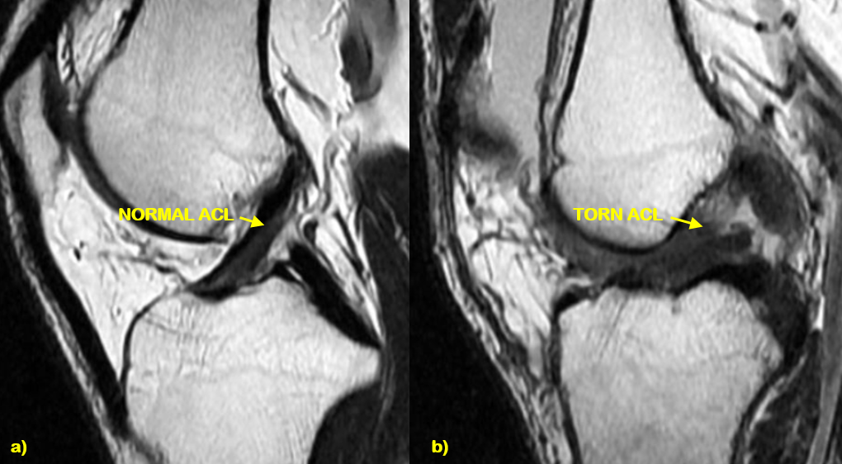
Figure 5: Oblique sagittal T2w images depicting a) Normal ACL b) Torn ACL.

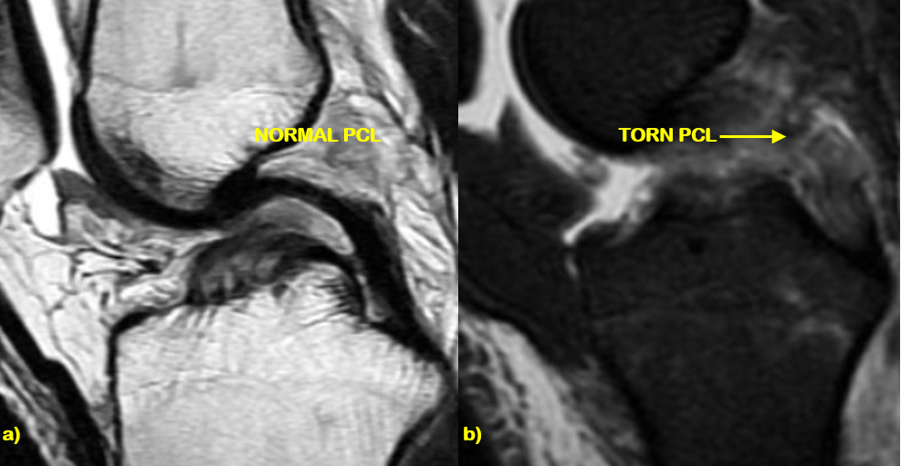
Figure 6: a) Sagittal T2w image and b) Sagittal STIR images shows normal and torn PCL.

DISCUSSION:
Imaging of the knee joint is challenging owing to its complex structure.⁵ Our objective was to compare and correlate MRI and Arthroscopic findings in the diagnosis of cruciate ligaments and meniscal injuries.
Out of 50 patients, 40 patients (80%) showed ACL tear. Out of 40 patients of ACL tears, 20 patients (50%) had mid-substance tear, 17 patients (42.5%) had tear at the proximal third and 3 (7.5%) at tibial attachment were detected on MRI. In our study, the most common tear location was at mid-substance. Berquist et al⁶ in their study also reported mid-substance tears as the most common type. In this study we found hyperintensity in the ligament as the most common sign as shown in Figure 5. One patient with positive finding on MRI was found having intact ACL on Arthroscopy. This was a case of partial tear of ACL. Discordant appearance of ACL (when one MRI sequence shows disrupted or poorly seen ACL fibers and other sequences show intact ACL fibres) was the reason for this false positive case. Umans et al⁷ have proved that when discordant appearance of ACL was seen, they appeared normal on Arthroscopy. There were two cases of ACL tear that had been missed by MRI but picked up by arthroscopy. These cases also had partial ACL tears. So the sensitivity (i.e. accurately identifying an ACL tear) of this test is 95.12%, specificity is 88.89 %, the positive predictive value (reliability of a positive MRI result) is 97.5 % and accuracy is 94 %. Mink et al⁸ reported accuracy of MRI for detecting ACL tear as 95 % whereas Polly et al⁹ found the sensitivity, specificity and accuracy of MRI in detecting ACL tear to be 100%, 96.9% & 97.3% respectively which are in concordance with our study.
The PCL being a stronger ligament has a low incidence of tears. There were 3 patients of PCL tear identified on MRI and confirmed on arthroscopy. Most common type of PCL tear was complete tear (67%) as shown in Figure 6. The sensitivity, specificity, predictive values and accuracy of MRI for identifying the PCL tear is 100% which is similar to the findings of Manoj et al.¹⁰
Out of 50 patients, 21 (42%) showed medial meniscal and 18 (36%) showed lateral meniscal tears on MRI which is corresponding with the study done by Pozo et al¹¹ who reported that medial meniscal tears are more common than lateral meniscal tears. On Arthroscopy, 19 (38%) showed medial meniscal and 16 (32%) showed lateral meniscal tears. In 21 patients of medial meniscal tears, most common tear location was at posterior horn with maximum being horizontal followed by bucket handle tears. In our study, we found posterior horn tear in 18 patients (85.71%), anterior horn tears in 2 patients (9.52%) and tear in body in 4 patients (19.04%) on MRI. 3 patients with positive MRI findings were found to be negative on Arthroscopy. These were cases of posterior horn tear of medial meniscus. FitzGerald et al¹² observed that the posterior horn of the medial meniscus may sometimes be difficult to assess with the standard anterior viewing portals and 30° arthroscopic lens, because the free edge of the posterior horn of the medial meniscus may be obscured by the medial femoral condyle. In 18 patients of lateral meniscal tears, most common tear location was at posterior horn with maximum being horizontal followed by radial tears. 3 patients with positive finding on MRI was found negative on Arthroscopy.
In our study the sensitivity, specificity, PPV, NPV and accuracy for detecting medial meniscal tears was 94.74%, 90.32%, 85.71%, 96.55% and 92% respectively, and 93.75%, 91.18%, 83.33%, 96.88% and 92% for detection of lateral meniscus tears which were corresponding to the Fischer et al. ⁽¹³⁾
CONCLUSION:
Ligamentous and meniscal injuries occur frequently in patients with trauma to the knee. It is noted that ACL and medial meniscus are the two ligaments which are most commonly torn.
MRI was found to be highly sensitive (95.12%, 100%, 94.74% and 93.75%) and accurate (94%, 100%, 92% and 92%) in detection of ACL, PCL, medial meniscal and lateral meniscal tears respectively.
MRI should be the initial investigation of choice in the evaluation of all cases of knee joint injuries because it can detect both intra and extra articular pathologies and also osseous structures. Based on the findings of MRI, it acts as road map for Arthroscopy for diagnostic as well as therapeutic procedures.

REFERENCES:
1. Kaplan PA, Gahl RH, Dussault RG, Anderson MW, Diduch DR. Bone contusions of the posterior lip of the medial tibial plateau (contrecoup injuries) and associated internal derangements of the knee at MR imaging. Radiology 1999; 211(3): 747-753.
2. Islam M, Ailani R, Bhattacharyya TD, Chakrabarty PS, Baruah S. Correlation between MRI Findings and Arthroscopic Findings in Internal Degeneration of Knee. J Dent Med Sci 2017; 16:22-5.
3. Alaia E.F., Alaia M.J., Gyftopoulos S. MRI-Arthroscopy Correlation of Knee Anatomy and Pathologic Findings: A Teaching Guide. AJR 2018; 211:1–7.
4. Gupta K, Guleria M, Sandhu P, Galhotra R. Correlation of clinical, MRI and arthroscopic findings in diagnosing meniscus and ligament injuries at knee joint: A prospective study. J Orthop Allied Sci 2013; 1:2-6.
5. Omar Faiz, David Moffat. The knee joint and popliteal fossa. In: Omar Faiz, David Moffat, editor. Anatomy at a glance. 5th ed. University of Cardiff: Blackwell Science Ltd, 2002:109-112.
6. Thomas H. Berquist. Osseous and Myotendinous Injuries About the Knee. Radiol clin N Am 2007; 45: 955-968.
7. Umans H, Wimphfeimer O, Harmati N et al. Diagnosis of partial tear of the anterior cruciate ligament of the knee: value of MR imaging. AJR 1995; 165: 893-897.
8. Mink JH, Levy T, Crues JV. Tears of the ACL and menisci of the knee. MR evaluation. Radiology 1988; 167:769–74.
9. DW Polly, JJ Callaghan, RA Sikes, JM McCabe, K McMahon and CG Savory. The Accuracy of Selective Magnetic Resonance Imaging Compared with the Findings of Arthroscopy of the Knee. Am J Bone Joint Surg 1988; 70: 192-198.
10. Manoj MK, Ray RS, Francis J. Correlation of MRI with arthroscopy in injuries of knee joint. Kerala J Orthop 2014;27:18-21.
11. Drosos GI, Pozo JL; The causes and mechanism of Meniscal injuries in sporting and non sporting environment in an unselected population. Knee 2004; 11: 143-149.
12. Sonin AH, Fitzgerald SW, Friedman H, Hoff FL, Hendrix RW, Rogers LF. PCL injury: MR imaging diagnosis and pattern of injury. Radiology 1994; 190: 455-458.
13. Fischer SP, Fox JM, Del Pizzo W, Friedman MJ, Snyder SJ, Ferkel RD. Accuracy of diagnosis from magnetic resonance imaging of the knee. A multi-center analysis of one thousand and fourteen patients. J Bone Joint Surg Am. 1991;73(1):2-10.

Date of Submission: 15 October 2020
Date of Acceptance: 18 November 2020
Date of Publishing: 15 December 2020
Author Declaration: Source of support: Nil, Conflict of interest: Nil
Ethics Committee Approval obtained for this study? YES
Was informed consent obtained from the subjects involved in the study? YES
Plagiarism Checked: Urkund Software
Author work published under a Creative Commons Attribution 4.0 International License

DOI: 10.36848/IJBAMR/2020/16215.55742

