Original article:
Study of HRCT as a prime modality of in the evaluation of pathology of the temporal bone
*Dr. KRUTHIN L.K. , Dr. PRAVEEN T. KOCHAR

Department of Radiodiagnosis , JJM Medical College, Dawangiri
Corresponding author *

This work is licensed under a Creative Commons Attribution-NonCommercial 4.0 International License
Date of submission: 08 April 2023
Date of Final acceptance: 20 May 2023
Date of Publication: 02 June 2023
Source of support: Nil
Conflict of interest: Nil

Abstract:
Objective: The objective of this study was to assess the role of high-resolution computed tomography (HRCT) as a prime modality in the evaluation of temporal bone pathology.
Methods: A cross-sectional study was conducted at Bapuji Hospital and Chigateri General Hospital attached to JJM Medical College, Davanagere. The study included 100 patients with ear problems who underwent HRCT of the temporal bone. Data regarding age, pathology distribution, congenital problems, structures involved, and etiology were collected and analyzed.
Results: The study revealed that 32.0% of cases with temporal bone pathology were aged over 60 years, followed by 28.0% aged between 51 and 60 years. Acoustic neuroma, metastasis, Glomus tympanicum, and meningioma were observed in 7.0%, 3.0%, 5.0%, and 2.0% of cases, respectively. Congenital problems accounted for 2.0% each for ossicular abnormality and microtia with ear atresia. Facial canal involvement was found in 11.7% of infections and 17.6% of trauma cases. HRCT showed varying sensitivity and specificity for different etiologies, with congenital problems demonstrating sensitivity of 7.1% and specificity of 100.0%, infections showing sensitivity of 58.3% and specificity of 31.25%, neoplastic lesions showing sensitivity of 17.9% and specificity of 87.5%, and trauma showing sensitivity of 16.7% and specificity of 81.25%.
Conclusion: HRCT is an invaluable modality for evaluating temporal bone pathology due to its ability to provide detailed imaging of bony and soft tissue structures. It aids in the diagnosis and management of neoplastic lesions, infections, and congenital anomalies. However, the sensitivity and specificity of HRCT vary depending on the etiology, necessitating a comprehensive diagnostic approach.
Keywords: high-resolution computed tomography, HRCT
Introduction:
The evaluation of pathology in the temporal bone, a complex anatomical region housing vital structures such as the auditory and vestibular systems, facial nerve, and related vasculature, requires a comprehensive diagnostic approach.¹ Over the years, various imaging modalities have been employed to investigate temporal bone pathology, including conventional radiography, computed tomography (CT), and magnetic resonance imaging (MRI). However, in recent times, high-resolution computed tomography (HRCT) has emerged as a prime modality in the evaluation of temporal bone pathology due to its exceptional spatial resolution and ability to provide detailed anatomical information.² HRCT utilizes thin-section imaging and advanced computer processing techniques to produce high-resolution images of the temporal bone. By utilizing narrow slice thickness (typically 0.5 to 1 mm) and high spatial resolution, HRCT enables visualization of intricate temporal bone structures and their pathological alterations with remarkable detail. The resulting images offer clinicians a comprehensive view of the bony and soft tissue components within the temporal bone, facilitating the diagnosis and management of a wide range of conditions.^{3,4}
One of the significant advantages of HRCT is its ability to depict osseous structures, such as the otic capsule, mastoid air cells, petrous ridge, and labyrinth, with exceptional clarity. This level of detail is crucial for evaluating congenital anomalies, fractures, and diseases affecting the bony structures of the temporal bone. HRCT can accurately detect bony erosions, discontinuities, and abnormalities, aiding in the diagnosis of conditions like otosclerosis, cholesteatoma, and temporal bone trauma. In addition to evaluating bony structures, HRCT also allows for the assessment of the soft tissues within the temporal bone. This includes the evaluation of the middle ear structures, such as the ossicles, tympanic membrane, and eustachian tube, as well as the inner ear structures, including the cochlea and vestibular apparatus. Pathologies affecting these structures, such as otitis media, tympanic membrane perforation, and vestibular schwannoma, can be effectively visualized and characterized using HRCT.^{5,6,7}
Furthermore, HRCT can aid in the assessment of vascular structures within the temporal bone, such as the internal carotid artery and jugular vein. This is particularly important in cases of temporal bone trauma or when investigating vascular anomalies like glomus tumors.
Material and methods:
A cross-sectional study was conducted among the patients attending Bapuji Hospital and Chigateri General Hospital, both attached to JJM Medical College in Davanagere, between December 2020 and May 2022, spanning a period of 18 months. Prior to commencing the study, clearance from the institution's ethics committee was obtained. Written informed consent, provided in bilingual form, was obtained from all the study participants before their inclusion in the study. The sample size consisted of a total of 100 cases with ear problems.
The inclusion criteria for the study were as follows:
- Patients who were clinically suspected of having symptoms related to the temporal bone.
- Patients with a history of ear discharge.
- Patients with a history of head trauma.
- Patients with a history of facial palsy.
- Patients with a history of tinnitus, vertigo, or hearing loss.
- Patients with a history of increased intracranial tension and a history of ear discharge.
The following were the exclusion criteria for the study:
- Patients with electric devices at the skull base, such as cochlear implants.
- Patients with a history of previous surgery.
The method of data collection involved performing HRCT of the temporal bone on all the patients who were clinically suspected of having symptoms related to the temporal bone and were referred to the Radiodiagnosis department. This process was carried out between December 2020 and May 2022.
Results:
This study had shown than, about 32.0% of the cases with temporal bone pathology were aged more than 60 years followed by 28.0% of the cases aged between 51 – 60 years.
Acoustic neuroma was present in 7.0% of the cases, metastasis in 3.0% of the cases, Glomus tympanicum in 5.0% of the cases and meningioma in 2.0% of the cases.

Table 1. Distribution of the study group according to congenital problems

Congenital | Frequency | Percent
Ossicular abnormality | 2 | 2.0
Microtia with ear atresia | 2 | 2.0
Anomalous facial nerve | 1 | 1.0
High riding Jugular bulb | 1 | 1.0

Table 2. Distribution of the study group according to structures involved and etiology
Structures involved | Infections n (%) | Trauma n (%)
Facial canal involvement | 7 (11.7) | 3 (17.6)
Hemosinus | 0 | 5 (29.4)
Hemotympanum | 0 | 8 (47.1)
Ossicle erosion | 31 (51.7) | 1 (5.9)
Semi-circular canal involvement | 9 (15.0) | 0
Tegmen tympani involvement | 13 (21.7) | 0
χ² value=176.834 df=6 p value, sig= 0.000, sig

Table 3. Predictive accuracy according to etiology

Etiology | HPE | HRCT  diagnosis | Sensitivity | Specificity | PPV | NPV
Congenital | 6 | 6 | 7.1 | 100 | 100 | 17.02
Infections | 60 | 49 | 58.3 | 31.25 | 81.7 | 12.5
Neoplastic | 17 | 15 | 17.9 | 87.5 | 88.23 | 16.87
Trauma | 17 | 14 | 16.7 | 81.25 | 82.35 | 15.66

The sensitivity was 7.1%m specificity was 100.0%, PPV was 100% and NPV was 17.02% for the congenital problems of temporal bone. The sensitivity for infections was 58.3%, specificity was 31.25%, PPV was 81.7% and NPV was 12.5%. The sensitivity for neoplastic lesions was 17.9%, specificity was 87.5%, PPV was 88.23% and NPV was 16.87%. The sensitivity for trauma was 16.7%, specificity was 81.25%, PPV was 82.35% and NPV was 15.66%.

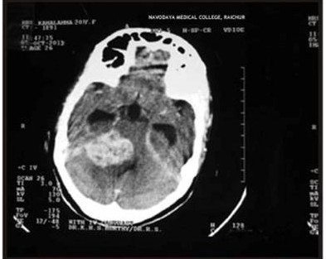
FIGURE 1 : ACOUSTIC NEUROMA

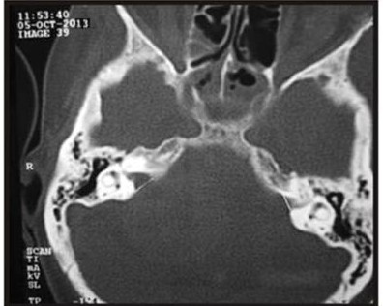
CECT Shows Evidence of Heterogenous Extra Axial Mass Involving Right CP Angle
Bone window shows widening of internal auditory canal on right side

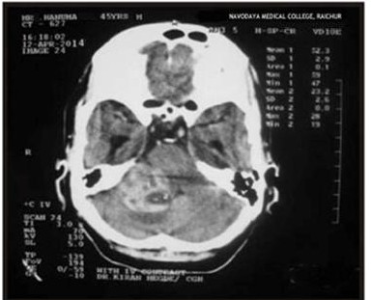
CECT Shows Evidence of Heterogenous Mass in the Right CP Angle

Plain CT shows hypodense mass with haemorrhage within it
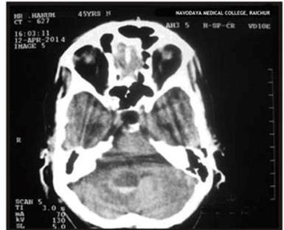
Discussion:
The results of this study provide valuable insights into the distribution of temporal bone pathologies and their characteristics among the study group. The findings reveal that a significant proportion of cases with temporal bone pathology were observed in individuals aged 60 years and above (32.0%), followed closely by those aged between 51 and 60 years (28.0%). This highlights the importance of considering age as a risk factor when evaluating and managing temporal bone conditions.^{8,9,10}
Among the specific pathologies identified, acoustic neuroma was found in 7.0% of cases, indicating its relevance as a significant pathology affecting the temporal bone. Metastasis, Glomus tympanicum, and meningioma were also observed, albeit in smaller proportions (3.0%, 5.0%, and 2.0% respectively). These findings emphasize the importance of comprehensive diagnostic imaging, such as HRCT, in detecting and evaluating various neoplastic lesions affecting the temporal bone.
In terms of congenital problems, the study identified ossicular abnormality (2.0%), microtia with ear atresia (2.0%), anomalous facial nerve (1.0%), and high-riding jugular bulb (1.0%) among the study group. These congenital anomalies reinforce the necessity of early detection and appropriate management strategies to prevent potential complications and improve patient outcomes.
Regarding the involvement of specific structures and etiology, the study found that facial canal involvement was present in 11.7% of cases in the infections group and 17.6% in the trauma group. Hemosinus was exclusively associated with trauma (29.4%), while hemotympanum was more prevalent in trauma cases (47.1%) than in infections. Ossicle erosion, an important indicator of temporal bone pathology, was observed in a substantial proportion of cases with infections (51.7%) but only in a single case (5.9%) within the trauma group. These findings emphasize the significance of careful evaluation and assessment of specific structures when investigating temporal bone infections and traumatic events.
The study also assessed the predictive accuracy of HRCT in diagnosing temporal bone pathologies according to different etiologies. For congenital problems, HRCT demonstrated high specificity (100.0%) and positive predictive value (PPV) (100%), indicating its reliability in confirming these conditions. However, the sensitivity (7.1%) and negative predictive value (NPV) (17.02%) were relatively low, suggesting that HRCT may not be as effective in ruling out congenital problems. In contrast, for infections and neoplastic lesions, HRCT showed moderate to high sensitivity and specificity, suggesting its usefulness as a diagnostic tool. Trauma cases exhibited moderate sensitivity (16.7%) and specificity (81.25%), indicating the potential role of HRCT in evaluating traumatic temporal bone injuries.
Overall, these findings underscore the significance of HRCT in the evaluation of temporal bone pathologies across different etiologies. The high-resolution imaging provided by HRCT enables detailed visualization of bony structures, soft tissues, and specific abnormalities associated with various conditions. However, it is important to consider the limitations of HRCT, such as its lower sensitivity in ruling out certain congenital problems, and to supplement the imaging findings with clinical assessment and other diagnostic modalities when necessary.
Conclusion:
In conclusion, this study highlights the value of high-resolution computed tomography (HRCT) as a prime modality for evaluating temporal bone pathology. The results demonstrate the utility of HRCT in detecting and characterizing a wide range of conditions affecting the temporal bone, including neoplastic lesions, infections, and congenital anomalies. HRCT provides detailed visualization of bony structures, soft tissues, and specific abnormalities within the temporal bone, aiding in accurate diagnosis and appropriate management.

References:
- Pineda C, Espinosa R, Pena A. Radiographic imaging in osteomyelitis: the role of plain radiography, computed tomography, ultrasonography, magnetic resonance imaging, and scintigraphy. Semin Plast Surg. 2009 May;23(2):80-9.
- Veillon F, Riehm S, Emachescu B, Haba D, Roedlich MN, Greget M, Tongio J. Imaging of the windows of the temporal bone. Semin Ultrasound CT MR. 2001 Jun;22(3):271-80.
- Chung WJ, Chung HW, Shin MJ, Lee SH, Lee MH, Lee JS, Kim MJ, Lee WK. MRI to differentiate benign from malignant soft-tissue tumours of the extremities: a simplified systematic imaging approach using depth, size and heterogeneity of signal intensity. Br J Radiol. 2012 Oct;85(1018):e831-6.
- Czerny C, Turetschek K, Duman M, Imhof H. Bildgebung des Mittelohres. CT und MRT [Imaging of the middle ear. CT and MRI]. Radiologe. 1997 Dec;37(12):945-53. German.
- Ohara A, Machida H, Shiga H, Yamamura W, Yokoyama K. Improved image quality of temporal bone CT with an ultrahigh-resolution CT scanner: clinical pilot studies. Jpn J Radiol. 2020 Sep;38(9):878-883.
- Trojanowska A, Drop A, Trojanowski P, Rosińska-Bogusiewicz K, Klatka J, Bobek-Billewicz B. External and middle ear diseases: radiological diagnosis based on clinical signs and symptoms. Insights Imaging. 2012 Feb;3(1):33-48
- Medical Advisory Secretariat. Multi-detector computed tomography angiography for coronary artery disease: an evidence-based analysis. Ont Health Technol Assess Ser. 2005;5(5):1-57.
- Thukral CL, Singh A, Singh S, Sood AS, Singh K. Role of High-Resolution Computed Tomography in Evaluation of Pathologies of Temporal Bone. J Clin Diagn Res. 2015 Sep;9(9):TC07-10.
- Anbarasu A, Chandrasekaran K, Balakrishnan S. Soft tissue attenuation in middle ear on HRCT: Pictorial review. Indian J Radiol Imaging. 2012 Oct;22(4):298-304.
- Chintale SG, Kirdak VR, Jatale SP, Shaikh K. Correlation of HRCT mastoid with clinical presentation and operative findings in ear diseases. Int J Otorhinolaryngol Head Neck Surg. 2017;3(3):656-60.

