Original article
Study of histopathological study of ovarian tumors
¹Dr Hrishikesh Ghodke, ² Dr M A Sameer

¹PG Resident , Department of Pathology , Dr. Shankarrao Chavan Government Medical College & Hospital - Vishnupuri, Nanded
² Prof and Head of Dept of Pathology, Department of Pathology , Dr. Shankarrao Chavan Government Medical College & Hospital - Vishnupuri, Nanded
Corresponding author: Dr Hrishikesh Ghodke

This work is licensed under a Creative Commons Attribution-NonCommercial 4.0 International License
Date of submission: 07 January 2023
Date of Final acceptance: 04 March 2023
Date of Publication: 30 March 2023
Source of support: Nil
Conflict of interest: Nil

Abstract:
Introduction: The overall 5-year survival is approximately 45%, primarily due to the late stage at diagnosis of the disease. [4] In comparison, the number of comprehensive cancer centres that can offer appropriate multidisciplinary care is quite meagre.
Material and methods: The present study was carried out in the department of Pathology, during period of December 2020 to December 2022 before the initiation of the study, approval from Institutional Human Research Ethics Committee was obtained. All the total hysterectomy and Oophorectomy/Salphingoophorectomy specimens submitted from OBGY Department were included in this study.
Results: In our study, there were total 100 cases, among them 56% were between the age group of 30 to 60 years of age, 34% cases were more than 60 years of age, 10% were less than 30 years of age.85% cases had Pain in abdomen as presenting symptom, 64% cases had Menorrhagia, while 21% cases had Distension of abdomen.Various Biopsies were received, among them 51% were Hysterectomy, 37% were Unilateral Salpingoopherectomy, 8% were Bilateral Salpingoopherectomy, 4% were Incisional biopsies.
Conclusion: Menstrual irregularities and abdominal pain are the typical symptoms of ovarian tumours in women between the ages of thirty and fifty. The most prevalent type of surface epithelium tumours was discovered to be most common, followed by germ cell tumour then sex cord stromal tumours . Serous cystadenomas are the most prevalent ovarian tumour subtype, followed by benign cystic teratoma and mucinous cystadenoma of age group.
Keywords: Ovarian tumors, histopathological study, malignancy

Introduction:
The overall 5-year survival is approximately 45%, primarily due to the late stage at diagnosis of the disease. [1] In comparison, the number of comprehensive cancer centres that can offer appropriate multidisciplinary care is quite meagre. Most of the ovarian cancers are initially operated by general gynecologists since trained gynecological oncologists are very few in the country.The age at diagnosis of ovarian cancer is younger among women with a hereditary ovarian cancer syndrome. [2,3] The typical age at diagnosis of ovarian cancer in women with Lynch syndrome (hereditary nonpolyposis colon cancer) is 43 to 50 years old. [4,5 ]A full-term pregnancy is associated with a decreased risk of EOC. [5] This was illustrated in EPIC, which found a significantly decreased risk in parous versus nulliparous women (0.27 versus 0.30 percent; RR 0.71, 95% CI 0.59-0.87). [6] Accordingly, the EOC risk appears to decrease with an increasing parity. [7,8] As an example, in EPIC, among women with at least one full-term pregnancy, the risk of EOC decreased 8 percent for each additional pregnancy. Infertility is a risk factor for EOC, but ovulation induction for treatment of infertility does not appear to increase the risk. An analysis of four case-control studies and four retrospective cohort studies, as well as three large meta-analyses including additional studies, found that infertility treatment did not independently increase the risk for ovarian cancer; however, infertility itself was an independent risk factor for this malignancy. [9]
Material and methods:
The present study was carried out in the department of Pathology, during period of December 2020 to December 2022 before the initiation of the study, approval from Institutional Human Research Ethics Committee was obtained.
STUDY DESIGN - Prospective study.
STUDY POPULATION - Total 100 cases of Ovarian Lesions diagnosed on Histopathological examination during study period were included.
STUDY PERIOD - From December 2020 to December 2022 Sample size:
N=4PQ/l2
Prevalence of ovarian tumour 6.6 (1)
Q=100-p
L is allowable error, taking it as 5 at 80% power and 95% confidence interval. 4*6.6*93.4/25
N=95.5
Thus total 100 cases were studied.

INCLUSION CRITERIA -
All the total hysterectomy and Oophorectomy/Salphingoophorectomy specimens submitted from OBGY Department.

EXCLUSION CRITERIA-
Autolysed specimens

METHODOLOGY-
Every patient was evaluated as per the proforma (Annexure) attached. Total 100 specimens with Ovarian lesions were studied. These included Oophorectomy, ovarian cystectomy specimens, and hysterectomies with salphingoophorectomy specimens.
Results:
In our study, there were total 100 cases, among them 56% were between the age group of 30 to 60 years of age, 34% cases were more than 60 years of age, 10% were less than 30 years of age.85% cases had Pain in abdomen as presenting symptom, 64% cases had Menorrhagia, while 21% cases had Distension of abdomen.
Various Biopsies were received, among them 51% were Hysterectomy, 37% were Unilateral Salpingoopherectomy, 8% were Bilateral Salpingoopherectomy, 4% were Incisional biopsies.
Morphologic types were identified, 67% cases were Benign, 28% were Malignant, while only 5% cases were Borderline.
Histological types were noted, 67% were Surface epithelial, 24% were Germ cell, while 7% were Sex cord stromal tumour and 2% were Metastatic.
There were 67 cases of Surface epithelial tumour, among them74.6% cases were Serous, 16.4% cases were Mucinous, 7.5% cases were Endometriod, while only 1.5% cases were Brenner.
Of the 7 Sex cord stromal tumour, 57.1% cases were Fibroma thecomas, 28.6% cases were Granulosa theca cell, while only 14.3% cases were Sertoli leydig cell.

Table 1) Association table of age and tumour
Tumour type | Mean | SD
Surface epithelial | 45.2 | 14.9
Sex cord –stromal tumour | 32.3 | 8.3
Germ cell | 34.5 | 9.5
Metastatic | 41.3 | 11.2

Mean age among surface epithelial tumour was maximum 45.2 years, Sex cord –stromal tumour mean was 32.3, germ cell was 34.5 and metastatic was 41.3 years.
Table 2) Distribution depending on Consistency
Consistency | Frequency | Percentage
Cystic | 67 | 67
Solid | 9 | 9
Mixed | 24 | 24
Total | 100 | 100

There were 67% Cystic cases, 24% Mixed cases, while only 9% cases were solid tumours. Of total 24 cases of Germ cell tumour, 66.7% cases were Mature teratoma, 12.5% cases were Immature teratoma and Dysgerminoma, while only 8.3% cases were Yolk sac tumour.
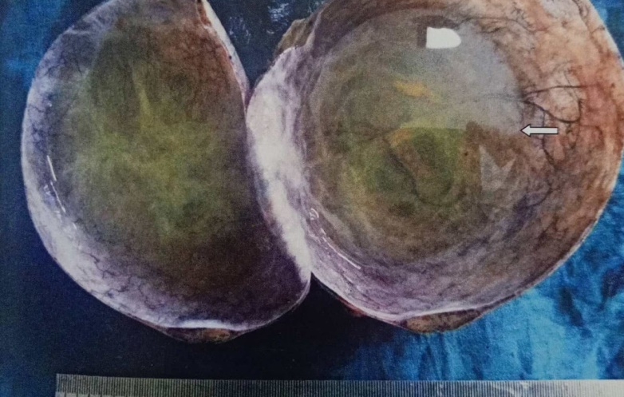
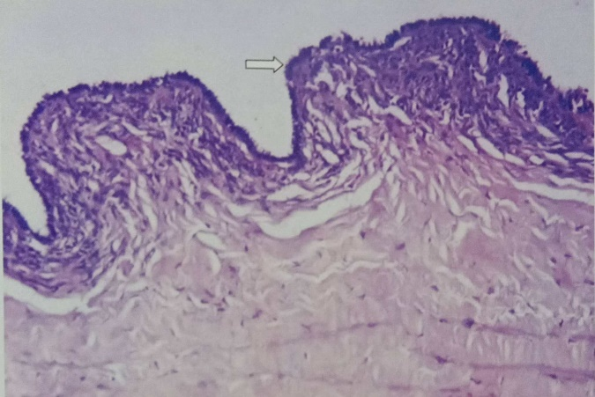
Fig 1: c/s of unilocular serous cystadenoma filled with serous fluid
Fig 2: serous cystadenoma lined by single layer of cuboidal epithelium

Discussion:
In our study, there were total 100 cases, among them 56% were between the age group of 30 to 60 years of age, 34% cases were more than 60 years of age, 10% were less than 30 years of age. Study by Sharma P et al 10 showed that 24.6% were in 41 to 50 years, 22.3% were in 21 to 30 years. Similar to the observations of Valson et al 11 in their study in the year 2017 who reported 30.85% cases in the 5 th decade. Jha and Karki et al12 in 2008 and Kuldeepa et al 13 in 2011 reported maximum number of cases in third decade of life with 26.7% cases and 36.7% cases in third decade respectively, 85% cases had Pain in abdomen as presenting symptom, 64% cases had Menorrhagia, while 21% cases had Distension of abdomen.
Study by Sharma P et al 10 showed that abdominal pain (46.1%) was the most common presenting complaint followed by mass per abdomen with irregular periods (10.7%), lump abdomen, distention of abdomen, and infertility.It was similar with studies done by Mankar et al 14 in 2015 (33.48%) and Kanthikar et al15 (53.33%) where pain in abdomen was the commonest symptom. In a study done by Bodal et al, 16 the commonest presenting feature was abdominal mass (in 69.33% cases). Various Biopsies were received, among them 51% were Hysterectomy, 37% were Unilateral Salpingoopherectomy, 8% were Bilateral Salpingoopherectomy, 4% were Incisional biopsies.
Study by Sharma P et al 10 showed that biopsies were received, among them 46.9% were Hysterectomy, 41.5% were Unilateral Salpingoopherectomy, 7.7% were Bilateral Salpingoopherectomy, 3.8% were Incisional biopsies. Of total 24 cases of Germ cell tumour, 66.7% cases were Mature teratoma, 12.5% cases were Immature teratoma and Dysgerminoma, while only 8.3% cases were Yolk sac tumour.
Study by Sharma P et al 10 showed that 16.9% were benign cystic teratoma, 0.7% had malignant teratoma.Mean age among surface epithelial tumour was maximum 45.2 years, Sex cord –stromal tumour mean was 32.3, germ cell was 34.5 and metastatic was 41.3 years. Study by Amita S Patel et al 16 showed that benign tumours were most commonly reported in reproductive age group from 20 to 40 years of age and malignant surface epithelial tumours were reported in more than 40 years of age group, while malignant germ cell tumours were reported in younger age group from 1 to 20 years of age.
Study by Shahnaz Begum et al 17 showed that mean age of patients with serous cyst adenocarcinoma (n 21) was 44.24 ± 13.33 yrs. In mucinous cyst adenocarcinoma patients (n=7), mean age was 40.57 ± 14.0, (median 35 and mode was 35 yr). Mean age of dysgerminoma (n=4), endometrioid tumours (n=2), yolk sac tumours, was 23.5 ± 4.43; 44±141 and 18±5.60 years respectively. In transitional cell carcinoma (n=1) and poorly differential carcinoma (n=1) mean age was 55 and 45 yrs respectively.
Menstrual irregularities and abdominal pain are the typical symptoms of ovarian tumours in women between the ages of thirty and fifty. The most prevalent type of surface epithelium tumours was discovered to be most common, followed by germ cell tumour then sex cord stromal tumours . Serous cystadenomas are the most prevalent ovarian tumour subtype, followed by benign cystic teratoma and mucinous cystadenoma of age group. Differentiation of a benign tumor from a malignant one is important for determining better management and prognosis. Most of the patients with malignant and benign ovarian tumours have presented in reproductive age adult women (20 – 49 yrs.); and some specific varieties of tumour (e.g. thecoma) presented the extremes of age. Further research of this kind is therefore necessary to distinguish a benign tumour from a malignant one in order to improve care and prognosis.

References;
- Parkin DM, Bray F, Ferlay J, Pisani P. Global cancer statistics, 2002. CA Cancer J Clin 2005; 55:74-108
- Cannistra SA. Cancer of the ovary. N Engl J Med 2004; 351:2519–2529.
- Consolidated Report of Population Based Cancer Registries 2001-2004. National Cancer Registry Program. Indian Council of Medical Research. Bangalore: 2006.
- Jemal A, Siegel R, Ward E, Murray T, Xu J, Smigal C, et al. Cancer statistics, 2006. CA Cancer J Clin 2006; 56:106-30
- King MC, Marks JH, Mandell JB, New York Breast Cancer Study Group.; 302:643. Breast and ovarian cancer risks due to inherited mutations in BRCA1 and BRCA2. Science 2003
- Satagopan JM, Boyd J, Kauff ND, et al. Ovarian cancer risk in Ashkenazi Jewish carriers of BRCA1 and BRCA2 mutations. Clin Cancer Res 2002; 8:3776.
- Crijnen TE, Janssen-Heijnen ML, Gelderblom H, et al. Survival of patients with ovarian cancer due to a mismatch repair defect. Fam Cancer 2005; 4:301.
- Watson P, Bützow R, Lynch HT, et al. The clinical features of ovarian cancer in hereditary nonpolyposis colorectal cancer. GynecolOncol 2001; 82:223.
- Mink PJ, Sherman ME, Devesa SS. Incidence patterns of invasive and borderline ovarian tumors among white women and black women in the United States. Results from the SEER Program, 1978-1998. Cancer 2002; 95:2380.
- Sharma P, Rao PS, Mogra N, Talreja K. Histopathological study of ovarian tumours in a tertiary healthcare centre of southern Rajasthan. Indian J Pathol Oncol 2020;7(4):561-566.
- Valson H, Arakeri S, Davis DM, Divya S. Retrospective study of tumor and tumor like conditions of ovary from a rural hospital in Kerala. Int J Reprod, Contracept, Obstet Gynecol. 2017;6(8):3275.
- Jha R, Karki S. Histological pattern of ovarian tumors and their age distribution. Nepal Med Coll J. 2008;10(2):81–5.
- Kuladeepa AV, Muddegowda PH, Lingegowda JB, Doddikoppad MM, Basavaraja PK, Hiremath SS. Histomorphological study of 134 primary ovarian tumors. Adv Lab Med Int. 2011;1(4):69–82.
- Mankar DV, Jain GK. Histopathological profile of ovarian tumours: twelve year institutional experience. Muller J Med Sci Res. 2015;6(2):107.
- Kanthikar SN, Dravid NV, Deore PN, Nikumbh DB, Suryawanshi KH. Clinico- Histopathological analysis of neoplastic and non-neoplastic lesions of the ovary: A 3-Year prospective study in Dhule. J Clin Diagn Res. 2014;8(8):4.
- Amita S Patel, Jignasha M Patel, Kamlesh J Shah. Ovarian tumors -Incidence and histopathological spectrum in tertiary care center, Valsad. IAIM, 2018; 5(2): 84-93.
- Shahnaz Begum, Ferdousi Begum2 , Nasimul Gani3 , Farhana Rahman4 , Farhana Israt Jahan. Relationship of Age and Different Histological Types of Ovarian Tumors. Bangladesh J Obstet Gynaecol, 2017; Vol. 32(2): 99-105

