Original article:
Study to correlate the clinical and neuroimaging pregnancy related posterior reversible encephalopathy syndrome to predict its outcome
¹DR.ADARSH SHANKAR* , ²DR.JEEVIKA M.U.

¹Junior Resident, Department of Radiodiagnosis, JJMMC,DAVANAGERE,KARNATAKA.
²Professor and HOD,Department of Radiodiagnosis ,Jjmmc,Davanagere,Karnataka.
Corresponding author*

ABSTRACT:
INTRODUCTION: The posterior reversible encephalopathy syndrome (PRES) is a neurological disorder of acute or subacute onset characterized by varied neurological symptoms, which may include headache, disorders of consciousness, confusion, seizures, and focal neurological deficits.Posterior reversible encephalopathy syndrome is commonly encountered in postpartum period with history of increased blood pressure during the antenatal period. It is also known as acute hypertensive encephalopathy. It occurs due to altered integrity of the blood brain barrier.
MATERIALS AND METHODS: Prospective study was conducted in department of radiodiagnosis JJMMC,davanagere,Karnataka for a period of 2 years .All the patient fulfilling the criteria were included in the study with informed consent.
RESULTS: 40 patients were included in our study. All the patient who had involvement of parieto-occipital region along with the involvement of frontal, temporal and cerebellum in some patient were included in the study. In our study,10 patient showed diffusion restriction of which 7 showed reversal of restriction on follow up imaging.3 patient developed intraparenchymal hemorrhage, patients were fully recovered within 4-6 weeks of period after prompt diagnosis and treatment.
CONCLUSION: Patient with clinical history of headache, seizure and altered sensorium during postpartum period need to diagnosed early for appropriate treatment for which neuroimaging should be done. Follow up studies should be done to prevent complications like status epilepticus, cerebral ischemia, intracerebral haemorrhage or intracranial hypertension.

INTRODUCTION:
Posterior reversible encephalopathy syndrome (PRES) is a neurological disorder characterized by a range of neurological signs and symptoms and distinctive neuroimaging findings reflecting vasogenic edema [1]. Both clinical and imaging characteristics are usually reversible [2]. On average, about 40% of all patients diagnosed with PRES require intensive care monitoring and treatment due to severe complications such as status epilepticus, cerebral ischemia, intracerebral haemorrhage or intracranial hypertension [3]. The syndrome was first described in 1996 by Hinchey and colleagues who reported on a series of 15 patients with neurological signs and symptoms including headache, seizures, visual disturbance and other focal neurological deficits [4]. Magnetic resonance imaging (MRI) alterations suggestive of cerebral edema were observed predominantly in the posterior regions [4]
There are two leading theories regarding the pathophysiology of PRES [5]. The first hypothesis proposes a rapid increase of arterial blood pressure up to a hypertensive crisis or emergency, which has been observed in a majority of patients at PRES onset [1]. According to this hypothesis, elevation of blood pressure levels above the upper autoregulatory limit leads to cerebral hyperperfusion, which may cause vascular leakage and vasogenic edema [7]. Increased cerebral perfusion pressure contributes to additional blood–brain barrier dysfunction causing extravasation of plasma and macromolecules through tight junction proteins [6].
Cerebrovascular autoregulation is supposed to preserve a continuous cerebral blood flow independently of systemic blood pressure fluctuations [8]. This is ensured by vasodilation of the cerebral arteries during hypotensive episodes. In contrast, during periods of hypertension, this results in cerebral vasoconstriction. This adaptive mechanism is mainly regulated by pressure and carbon dioxide reactivity, as well as the release of vasoactive substances such as nitric oxide, thromboxane A2 or endothelin-1 from the vascular endothelium [1]. In healthy individuals a continuous cerebral blood flow can be maintained between the lower and upper autoregulatory limits, usually a cerebral perfusion pressure between 50 and 150 mmHg [9].
Various conditions such as arterial hypertension, acute fluctuations of blood pressure or autonomic activity may induce changes of these autoregulatory thresholds. This may lead to increased vulnerability of the cerebral circulation and predispose to cerebral ischemia during periods of hypotension on the one hand, or cerebral hyperperfusion and vascular leakage on the other, when blood pressure rises above the upper autoregulatory limit [10,11]. The ‘‘hyperperfusion theory’’ is supported by observations of elevated or fluctuating blood pressure, or hypertensive episodes in a majority of patients with PRES at disease onset [3].
The second theory regarding the cause of PRES is that the syndrome is triggered by endothelial dysfunction caused by circulating endogenous or exogenous toxins [5]. Arguing for this hypothesis, PRES is frequently observed in patients with (pre)eclampsia, sepsis or during treatment regimens with immunosuppressive agents or cytotoxic medication [12,13,14]. The common factor in these diverse conditions is the presence of endogenic (preeclampsia, sepsis) or exogenic (chemotherapy, immunosuppressive agents) toxins causing endothelial dysfunction [13].
One of the key features of the vascular endothelium is the preservation of vascular integrity by inter-endothelial adhesion molecules. Circulating toxins could trigger vascular leakage and edema formation, and additionally lead to endothelial activation resulting in the release of immunogenic and vasoactive substances [15]. Vasoconstrictive agents released by vascular endothelial cells are thought to mediate cerebral vasospasm, which is frequently observed in PRES patients [2]. In this ‘‘toxic’’ theory, blood pressure elevations occur as a consequence of primary endothelial dysfunction. A variation on the ‘‘toxic/ immunogenic’’ theory is that the trigger is the excessive release of pro-inflammatory cytokines resulting in endothelial activation, release of vasoactive agents, increased vascular permeability and edema formation. This mechanism is regarded as the key feature causing PRES in patients with autoimmune disorders or sepsis [15].
Apart from arterial hypertension, a variety of conditions have been linked to the diagnosis of PRES. PRES has been frequently reported in patients receiving immunosuppressive medication after solid organ, bone marrow or stem cell transplantation [16,17]. The incidence of PRES after solid organ transplantation is reported to be between 0,4 and 6%, whereas up to 8% of patients after bone marrow transplantation may be affected [16,18].
MRI is more sensitive displaying hyperintense lesions in T2-weighted or fluid-attenuated inversion recovery (FLAIR) sequences [2]. MRI lesions reflecting vasogenic edema frequently follow a parieto-occipital pattern [13]. Though usually bihemispheric, lesions may be distributed asymmetrically . Due to the lower density of the white matter, subcortical areas are affected predominantly. However, cortical involvement has also been described [2]. While the parieto-occipital distribution occurs in about 70% of all patients, a frontal sulcus or watershed pattern is also frequently seen [19]. Lesions in other areas such as the cerebellum, brain stem, basal ganglia or the spinal cord are less common [20].
The prognosis of PRES is mainly determined by the underlying condition, since the neurological manifestations are reversible in the majority of patients. However, since PRES is often accompanied by severe complications, neurological sequelae may persist. In a recent retrospective chart review, poor neurological outcome, as defined by a modified Rankin scale score between 2 and 6, was reported in 36% of all patients at hospital discharge [21]. The authors found that preexisting diabetes mellitus and corpus callosum involvement of the PRES-associated lesions were strong predictors of poor outcome. In 81% of cases, neuroimaging findings were reversible on follow-up MRI scans.
MATERIALS AND METHODS:
Prospective study was conducted in department of radiodiagnosis ,JJMMC,davanagere,Karnataka for a period of two years .Prior to the commencement of the study, the ethical clearance was obtained from the Ethics Committee, JJM Medical College , Davanagere.
All the patients fulfilling the selection criteria were explained about the purpose of study and a written informed consent was obtained to participate in the study before enrolment.
Inclusion criteria:
a. Women presenting with eclampsia atleast one episode of seizure in women with >28 weeks gestation.
b. Blood pressure of 140 mm of Hg systolic or 90 mm of Hg diastolic.
Exclusion criteria:
Not willing to participate in the study.
Patient known case of epilepsy, who had organ transplantation, high dose chemotherapy.
Seizures due to metabolic disturbances, lesions or intracerebral infections.

Preparation:
- History and physical examination of all patients was performed.
- Patients were asked to remove all ornaments & metallic accessories.

Technique:
- All the patients underwent MRI scanning at our department on Philips Achieva 1.5 Tesla.
- Patient was placed supine on the table and the area from the vertex to the skull base was included.
PROTOCOL: MRI Brain: T1, T2, FLAIR, GRE & Diffusion sequences.

RESULTS:

Table 1 Age wise Distribution of the cases
Age | Frequency | Percentage
<20years | 7 | 17.5%
21-25years | 14 | 35%
26-30years | 17 | 42.5%
>30years | 2 | 5%

Our study showed high prevalence of cases in the age group of 26-30years accounting for 17 (42.5%) of cases, followed by age group of 21- 25 years which were 14 (35%).

Table 2 . Study distribution according to the gravida
Gravida | Frequency | Percentage
Primigravida | 28 | 70%
Multigravida | 12 | 30%
Total | 40 | 100%
Our study showed out of 40 patients 28 cases (70%) were primi gravida and 12 patients (30%) were multi gravida.

Table 3 . Study distribution according to the mode of delivery
Mode of delivery | Number of patients | Percentage
Caesarean | 32 | 80%
Normal vaginal delivery | 8 | 20%
Our study 32 (80%) cases who were diagnosed with PRES underwent caesarean section and 8 (20%) patients had normal delivery.

Table 4 . Study distribution according to the postpartum day
Postpartum days | Frequency | Percentage
<5days | 11 | 27.5%
6-10days | 17 | 42.5%
11-15days | 10 | 25%
>15days | 2 | 5%
In our study maximum number of patients presented to the hospital between 6- 10 days post-partum followed by <5days postpartum.

Table 5. Distribution bases on clinical features
Clinical features | Frequency | Percentage
Headache | 12 | 30%
Seizure | 21 | 52.5%
Altered sensorium | 7 | 17.5%

Maximum number of patients presented with seizures (52.5%) and headache (30%).

Table 6. Distribution based on the affected areas of brain in imaging:
Affected area | Number of patients | Percentage
Frontal | 22 | 55%
Parieto-occipital | 40 | 100%
Temporal | 20 | 50%
Cerebellum | 8 | 20%
Brainstem | 3 | 7.5%
All 40 patients had involvement of parieto-occipital lobes followed by frontal (55%), temporal (50%), cerebellum (20%) and brainstem (7.5%)

Table 7. Cases distribution of with diffusion restriction
DWI | Frequency | Percentage
Yes | 10 | 25%
No | 30 | 75%
Total | 40 | 100%

Table 8. Comparing follow up imaging
Reversal of the imaging findings after 4 weeks of initial imaging | 37
Developed complications | 3

Out of 40 patients, 10 patients showed diffusion restriction. Out of 10 patients, 7 patients showed reversal of diffusion restriction in the subsequent scanning after 4 weeks from the initial imaging. Three patients developed intraparenchymal haemorrhage.

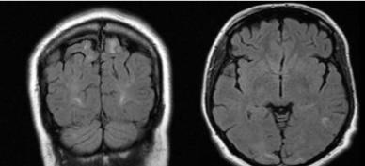
25 years old female with history of seizures with pregnancy induced hypertension shows FLAIR hyperintensities in bilateral parieto-occipital lobe cortex in addition FLAIR hyperintensities are also noted in bilateral cerebellar hemisphere and left temporal lobe.
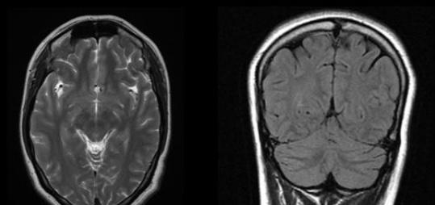
Follow up imaging of the same patient showed complete reversal .

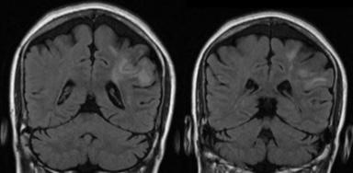
27yrs old female with history of severe headache (postpartum day 2) shows FLAIR hyperintensities in left parietal lobe.

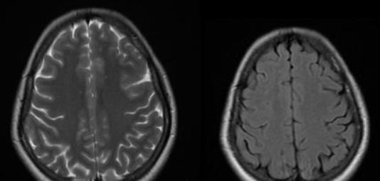
Follow up images shows complete reversal.

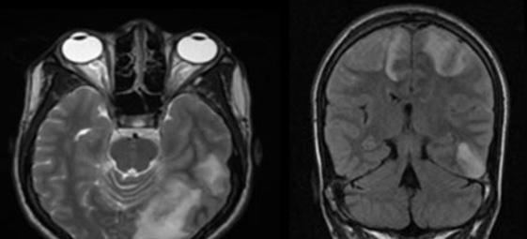

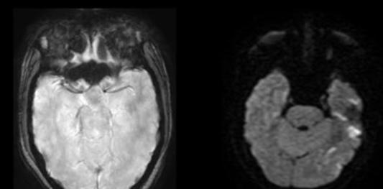

29yrs old female with history of headache and seizure(postpartum day 9) shows T2/FLAIR hyperintensities in bilateral parietal,left occipito-temporal lobe cortex,subcortical white matter with diffusion restriction at left temporal and occipital lobes.No evidence of blooming.

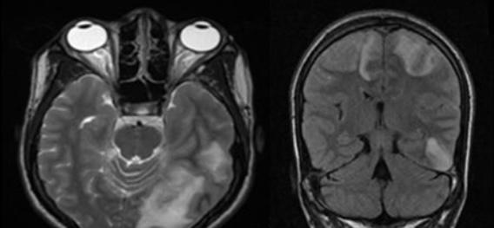
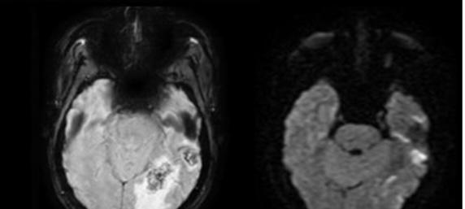
Follow up imaging shows FLAIR hyperintensities seen in bilateral parietal,left occipital and temporal lobe cortex and subcortical white matter with diffusion restriction and development of intraparenchymal haemorrhage in left temporal and occipital lobes.

DISCUSSION:
40 cases of Pregnancy with posterior reversible encephalopathy syndrome were studied. Posterior Reversible Encephalopathy Syndrome commonly affects young and middle aged females individuals, the mean age being 19 years to 47years[22] But in our study Posterior Reversible Encephalopathy Syndrome was common in the ages 26-30 years consistent with a study reported from India – (case series of 20 patients by Praveen Kumar et al (23) ,Posterior Reversible Encephalopathy Syndrome, 60% of the patients were in the age group 20 – 30 years. In most of the studies, impaired consciousness was the commonest symptom of Posterior Reversible Encephalopathy Syndrome [3,4,5,20]. But in our study seizures (52.5%) and headache (30%) were the commonest symptoms. The same was observed in the study conducted by Esther V. Hobson [24]. In our study, neuroimaging in pregnancy related PRES demonstrated typical manifestations of symmetrical parieto-occipital subcortical white matter hyperintensities in bilateral hemispheres. Atypical location, asymmetry and diffusion restriction PRES were predictors of poor outcome. In our sztudy,atypical location of PRES showed significant correlation with complications and poor outcome. Early treatment and management of PRES is very important as it prevents development of complications. Neuroimaging plays a major role in the early diagnosis in patients suspected of PRES with a clinical history of eclampsia, therefore patients with suspected PRES should be diagnosed early for the better prognosis. Also consider repeat neuroimaging in patients diagnosed with atypical PRES as they have higher chances of developing complications like intraparenchymal haemorrhages and infarcts.
CONCLUSION:
Patients with history of increased blood pressure during antepartum period and complaining of headache, seizures and altered sensorium in postpartum should undergo neuroimaging for early diagnosis and for the treatment aspect. Atypical presentation has poor outcome and follow up scans should be done to rule out complications.

REFERENCES:
1.Fugate JE, Rabinstein AA (2015) Posterior reversible encephalopathy syndrome: clinical and radiological manifestations, pathophysiology, and outstanding questions. Lancet Neurol 14(9):914–925.
2. Bartynski WS (2008) Posterior reversible encephalopathy syndrome, part 1: fundamental imaging and clinical features. AJNR Am J Neuroradiol 29(6):1036–1042.
3. Lee VH, Wijdicks EF, Manno EM, Rabinstein AA (2008) Clinical spectrum of reversible posterior leukoencephalopathy syndrome. Arch Neurol 65(2):205–210
4.Hinchey J, Chaves C, Appignani B, Breen J, Pao L, Wang A, Pessin MS, Lamy C, Mas JL, Caplan LR (1996) A reversible posterior leukoencephalopathy syndrome. N Engl J Med 334(8):494–500.
5. Bartynski WS (2008) Posterior reversible encephalopathy syndrome, part 2: controversies surrounding pathophysiology of vasogenic edema. AJNR Am J Neuroradiol 29(6):1043–1049.
6.Fugate JE, Claassen DO, Cloft HJ, Kallmes DF, Kozak OS, Rabinstein AA (2010) Posterior reversible encephalopathy syndrome: associated clinical and radiologic findings. Mayo Clin Proc 85(5):427–432.
7.Strandgaard S, Olesen J, Skinhoj E, Lassen NA (1973) Autoregulation of brain circulation in severe arterial hypertension. Br Med J 1(5852):507–510.
8.Lassen NA (1971) Regulation of cerebral circulation. Acta Anaesthesiol Scand Suppl 45:78–80.
9. Meng L, Gelb AW (2015) Regulation of cerebral autoregulation by carbon dioxide. Anesthesiology 122(1):196–205.
10. Kontos HA, Wei EP, Navari RM, Levasseur JE, Rosenblum WI, Patterson JL Jr (1978) Responses of cerebral arteries and 1614 J Neurol (2017) 264:1608–1616 123 arterioles to acute hypotension and hypertension. Am J Physiol 234(4):H371–H383
11. MacKenzie ET, Strandgaard S, Graham DI, Jones JV, Harper AM, Farrar JK (1976) Effects of acutely induced hypertension in cats on pial arteriolar caliber, local cerebral blood flow, and the blood-brain barrier. Circ Res 39(1):33–41.
12.Bartynski WS, Boardman JF, Zeigler ZR, Shadduck RK, Lister J (2006) Posterior reversible encephalopathy syndrome in infection, sepsis, and shock. AJNR Am J Neuroradiol 27(10):2179–2190
13. Lamy C, Oppenheim C, Mas JL (2014) Posterior reversible encephalopathy syndrome. Handb Clin Neurol 121:1687–1701.
14. Mayama M, Uno K, Tano S, Yoshihara M, Ukai M, Kishigami Y, Ito Y, Oguchi H (2016) Incidence of posterior reversible encephalopathy syndrome in eclamptic and patients with preeclampsia with neurologic symptoms. Am J Obstet Gynecol 215(2):239 e231–239 e235.
15. Marra A, Vargas M, Striano P, Del Guercio L, Buonanno P, Servillo G (2014) Posterior reversible encephalopathy syndrome: the endothelial hypotheses. Med Hypotheses 82(5):619–622.
16. Bartynski WS, Tan HP, Boardman JF, Shapiro R, Marsh JW (2008) Posterior reversible encephalopathy syndrome after solid organ transplantation. AJNR Am J Neuroradiol 29(5):924–930. 17. Masetti R, Cordelli DM, Zama D, Vendemini F, Biagi C, Franzoni E, Pession A (2015) PRES in children undergoing hematopoietic stem cell or solid organ transplantation. Pediatrics 135(5):890–901.
18. Wu Q, Marescaux C, Wolff V, Jeung MY, Kessler R, Lauer V, Chen Y (2010) Tacrolimus-associated posterior reversible encephalopathy syndrome after solid organ transplantation. Eur Neurol 64(3):169–177.
19.Bartynski WS, Boardman JF (2007) Distinct imaging patterns and lesion distribution in posterior reversible encephalopathy syndrome. AJNR Am J Neuroradiol 28(7):1320–1327.
20. McKinney AM, Short J, Truwit CL, McKinney ZJ, Kozak OS, SantaCruz KS, Teksam M (2007) Posterior reversible encephalopathy syndrome: incidence of atypical regions of involvement and imaging findings. AJR Am J Roentgenol 189(4):904–912.
21. Hinduja A, Habetz K, Raina S, Ramakrishnaiah R, Fitzgerald RT (2016) Predictors of poor outcome in patients with posterior reversible encephalopathy syndrome. Int J Neurosci 1–10.
22.Legriel,pico, azoulay – understanding posterior reversible encephalopathy syndrome. Annual update in intensive care and emergency medicine 2011.
23.Yadav PK, Sen D. Clinicoradiological Profile and Outcome of Patients with Posterior Reversible Encephalopathy Syndrome. The Journal of the Association of Physicians of India. 2019 Jan;67(1):13-6.
24. Hobson EV, Craven I, Blank SC. Posterior reversible encephalopathy syndrome: a truly treatable neurologic illness. Peritoneal Dialysis International. 2012 Nov 1;32(6):590-4.

