Original article:

Cartridge based nucleic acid amplification test (CBNAAT): A boon for early diagnosis of pulmonary and extra pulmonary tuberculosis

*Dr. Tanvi Narayan Khirade1, Dr. Vimal S. Rathod2, Dr. Sanjaykumar More3, Dr Supriya Emekar⁴

1 Junior Resident Third, Dept of Microbiology, Dr. Shankarrao Chavan Government Medical College and Hospital, Vishnupuri, Nanded.
2 Associate Professor, Dept of Microbiology, Dr. Shankarrao Chavan Government Medical College and Hospital, Vishnupuri, Nanded.
3 Professor and Head of Department, Dept of Microbiology, Dr. Shankarrao Chavan Government Medical College and Hospital, Vishnupuri, Nanded.
⁴ Associate Professor, Dept of Microbiology, Dr. Shankarrao Chavan Government Medical College and Hospital, Vishnupuri, Nanded.
Corresponding author *

This work is licensed under a Creative Commons Attribution-NonCommercial 4.0 International License
Date of submission: 12 January 2023
Date of Final acceptance: 19 March 2023
Date of Publication: 30 March 2023
Source of support: Nil
Conflict of interest: Nil

ABSTRACT
Background: Rapid detection of MTB and RIF resistance are very essential for effective disease management. CBNAAT is an automated, semi-quantitative real time PCR assay designed for the rapid and simultaneous detection of MTB and RIF resistance. So this study was done to assess prevalence of TB and RIF resistance by CBNAAT.
Material & Methods: Study was carried out on 2315 pulmonary and extra pulmonary samples as per RNTCP guidelines for TB detection and RIF resistance by CBNAAT Xpert MTB/Rif assay technique according to manufacturer instructions (Cepheid) in the department of microbiology at DRSCGMC, Nanded from July ‘2020 to May ‘2022.
Results: Out of 2315 samples, 409 (17.66%) were MTB positive and 30 (1.29%) were RIF resistant. Our study shows male predominance with 12.22%.
Discussion: Our study results of pulmonary and extra pulmonary TB show male predominance which compare with the study by Gupta et al (66.6%), Desai et al (64.86%)⁶ and Sumangala et al (67%). Prevalence of RIF resistance was noted to be 1.29% which resemble with study by Sowjanya et al where it was 1.9%⁷.
Conclusion: Gene Xpert MTB/RIF assay is a good screening tool for diagnosis of MTB and detection of RIF resistance within 2 hours.
Key word: CBNAAT, MDR

INTODUCTION
Tuberculosis (TB) is a major public health problem associated with high mortality worldwide. India is the highest TB burden country in the world having an estimated incidence of 26.9 lakh cases in 2019 reported by (WHO)^{1,2}. Geographically, most TB cases were in the regions of South-East Asia. MDR-TB is defined as resistance to rifampicin and isoniazid the two most effective first-line anti-TB drugs^{1,2}. In India the burden of multi drug Rifampicin-resistant TB (MDR/RR-TB) was 2.8% with interval ranges from 2.3 to 3.5 % in newly diagnosed cases of tuberculosis and it was 14 % with interval ranges from 12- 14% with previously treated case of tuberculosis. Early diagnosis is needed for early patient management and successful treatment. Emergence of MDRTB has become a significant obstacle for Tuberculosis (TB) control. Rifampicin (RIF) resistance is important indicator of MDRTB. Rapid simultaneous detection of Mycobacterium tuberculosis (MTB) and RIF resistance are very essential for effective disease management. Mycobacterial culture is considered as the gold standard but is slow and usually takes 2–6 weeks to get the final result. CB-NAAT is an automated, semi-quantitative real time PCR assay designed for the rapid and simultaneous detection of Mycobacterium tuberculosis and Rifampicin resistance within 2 hours. 'Rifampicin' resistance is a surrogate marker of MDR-TB³. So, this study was done to assess usefulness of CBNAAT for rapid detection of MTB and RIF resistance in MDRTB suspected cases.

MATERIAL AND METHODS
The study was carried out in the Department of Microbiology at Dr. Shankar Rao Chavan Medical College Nanded. In the present study, samples presumptive of TB since July 2020 to May 2022 were subjected to CBNAAT for the diagnosis of TB and Rifampicin resistant
Inclusion Criteria
- Patients with clinical suspicion of pulmonary and Extra pulmonary TB
- Both new cases and previously treated cases
Exclusion Criteria
- Samples received without clinical history

A total of 2315 pulmonary and extra pulmonary samples of suspected TB and MDRTB cases including both new cases and previously treated cases were included. All the samples were collected in special falcon tubes, sputum sample collected after thorough rinsing of the oral cavity with clean water. All the details of the patients like Name, Address, Age, Sex, and History of contact, HIV status, socioeconomic status and treatment received were noted. The gene expert assay was performed according to manufacturer instructions (CEPHEID). In this study pulmonary and extra pulmonary samples presumptive of TB were processed as per RNTCP guidelines for TB detection and RIF resistance by CBNAAT Xpert MTB/Rifassay technique.
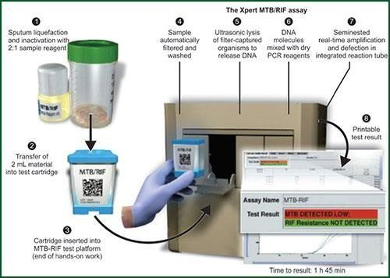
The results can be distinguished as MTB detected, MTB not detected, RIF resistance detected; RIF resistance not detected.
RESULTS
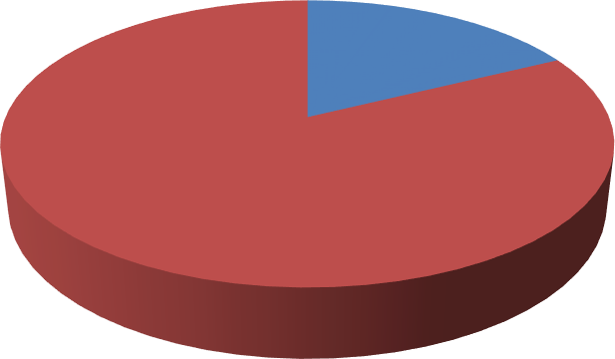A total number of 2315 samples were collected from suspected cases of pulmonary& extra pulmonary tuberculosis and were tested on Gene Xpert MTB/Rif assay. Out of 2315 samples, MTB was detected in 409 (17.66%) (Figure 1) and RIF resistance was found in 30 (1.29%). (Table:1). MTB and RIF resistance was more commonly seen in males than females (12.22%) (Table No. 2 and Figure No. 2). In this study, we observed RIF resistance which is a surrogate marker of MDR-TB in 1.29%.
Figure 1: Detection of Mycobacterium tuberculosis by
Cartridge-based nucleic acid amplification test

MTB POSITIVE (17.66)
MTB NEGATIVE (82.33)

Table 1- Showing Prevalence of RIF resistance
 | No of samples (n=2315) | Percentage (%)
RIF Sensitive | 2285 | 98.70
RIF Resistant | 30 | 1.29

Table 2- Showing sex distribution of patients positive for MTB

Sex wise distribution | No of patients(n=2315) | Percentage (%)
Male | 283 | 12.22
Female | 126 | 5.44
Total | 409 | 17.66

Figure 2 : Year Wise Sex Distribution of RIF Resistant
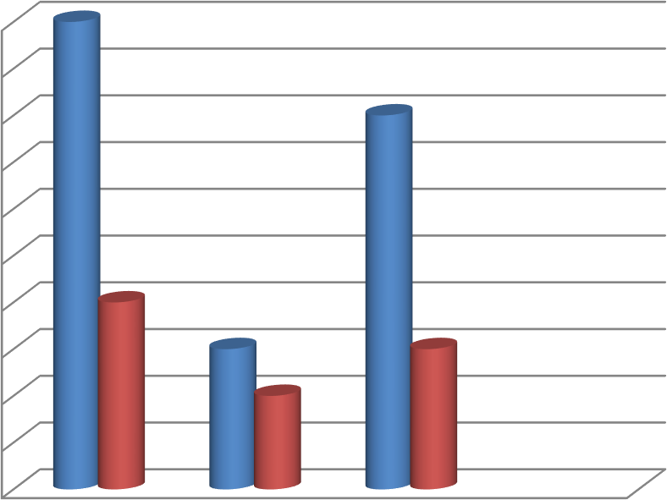
10
9
8
7
6
5
RIF Resistant Male
RIF Resistant Female
4
3
2
1
0
2020
2021
2022

DISCUSSION
In this study MTB was detected in 17.66 % cases. Similar finding was reported by Sachdeva and Shrivastava et al (28.3%) and Youngs et al (38%)⁴. In our study, we observed RIF resistance in 1.29% of suspected cases. This finding is consistent with the finding of D.S. Sowjanya et al (1.9%), Giridhar et al(2%)⁷. However, higher prevalence of MDR-TB has been reported in some other Indian studies like Jain et al (27.8%), Singhal et al 17.9% and Desikan et al (17%)⁹. In this study, we noted a male predominance. This results are correlated with the studies by PremPrakash Gupta et al (66.6% and 33.3%)¹⁰, Desai K et al (64.86%s) and Sumangala V. et al (67%and 33%) which also show male predominance⁶.

CONCLUSION
Missing out a large number of undiagnosed cases of Tuberculosis remains to be a global concern. The development of the Xpert_MTB/RIF assay for the GeneXpert platform is considered as an important breakthrough in the fight against TB. Xpert MTB/RIF is a better screening tool for simultaneous detection of MTB and RIF resistance in a shorter period of time and this could help to improve early recognition of MDR-TB and prevention of its further transmission.
From this study we conclude that RIF resistance cases are found in significant no. of MDR TB suspects using CBNAAT (GeneXpert MTB/RIF).

Acknowledgment
I would like to express my profound gratitude to my PG teacher and guide, Dr. Vimal S. Rathod, Asso. Professor and Dr.Sanjaykumar More, Professor and HOD Dept. of Microbiology, Dr. Sanjaykumar More

SCGMC, Nanded for their constant encouragement and valuable guidance throughout the present study.

References

TB India 2018. RNTCP Annual Status Report, Central TB Division. Available from: https://tbcindia.gov.in/showfile.php?lid=3314.
- WHO. Global Tuberculosis Report; 2012 Available from: http://www.apps.who.int/iris/bitstream/10665/75938/1/9789241564502_eng.pdf
- GeneXpert MTB/RIF Wikipedia. https://en.wikipedia.org/wiki/GeneXpert_MTB/RIF.
- Sachdeva K, Shrivastava T. CBNAAT: A Boon for Early Diagnosis of Tuberculosis-Head and Neck. Indian J Otolaryngol Head Neck Surg 2018; 70:572-7.
- Youngs J, Patil S, Jain Y. A prospective study evaluating the impact of cartridge-based nucleic acid amplification test (CBNAAT) on the management of tuberculosis in a low-resource high-burden Indian rural setting. J Fam Med Prim Care 2018;7:982-92
- Sasikumar C, Utpat K, Desai U, Joshi J. The role of GeneXpert in the diagnosis of Mycobacterium tuberculosis. Adv Respir Med 2020; 88:184-8.
- Sowjanya DS, Behera G, Ramana Reddy VV (2014) CBNAAT: a novel diagnostic tool for rapid and specific detection of mycobacterium tuberculosis in pulmonary sample. Int J Health Res Modern Integr Med Sci (IJHRMIMS), ISSN 2394-8612 (P), ISSN 2394-8620 (O) 0.00 3.00 6.00 9.00 12.00 CBNAAT Microscopy HPR FNAC Culture Negative for TB Positive for TB Fig. 4 Diagnosis of TB as per various relevant investigations Indian J Otolaryngol Head Neck Surg (Oct–Dec 2018) 70(4):572–577 577
- Giridhar, M.K., V. Rao and Setty C.R. 2014. Study of Prevalence of Multi-Drug Resistant Tuberculosis in a Tertiary Care Hospital. Sch. J. App. Med. Sci., 2(1C): 269-273.
- Singhal, R., V.P. Myneedu, J. Arora, N.Singh, M. Bhalla, Verma A, et al. 2015. Early detection of multi-drug resistance and common mutations in Mycobacterium tuberculosis isolates from Delhi using GenoType MTBDRplus assay. Indian J. Med. Microbiol., 33 Suppl (1): 46-52
- Prem Prakash Gupta, Adarsh B Mynalli, Aparna Yadav. Diagnostic role of Cartridge Based Nucleic Acid Amplification Test in Diagnosing Tuberculosis in Patients Co-infected with Human Immunodeficiency Virus. Journal of Medical Science and Clinical Research. Volume 05, Issue 05, May 2017, P 21841-21848.

