Original article:

Platelet Distribution Width And White Blood Cell Count On Admission With St-Segment Resolution In Patients With St Elevation Myocardial Infarction Thrombolysis

With Streptokinase
Dr.M.A.Shakeel Ahmed ¹, *Dr.N.Kirubanand ²

¹ Associate Professor, Department Of Medicine ,Tiruvannamalai Medical College/ Tamil Nadu Dr.MGR University, India
² Senior Assistant Professor, Department Of Medicine , Tiruvannamalai Medical College/ Tamil Nadu Dr.MGR
University, India
Corresponding Author *

Abstract:
There is an alarming rise in the incidence and mortality of myocardial infarction. In the context of management of myocardial infarction there are few strategies and indicators to risk stratify patients. Taking the hypothesis that platelets produced during an acute thrombotic event is larger and aggressive we studied the relationship between platelet distribution width (which is a more specific marker of platelet size variation) and the success of thrombolysis in patients with STEMI treated with streptokinase as evidenced by ST segment resolution in ECG after thrombolysis (an ST segment resolution of more than 50% after 60 minutes of thrombolysis is taken as successful thrombolysis). We found that more the Platelet Distribution Width (cut off taken as 12.85) there is more chance of failed thrombolysis. We also studied the relationship between WBC count and ST segment resoulution in the same set of patients and found out that more the WBC count (cut off taken as 12,650 cells per microlitre) at presentation, more is the chance of failure of thrombolysis. Hence these simple markers can be used to prognosticate the treatment and the disease warranting more aggressive and alternative therapies in these set of patients.
Keywords : STEMI, Platelet Distribution Width, ST segment Resolution, WBC count , Thrombolysis.

Introduction
Cardiovascular disease is on the rise , accounting for upto 16 million deaths globally in 2010 [1]. Ischemic heart disease (IHD) is a condition which comprises inadequate supply of nutrients to the myocardium and occurs typically when there is mismatch between oxygen supply and demand. Ischemic heart disease can present as the following syndromes : Myocardial Infarction (MI), Angina pectoris, Chronic IHD with heart failure and sudden death. Acute myocardial infarction (AMI), unstable angina (UA) and sudden cardiac death (SCD) are referred to as acute coronary syndromes sharing the pathology of plaque disruption or acute plaque change [2]. The early risk stratification for ST segment Elevation Myocardial Infarction (STEMI) aim to provide early access to known therapies which will improve outcome. The mainstay of treatment in STEMI is fibrinolysis in a patient who presents to the hospital with no Percutaneous Coronary Intervention (PCI) or could not be transferred to a PCI centre and who has no contraindications for thrombolysis [3] .ST segment Resolution(STR) remains a cost effective solution to assess reperfusion after fibrinolysis in STEMI [4] . It is well established that large platelets are involved in the development of atherosclerotic plaques and Acute Coronary Syndrome(ACS) [5] . Studies have shown that patients with elevated White Blood Cell Count (WBC- C) during acute myocardial infarction are at higher risk of mortality and recurrent AMI [6] . Here my study aims on the relationship between platelet distribution width and white blood cell count with ST segment resolution in patients with acute ST elevation myocardial infarction treated with streptokinase.

Materials And Methodology
Study design :
This is a cross sectional study.

Patient selection
100 patients admitted to Tiruvannamalai Medical College Hospital with ST segment elevation myocardial infarction and who are candidates for thrombolysis during the time period from 1st July 2014 to 30th June 2015.

Inclusion criteria
- Patients admitted with ST segment elevation myocardial infarction who are treated by streptokinase.
- Presenting within 6 hours of chest pain.
- Without any contraindication for thrombolysis.
- Age group from 20 to 100 years.

Exclusion criteria
- Previous history of coronary artery heart disease.
- Known case of bleeding diathesis.
- Abnormal platelet counts .
- White blood cell counts more than 25000 cells /microlitre.

Techniques
History and examination
Patients admitted in the casualty with ST segment elevation myocardial infarction are taken a detailed history to find out the duration of symptoms, any contraindications for thrombolysis, any previous history of coronary artery heart disease and any previous history of bleeding tendencies. Those patients who meet the inclusion criteria are taken up into the study. Patients who present within six hours of myocardial infarction but with contraindications to thrombolysis are not included in the study. A detailed clinical examination of all the systems were done.

Complete hemogram
A blood sample was drawn from the patients and sent for a complete hemogram to find out the platelet distribution width and white blood cell count. The hemogram is done with an automated analyser. Patients with gross abnormalities in the platelet counts and white blood cell counts are not included in the study.

Electrocardiogram
The eligible patients are then thrombolysed with streptokinase. A follow up electrocardiogram was taken to assess the percentage of ST segment resolution on comparison with the first electrocardiogram taken in the casualty before thrombolysis. Patients with more than 50% of ST segment resolution are taken as successful thrombolysis.

Results
The p value of 0.913 shows that there is no significant association between area of myocardial infarction and ST segment resolution.

Table no : 1 - duration of myocardial infarction and st-segment resolution

DURATION OF MYOCARDIAL INFARCTION | STR  MORE THAN 50 % | STR  LESS THAN 50 %
LESS THAN 3 HOURS | 35 | 4
MORE THAN 3 HOURS | 10 | 51

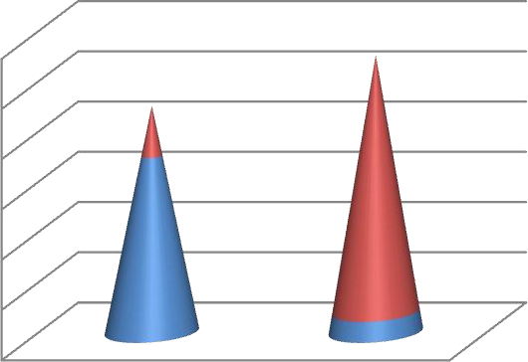
60
50
40
30
20
10
0
DURATION OF MI > 3
HOURS
DURATION OF MI < 3 HOURS
MORE THAN 50 LESS THAN 50 %
%
P VALUE : <0.001
The above p value shows that there is significant association between the duration of myocardial infarction and ST segment resolution. More the duration of myocardial infarction lesser the ST segment resolution.

Table no 2- door to needle time and st-segment resolution

DOOR TO NEEDLE TIME | STR  MORE THAN 50 % | STR  LESS THAN 50 %
LESS THAN 30 MINUTES | 37 | 9
MORE THAN 30 MINUTES | 8 | 46
Chart no 2- door to needle time and st-segment resolution
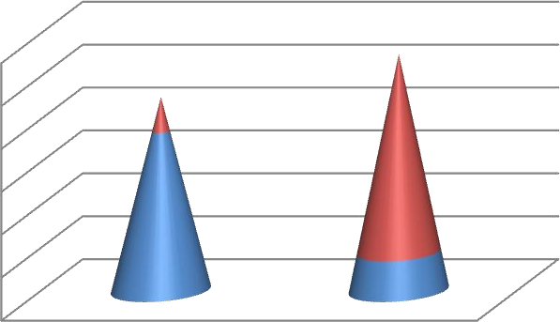
60
50
40
30
20
10
0
DNT > 15 MIN
DNT < 15 MIN
more than 50% less than 50%

ST-SEGMENT RESOLUTION
The p value of <0.001 shows that there is significant association between door to needle time and ST segment resolution. More the door to needle time, lesser is the ST segment resolution.

Table no : 3- st-segment resolution and hospital stay
HOSPITAL STAY | STR  MORE THAN 50% | STR  LESS THAN 50 %
LESS THAN 3 DAYS | 43 | 26
MORE THAN 3 DAYS | 2 | 29

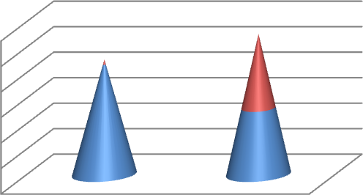
60
50
40
30
20
10
0
HOSPITAL STAY > 3
DAYS
HOSPITAL STAY < 3 DAYS
MORE THAN 50 STR LESS THAN
% 50 %

ST-SEGMENT RESOLUTION
The p value of <0.001 shows that there is significant association between ST segment resolution and hospital
stay. Patients with more than 50% resolution had a lesser hospital stay than those patients who had less than 50% resolution.

Table no :4 - st-segment resolution and mortality at 30 days

MORTALITY AT 30 DAYS | STR  MORE THAN 50 % | STR  LESS THAN 50 %
ALIVE | 44 | 47
NOT ALIVE | 1 | 8
Chart no : 4 - st-segment resolution and mortality at 30 days
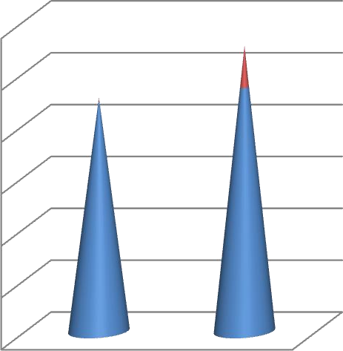
60

50

40

30

20
NOT ALIVE @ 30 DAYS
ALIVE @ 30 DAYS
10

0
MORE THAN LESS THAN 50
50 % %

ST-SEGMENT RESOLUTION
The p value of 0.032 shows that there is no significant association between ST segment resolution and mortality at 30 days.
Table no :5 - wbc- count and st- segment resolution

ST-SEGMENT RESOLUTION | WBC COUNT LESS THAN 12650 | WBC COUNT MORE THAN 12650
MORE THAN 50 % | 39 | 6
LESS THAN 50 % | 11 | 44

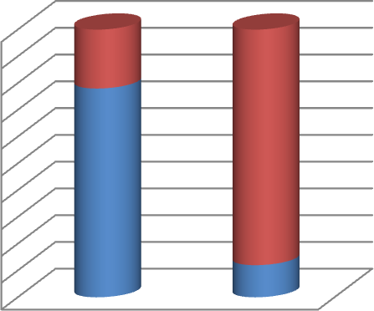
50
45
40
35
30
25
20
15
10
5
0
STR LESS THAN 50 %
STR MORE THAN 50
%
LESS THAN MORE THAN
12650 12650

WBC-COUNT
The p value of <0.001 shows that there is significant association between white blood cell count and
ST segment resolution. Higher the white blood cell count, lower the ST segment resolution.

Discussion
Coronary thrombosis is a known cause of mortality since the beginning of 19th century. Eletrocardiography (ECG) created by Einthoven in 1902 is the major diagnostic tool for acute myocardial infarction until the present time .The reperfusion era was in the 1950s and 1960s when Fletcher and Verstraete, experimentally were pioneers in the use of thrombolytic agents [7]. The criteria for diagnosing STEMI is ST elevation of more than or equal to 0.1 mV in more than or one inferior or lateral leads or ST elevation of more than or equal to 0.2 mV in more than or one anteroseptal precordial leads [8] .
The resolution of ST segment in ecg after thrombolysis was studied as a prognosticator for patients with Acute Myocardial Infarction. It was elucidated in previous studies that ST segment resolution more than 70% in three hours after thrombolysis favours a good outcome in terms of reperfusion of the coronaries, short term and long term mortality. ST segment resolution less than 30 % is found to have an adverse outcome in patients thrombolysed for acute myocardial infarction [19] . Schroder et al tried to analyse the prognostic power of ST segment resolution for the outcome of acute myocardial infarction by taking data from the Intravenous Streptokinase in Acute Myocardial Infarction (ISAM) study which has a well characterized and large population group in which multivariate analytic study was performed. They had three groups with ST resolution less than 30 %, 30 to 70% and more than 70% at three hours of thrombolysis. Several outcomes like size of infarct by creatinine kinase MB curve area, left ventricular ejection fraction and short term mortality were analysed. There are also studies done by Saran et al. [20] who studied a cut off point of 30 % in three hours of thrombolysis and Barbash et al. [21] who studied a cut off of 50% in one hour of thrombolysis. All these studies showed an adverse outcome in patients with inadequate ST segment resolution. ST segment resoulution has been studied for years together not only to represent coronary reperfusion but has also been studied in comparison with the gold standard coronary angiography for coronary reflow. It has been stated that coronary angiography gives an illusion on coronary reflow [22] . There was a search for more physiological indicators of coronary reperfusion , that is ST segment resolution and contrast echocardiography [23] . There has also been studies to say that ST segment resolution is better than coronary angiography for coronary reperfusion [24] . When several studies give various cut off for ST segment resolution to stratifty patients and their risk, Per Johansen et al. studied what level of ST segment resolution and in what time to be identified to risk stratify patients. They studied different ST segment resolution cut offs at different times and found that a resolution of more than 50% in 60 minutes was found to have a favourable outcome.
Platelet indices
Platelets are anucleate cells, smaller in size and they play an essential role in the process of primary hemostasis and thrombosis . Newly formed or young platelets are functionally active [25] .
Following are the specialised functions of platelets and they are change in shape, adherence, aggregation, secretion , action of procoagulation and retraction of clot.There are several indices derived from the platelets by using automated analysers. They include the Mean platelet Volume (MPV), the Platelet Distribution Width (PDW), Plateletocrit, and the Platelet Lymphocyte Ratio (P-LCR). The clinical implications of these indices are under elaborate study [26] .

Mean platelet volume (MPV)
The assessment of volumes, size and shapes of platelets provide useful clinical and pathophysiological characteristics of platelets. The platelet function is directly proportional to the Mean Platelet Volume. It is studied that large platelets are more functional and are more granular . these concepts are proved in in-vivo studies. Platelets with a high mean platelet volume respond more aggressively to platelet agonists like collagen, ADP, arachidonic acid. They express more adhesion molecules like GPIIb/IIIa and are more prothrombotic [27,28] .

Megakaryocyte platelet axis
Platelets do not contain nucleus and they cannot synthesize any proteins. They are heterogenous in nature in respect to their shape, size and density . The protein content and the reactivity of platelets are pre determined before they are released. Megakaryoctyes have a unique property of redoubling their chromosomes without a mitotic division and this is called as the process of endomitosis. Using this process megakaryoctes can produce 14N to 128N ploidy cells. The modal ploidy being 16 N ( the normal ploidy being 2N). Each cell produce around 1000-2000 cells which are the fragmentary processes of megakaryocytes. The specialized axis termed the MPHA (megakaryocyte-platelet hemostatic axis). The platelet mass and the platelet count are inversely proportional to the mean platelet volume. The platelet count and mean platelet volume product is always a constant. Bleeding time is inversely related to the MK ploidy. Whenever there is platelet destruction, there is increase in MPV and MK ploidy will remain the same . but when there is platelet synthesis, MK ploidy increases. So both these parameters can change either independently or together depending upon the needs and hemostatic situation [27] .

Platelet volume measurement
There are several methods to measure platelet volume. The basically used method is using the coulter principle in which cells are allowed to pass through a small aperture in an electrical field which produces a change in voltage depending upon the size of the cells passing through. This is interpreted as a histogram and is analysed to conclude the platelet count and size. The curve is used to calculate the mean platelet volume by the formula MPV(fl)=pct(%)x1000/plt(x10³ per microlitre) [28] .The other method with Technicon instruments uses laser optic technology which interprets the granularity and the size of platelets in suspension. Here light beams are passed through the cells and the scatters are studied. The forward scatter represents the size of the cells and the side scatter denotes the granularity of the cells. MPV is calculated as a mode from the histogram obtained. There is approximately 40 % difference with the Technicon and the Coulter techniques [29] .The normal values for MPV ranges from 4.5 to 8.5 fL (mean – 6.5 fL) [28] .

Platelet distribution width (PDW)
Platelet distribution width shows the heterogenosity in the size of platelets and is derived from the platelet indices from an automated analyzer. The reference range in a study done by Mariela Graniro Farias was derived as 13.3 % as median with a reference range of 10% to 17.9% . Platelet distribution width is a marker of platelet reactivity [30] .When laser technology is used in an analyzer it primarily detects the cross diameter of the cell to derive its volume. Machines using impedance principle focus on the vertical diameter of the cell to asses the cell’s size. Whatever may be the technique used, activated platelets will be larger and is not dependent on the technique of analysis [31] .

Role of platelets in coronary artery heart disease
Whenever there is a stressful situation, the platelets that are produced are larger in size and they posses a very high potential for thrombus formation since they produce more thromboxane B2 . During situations of platelet activation both MPV and PDW increase. This change is hypothesized due to the change in platelet shape from that of discoid to spherical shape to attain larger surface area. These changes can be analyzed by the hematology analyzers that works on the impedance principle discussed already. Platelet activation is a very essential step in the production and propagation of the process of atherothrombosis [32] .
The platelet parameters like MPV and PDW are independent risk parameters in Myocardial Infarction (MI) and stroke indicating worse clinical course and mortality [33]. ST-segment Elevation Myocardial Infarction (STEMI) and failure of thrombolysis is influenced by high PDW values. Also it has been studied that PDW is higher in patients with STEMI rather than stable Coronary Artery Disease (CAD). Rather than just association they also influence the success of thrombolysis in STEMI patients [34]
There are several studies which analysed the risk of Platelet Distribution Width (PDW) in acute coronary syndrome like ST Elevtion Myocardial Infarction. Varasteh-ravan et al. [30] studied the relationship of platelet distribution width in patients with acute STEMI thrombolysed with streptokinase and found that patients with higher platelet distribution width had more risk of thromblysis failure measured by ST segment resolution. PDW can be used as an independent marker of risk of thrombolysis failure and short term mortality in patients with STEMI.

White blood cells
Human white blood cell count is normally 4000 to 11000 cells per microlitre. The most predominant of these cells are the polymorphonuclear leukocytes. Leukocytosis indicates an increase in the blood leukocytes number. As a response to many of the inflammatory states and neoplastic states leukocyte count increases. The increase in leukocyte count depends upon several factors like the storage pool of the precursors, size of the precursors, presence of growth factors, rate of release of the cells from the storage pool, the amount of cells marginating (adhered to) the vessel wall at any time, the extravasation of cells from blood into the tissues [35] .

WBC and ischemic heart disease
The relationship between leukocytes and ischemic heart disease has been studied by several authors. It is also found that WBC count in high normal range is a risk factor for myocardial infarction. Those patients with raised WBC count has a high risk for re-infarction and high in-hospital mortality [36] .
Friedman et al. in 1974 studied the association between WBC count and myocardial infarction. It was found that a raise in the WBC count not only significantly increased the risk of acute myocardial infarction but also the rate of re-infarction. Patients with WBC count more than 10,000 cells per microlitre has double the risk than those patients with a count less than 6000 cells per microlitre. A study in the survivors of Hiroshima and Nagasaki also showed similar results. The risk increases if the patient is a smoker and in later studies it was proved that leukocytosis increases the risk of myocardial infarction independent of smoking. Leukocytosis as a
risk factor is also considered as equal to serum cholesterol level and blood pressure measurement. Surveillance and follow up studies also show that a fall in the WBC count also decreases the risk of myocardial infarction. This hypothesis was also extended to patients with stroke. On differential count examination strong association was found to be with neutrophils. When the risk of myocardial infarction for men with WBC count of 5000 cells per microlitre is set to 1, men with a WBC count of 9000 cells per microlitre is estimated to have a 3.5 times risk of getting a re-infarction [37] . Cole et al. [38] studied that myocardial infarction patients with WBC counts more than 15,000 cells per microlitre had a risk of death in two months than patients with WBC counts less than 10,000 cells per microlitre. It was reported by Maisel et al. [39] that WBC count studied on admission in patients with acute myocardial infarction was found to be an independent risk factor for ventricular fibrillation. Furman and his co-workers [40] studied the association between WBC count on admission and the short term mortality in patients admitted with acute myocardial infarction. Patients with WBC count in the uppermost quintiles had more complicated hospital course and also extensive necrosis of the cardiac muscle. These studies showed the individual risk prediction of admission WBC count on short term mortality following an acute myocardial infarction.
Even in normal circumstances there is slowing of blood flow due to the rheological properties of the white blood cells. They traverse the nutrient capillaries by alteration in their rheology. In certain pathological conditions, this leads to tissue ischemia by a vicious circle [41,42] .WBCs are found to be responsible for the formation of larger thrombus in plaques indicating a marker for hypercoagulable state. It can be due to the following mechanisms.
- Acyte myocardial infarction creates a state of systemic inflammation as evidenced by the ability of plasma from these patients to induce expression of interleukin 8 and interleukin 1 beta.
- The activation of procoagulant activity of monocytes by interleukin 6 and interleukin 8 has been proposed as a link between thrombosis and inflammation. These cytokines increase the expression of tissue factor on the surface of monocytes which increases the procoagulant activity.
- Mac 1 (CD 11b/CD 18) which is a beta 2 integrin causes leukocyte adhesion and also converts factor X to Xa and binds fibrinogen. Platelet adhesion to polymorpho nuclear cells through Mac 1 can also lead to formation of thrombus [43,44] .

WBC count in acute coronary syndrome
There are strong evidences to say that systemic inflammatory response play an important role in acute coronary syndromes [45] . More studies have been done to find the association between white cell count and acute coronary syndrome. It has also been found that high counts are associated with increased mortality and reinfarction and it can also be used as an inexpensive and simple tool to risk stratify patients with acute coronary syndrome [46,47] .

Limitations
Further angiographic correlation could give better picture of the association between platelet distribution width and white blood cell count with coronary flow and prognosis of the patients post myocardial infarction.

Conclusion
The results of our study has shown significant association between platelet distribution width and white blood cell count with ST segment resolution in patients with STEMI thrombolysed with streptokinase. These factors can be used as simple markers for failure of thrombolysis to suggest an alternative and aggressive management protocol for these patients which require further studies in this context.

References
[1]. Kasper, Fauci, Hauser, Longo, Jameson and Loscalzo et al. Harrison’s Principles Of Internal Medicine 19th edition. United States Of America. (Mc Graw Hill); volume 2; 1442.
[2]. Kumar et al. Robbins and Cotran Pathologic Basis Of Disease 7 ^{th} edition.( Pennsylvania. Elsevier); 571.
[3]. Bonow, Mann, Zipes, Libby et al. Braunwald’s Heart Disease : A Text Book Of Cardiovascular Medicine 9 ^{th} edition. (Philadelphia.
Elsevier); 55.
[4]. Shuja-ur-Rehman, Sheikh S, Nazeer M. ST segment resolution post MI – a predictor of better outcomes. J Pak Med Assoc. 2008 May, 58(5) : 283-6.
[5]. Salim R. Hamudi Al-Obeidi, Saad H. Ahmedm, Fatma A. Obeid. Evaluation of Platelet Indices in Patients with Acute Coronary Syndrome. Mustansiriya Medical Journal, June,12(1).2013.
[6]. Lowe GD, Machado SG, Krol WF, Barton BA, Forbes CD. White blood cell count and haematocrit as predictors of coronary recurrence after myocardial infarction. Thromb Haemost. 1985 Oct, 30; 54 (3) : 700-3.
[7]. Brauwald E. Evolution of the management of acute myocardial infarction: a 20th century saga. Lancet 1998; 352: 1771-4.
[8]. Amsterdam E A et al. 2014 AHA/ACC Guidelines for the Management of Patients with Non-ST Elevation Acute Coronary Syndromes. Journal of the American College of Cardiology. Sep 2014.
[9]. Y Birnbaum, B J Drew .The electrocardiogram in ST elevation acute myocardial infarction: correlation with coronary anatomy and prognosis. Postgrad Med J 2003;79:490–504.
[10]. Maroko P, Libby P, Ginks W, Bloor C, Shell W, Sobel B, Ross JJ. Early eﬀ ects on local myocardial function and the extent of myocardial necrosis. J Clin Invest 1972; 51: 2710–6.
[11]. Chazov EI, Matveeva LS, Mazaev AV, Sargin KE, Sadovskaia GV, Ruda MI. Intracoronary administration of ﬁbrinolysin in acute myocardial infarct. Ter Arkh 1976; 48: 8–19.
[12]. Nikhil Sikri, Amit Bardia. A History of Streptokinase use in Acute Myocardial Infarction. Text Heart Inst J 2007;34:318-27.
[13]. Diwedi SK, Hiremath JS, Kerkar PG, Reddy KN, Manjunath CN, Ramesh SS, et al. Indigenous recombinant streptokinase vs natural streptokinase in acute myocardial infarction patients: Phase III multicentric randomized double blind trial. Indian J Med Sci 2005;59:200-7.
[14]. Michels KB, Yusuf S. Does PTCA in acute myocardial infarction affect mortality and reinfarction rates? A quantitative overview (meta-analysis) of the randomized clinical trials. Circulation 1995; 91: 476-85.
[15]. Andreotti F, Pasceri V, Hackett DR, Davies GJ, Haider AW, Maseri A. Preinfarction angina as a predictor of more rapid coronary thrombolysis in patients with acute myocardial infarction. N Engl J Med 1996; 334: 7-12.
[16]. Grines CL, Topol EJ, O'Neill WW et al. Effect of cigarette smoking on outcome after thrombolytic therapy for myocardial infarction. Circulation 1995; 91: 298-303.
[17]. Andreotti F, Patti G. Chronobiology of the haemostatic system. In: Redfern PH, Lemmer B, eds. Handbook of Experimental Pharmacology. Physiology and Pharmacology of Biological Rhythms.( Springer-Verlag, Heidelberg).

