Original article:
Attitude of medical students towards online classes amidst of covid-19 pandemic
Dr. Debjani Laha

Associate Professor, Department of Physiology,
North Bengal Medical College Sushrutnagar, District- Darjeeling , West Bengal, India, Pin Code- 734012
E-mail-lahadebjani.123@gmail.com

ABSTRACT
Background: The internet becomes the “information superhighway”. From its inception, it had grown that it could be accessed in any part of the world. It helped in sharing of information of any kind through different social media. Conventional classroom-based learning, though convenient, natural calamities often compelled us to take alternative decisions- like in recent COVID-19 pandemic.
Objective: To assess their perception and attitude towards online classes after completion of the syllabus.
Methods: Both live classes (synchronous) and recorded classes (asynchronous) were taken. After completion of the course, the Ethics committee clearance had been taken and a survey was undertaken based on the Google Form, and responses were analyzed with Microsoft Excel 365 software. A link of Google form was shared in the WhatsApp of the students.
Result: 136 M.B.B.S students consented for the study. Only 18% of them had proper internet connections. Both kinds of classes were taken. 59% of students preferred recorded classes for ease and repeatability. The main disadvantage they found as there was no practical classes. As a whole, their opinion about online teaching was internet connectivity problems. As 94% of the students use mobile phones as their learning media, had problems like headaches, migraine, eye ache. They get distracted by other social media. Interaction with the teachers had done in streaming classes and for recorded classes students interact with the teachers in WhatsApp group chat.
Conclusion: It was clear that if proper strategies could be taken and if widespread internet connection would be provided then online classes could be effective as classroom teaching
Key words- COVID-19; Pandemic; Live online learning classes; Recorded online learning classes.

INTRODUCTION
Internet provides global communication, access to information, and research. After the invention of smartphones internet is easily accessible to everybody. The regular classroom teaching was the practiced method in India. Students and teachers are convenient with this method. It increases a student’s self-awareness about the learning process and enables him to learn more effectively, it improves social skills also.In recent times the Medical Council of India proposed a new M.B.B.S curriculum. The main idea here is that teachers act as facilitators and help the students for self-directed learning. In the COVID-19 era, it is difficult to pursue regular classroom teaching. So, the only solution would be online teaching.
The Ebola Virus epidemic and civil war in Liberia left the country in need of strengthening the health workforce. E-learning in medical education provided learning opportunities for students, developed faculty competencies, and assists with the retention of healthcare workers. (4) Live classes are prescheduled and a link is shared among the participants. In this type of platform, various tools can be used, like a real or virtual whiteboard, PowerPoint presentation, screen recording, etc. It promotes live discussions, presentations, case studies. Interactions is possible. In the recorded classes, prerecorded teaching materials are uploaded in the e-learning platform, students are sent with a link of the same, and they can see the content at their convenient time. It is a student-centered learning method. The proper feedback system should be there to fulfill the goal of e-learning. After completion of the online classes, I did a survey about the experiences of the students about the classes.
AIMS AND OBJECTIVES
To assess the perception and attitude towards online classes of the first year M.B.B.S students after completion of the syllabus.
MATERIALS AND METHODS
Study design: It was an online questionnaire-based (Google form), observational, cross-sectional study.
Place and duration of the study: done at department of Physiology, North Bengal Medical College, Sushrutnagar, Darjeeling district, West Bengal, India. Duration for submission of the form was two weeks, from 15th to 30th June, 2020.
Sample size and sampling method: All first year M.B.B.S students of both genders were included and approached in the study. They were 200 in numbers.
Method of data collection: A semi-structured Google form was made containing 20 questions. Both structured and open questions were included in that questionnaire. All the students of both genders were approached, but 136 were consented and participated in that survey. Questions were designed such that asked for their demographic record, availability of the internet at their locality, their opinion about types of online classes we provided, media used, problems faced during classes, interaction with teachers and friends, pros and cons of these types of classes. Students were approached through link sharing of the form in a WhatsApp group. Two weeks was provided to them for completing the survey. As their classes were over at that time so that they could give their answers properly.
Ethical approval and consent of the participants: Proposal of the study had been submitted to the Institutional Ethics Committee on 16th May, 2020. They reviewed the proposal they consented for it on 31st May 2020. They considered the fact that in the study, no invasive method would be involved and as it would be a single blinded study, participants’ identity would not be disclosed. After getting the Ethics committee approval, a prospective cross-sectional qualitative study was designed, based on Google Form at the Department of Physiology of North Bengal Medical College, India.
Inclusion and exclusion criteria: No such criteria.
Statistical analysis and software package: In the case of structured questions, data analysis was done by Google form itself, but for open questions, data analysis was done by Microsoft Excel 365 package.

OBSERVATION AND RESULTS
200 students were approached, 136 students consented (68%)

FIG.1
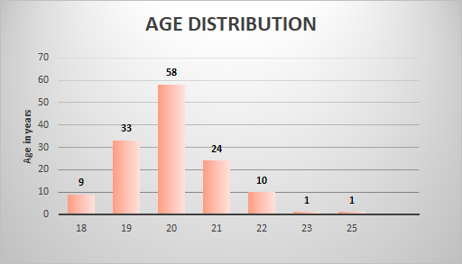
58% of students were of the age group of 22years.(FIG.1)
62% male and 38% were female.
They were asked about if the internet connection allowed them to complete the classes or not, the response was as follows: (FIG.2)
FIG.2
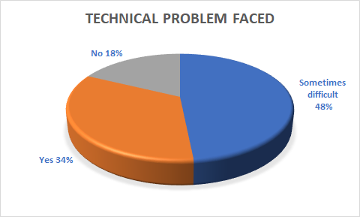

Different departments either uploaded video tutorials or taught by live classes, depending upon the preferences and internet availability. So, when students asked about the, which type of classes they attendant they had more than one type to answer, (FIG.3)

FIG.3
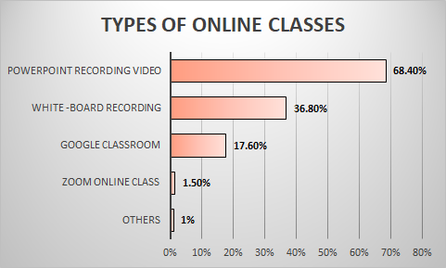
Students asked questions during live classes and after recorded classes as they had a particular WhatsApp group assigned to a particular teacher. They were asked about the same 56.6% of students who gave positive answers.

FIG.4
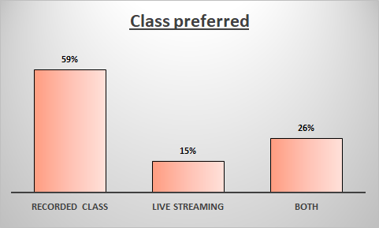
59% of students prefer recorded classes, 15% live classes, and 26% of students like both the classes.
94% of students use the mobile phone as their media of teaching and interaction. Rest used laptops.
When they were asked what were the causes that they preferred live classes, 58% students answered that they had interaction with teachers and friends, 44% of students felt like original classes,56% of students said that they had doubt cleared and 1.6% students thought that it gave them the extra potential for study.
Students who preferred recorded classes, 80% students answered that it was convenient in respect of timing and place, high-speed internet is not necessary for the classes in the opinion of 57% of students, the revision could be possible there (61%), helpful for slow learners so that they can learn with their own pace (55%).
Overall advantages and disadvantages of online classes, when they asked gave the following answers:

FIG.5
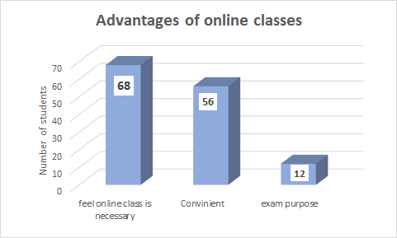

FIG.6
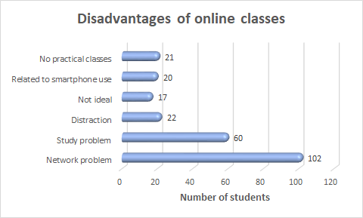

Online tests with MCQ type of questions, average marks obtained were as follows,

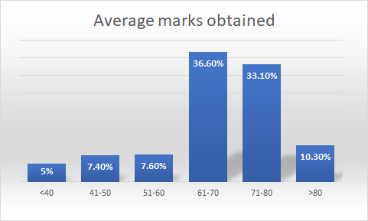
FIG.7

DISCUSSION
It was a questionnaire-based cross-sectional study. 200 students of the first year M.B.B.S. were approached, in whom 136 students consented for the same (68%). A single-blinded study where a semi-structured questionnaire with Google form was made and distributed in the WhatsApp group. The students were allowed to answer anonymously.
After the COVID-19 pandemic, students went to their places. Most of them didn’t have their textbooks with them and only relied on e-books.
When they were asked, whether their net connection permits them to complete their classes, 18.4% of students responded positively. It meant the rest of the students had a problem with internet connectivity.Both the online live classes and the recorded classes were offered to them according to the preference of the teaching departments and availability of the internet facilities. When students were asked what type of classes they had done, they had multiple answers. As both streaming and recorded classes were offered to them and were asked which class type, they preferred, 59% of students preferred recorded classes because they felt it the most convenient in all respects.
Students could be asked questions directly during live classes and in WhatsApp groups of the particular teacher. So, it was obvious if properly planned recorded classes could be made. interactive, as 57% of the students responded that way. Responses made by the teachers by texting, voice chats, sharing links of the video, or sharing pdf documents.
98% of the students used mobile phones as their main media for the tutorials. At that time, they faced internet connectivity problems. At that point, they preferred recorded classes.
Open questions, “what do they think about the advantages and disadvantages of the online classes (both live and recorded classes)?” Advantages they found that, it was only way to pursue the classes, the teaching materials were in front of them and could revise the class at their place and their own pace and timing. The Syllabus was in their hands so they could predict how much they had to read, the classes were also time-saving. As teachers prepared their notes after consulting more than one textbook, the students could get ready-made teaching materials. Some online videos were also linked with the classes for the better understanding of the topic.
They found some disadvantages also. The most prominent problem they complained of was internet availability and connectivity, especially for the students who lived in the remote areas of India. Many times, live classes were missed for that reason.
As discussed earlier, mobile phones were the media of study in most of the cases, though convenient, it had disadvantages of its own. Many students complained, due to a small screen it caused eye-pain, headache, precipitation of migraine and might have some radiation exposures. Moreover, they get distracted by social media while learning and could not concentrate properly. Some experienced as the syllabus was overwhelming and topics were uploaded in quick successions. It led to frustration.
The above discussions pointed out that online classes had both pros and cons. Heeyoung Han Erica Nelson Nathan Wetter in their article titled, “ Medical students’ online teaching and technology needs”, published in 2014, the survey focused on five major areas: students’ hardware and software use, perception of educational technology (ET) in general, online behaviors, perception of ET use in the school, and demographic pieces of information. They concluded that ‘medical students’ ET needs differ between preclinical and clinical years. Technology supporting ubiquitous mobile learning and health information technology systems at the hospital and outpatient clinics can be integrated into clerkship curricula¹.
Online classes need strategies to engage students. In a study by Shuhong Luo and Melanie Kalman, made a series of summary videos for students’ assignments, then investigated their impact on students’ learning. Investigators used exploratory sequential mixed method research design: qualitative phase, quantitative phase. After that they analyzed data and found summary videos had little impact on the learning of the nursing students, after that, they formulated better teaching strategies. Then the result indicated that the summery videos helped facilitate students’ achievements and reinforce previous knowledge, engaging students cognitively, emotionally and socially².
Medical students use smartphones for teaching and learning purposes and it is increasing day by day. Muhammad Zahid Latif et al in their study showed that medical students use the mobile phone for online textbooks (70%), medical podcasts (60%), online lectures (50%), medical calculators (75%)³. So, this study revealed that medical education can be provided by the above means also.
The Ebola Virus epidemic and civil war in Liberia left the country in need of strengthening the health workforce. E-learning in medical education provided learning opportunities for students, developed faculty competencies and assisted with the retention of healthcare workers⁴. A blended classroom consisting of traditional classroom plus online classes were compared with the traditional classroom teaching in a study in a Chinese nursing school with 2nd year nursing students, they prefer blended classes rather than traditional classes⁵.
So, it is a big shift from teacher-oriented classroom teaching to student oriented online teaching where teachers guide the students “how to learn”. As many modes of information starting from text, PowerPoint presentation, podcast, video files are available on the internet, they helped both teachers and students to understand the topic in a lucid way. So, the concept of the “flipped classroom” where the instructional strategy of the teacher focused on students’ engagement and active learning, will emerge as a new concept of teaching, if proper strategy will be taken before designing the classes. Accessibility of the internet and proper designing of the practical classes are the major loopholes of this kind of teaching.

CONCLUSION
As stated in the introduction, purpose of the study was to assess the perception and attitude of the first year M.B.B.S. students, the study fulfilled the purpose. Students were explicitly presented their views, as it was a single blinded study. Both pros and cons they pointed out, their likes and dislikes they expressed.
It was a simple and well-designed study. The method was well validated and could be reproduced easily in the future. It needed few clicks to answer and well suited with modern technology. Some other relevant questions could be included in above study, like ‘what would be the solutions of the problems they faced’, ‘how they study at home’ etc.
The COVID-19 era forced us to think differently being confined at home. It is an era of ‘new normal’. With this study I can understand what are the needs of the students, so I can recommend future improvements to the respective departments. Mobile phones were not ideal media for long term use during classes. With this research the future generation can understand the importance of the personal computers as the learning medium.
LIMITATIONS
The study did not cast light on the solution of the problems, students faced.

ACKNOWLEDGEMENTS
- I acknowledge all my dear students and my colleagues for their cooperation.
- I also acknowledge the contribution of the Ethics committee members in my study

REFERENCES
- Han H, Nelson E, Wetter N. Medical students’ online learning technology needs. The clinical teacher. 2014 Feb;11(1):15-9.
- Luo S, Kalman M. Using summary videos in online classes for nursing students: A mixed-methods study. Nurse education today. 2018 Dec 1;71:211-9.
- Latif MZ, Hussain I, Saeed R, Qureshi MA, Maqsood U. Use of Smartphones and Social Media in Medical Education: Trends, Advantages, Challenges, and Barriers. Acta Informatica Medica. 2019 Jun;27(2):133.
- Walsh S, De Villiers MR, Golakai VK. Introducing an E-learning solution for medical education in Liberia. Annals of global health. 2018;84(1):190.
- Shang F, Liu CY. Blended learning in medical physiology improves nursing students’ study efficiency. Advances in physiology education. 2018 Dec 1;42(4):711-7.
- Dumford AD, Miller AL. Online learning in higher education: exploring advantages and disadvantages for engagement. Journal of Computing in Higher Education. 2018 Dec 1;30(3):452-65.
- James G. Advantages and disadvantages of online learning. Retrieved July. 2002;1:2006.
- Clark T. Disadvantages of collaborative online discussion and the advantages of sociability, fun and cliques for online learning. InProceedings of the 3.1 and 3.3 working groups conference on International federation for information processing: ICT and the teacher of the future-Volume 23 2003 Jan 1 (pp. 23-25).

Date of Submission: 2 August 2020
Date of Peer Review: 18 August 2020
Date of Acceptance: 22 September 2020
Date of Publishing: 28 September 2020
Author Declaration: Source of support: Nil, Conflict of interest: Nil
Ethics Committee Approval obtained for this study? YES
Was informed consent obtained from the subjects involved in the study? YES
For any images presented appropriate consent has been obtained from the subjects: YES
Plagiarism Checked: YES

Author work published under a Creative Commons Attribution 4.0 International License
DOI: 10.36848/IJBAMR/2020/18215.56030

