Original article:
To study and compare the effect of intermittent hypoxic training via breathing exercises on anxiety and fatigue over the professors of various North Indian Universities
*Arushi Chawla (BPT), Dr. Heeral Joshi

Department of Physiotherapy, Manav Rachna International Institute of Research and Studies, Faridabad.
Corresponding author*

ABSTRACT
Objective: Oxygen is the most essential element for our survival so it might be alarming and confusing for us to believe in the therapeutic or beneficial effects of controlled oxygen exposure in order to produce a range of beneficial physiological adaptations. The purpose of this study is to create a hypoxic environment through a lesser known Pranayama technique in yoga known as Nisshesha Rechaka Pranayama to recognize its physiological effects & psychological effects: fatigue & anxiety respectively.
Methodology: Participants fulfilling the inclusion and exclusion criteria underwent 2 weeks of intermittent hypoxic training for 15minutes everyday excluding weekends. Pre and Post anxiety and fatigue levels were assessed by filling up of questionnaires at prior to the commencement and post training. During the training, the oxygen levels and pulse rate of the participants were monitored by a pulse oximeter to establish hypoxia and recognize physical effects respectively. The parameters were analyzed using the Hamilton Anxiety Rating scale and Fatigue Assessment Scale.
Results: There was significant reduction in anxiety and fatigue levels in the participants in comparison with the levels prior to the training. The oxygen saturation levels decreased significantly during training thus confirming a hypoxic environment.
Conclusion: This study showed beneficial effects of short term (15 days) regular intermittent hypoxic training through pranayama practice on anxiety and fatigue levels irrespective of age, gender and BMI in normal healthy individuals.
Keywords: Intermittent Hypoxia, anxiety, fatigue, professors, pranayama, yoga, Nisshesha Rechaka, breathing exercise.

INTRODUCTION
Intermittent Hypoxic Training (IHT) also known as Hypoxic Therapy Technique is aimed at improving overall human physiology and psychology both directly and indirectly by way of adaptation to reduced oxygen. It has been predominantly referred to as the intermittent use of normobaric or hypobaric hypoxia, in an attempt to replicate some of the key features of altitude acclimatization. The aim of the training is to boost the athletic performance at sea level. However, recent studies have established that short term intermittent hypoxic training has beneficial effects on various physiological and mental aspects of the human body in a non-athletic individual as well. [1]

An IHT session includes several minutes of breathing hypoxic (low oxygen) air, alternated with intervals of breathing ambient (normal) air. The training sessions may be repeated several times in variable-length sessions per day, depending on an individual’s need or a specific exercise protocol prescribed by a physician. A hypobaric chamber, also known as decompression chamber or an altitude chamber is usually used for creating an environment of either a low pressure or low oxygen which is essential for experimental and training purposes which primarily aims at increasing endurance levels of athletes and help them with the acclimatization to the challenging environmental conditions on the mountains or in underwater sports.
Since it is not feasible to install a hypobaric chamber in hospitals, clinics or research centers in order to produce hypoxia, various breathing exercises/techniques have evolved over centuries in the field of yoga that produce intermittent hypoxia in the body up to a considerate level thus mimicking the conditions and physiological effects created by a hypoxic chamber. One such category of breathing exercise/yoga technique is known as the “PRANAYAMA” which is the practice of conscious breath control (inhalation and exhalation).
Praṇayama is made out of two Sanskrit words: praṇa (breath) and ayama (restraining, extending, stretching) which is performed in several ways and in various different positions. It usually involves a breathing pattern of inhaling and then suspending exhalation for a brief period, followed by exhaling and then suspending inhalation for a brief period, and in the end, by gradually slowing the inhalation and exhalation. The pattern forces one to consciously change the time/length of breath (deep, short breathing). [2]
The yogic breathing exercises or “Kriya” or “pranayama” that deliver a similar kind of Intermittent Hypoxic Training are ‘Nisshesha Rechaka Pranayama’ (NRP) and ‘Sudarshan Kriya Yoga’ (SKY).
    - Our focus will be mainly on the lesser known variety of pranayama ‘Nisshesha Rechaka Pranayama’ (‘NRP’) which is a type of controlled breathing practice (Pranayama) with roots in traditional yoga. It’s believed to be the simplest method to produce brief, intermittent hypoxia. Nisshesha Rechaka means holding the breath in full expiration (at Residual Volume). The technique causes the emptying of lung alveoli and therefore the blood flowing in alveolar capillaries returns without oxygenation.
    - The carbon dioxide present in the respiratory system is flushed out by hyperventilation and consequently creates a significant stimulus for normal respiration. After this activity the breath can be held for a longer duration. Various studies have demonstrated that ‘NRP’ produces beneficial effects in the body at different physiological and psychological levels. [3]

The NRP Kriya, while creating conditions of brief intermittent hypoxia in the body, significantly increases the ventilatory output of the body. This change occurs because the peripheral chemoreceptors in the carotid bodies present in several areas outside the brain efficiently detect any immediate or sudden changes in the oxygen levels in the blood. Furthermore, the chemoreceptors transmit nervous signals to the respiratory centre in the brain to help regulate the respiratory activity.
Breathing exercises have long been associated with providing relaxation, for stress management, control of psychophysiological states and also in improving organ function. [4]. Similarly, Yoga breathing techniques have been prescribed for the treatment of stress, anxiety and depression. (5).
This study aims to establish beneficial results similar to the above mentioned scenario in university professors.
Teaching is a demanding profession and professors/teachers have consistently been required to convey quality training in various kinds of school programs as they shape the eventual fate of the nation and are likewise required to keep up a collection of intellectual and relational abilities ,which thusly subjects them to work under high-stress circumstances and make them susceptible to a number of psychological and physiological conditions .[6] For starters, chronic stress triggers a range of physical and mental health symptoms. Physically, prolonged stress weakens the immune system and as a result makes the individual prone to further illnesses. Stress also exaggerates pain and reduces physical stamina leading to chronic fatigue symptoms which varies in each individual.
Moreover, prolonged stress may increase risk of heart disease and other ailments. Stress also depletes mental stamina which hampers with the activities of daily living. Common symptoms include irritability, moswings and exhaustion, which may escalate into depression, anxiety and lower quality of life and eventually affect the quality of education that is to be imparted.
Hence the research aims at studying the pre and post effects of ‘Nisshesha Rechaka Pranayama’on anxiety and fatigue levels in university professors.

AIM OF THE STUDY
The aim of the study is to study the pre and post effects of Intermittent Hypoxic Training via breathing exercises on anxiety and fatigue over the professors of various North Indian Universities.

OBJECTIVE OF THE STUDY
To aid college professors cope, with anxiety and fatigue in their daily lives via breathing exercises.
MATERIAL AND METHOD
- Study Design: A comparative, intervention study to assess pre and post effects in specific psychological and physiological variables.
- Sample Size: 30 subjects (professors/assistant professors) were selected irrespective of gender, caste, race etc. and according to the inclusion criteria.
- Study Centre and Location: Manav Rachna International Institute of Research and Studies (MRIIRS), K.D College, Simbhaoli ,Uttar Pradesh
- Sampling: The subjects were selected through simple random sampling.
- Instrumentation: Fingertip Pulse Oximeter, Yoga mat, Stop watch

Inclusion Criteria:-
- Both males and females.
- Subjects aged between 25-50 years.
- Subjects with significant anxiety (<18) and stress (<10) levels/scores in questionnaires prior to administration of breathing exercises.
- Individuals with insomnia, stress, iron deficiency anemia, etc.

Exclusion Criteria:-
- Pregnant females
- Individuals with severe hypertension
- Subjects with poor lung capacity. (COPD, emphysema)

PROCEDURE
  - Before starting the procedure all the subjects were introduced with the protocol of the research and informed consent was signed by the subjects.
  - The subjects included were given two questionnaires- the Fatigue Assessment Scale (FAS) and the Hamilton Anxiety Rating Scale (HARS) prior to the administration of the hypoxic training.
  - The subjects were informed and explained the breathing exercise technique elaborately before the session started.
  - The subjects were made to sit either on a comfortable chair, or on the yoga mat in a specific yoga asana known as the Sukhasana (cross-legged pose).
  - The subjects were requested to close their eyes before and during the commencement of the exercises.
  - The sequence of the training/breathing exercises and relaxation techniques is as follows:-
    - A 15-min recitation of “Om” with Bhastrika Pranayama for 2-3 minutes:-
    - Traditionally, Omkar japa is performed sitting still in a comfortable asana, by reciting “Om” once in a single breath, repeating several times. Thus, while reciting “Om,” one takes deep inspirations and the breath is prolonged to 30 s or even more.
    - Bhastrika or "Bellows Breath,"- air is rapidly inhaled and forcefully exhaled at a rate of 30 breaths per minute. It causes excitation followed by calmness.
- ‘Nisshesha Rechakha’ is a kind of breathing that, in physiological terms means hyperventilation followed by breath holding followed by full expiration.
- The subjects were instructed to breathe in and out rapidly 30 times and at the end of the 30th inhaled breath, they were instructed to hold the breath till maximal breath holding capacity which was followed by prolonged exhalation. This entitles as 1 round.
- The readings denoting the SpO2 levels were taken for 15 days from a fingertip pulse oximeter while the Kriya was performed to check the range of intermittent hypoxia created during the Kriya respectively.
- Each day comprised of 1 session that further comprised of 6 rounds of breathing.
- The subject performed the Kriya with a relaxed mind and was seated on a yoga mat/stool in a quiet environment.
- The whole process took about 15-20 minutes approximately.
- The data was collected for 15 sessions in total (for each subject) distributed over 2 weeks.
- As soon as the Pranayama Kriya was completed the subject was asked to fill the questionnaires at the end of 15 sessions as mentioned above to compare the results from the data collected at the start of the procedure.
- The subjects were asked for any side effects (head ache) after the end of the procedure.
- The subjects were allowed to consume water in between the Kriya in case of any dryness that would be felt in mouth.

FLOW DIAGRAM OF TOTAL EXPERIMENTAL PROCEDURE
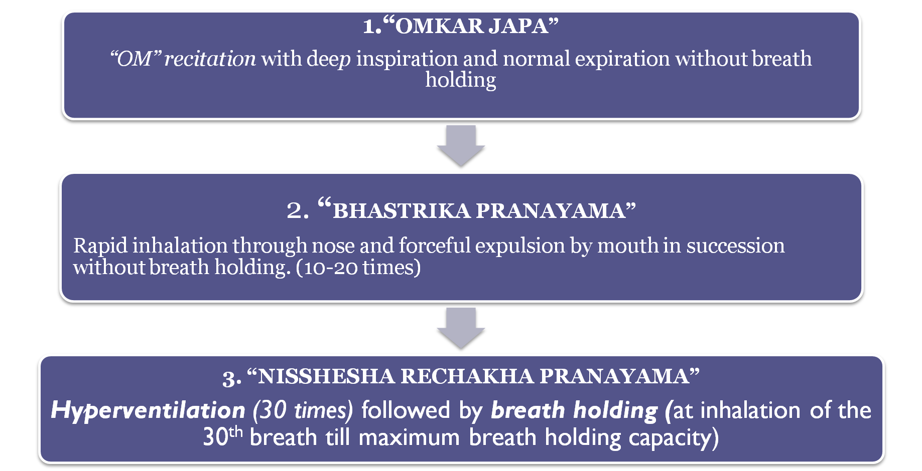

STATISTCAL ANALYSIS
- The arithmetic mean of all the parameters was calculated from the tabulated data of 30 subjects using this formula:
x = ΣX
N

Where:

$\overline{x}$ is the symbol for the mean

Σ is the symbol for summation
Χ is the symbol for the scores
N is the symbol for the number of scores

- Calculation of percentage of Pre and Post mean & standard deviation:-
(Post score - Pre score) X 100
Pre Score

- The formula used for standard was:
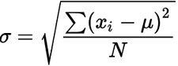
Where,

  - σ = Population standard deviation
  - N = The size of the population
  - x = Each value from the population
i
  - μ = The population mean.

RESULTS
- A total of 30 subjects were included in the study. The result was obtained from the above mentioned questionnaires and instrument readings for the dependent variables-Anxiety & Fatigue. All statistical analysis was carried out on Microsoft Excel and the following results were obtained:

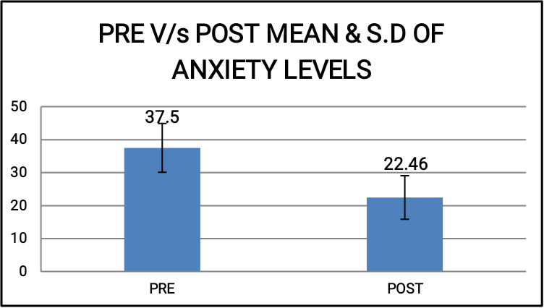
- GRAPH 5.1- Comparison of Pre V/s Post Mean and Standard Deviation (S.D) levels of anxiety.

- GRAPH 5.2-Comparison of pre v/s post levels of fatigue.

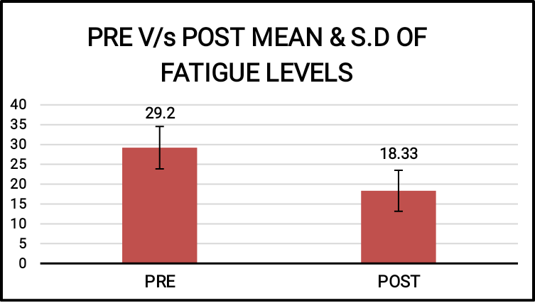

- GRAPH5.3- Decrease in mean values of SpO2 levels during 15days.

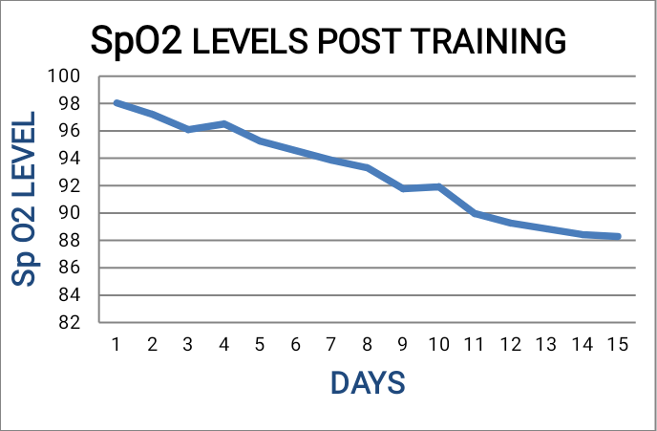

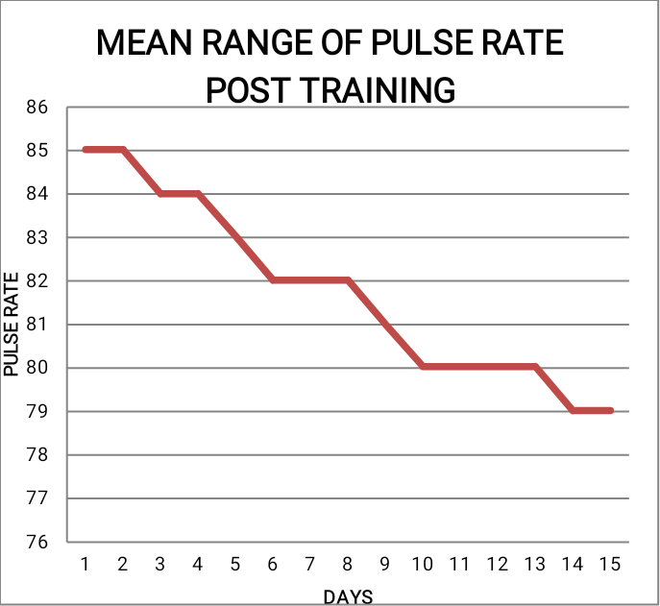
- GRAPH 5.4- Decrease in mean values of pulse rate post training.

DISCUSSION
Various studies have established methods and results that support the fact that Intermittent Hypoxic Training is a beneficial technique to overcome a variety of physical and mental disorders. The clinical application and effectiveness of the technique remains controversial among the researchers. Various studies have established methods and results that support the fact that Intermittent Hypoxic Training is a beneficial technique to overcome a variety of physical and mental disorders.
The present study was carried out to establish a parallel between the impact of a hypobaric chamber amongst athletes and impact of similar training on the non-athletic population (professors).It has tried to determine a similar increase in endurance and resistance to fatigue in the regular population. The study also aimed to compare the pre and post effects of the IHT on anxiety levels in healthy university professors/assistant professors whilst also studying its effect on oxygen saturation levels and Pulse Rate.
30 subjects including both males and females participated in the study. They were given a couple of questionnaires that were supposed to be filled by them once before starting the training and once after completing it. All the subjects were given 1 session each daily for 15 days and the results were monitored simultaneously. In this study, we evaluated the effect of the “Pranayama” technique and tried to establish supporting evidence that the technique resulted in beneficial physical and mental outcomes in the subjects.
The hypoxic training also brings into play the ‘HYPOXIA INDUCIBLE FACTOR-1(HIF-1)’ which has been shown to play a major role in maintaining the oxygen homeostasis in the blood cells and in and also increasing hemoglobin in those cells, eventually increasing overall oxygen concentration in the body.[7].
The short term hypoxic training aimed at mainly improving cardio respiratory function and also at increasing individual awareness about it by voluntary participation.
The professors were keen to improve the breathing techniques i.e. the ‘Kriya’ after each session and also gave valuable feedback about the physiological and mental changes they felt during their teaching hours and during rest of the day after each session.
Nisshesha Rechaka Pranayama required daily practice by the professors as it is tricky to get the correct/required breathing rhythm going once the session commenced. This also eventually helped the participant to acclimatize the body and the overall breathing mechanism to the reduced levels of oxygen in the blood. The participant did not feel any discomfort or major difficulty in breathing during hypoxic periods and the pulse rate was simultaneously monitored.
The findings of my study concur with other previous studies that have reported similar results. Prakash Chintamani Malshe, in 2011 reported that through persistent efforts in creating brief intermittent hypoxia by NRP is the safest way to establish blood oxygen levels up to 88% and sometimes even below or till 80%.
NRP works on increasing the nerve impulses in the brain that stimulate better breathing through chemical regulation in the respiratory control centre. Special nervous peripheral chemical receptors come into play when the blood cells are under hypoxic environment.
The peripheral chemoreceptors are those that specifically detect oxygen changes in blood and transmit nervous signals to the respiratory center in the brain to help regulate respiratory centre. [8]

❑ LIMITATIONS OF STUDY:-
- Study can’t be performed in a noisy environment.
- Study can’t be performed without perfecting the technique.
- The technique involved in the study may not be adapted comfortably by a younger age group in order to practice.
- The study cannot be carried out without the availability of a pulse oximeter.

❑ FUTURE SCOPE:-
- Research technique can be applied on athletes to compare the mental and physiological results between hypoxic training through yoga and hypoxic training through hypoxic chambers.
- The study can be performed on normal population/athletes of other age groups to recognize effects on different variables such as depression, withdrawal symptoms, panic attacks, stress etc.
- The study may benefit pilots in the aviation academies to help them acclimatize themselves to high altitude conditions and manage anxiety.

CONCLUSION
The data collected reveals that the Intermittent Hypoxic Training that produces brief intermittent hypoxia had a positive effect on the anxiety and fatigue levels on the university professors. It revealed that there was also gradual and significant decrease in the dependent variables–oxygen saturation level in blood and pulse rate.
It was an intervention study with a protocol of 15 days.The study proved that a short term yogic breathing program (to create brief intermittent hypoxia) and performing other meditation exercises in a quiet environment helped university professors to deliver education in a more effective and compelling manner as they could deal with their day-to-day anxiety and fatigue efficiently.
It also proved beneficial in improving their overall physiological and psychological status.
The study also throws light on the mechanism of the nervous system of the body which comes into play during the training along with the function of the Hypoxia Inducible Factor or (HIF), which has various effects on various systems in the body. In conclusion the study proved to be beneficial for professors and also created awareness about a new technique to maintain and improve ventilation system in non-athletic individuals through brief intermittent hypoxia.

REFERENCES
- Levine BD. Intermittent hypoxic training: fact and fancy. High altitude medicine & biology. 2002 Jun 1;3(2):177-93.
- Iyengar BK. Light on the yoga sutras of Patanjali. Aquarian/Thorsons; 1993.
- Malshe PC. Nisshesha rechaka pranayama offers benefits through brief intermittent hypoxia. Ayu. 2011 Oct;32(4):451.
- Zope SA, Zope RA. Sudarshankriya yoga: Breathing for health. International journal of yoga. 2013 Jan;6(1):4.
- Brown RP, Gerbarg PL. SudarshanKriya Yogic breathing in the treatment of stress, anxiety, and depression: part II—clinical applications and guidelines. Journal of Alternative & Complementary Medicine. 2005 Aug 1;11(4):711-7.
- Hartfiel N, Havenhand J, Khalsa SB, Clarke G, Krayer A. The effectiveness of yoga for the improvement of well-being and resilience to stress in the workplace. Scandinavian journal of work, environment & health. 2011 Jan 1:70-
- Ziello JE, Jovin IS, Huang Y. Hypoxia-Inducible Factor (HIF)-1 regulatory pathway and its potential for therapeutic intervention in malignancy and ischemia. The Yale journal of biology and medicine. 2007 Jun;80(2):51
- Essentials of Medical Physiology K. Sembulingam

Date of Submission: 05 August 2020 Date of Publishing: 30 September 2020
Author Declaration: Source of support: Nil, Conflict of interest: Nil
Ethics Committee Approval obtained for this study? YES
Was informed consent obtained from the subjects involved in the study? YES
For any images presented appropriate consent has been obtained from the subjects: YES
Plagiarism Checked: YES
Author work published under a Creative Commons Attribution 4.0 International License

DOI: 10.36848/IJBAMR/2020/18215.56085

