Original research article:

Comparison of haemodynamic responses between clinical assessment and neuromuscular block monitoring guided tracheal intubation in patients undergoing general anaesthesia

1Dr. N Periyasamy Sakya 2. Dr.D.ELAVARASAN.*, 3. Dr. C Preethi

1. ASSISTANT PROFESSOR, DEPARTMENT OF ANESTHESIA K.A.P.Viswanatham Government Medical College and Mahathma Gandhi Memorial Government Hospital, Trichy.
2.ASSISTANT PROFESSOR, DEPARTMENT OF ANESTHESIA. K.A.P.Viswanatham Government Medical College and Mahathma Gandhi Memorial Government Hospital, Trichy.
3.SENIOR RESIDENT, DEPARTMENT OF ANESTHESIA, K.A.P.Viswanatham Government Medical College and Mahathma Gandhi Memorial Government Hospital, Trichy.
*Corresponding author

ABSTRACT
BACKGROUND: Haemodynamic responses to tracheal intubation and laryngoscopy poses greater challenges in patients with systemic illness. The purpose of the study was to compare the effects of laryngoscopy and intubation on cardiovascular responses when the appropriate moment for intubation was directed by either clinical judegement of jaw relaxation or by neuromuscular monitoring of TOF assessment
MATERIALS AND METHODS: A total of 60 patients, posted for elective surgeries under general anesthesia , were randomised into two groups as Group C and Group M. In Group M, the patients, were intubated after complete absence of all four responses to train of four count in adductor pollicis muscle, whereas in Group C, the patients were intubated after the clinical judgment of jaw muscle relaxation. Changes in heart rate (HR) , Systolic blood pressure, Diastolic blood pressure and mean arterial pressure, and the time between the administration of a neuromuscular blocking agent and endotracheal intubation were recorded. Results were analysed by the Analysis of variance and chi-square tests. If p value was less than
0.05 , they were considered to be statistically significant
RESULTS: Heart rate and mean arterial pressure were significantly higher in Group C as compared to Group M after laryngoscopy and tracheal intubation (P < 0.05). The mean time required for intubation was significantly shorter in Group C compared to Group M (177.33 ±4.63 s vs. 284.67 ± 8.94 s) and found that more favorable intubating conditions were seen in Group M compared to Group C.
CONCLUSION: Haemodynamic responses to laryngoscopy and tracheal intubation can be significantly attenuated if tracheal intubation was performed following complete paralysis of laryngeal muscles, detected by neuromuscular monitoring of adductor pollicis muscle.
KEY WORDS: Haemodynamic responses , Laryngoscopy , Clinical assessment, Neuromuscular monitoring , TOF.

INTRODUCTION:
Laryngoscopy and endotracheal intubation during induction of general anaesthesia elicits strong nociceptive stimuli, which often leads to unintended stimulation of the sympathetic nervous system. In general, cardiovascular changes accompanying intubation are transient and do not result in significant adverse effects. However, in patients with concomitant coronary artery disease, arterial hypertension or intracranial pathology,
the exaggerated haemodynamic parameters may lead to myocardial ischaemia or secondary brain damage. To blunt this pressor response, many drugs are successfully used[1].

METHODS AND MATERIALS:

STUDY SETTING K.A.P.Viswanatham government medical college and Mahathma gandhi memorial government hospital, Trichy.

STUDY DURATION:
January 2020 to September 2021.

STUDY POPULATION:
Patients posted for Elective Surgeries under General anaesthesia.

RANDOMIZATION AND ALLOCATION
60 patients were randomly divided into two groups of 30 each by computed generated randomization.
GROUP C: OROTRACHEAL INTUBATION UNDER CLINICAL GUIDANCE
GROUP M: OROTRACHEAL INTUBATION UNDER NEUROMUSCULAR MONITOR GUIDANCE

STUDY DESIGN
A prospective randomised interventional controlled study

ETHICAL COMMITTEE
Institutional Ethical Committee approval obtained (I.E.C No . 24/2020)

INCLUSION CRITERIA
ASA Physical status 1 and 2 Patients posted for elective surgery under GA Age between 18 to 60 years Body mass index <30kg/m2 MPC 1 and 2

EXCLUSION CRITERIA
Age <18 years and > 60 years MPC 3 and 4 Uncontrolled systemic diseases Patients with neuromuscular disorders
Anticipated difficult airway Patient refusal

METHODOLOGY
All the patients in the study were evaluated in pre-anaesthetic check-up, informed consent was obtained after informing the patients about the study protocol in their own language. The patients were maintained nil per oral for 8 h and were pre-medicated with Inj Ranitidine 50 mg IV and Inj Metoclopromide 10 mg IV 2 hrs prior to induction. .

In the operating room, monitors including electrocardiogram, non-invasive blood pressure, pulse oximeter, neuromuscular monitor (train of four [TOF] ) and Etco2 were connected and baseline vitals were recorded. Peripheral venous access was secured with 18 G cannula. Anaesthesia was induced with intravenous Inj. Fentanyl 2 μg/kg and 2.5% Thiopentone till the disappearance of the eyelash reflex. After the disappearance of the eyelash reflex, a supramaximal TOF stimulus was applied to the ulnar nerve at the wrist through surface electrodes (stimulation current set at 60 mA) using neuromuscular monitor. Baseline TOF ratio percentage was noted. Vecuronium 0.1 mg/kg was administered over 5 s. After the administration of the vecuronium, patients were ventilated with 1% isoflurane in 100% oxygen till the tracheal intubation. The technique of tracheal intubation was as per randomised group. Totally, 60 patients were randomised into two groups (Group C and Group M). Allocation concealment was done by sequentially numbered sealed envelope technique.
In Group C, the trachea was intubated following clinical assessment of neuromuscular blockade using jaw relaxation. Grade I of jaw relaxation was considered acceptable for intubation. In Group M, the trachea was intubated following neuromuscular block monitoring by TOF. In Group C, the timing of intubation was judged based on clinical assessment starting at 1 min after administration of muscle relaxant and at every 30 s thereafter. The timing of laryngoscopy was based on ease of ventilation, jaw and upper airway tone. Jaw tone was assessed by attempting to open patient's mouth, whereas upper airway tone was determined by amount of jaw support necessary to maintain patent airway.

SCORING SYSTEM FOR JAW RELAXATION
GRADE 1 - Fully relaxed. GRADE 2 - Mild resistance GRADE 3 - Tight but opens. GRADE 4 - Closed.
GRADE 1 was acceptable for Intubation
In Group M, intubation was performed after complete loss of all 4 responses to TOF stimulation (TOF count zero), carried out every 30 s starting at 1 min after administration of vecuronium. The electrical stimulation was done with 60 mA, 2 Hz current lasting 0.2 ms. The trachea was intubated with endotracheal tubes of appropriate sizes. The cuff of the endotracheal tube was inflated over 5 s. The time from administration of neuromuscular blocking drugs to the time of tracheal intubation and cuff inflation was noted. The patients who had oesophageal intubation were excluded from the study. Thereafter, patients were ventilated using 1% isoflurane in oxygen: nitrous oxide (50:50) mixture. The ventilator parameters were adjusted to maintain end-tidal carbon dioxide ranging from 35 to 40 mm Hg.
The primary outcome was HR changes in response to tracheal intubation. HR, SBP, DBP, MAP were recorded at T0 – before shifting the patient to OT table (baseline data), T1 – immediate after vecuronium administration,
T2 – after inflation of the cuff following intubation, T3 – 1 min after intubation,
T4 – 3 min after intubation,
T5 – 5 min after intubation.
The secondary objectives included changes in mean arterial pressure in response to intubation. The laryngoscopic views were also graded as per Cormack–Lehane (CL) grading. The time between the administration of a neuromuscular blocking agent and endotracheal intubation (end of 5s inflation of the sealing cuff) was also recorded.

DATA COLLECTION
The following data were collected during the study
- Demographic data of the patients like Age, Sex, BMI
- Jaw relaxation
- Heart rate , SBP, DBP , MAP at T0 , T1 , T2, T3, T4 , T5
- Time required for intubation
- Complications if any occurred

STATISTICAL ANALYSIS
The observed data was analysed with SPSS software , version 21.0.
The collected data were tabulated and expressed as mean, standard deviation, numbers and percentages.
The comparison between the two groups was done by student t- test for parametric data and chi square test for nonparametric data and the appropriate values were reported as 95% confidence interval.
P value of less than 0.05 was considered statistically significant.

RESULTS
Heart rate level in both Group C and Group M at baseline, at induction, at inflation of cuff and at 1 min, 3 mins and 5 mins following intubation.
The mean heart rate in Group C at baseline was 81.87 ± 9.30.
The mean heart rate in Group M at baseline was 81.53 ± 8.48.
The heart rate response at baseline was statistically insignificant with p value of 0.885.
The mean heart rate in Group C was 102.60± 9.67, 104.50±9.74, 105.33±9.75, 105.00±9.60 at inflation of cuff, 1 min, 3 min, 5 min following intubation respectively.
The mean heart rate in Group M was 85.43±8.48, 85.30± 7.70, 83.27±7.71, 84.67±7.33 at inflation of cuff, 1 min , 3 mins, 5 mins following intubation respectively.
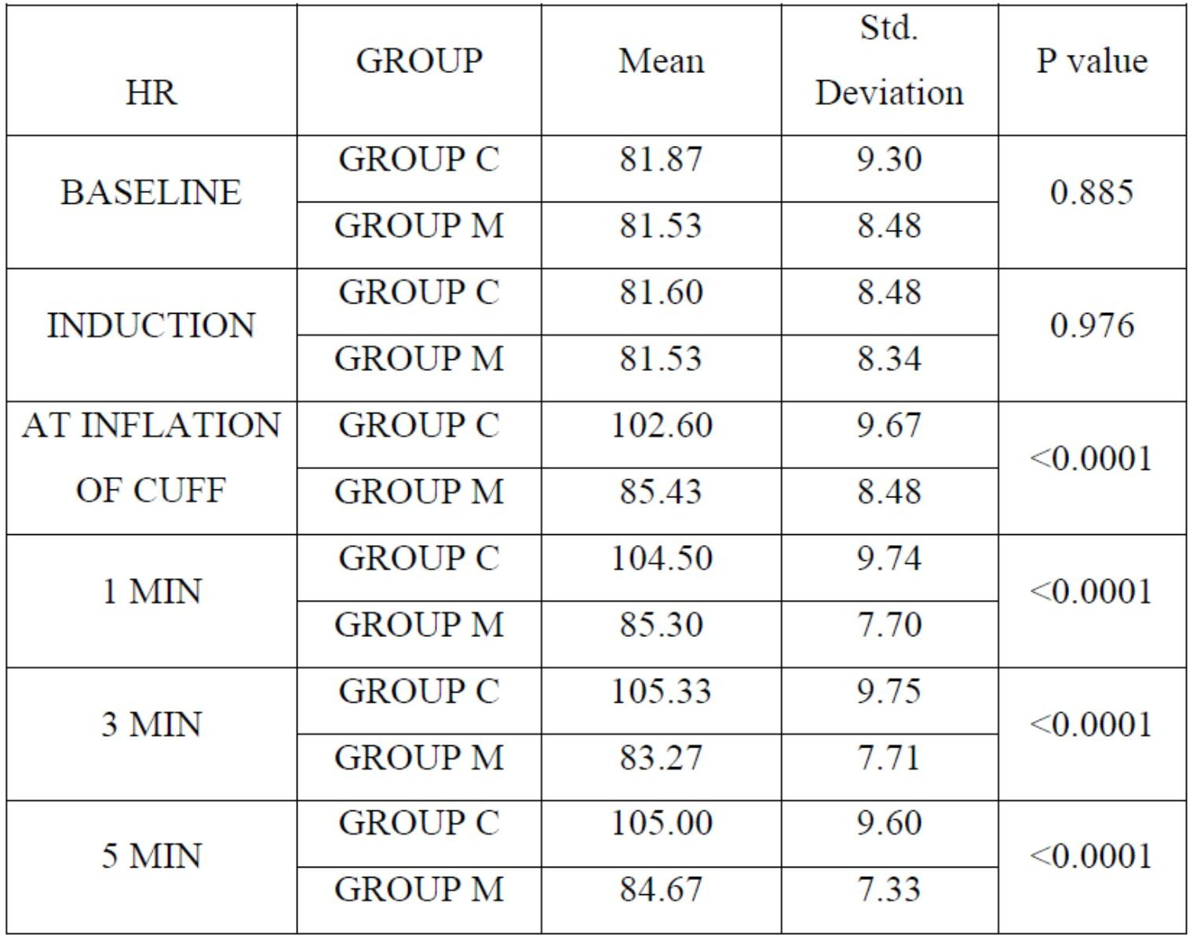
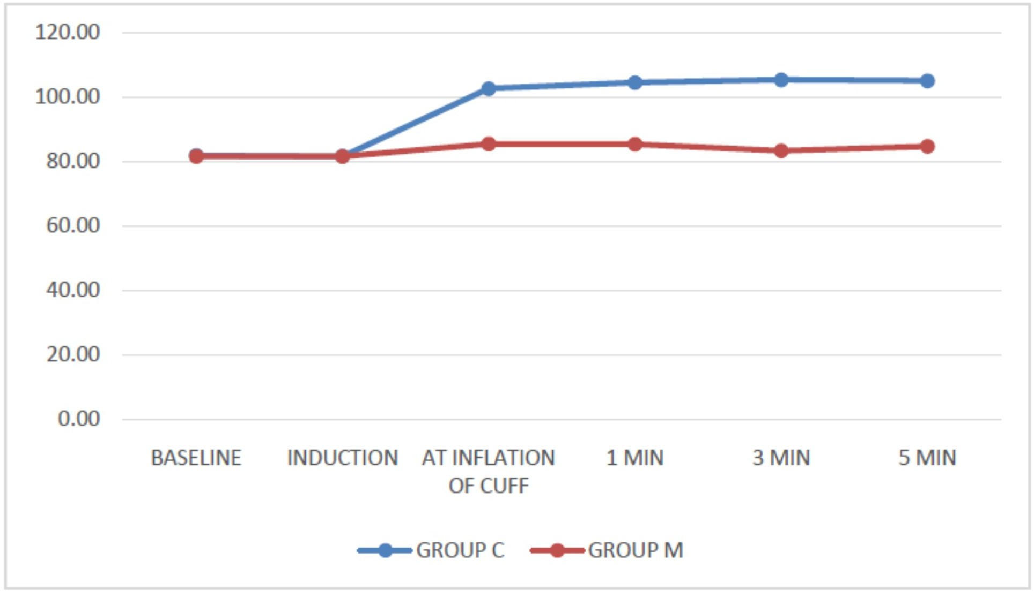
This shows that heart rate was significantly higher in Group C than Group M at inflation of cuff, and at 1 min, 3 mins, 5 mins following intubation compared to Group M with p value <0.0001.

Systolic blood pressure in both Group C and Group M at baseline, at induction, at inflation of cuff and at 1 min, 3 mins and 5 mins following intubation.
The mean systolic blood pressure in Group C at baseline was 128.07 ± 6.88.
The mean systolic blood pressure in Group M at baseline was 127.37 ± 8.14.
The Systolic blood pressure response at baseline was statistically insignificant with p value of 0.720.

The mean SBP in Group C was 142.27± 7.93 , 140.17±9.35 , 136.10±8.06 , 135.47±7.41 at inflation of cuff, 1 min , 3mins, 5 mins following intubation respectively.
The mean SBP in Group M was 127.43±7.35 , 123.07±6.43, 123.20±6.64 , 124.47±6.76 at inflation of cuff, 1 min , 3 mins, 5 mins following intubation respectively.
This shows that SBP was significantly higher in Group C than Group M at inflation of cuff, and at 1 min , 3 mins
, 5 mins following intubation compared to Group M with p value <0.0001.
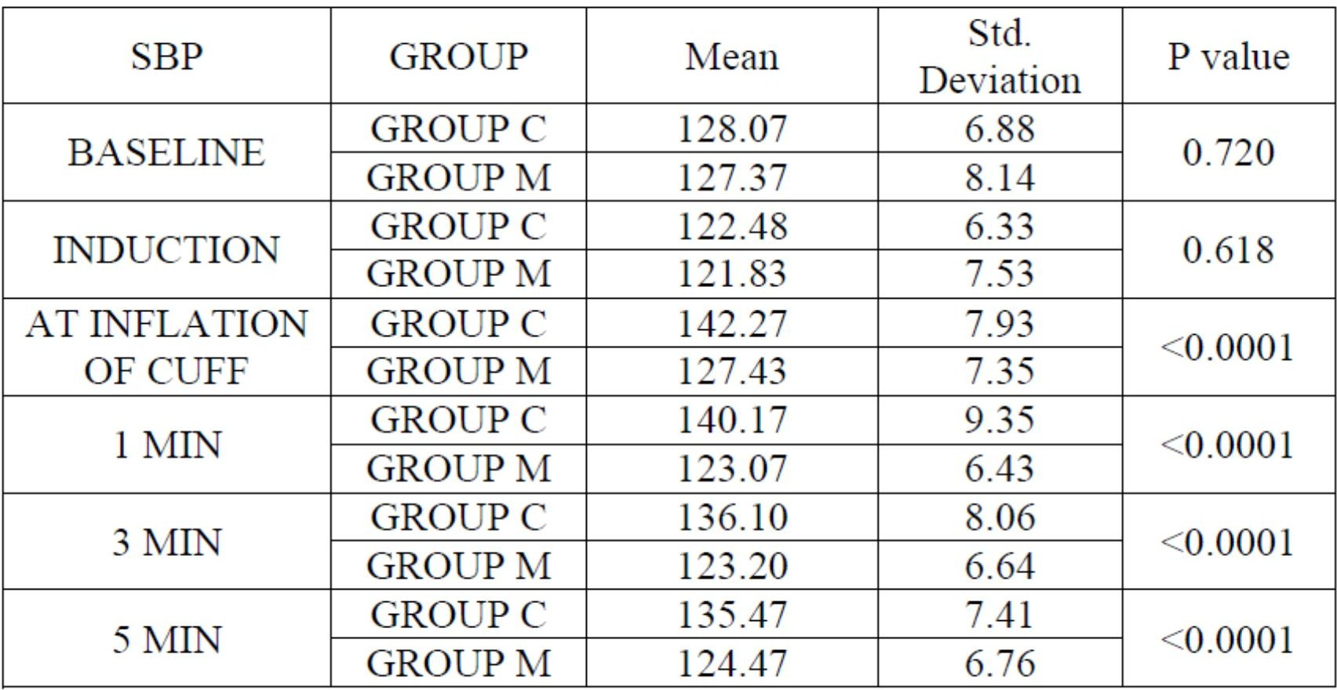
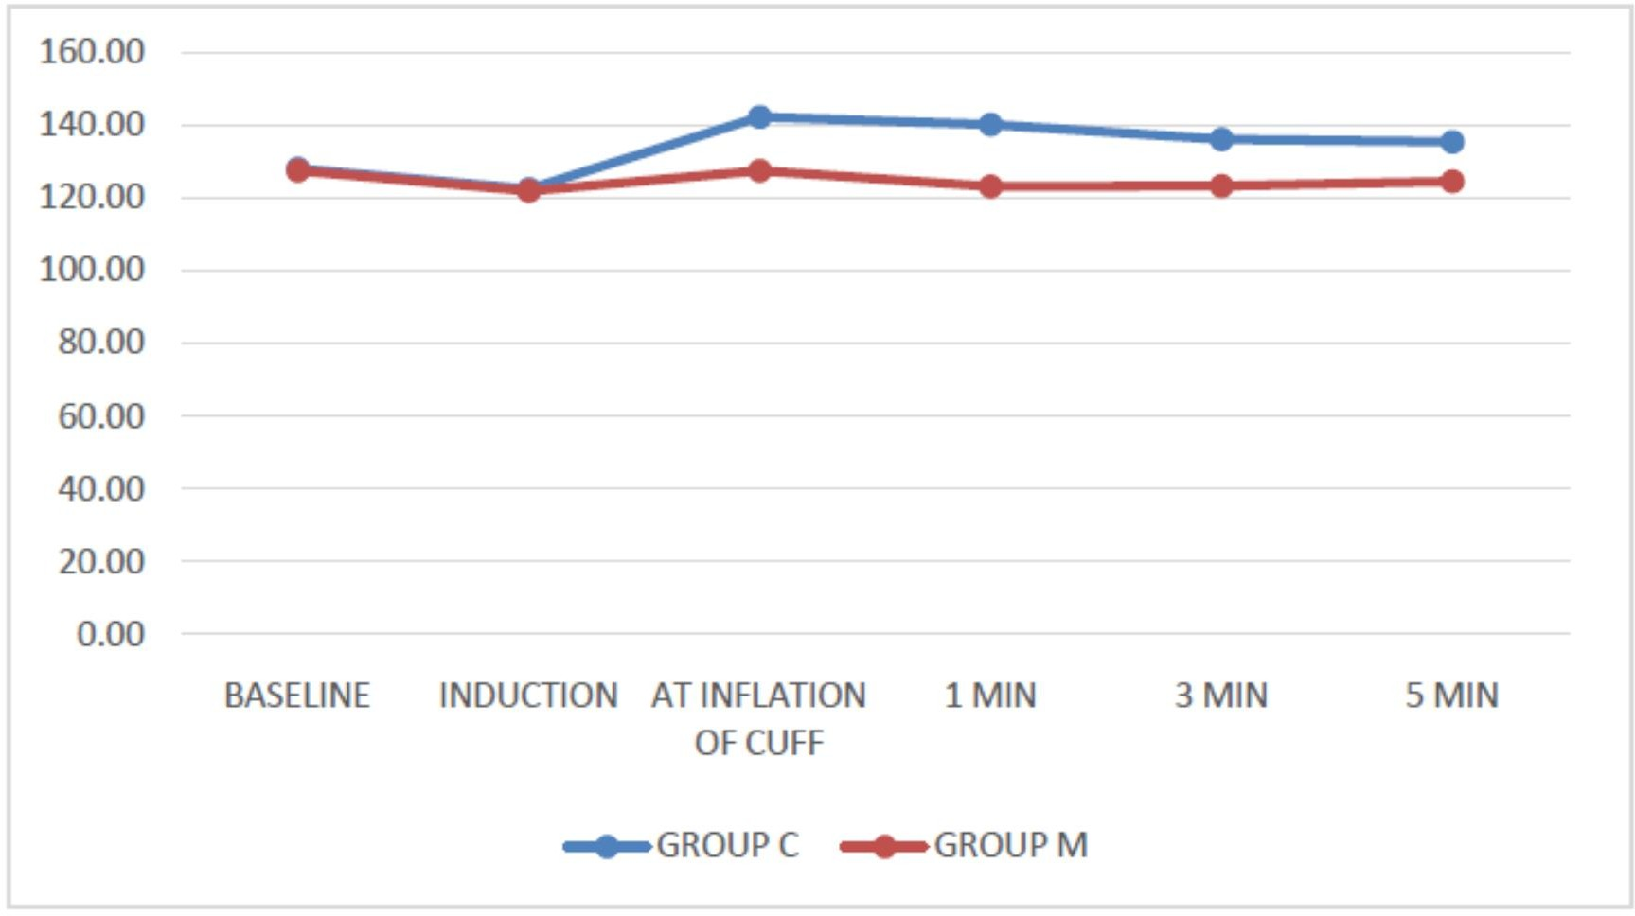
Diastolic blood pressure in both Group C & Group M at baseline, at induction, at inflation of cuff and at 1 min, 3 min and 5 min following intubation.
The mean Diastolic blood pressure in Group C at baseline was 80.13 ± 8.97.
The mean Diastolic blood pressure in Group M at baseline was 81.57 ± 8.47.
The Diastolic Blood pressure response at baseline was statistically insignificant with p value of 0.527.

The mean DBP in Group C was 99.60± 10.56, 95.47±8.74, 92.63±10.85, 92.03± 10.32 at inflation of cuff, 1 min , 3mins, 5 mins following intubation respectively.
The mean DBP in Group M was 81.27± 9.15, 80.13± 9.04, 80.07±8.01, 79.83± 7.97 at inflation of cuff, 1 min , 3mins, 5 mins following intubation respectively.
This shows that DBP was significantly higher in Group C than Group M at inflation of cuff, and at 1 min , 3 mins
, 5 mins following intubation compared to Group M with p value <0.0001.
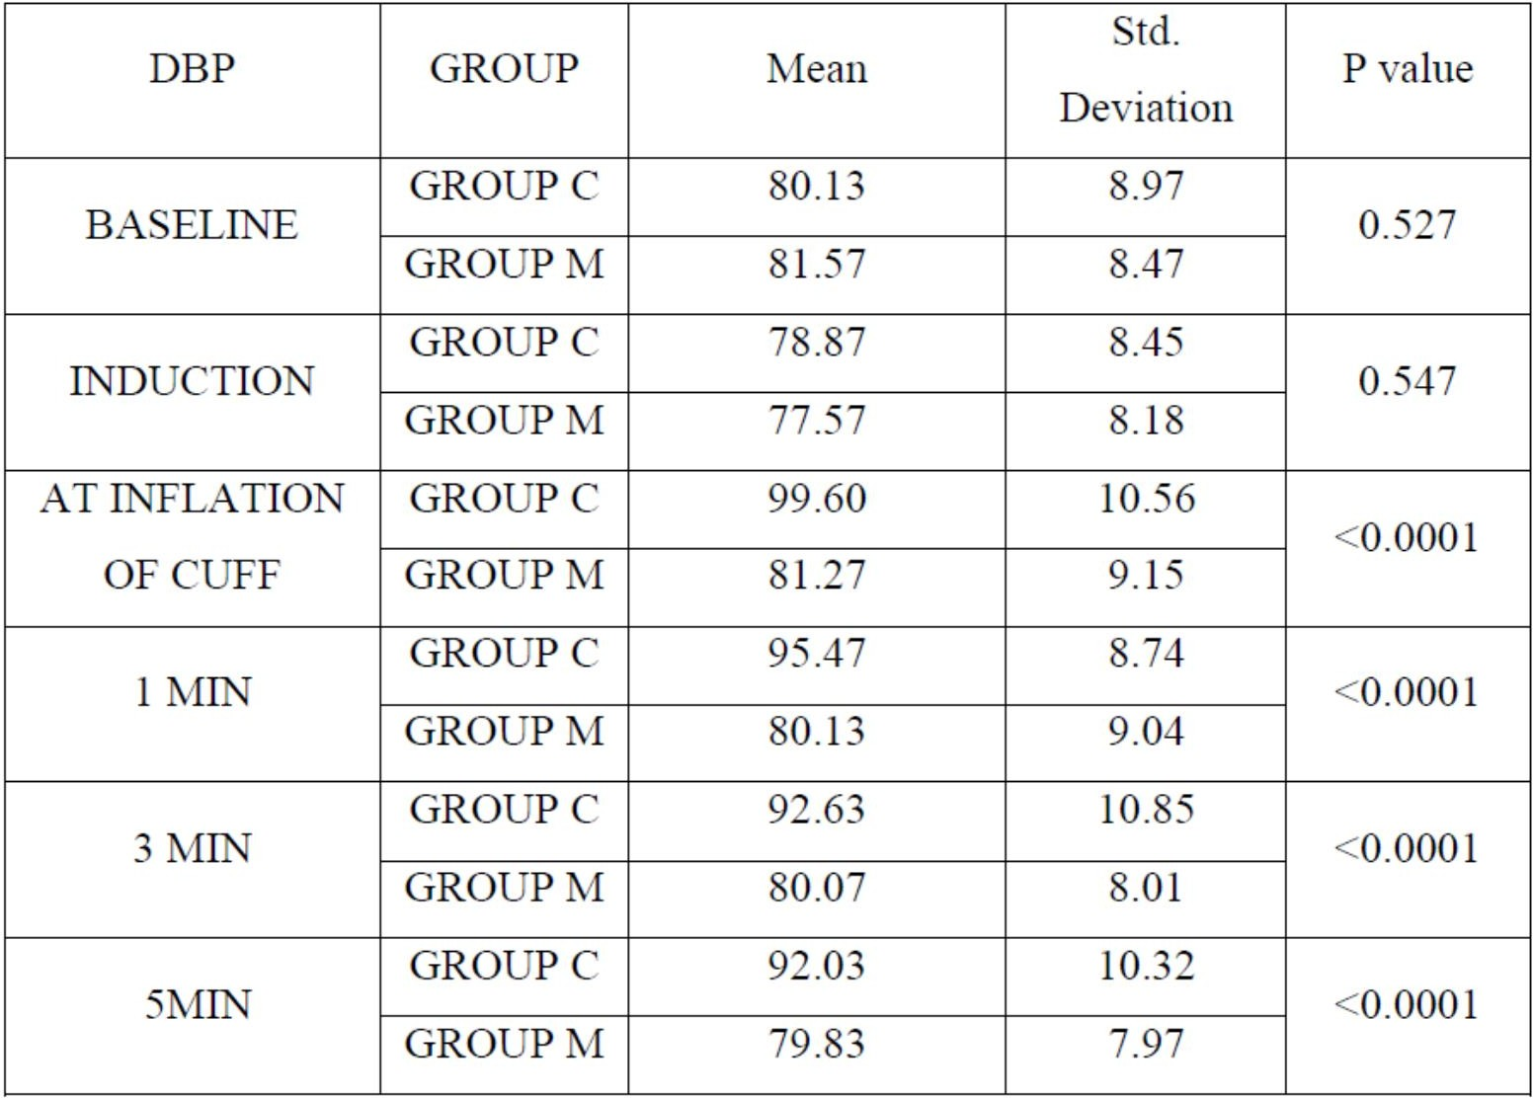
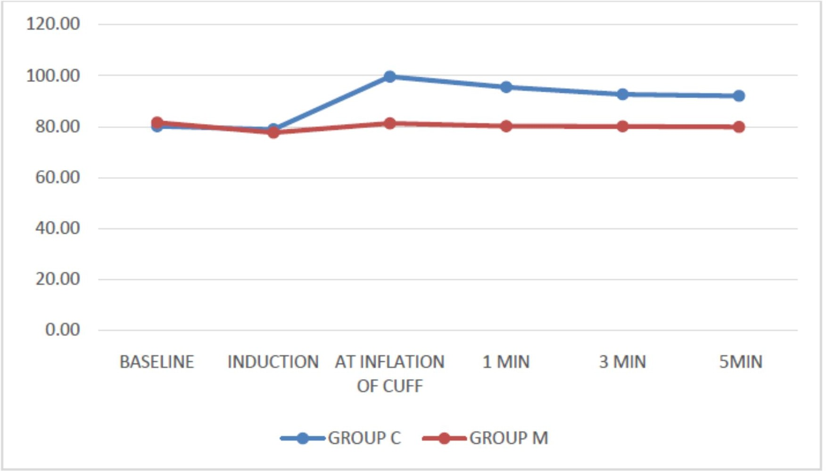

Mean arterial pressure in both Group C & Group M at baseline, at induction, at inflation of cuff and at 1 min, 3 min and 5 min following intubation.
The mean MAP in Group C at baseline was 96.10 ± 7.25.
The mean MAP in Group M at baseline was 95.80 ± 8.15.
The MAP response at baseline was statistically insignificant with p value of 0.881.

The mean MAP in Group C was 114.10± 8.17, 111.03±8.02, 105.73 ±8.38, 101.70 ±8.00 at inflation of cuff, 1 min , 3mins, 5 mins following intubation respectively.
The mean MAP in Group M was 95.57± 8.33 , 93.47± 8.14, 93.30± 6.75, 93.53± 7.36 at inflation of cuff, 1 min , 3mins, 5 mins following intubation respectively.
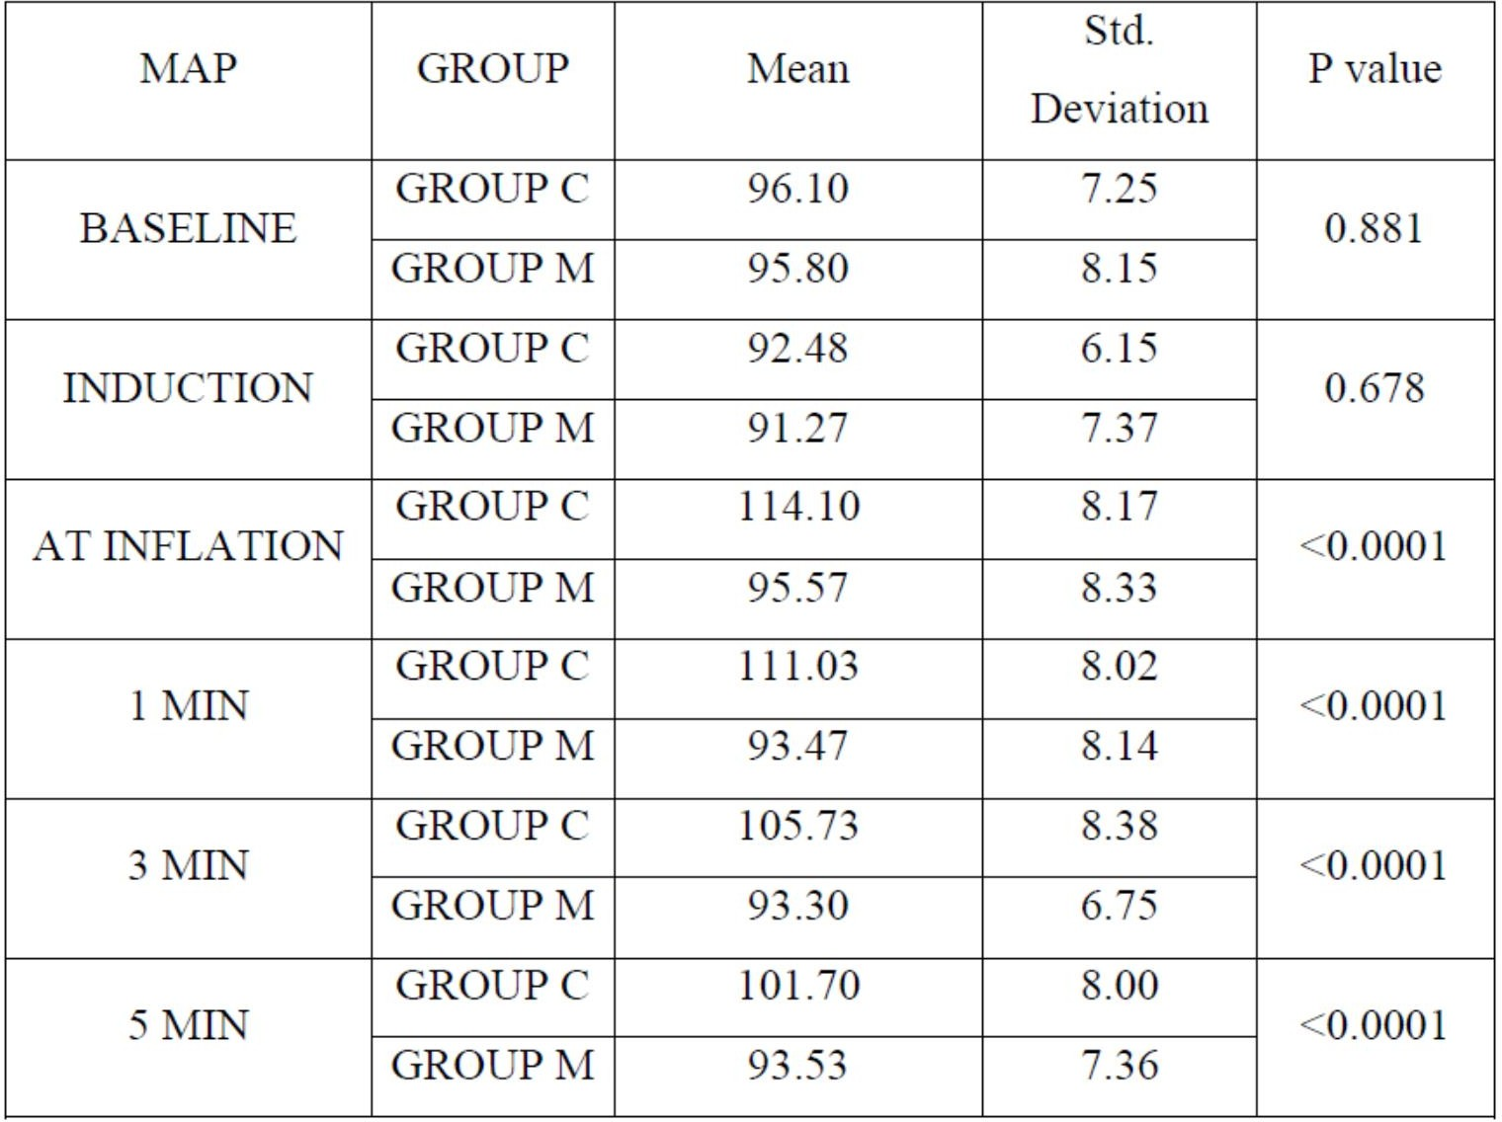
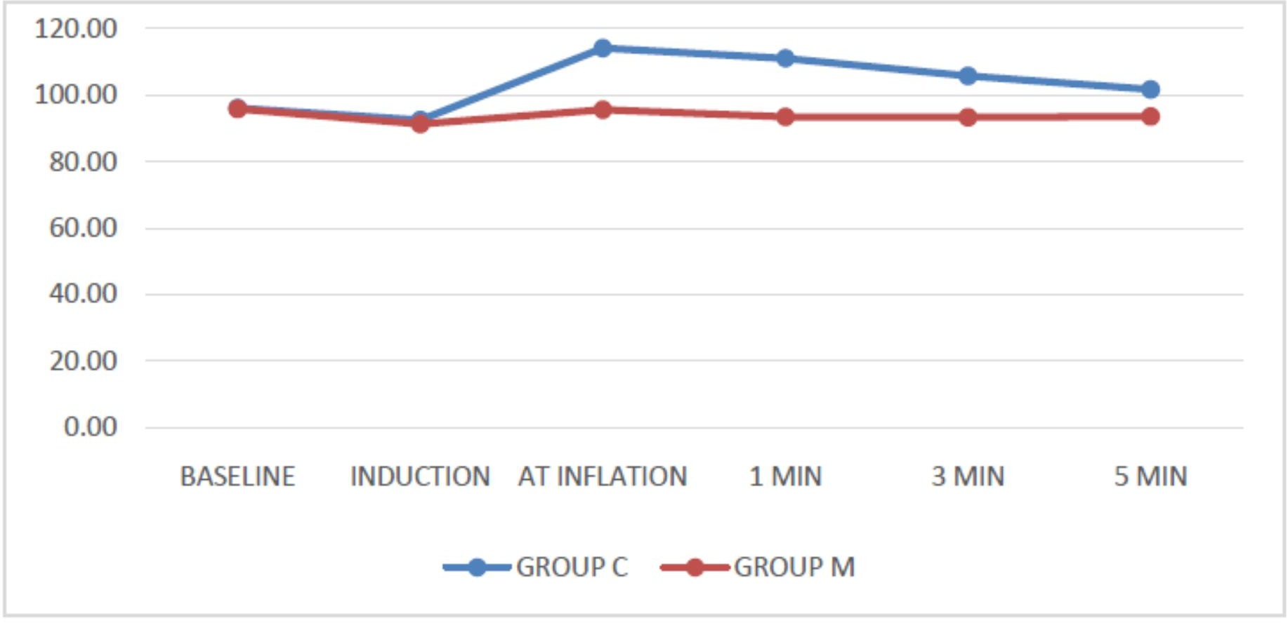
This shows that MAP was significantly higher in Group C than Group M at inflation of cuff, and at 1 min , 3 mins , 5 mins following intubation compared to Group M with p value <0.0001.

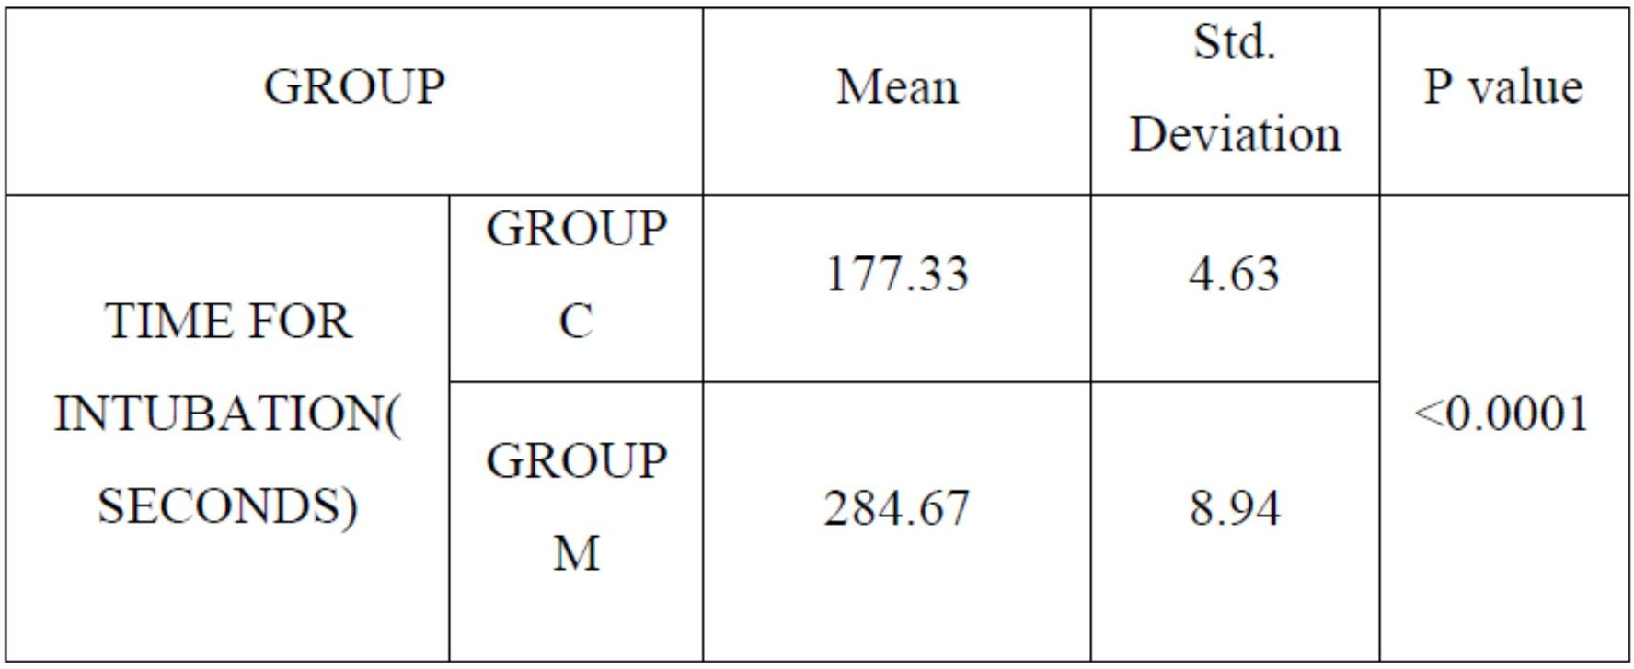
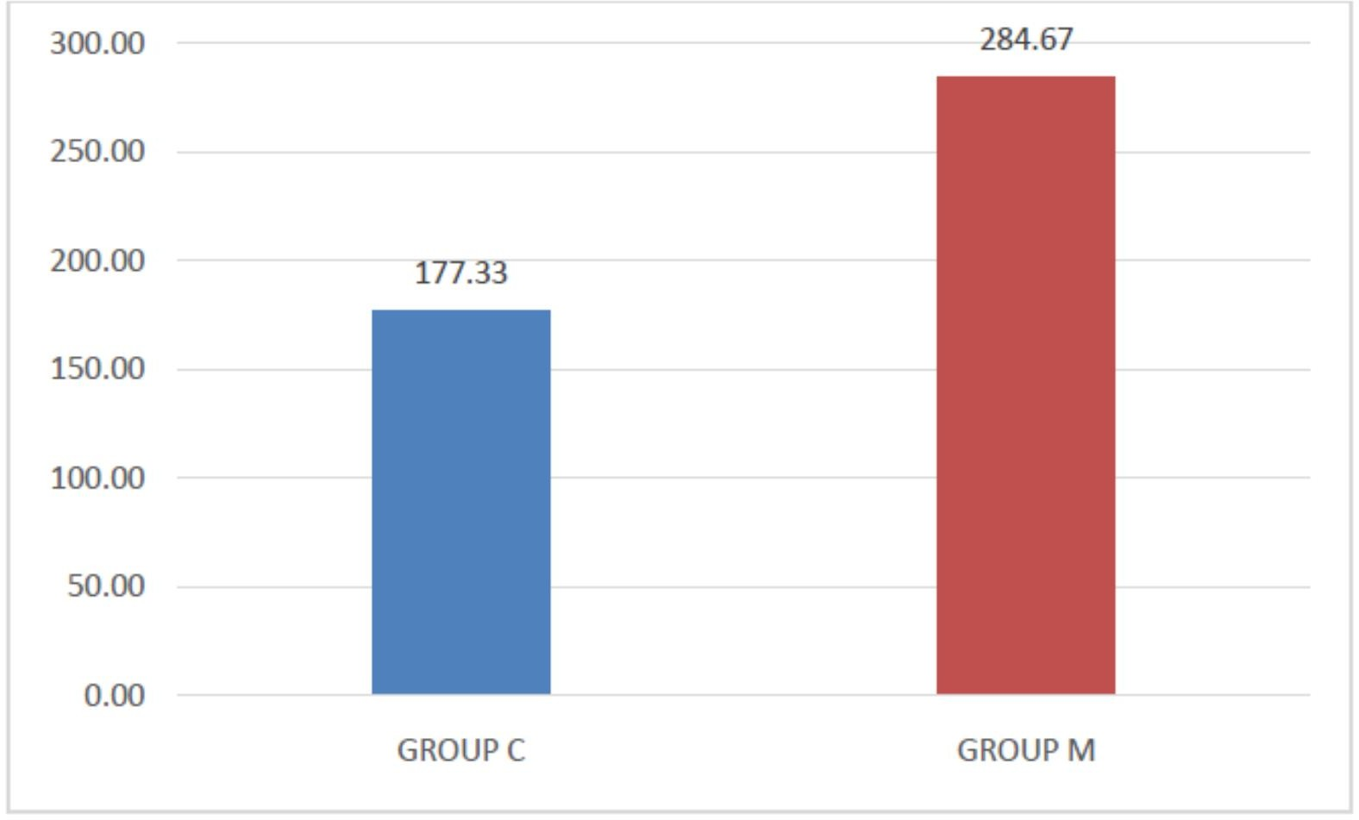
The mean time for intubation (seconds) in Group C and Group M which is 177.33± 4.63 and 284.67 ± 8.94 respectively. It shows the mean time for intubation was significantly longer in Group M than Group C with p value of < 0.0001.

DISCUSSION:
We observed from the study that the neuromuscular monitoring-based timing for tracheal intubation causes lesser haemodynamic surge as compared to clinical-based timing for tracheal intubation. Laryngoscopy and endotracheal intubation can cause striking changes in haemodynamics and intracranial pressure, probably as a result of intense sympathetic nervous system stimulation[35,36]. Various technique
using various pharmacological agents are reported to attenuate these cardiovascular responses.The effect of these drugs may persist even after the stimulus of laryngoscopy and tracheal intubation ceases, and thus, causes subsequent haemodynamic fluctuation. Here lies the importance of a non-pharmacological measure to prevent this surge. Many studies have already shown that these haemodynamic responses also depends on the duration of laryngoscopy and intubation as well as ease of the procedure. Therefore, achievement of adequate neuromuscular blockade with a muscle relaxant is of utmost importance to avoid undue stimulation of sympathoadrenergic system. Thus, assessment of complete neuromuscular blockade appears to be necessary for proper timing of intubation. Assessment of complete paralysis was done by observing the response to TOF stimulation.
When the TOF count becomes zero it can be said that the laryngeal muscles are completely paralysed. In this study, in the neuromuscular monitoring group (M), intubation was performed when there was complete loss of all 4 responses to TOF stimulation. The laryngoscopy and subsequent endotracheal intubation induce strong nociceptive stimuli resulting in numerous responses by stimulation of the sympathetic nervous system manifested by increased arterial pressure and accelerated heart rate. In our study, patients intubated by clinical judgment showed higher mean values of mean arterial pressure and heart rate during and after intubation in comparison to the patients who were intubated under guidance of neuromuscular monitoring (P < 0.05). It seems that in patients with incomplete neuromuscular block, laryngoscopy and intubation cause stronger nociceptive stimulation, hence a stronger reflex cardiovascular reaction. The previous studies showed that if neuromuscular block monitoring technique is used to find out the timing for tracheal intubation, more time gap would be available between neuromuscular blockade administration and tracheal intubation. It also improves intubation conditions and minimises cardiovascular responses. In our study, we used vecuronium as muscle relaxant and the result was found that clinical judgment underestimated the time required for adequate onset of action of vecuronium, resulting in less favourable intubating condition. In our study, we also found that monitoring of neuromuscular block substantially prolonged the time between vecuronium administration and intubation.
As in the control group, we intubated the patients following clinical judgment, this similarity in intubation time in this group may be due to our habits in day-to-day practice. Adductor pollicis muscle was chosen to monitor the neuromuscular block in our study. It is reported that in the orbicularis oculi muscle, TOF count becomes zero more earlier than the adductor pollicis muscle after administration of neuromuscular blocking drugs. As a result, early intubation can be performed if orbicularis oculi muscle was chosen for monitoring.
However, in some patients, unsatisfactory intubation conditions were found. It has also been reported that when adductor pollicis is monitored for tracheal intubation, more favourable intubation condition is observed in all patients. As the favourable intubation condition helps to reduce the haemodynamic surge, adductor pollicis muscle was chosen for monitoring in this study. Furthermore, being a peripheral muscle it is easier-to-monitor.
In our study, in the clinical group, intubation was tried after an average of 175 s after vecuronium administration in the neuromuscular monitoring group, intubation was tried after an average of 280 s of vecuronium administration and more favorable intubating conditions were seen in Group M compared to Group C. Using neuromuscular monitor during endotracheal intubation is not a common practice among anaesthesiologists. It is mainly used for muscle relaxation monitoring during operative procedure and to diagnose any residual paralysis at the end of the procedure. Hence, more research in neuromuscular monitoring during intubation is required.

STUDY LIMITATION
A limitation of the study is that the time gap between vecuronium administration and endotracheal intubation is different in two groups. This may have contributed to the difference in haemodynamic response in the above- mentioned groups

CONCLUSION:
The haemodynamic responses to laryngoscopy and tracheal intubation can be significantly attenuated if tracheal intubation is done following complete paralysis of laryngeal muscles, detected by neuromuscular block monitoring of adductor pollicis muscle as compared to conventional time-based clinical assessment. And also, the intubating conditions are improved when endotracheal intubations were attempted following neuromuscular monitoring. We conclude from our study that at an intubating dose of 0.1 mg/Kg of vecuronium, if intubation was performed after about 280±10 seconds following vecuronium administration ,the haemodynamic responses to intubation and the intubating conditions were favourable.

REFERENCES:
- Kovac AL. Controlling the hemodynamic response to laryngoscopy and endotracheal intubation. J Clin Anesth. 1996;8:63–79.
- Soltesz S, Stark C, Noé KG, Anapolski M, Mencke T. Monitoring recovery from rocuronium-induced neuromuscular block using acceleromyography at the trapezius versus the adductor pollicis muscle: an observational trial. Can J Anaesth. 2016 Jun;63(6):709-17
- Jung W, Hwang M, Won YJ, Lim BG, Kong MH, Lee IO. Comparison of clinical validation of acceleromyography and electromyography in children who were administered rocuronium during general anesthesia: a prospective double-blinded randomized study. Korean J Anesthesiol. 2016;69(1):21-26. doi:10.4097/kjae.2016.69.1.21
- Bhananker SM, Treggiari MM, Sellers BA, Cain KC, Ramaiah R, Thilen SR. Comparison of train-of-four count by anesthesia providers versus TOF-Watch® SX: a prospective cohort study. Can J Anaesth. 2015;62:1089–1096. doi: 10.1007/s12630-015-0433-9.
- Witkowska M, Karwacki Z, Wierzchowska J, Bukowski P. Monitorowanie Neuromuscular block monitoring for optimisation of conditions for endotracheal intubation. Anestezjol Intens Ter. 2009 Jul-Sep;41(3):140-4. Polish. PMID: 19999600.
- Lee HJ, Kim KS, Jeong JS, Cheong MA, Shim JC. Comparison of the adductor pollicis, orbicularis oculi, and corrugator supercilii as indicators of adequacy of muscle relaxation for tracheal intubation. Br J Anaesth. 2009 Jun;102(6):869-74. doi: 10.1093/bja/aep064. Epub 2009 Apr 17. PMID: 19376787.
- Cheng KI, Chu KS, Chen WC, Tang CS. The train of four ratio decreases to zero in anesthetized children is the guide to achieve a satisfactory intubation condition. Kaohsiung J Med Sci. 2002;18:23–9.
- Le Corre F, Plaud B, Benhamou E, Debaene B. Visual estimation of onset time at the orbicularis oculi after five muscle relaxants: application to clinical monitoring of tracheal intubation. Anesth Analg. 1999 Nov;89(5):1305-10. PMID: 10553857.
- Smith I, Saad RS. Comparison of intubating conditions after rocuronium or vecuronium when the timing of intubation is judged by clinical criteria. Br J Anaesth. 1998;80:235–7
- Plaud B, Laffon M, Ecoffey C, Meistelman C. Monitoring orbicularis oculi predicts good intubating conditions after vecuronium in children. Can J Anaesth. 1997;44:712–6
- Haller G, Gardaz JP, Bissonnette B. Assessment of intubation time and conditions under the influence of rocuronium. Can J Anaesth. 1998;45:312–6
- Tintignac LA, Brenner HR, Rüegg MA. Mechanisms regulating neuromuscular junction development and function and causes of muscle wasting. Physiol Rev. 2015;95:809–8 Jonsson M, Gurley D, Dabrowski M, et al. Distinct pharmacologic properties of neuromuscular blocking agents on human neuronal nicotinic acetylcholine receptors: a possible explanation for the train-of-four fade. Anesthesiology. 2006;105(3):521–533.

