Original article:
Study of correlation of H.Pylori positivity with grade of inflammation seen on basic H & E stain
¹Dr Saurabh Kusurkar* , ²Dr Somnath Khedkar

¹Ex Resident,(2019-2022), Department of Pathology , B.J. Medical College and Sassoon general hospital Pune & Persuing Post doc fellowship at Tata Memorial Hospital at present
²Associate Professor, Department of Pathology, B.J Medical College and Sassoon general hospital Pune
Corresponding author *

This work is licensed under a Creative Commons Attribution-NonCommercial 4.0 International License
Date of submission: 25 April 2023
Date of Final acceptance: 06 May 2023
Date of Publication: 02 June 2023
Source of support: Nil
Conflict of interest: Nil

Abstract:
Introduction: Helicobacter pylori (H. pylori) is a gram-negative bacterium associated with various gastric pathologies. Histopathological examination using hematoxylin and eosin (H&E) stain is a standard method for assessing inflammation severity. Understanding the correlation between H. pylori positivity and H&E-based inflammation grade is clinically significant.
Methodology: This descriptive cross-sectional study included 80 patients with urease breath test positivity and chronic dyspepsia. Gastric biopsy samples were analyzed using H&E, Giemsa, and Warthin-Starry silver stains, as well as immunohistochemistry (IHC) for H. pylori. The grade of inflammation was assessed according to the updated Sydney system.
Results: Among the 80 samples, 11 cases (8.8%) showed H. pylori positivity on H&E stain. The sensitivity of H&E staining was 11.8%. Mild inflammation was observed in 50% of cases, moderate inflammation in 41.3%, and severe inflammation in 9%. The detection rates of H. pylori decreased with increasing inflammation severity. Comparing H&E staining with IHC as the gold standard, Giemsa staining showed a sensitivity of 85.5% and Warthin-Starry silver staining showed a sensitivity of 92.1%.
Conclusion: H&E staining alone has limited sensitivity for detecting H. pylori infection, emphasizing the need for additional staining techniques. The severity of inflammation inversely correlated with H. pylori detection rates on H&E stain. Giemsa and Warthin-Starry silver stains demonstrated higher sensitivity for H. pylori detection. Using these stains in combination with H&E staining can enhance the accuracy of H. pylori diagnosis in gastric diseases.
Keywords: Helicobacter pylori, inflammation, H&E stain, Giemsa stain, Warthin-Starry silver stain,

Introduction:
Helicobacter pylori (H. pylori) is a gram-negative bacterium that colonizes the human gastric mucosa. It is a well-known etiological factor for various gastric pathologies, including chronic gastritis, peptic ulcer disease, gastric adenocarcinoma, and mucosa-associated lymphoid tissue (MALT) lymphoma.¹ The presence of H. pylori in the gastric mucosa leads to a host inflammatory response, which can vary in intensity and severity.²
Histopathological examination of gastric tissue using basic hematoxylin and eosin (H&E) stain is a standard diagnostic tool to assess the degree of inflammation in the gastric mucosa. The grade of inflammation observed on H&E stain provides valuable information about the severity of the host immune response against H. pylori infection.^{3,4,5}
Understanding the correlation between H. pylori positivity and the grade of inflammation seen on H&E stain is of significant clinical importance. It can aid in the diagnosis, risk assessment, and management of H. pylori-associated gastric diseases. By examining the intensity of inflammation, clinicians can determine the appropriate therapeutic interventions, such as eradication therapy for H. pylori, to prevent disease progression and reduce the risk of complications.^{6,7}
Several studies ^{8,9,10} have investigated the relationship between H. pylori positivity and the grade of inflammation on H&E stain, but the findings have been somewhat conflicting. While some studies have reported a positive correlation between H. pylori colonization and the severity of inflammation, others have found no significant association. Therefore, further research is necessary to clarify and consolidate the existing evidence.
In this study, we aim to investigate the correlation between H. pylori positivity and the grade of inflammation observed on basic H&E stain. By elucidating this relationship, we can contribute to the existing knowledge base and provide insights into the clinical implications of H. pylori-associated inflammation.
Material and methods:
This descriptive cross-sectional study was conducted at a tertiary hospital and involved a sample size of 80 patients diagnosed with urease breath test positivity and chronic dyspepsia between January 2020 and June 2021. The sample size was determined based on a relative precision of 10% and a 95% confidence level.
Gastric biopsy samples obtained from the patients with chronic dyspepsia were received in 10% Neutral Buffered Formalin and used to prepare formalin-fixed paraffin-embedded tissue blocks. Relevant clinical information, such as the duration of symptoms and urease breath test results, was obtained from the histopathology sample forms.
Histopathological analysis was performed on slides prepared from the paraffin-embedded tissue blocks. The slides were stained using hematoxylin and eosin (H&E), Giemsa, and Warthin-Starry silver stains to study their histopathological and morphological features. Additionally, immunohistochemistry (IHC) was performed using an H. pylori-specific monoclonal antibody on the paraffin blocks. The results of all stained slides were noted and later compared.
The study included subjects of all age and sex groups who were clinically suspected cases of chronic gastritis. Patients with urease breath test positivity were included in the study. Inadequate specimens, autolyzed specimens sent in normal saline instead of formalin, tissues with extensive areas of hemorrhages, and biopsies from proven or known gastric malignancies were excluded from the analysis.

H and E-stained slides were interpreted in accordance with updated Sydney system of gastritis grading.
The histopathological variables like H.Pylori density ,chronic inflammation and neutrophilic activity were graded as absent,mild,moderate and severe with scoring of 0,1,2,3, respectively.

Results:
Out of 80 samples analysed 57 were males and 23 were females. The age group varied between 19 to 81 years. In accordance with updated Sydney scoring system, biopsies were classified based in inflammation as mild 40(50%), moderate 33 (41.3%), and severe 7(9%).
In accordance with updated Sydney scoring system, biopsies were classified based in inflammation as mild 40(50%), moderate 33 (41.3%), and severe 7(9%).
Out of 80 cases 46 (57%) cases show presence of activity and atrophy was present in 7 cases (9%). Intestinal metaplasia was found in 4 cases (3.2%).
Out of 46 cases showing presence of activity,38 cases showed mild activity whilst 8 cases show moderate activity. No cases with severe activity were identified.
Out of 80 cases studied only 7 cases showed presence of mild atrophy.
Results of H & E stained slides:
With H & E, H.pylori organism was detected in 11 cases (8.8%) (Table 6)

Table 1 : H& E * IHC Result comparison

 |  |  | IHC
 |  |  | Negative | Positive
H& E | Negative | Count | 2 | 67
 |  | % within IHC | 50.0% | 88.2%
 | Positive | Count | 2 | 9
 |  | % within IHC | 50.0% | 11.8%

Percentages of bacterial detection for 40 cases showing mild grade of inflammation were 10% for H &E. Only 4 cases out of 40 cases showing mild inflammation showed presence of H.Pylori by H & E stain.
Percentages of bacterial detection for 33 cases showing moderate grade of inflammation were 15% for H&E. Only 5 cases out of 33 cases showing moderate inflammation showed presence of H.Pylori by H & E stain.
Percentages of bacterial detection for 7 cases showing severe grade of inflammation were Nil for H &E. No H.Pylori bacteria was detected by H & E stain in 7 cases showing severe grade of inflammation.

Table 2: Inflammation * H & E Crosstabulation
 |  |  | H& E |  | Total
 |  |  | H pylori (Negative) | H pylori (Positive)
Inflammation | Mild | Count | 34 | 6 | 40
 |  | % within H& E | 49.3% | 54.5% | 50.0%
 | moderate | Count | 28 | 5 | 33
 |  | % within H& E | 40.6% | 45.5% | 41.3%
 | severe | Count | 7 | 0 | 7
 |  | % within H& E | 10.1% | 0.0% | 8.8%
Total |  | Count | 69 | 11 | 80
 |  | % within H& E | 100.0% | 100.0% | 100.0%

TABLE 3 - Validity of H&E Giemsa and WSS

 | Sensitivity | Specificity | PPV | NPV
H&E | 11.80% | 50% | 88.8 | 2.9
Giemsa | 85.50% | 50% | 97.01 | 15.4
WSS | 92.10% | 75% | 92.10% | 75%

Validity of H&E and special stains was done using sensitivity, specificity, positive and negative predictive value by comparing with IHC as gold standard.

Table 4 : Test Result Variable(s) for IHC Staining
Statistic | Value | 95% CI | P
Sensitivity | 100.00% | 94.79% to  100.00%
Specificity | 63.64% | 30.79% to 89.07%
Area Under the  Curve | 0.973 | 0.939 to 1 | <0.0001

Sensitivity-specificity receiver operating curve of IHC for mild to moderate inflammation with P value <0.0001 indicating statistical significance.

Discussion:
The present study aimed to investigate the correlation between H. pylori positivity and the grade of inflammation observed on H&E stain in patients diagnosed with chronic dyspepsia. The results showed interesting findings regarding the prevalence of H. pylori infection, the severity of inflammation, and the detection rates of H. pylori using H&E staining.
Among the 80 samples analyzed, H. pylori organisms were detected in 11 cases (8.8%) using H&E stain. This detection rate suggests that H&E staining alone may have limitations in identifying H. pylori infection accurately. When comparing the H&E stain results with the gold standard immunohistochemistry (IHC) staining, the sensitivity of H&E staining was found to be low (11.8%), indicating a higher number of false negatives. This emphasizes the importance of using additional staining techniques, such as Giemsa and Warthin-Starry silver stains, to improve the detection rate of H. pylori.
The severity of inflammation assessed according to the updated Sydney scoring system revealed that most biopsies showed mild (50%) or moderate (41.3%) inflammation, while a smaller proportion had severe inflammation (9%). Interestingly, there was a trend of decreasing H. pylori detection rates with increasing severity of inflammation. Among the cases with mild inflammation, only 10% showed the presence of H. pylori using H&E stain. In contrast, no H. pylori organisms were detected in the cases with severe inflammation. These findings suggest that H. pylori colonization might be more prevalent in milder forms of inflammation and may play a less significant role in severe inflammatory processes.
Furthermore, the study assessed the validity of H&E, Giemsa, and Warthin-Starry silver stains by comparing them with IHC staining as the gold standard. The sensitivity of H&E staining was very low (11.8%), indicating a high rate of false negatives. Giemsa staining showed a much higher sensitivity (85.5%), while Warthin-Starry silver stain demonstrated the highest sensitivity (92.1%). This indicates that both Giemsa and Warthin-Starry silver stains are more reliable methods for detecting H. pylori infection compared to H&E stain.
The findings of this study have important clinical implications. ^{11,12} The low sensitivity of H&E staining alone suggests the need for additional staining techniques, such as Giemsa or Warthin-Starry silver stains, to improve the accuracy of diagnosing H. pylori infection. These stains provide better visualization of the bacteria, leading to higher detection rates. Accurate identification of H. pylori colonization is crucial for appropriate management strategies, such as eradication therapy, to prevent disease progression and reduce the risk of complications.
Conclusion:
In conclusion, the severity of inflammation showed an inverse correlation with the detection rates of H. pylori using H&E stain. Giemsa and Warthin-Starry silver stains demonstrated higher sensitivity in detecting H. pylori. Clinicians should consider using these stains in combination with H&E staining to improve the accuracy of H. pylori detection and enhance patient care in H. pylori-associated gastric diseases.
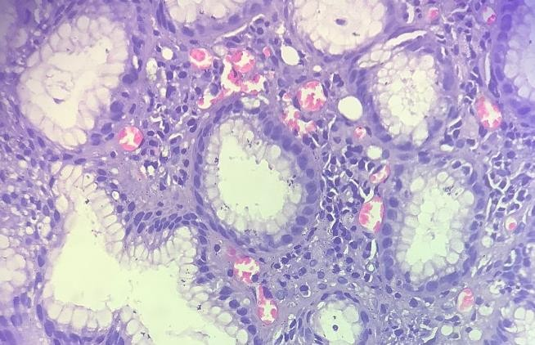
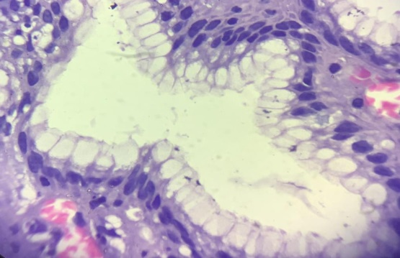
Image 1 : H & E stained gastric biopsy showing mild inflammation.(10X)
Image 2 : Intra-epithelial bacteria seen on H & E stain (Arrow) (Oil Immersion )
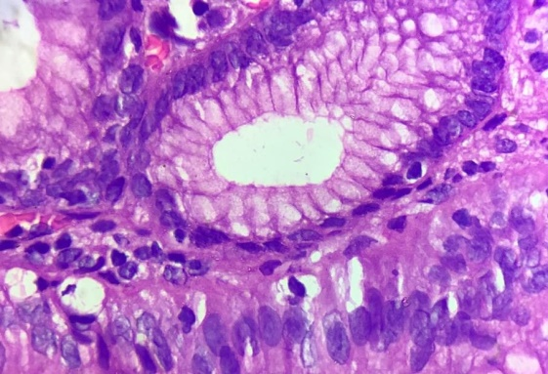
Image 3: Intra-Luminal bacteria seen on H & E stain (Arrow) (40X)
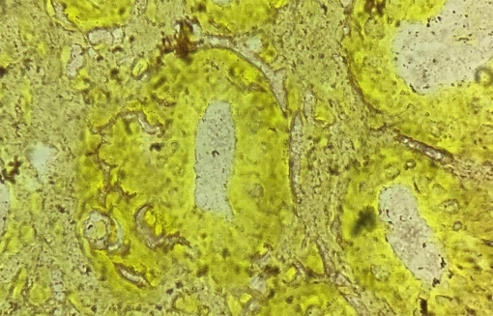
Image 4: Intra-Luminal bacteria seen on Warthin Starry Silver stain (Arrow) (Oil Immersion)

References:
- Yantiss RK, Lamps LW. To stain or not to stain...That remains the question. Am J Clin Pathol 2012 Mar; 137(3):343-5.
- Kusters JG, van Vliet AH, Kuipers EJ. Pathogenesis of Helicobacter pylori infection. Clin Microbiol Rev. 2006 Jul; 19(3):449-90.
- Sulakshana M S, Siddiq M Ahmed and Raghupathi A R. A histopathological study of association of Helicobacter pylori with gastric malignancies.International Journal of current research and academic review 2015;3;10-42
- de Boer WA. Diagnosis of Helicobacter pylori infection: review of diagnostic techniques and recommendations for their use in different clinical settings. Scand J Gastroenterol Suppl. 1997;223:35-42.
- Anim J T, Al-Sobkie N, Prasad A, John B, Sharma P N, Al-Hamar I. Assessment of different methods for staining Helicobacter pylori in endoscopic gastric biopsies. Acta Histochem 2000; 102: 129- 37.
- Laine L, Lewin DN, Naritoku W, Cohen H. Prospective comparison of H&E, Giemsa, and Genta stains for the diagnosis of Helicobacter pylori. Gastrointest Endosc. 1997 Jun; 45 (6): 463–7.
- Testerman TL, Morris J. Beyond the stomach: An updated view of Helicobacter pylori pathogenesis, diagnosis, and treatment. World J Gastroenterol 2014; 20(36): 12781- 12808
- Priyadarshini M. et al; Comparative study using routine stains and Immunohistochemistry staining techniques for detection of Helicobacter pylori Tropical journal of pathology and microbiology, July, 2018; 4;3;288-296
- Ali K. Riba, MD, Trevor J. Ingeneri, MD, Calvin L. Strand, MD.Improved Histologic Identification of Helicobacter pylori by Immunohistochemistry Using a New Novocastra Monoclonal Antibody.Science2011;42:1-35
- El-Zimaity HM, Segura AM, Genta RM, et al. Histologic assessment of Helicobacter pylori status after therapy: comparison of Giemsa, Diff-Quik, and Genta stains. Mod Pathol. 1998;11:288-291.
- L Laine, D Chun, C Stein, I El-Beblaw ,The influence of size or number of biopsies on rapid urease test results: a prospective evaluation Journal of gastrointestinal endoscopyVolume 43, Issue 1 January 1996, Pages 49-53
- Rotimi O, Cairns A, Gray S, et al. Histological identification of Helicobacter pylori: comparison of staining methods. J Clin Pathol. 2000;53:756-759.

