Original article:
Study of etiological causes of acute leukemia
Dr.Poonam Nanwani¹, Dr. Nidhi Sharma², Dr.Sandhya Shakya³ Dr.Rohini Bhaskar Kunder⁴ , Dr.Sandhya Shakya⁵,Dr.Ashok Panchonia⁶,Dr.Chhaya Dhangar⁷,Dr.AnupBhadur Jain⁸.

¹Assistant Professor, 2- Demonstrator , 3- PG resident , 4 - PG Resident, 5- PG Resident 6- Professor and Head of Department, 7- PG Resident 8- PG Resident
Department of Pathology, Mahatma Gandhi Memorial Medical College, Indore, Madhya Pradesh
Corresponding Author : Dr.Poonam Nanwani , Assistant Professor , M.G.M. medical college, Indore

Abstract
Background-Acute leukemia are one of the most common cancers affecting all age groups. A large number of genetic and environmental factors are responsible for their development.Genetics play a major role,but effects of enviormental factors,occupation also play a very important role.The role of variety of factors including pre existing and acquired genetic mutations,exposure to radiation and various chemical exposure during preconception ,pregnanacy and throughout life have been studied. A number of pre and post natal environmental conditions and exposure to infections have been suggested.
Objective- This study includes cases of acute leukemia associated with exposure to various chemicals such as pesticides and determine the most common age of presentation and etiology of leukemia.
Materials And Methods-This was a retrospective study done in the Department of Pathology, Mahatma Gandhi Medical College, Indore. We included cases of acute leukemias diagnosed on peripheral smear and on bone marrow aspirates,that were reported in our department from January 2020 to June 2021.
Results-50 cases including both acute myeloid leukemia and acute lymphoid leukemia were studied.
Conclusion-Exposure to pesticides was shown to be one of the most important cause for acute leukemia.
Key words - Acute myeloid leukemia , Acute lymphoid leukemia, lymphoblasts , Myeloblasts

Introduction
Leukemia is one of the most common malignancy affecting the world population. In 2018 , leukemia ranked as the fifteenth most common diagnosis with 437,033 cases and 309,606 mortalities, amounting the eleventh cause of death due to malignant disorder.[1]American cancer society,in 2020 estimated about 178,520 individuals who were diagnosed with leukemia, lymphoma and myeloma in the united states.[1] Acute leukemia are malignant clonal disorder of blood- forming organs involving one or more cell-lines in the hematopoietic system. In these conditions bone marrow is replaced by abnormal immature and undifferentiated hematopoietic cells, resulting reduction in erythrocytes and platelets and increased number of immature leucocytes in peripheral blood. Based on the origin of the abnormal hematopoietic cells involved , such as lymphoid, myeloid , mixed or undifferentiated, these disorder are classified accordingly .
Acute lymphoblastic leukemia (ALL) is the most frequently diagnosed cancer in the pediatric age group, amounting to approximately 25–30% of all childhood malignant disorders.[2]
Objective-This study includes cases of acute leukemia associated with exposure to various chemicals such as pesticides and determine the most common age of presentation and etiology of leukemia.

Materials and methods
This was a retrospective study done in the Department of Pathology, Mahatma Gandhi Medical College, Indore. We included cases of acute leukemias diagnosed on peripheral smear and on bone marrow aspirates,that were reported in our department from January 2020 to June 2021. A record of patient details and history was made.
Inclusion Criteria –All diagnosed cases of acute leukemias.
Exclusion Criteria-Cases other than acute leukemias.
Procedure of collection of data-
All cases of acute leukemia including acute myeloid leukemia and acute lymphoid leukemia which were diagnosed were studied and were included in our study.We collected detailed history of all the patients which included the enviormental factors ,occupational exposures and exposure to various chemicals.
The cases were evaluated and we tried to find the association between the exposure and its role in caustion of leukemias.

Results-
50 cases including both acute myeloid leukemia and acute lymphoid leukemia were studied.

Table 1-age wise distribution of leukemias

Age group(Years) | ALL | AML
0-1 | 03 | -
2-10 | 21 | 01
11-19 | 08 | 02
20-25 | 03 | 04
>25 | 00 | 08
Total | 35 | 15
Out of 50 cases,35 cases were of Acute lymphoblastic leukumia and 15 cases of acute myeloid leukemia.

Table 2:-Male :Female ratio of ALL and AML

 | ALL | AML
MALE | 20 | 08
FEMALE | 15 | 07

Table 3-Leukemia with associated occupation

Occupation | No of cases(%)
Farming | 32
Industrial worker | 10
Textile worker | 05
Painter | 01
Driver | 01
Fruit seller | 01

Graph is showing occupation wise distribution of cases

Hematological findings-hemoglobin is decreased,white cell count is markedly elevated in 60-70 % of patients.TLC may low in some cases.There is neutropenia and thrombocytopenia.
Blast cell-Differential count usually shows 40-95% blast cells.
Bone marrow may be completely replaced with blast cells.

Fig1- Acute lymphoblastic leukemia Peripheral smear finding showing Lymphoblast cells with high N/C ratio
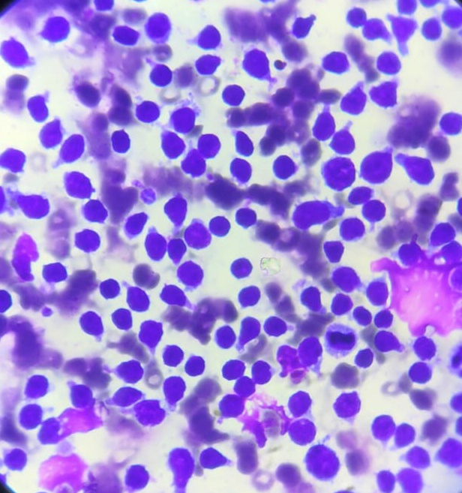

Fig 2-Acute lymphoblastic leukemia- Bone marrow aspirate smear showing infiltration by Lymphoblast cells.
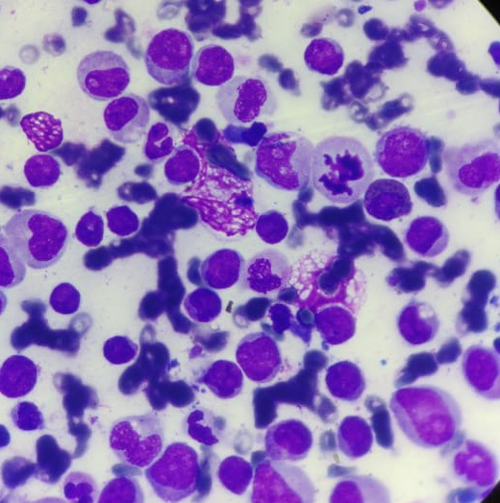
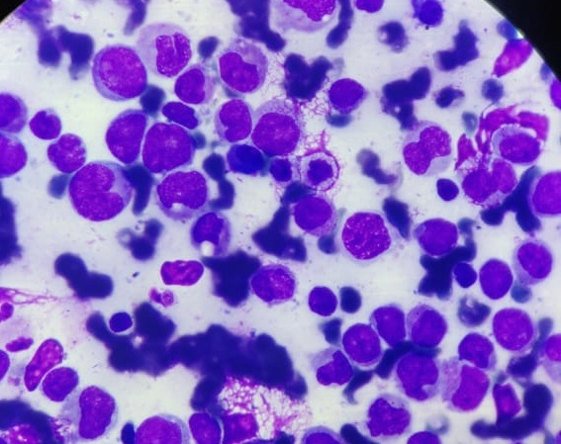

Fig-3 Acute myeloblastic leukemia- Bone marrow aspirate smear showing all stages of maturation by myeloblast cells, myelocyte, metamyelocyte.

Discussion
Acute leukemias- Acute leukemia are defined as neoplasm with more than 20% blasts in peripheral smear / bone marrow(WHO). Acute leukemias comprise a large number of leukemias which is differ in etiology , pathogenesis, morphology, course and prognosis.
Broadly leukemias are divided into acute myeloid leukemia,acute lymphoid leukemia and leukemia of ambiguous lineage.
Acute lymphoblastic leukemia is the hematologic malignancyof lymphoid stem cells that originate in the lymphoid precursors of bone marrow ,lymph nodes and thymus.75-80% of ALL cases are pre B cells and 15-20% cases are of the T cell lineage.
ALL is most common cancer in children under 15 years of age.Signs and symptoms result from involvement of extramedullary sites or marrow failure due to replacement of marrow by leukemic blast cells.signs and symptoms include fatigue,bone and joint pain,fever,lymphadenopathy,spleeenomegaly,hepatomegaly,bleeding manifestations.
Acute myeloid leukemia is the hematologic malignancy of the cells of myeloid lineage with blast more than 20% in the peripheral blood or bone marrow.
AML is most common acute leukemias is adults.[3]Clinical manifestations of AML are due to accumulation of malignant poorly differentiated myeloid cells in the bone marrow ,peripheral blood and other organs.fatigue ,anorexia and weight loss are common complaints.
Hematological findings-hemoglobin is decreased,white cell count is markedly elevated with blast more than 20% and immature myeloid precursors.There may be thrombocytopenia.
Risk factor for acute leukemia include exposure to chemicals caused DNA damage , congenital disease and gene polymorphism associated with impaired DNA repair for DNA damage. Identified occupational , environmental , lifestyle – related and medical risk factor for development of acute leukemia are discussed below.
Age and race are important factors in the incidence of leukemias. Leukemias affects all age groups.Its distribution is based on the type ofthe leukemia. Acute lymphoblastic leukemia(ALL)is more common in children and adolescent age group which accounts for approximately75% of all cases in children under 20 years of age and about one fourthof all pediatric cancers. The peak incidence occur in the age group of 2–5 years. In the present study ,ALL was found most commonly in the children under 10 years of age.Out of total 35 cases of acute lymphoblastic leukemias,21 cases were found in the age group of 2-10 years.
On the contrary, acute myeloblastic leukemia (AML), is more prevalent in adults.[3].In the present study also,most common age group for AML was >25 years.
Racial differences in the incidence of and mortality caused by different
types of acute leukemias have been reported.
In our study ALL was found in 26(52%) cases with age less than 20years.
Certain occupations which causes exposure to various industrial hazards have been implicated in a higher risk of leukemia.Occupations associated with increased risk for leukemias includeagriculture including farmingand crop production as these are associated with exposure to pesticides and fertilizers.[4,5]One of the most common constituent of fertilizers and pesticides is an aromatic hydrocarbon benzene occupational exposure benzene is an important leukemogenic factor[6,7,8]Benzene is absorbed through the skin and lungs and can accumulate in body fat and neurologic tissue.
In our study 32 cases of acute leukemia which found to be associated with farming and use of pesticides and fertilizer.
In the study conducted by Amelie Foucault et al.. also showed that acute leukemia demonstrated in patient with occupational exposure of pesticide and fertilizers.[10]
In the study done by Zakerin Mrym et al… also showed the exposure to pesticides as most important causes of acute leukemia.[9]
In our study 18 children of acute leukemia were offspring of parents were associated with farming.
Similarly the study conducted by Maria Luisa et al… show the association between a fathers occupational exposures and presence of acute leukemia in their offspring.[11]
Conclusion
In a our study we found that Acute lymphoblastic leukemia(ALL)is more common in children and adolescent age group which accounts for approximately75% of all cases in children under 20 years of age and about one fourth of all pediatric cancers. The peak incidence occur in the age group of 2–5 years. Multiple etiological factors like enviormental , occupational factors are responsible for acute leukemia.

References:
1.Bray, F.; Ferlay, J.; Soerjomataram, I.; Siegel, R.L.; Torre, L.A.; Jemal, A. Global cancer statistics 2018: GLOBOCAN estimates of incidence and mortality worldwide for 36 cancers in 185 countries. CA Cancer J. Clin. 2018, 68, 394–424.
2. Deschler, B.; Lübbert, M. Acute myeloid leukemia: Epidemiology and etiology. Cancer 2006, 107, 2099–2107.
3. Bispo, J.A.B.; Pinheiro, P.S.; Kobetz, E.K. Epidemiology and Etiology of Leukemia and Lymphoma. Cold Spring Harb. Perspect. Med. 2020, 10, a034819
4. Pearce, N.E.; Sheppard, R.A.; Howard, J.K.; Fraser, J.; Lilley, B.M. Leukemia among New Zealand agricultural workers. A cancerregistry-based study. Am. J. Epidemiol. 1986, 124, 402–409.
5. Burmeister, L.F.; Van Lier, S.F.; Isacson, P. Leukemia and farm practices in Iowa. Am. J. Epidemiol. 1982, 115, 720–728.
6.Keller-Byrne, J.E.; Khuder, S.A.; Schaub, E.A. Meta-analysis of leukemia and farming. Environ. Res. 1995, 71, 1–10.
7.Nilsson, R.; Nordlinder, R.; Järvholm, B. Health risks of gasoline handling. Exposure to benzene can cause leukemia. Lakartidningen1993, 90, 1553–1557.
8.Glass, D.C.; Gray, C.N.; Jolley, D.J.; Gibbons, C.; Sim, M.R.; Fritschi, L.; Adams, G.G.; Bisby, J.A.; Manuell, R. Leukemia riskassociated with low-level benzene exposure. Epidemiology 2003, 14, 569–577.
9Hematology Research Center, 2Department of Internal Medicine, 3Kish International Branch, 4Ophthalamology Department, 5Adult Hematology-Oncology Ward, 6Pediatric Hematology Research Center, Oncology Ward, 7Stem Cell and Transgenic Technology Research Center, Shiraz University of Medical Sciences, Shiraz, Iran *For correspondence: mehrabad@sums.ac.ir
10Beard J, Sladden T, Morgan G, et al (2003). Health impacts of pesticide exposure in a cohort of outdoor workers. Environ Health Perspect, 111, 724-30. 0 25.0 50.0 75.0 100.0 Newly diagnosed without treatment Newly diagnosed with treatment Persistence or recurrence Remission None Chemotherapy .
11. Miller, R.W. Persons with exceptionally high risk of leukemia. Cancer Res. 1967, 27, 2420–2423.
12. Moloney,W.C. Leukemia in survivors of atomic bombing. N. Engl. J. Med. 1955, 253, 88–90.

