Original article:

Short Term Outcome of “Double Crown” Tackers Mesh Fixation Vs Intra-corporeal Suture Fixation In Laparoscopic Ventral Hernia Repair

¹Dr. Harisha N S ,²Dr. Amrit Preetam Panda* , ³Dr. Shravan Kumar

Department and Institution: KIMS Hospital And Research Center, V V puram, Bengaluru – 560004.

Corresponding author: Dr Amrit Preetam Panda

ABSTRACT:
CONTEXT: Laparoscopic ventral hernia repair (LVHR) is a well-recognized minimally invasive surgical technique for repair of different types of abdominal wall ventral hernias. Fixation of mesh in laparoscopic ventral hernia repair is most important step of surgery. But till date, we have not been able to reach on an any universal consensus in respect of finding any gold standard or at least so called an ideal technique of mesh fixation.
AIMS: The aim of this study is to compare the intra operative and post-operative outcomes between the two mesh fixation techniques: repair by intracorporeal sutures alone vs tackers alone.
METHODS AND MATERIAL: 20 patients admitted for LVHR repair were randomized in two groups: group T, tacker fixation (10 patients) and group S, intra-corporeal suture fixation (10 patients). Various intraoperative variables and postoperative outcomes were recorded and analysed. The patients in the two groups were well matched in terms of age, sex and hernia characteristics
STATISTICAL ANALYSIS USED: The variables were compared using chi-square test and un-paired students t test for qualitative and quantitative parameters as appropriate. A p value of <0.05 was considered significant
RESULTS: Patients in group S were found to have significantly lower pain scores at day 1, day 3, 1 week, and 3 months than group T. There was less incidence of intra operative complications in the group S. Operative time was slightly more in group S as compared to group T
CONCLUSIONS: Thus, intracorporeal suturing is a novel method of mesh fixation that can achieve secure fixation with reduced post-operative pain and significant lower cost to the patients.

Key-words: Ventral hernia, Incisional hernia, Laparoscopy, Mesh Fixation

INTRODUCTION
A protrusion or bulge of abdominal contents through the abdominal wall muscle/fascia represents an abdominal wall hernia. This may be present at birth or acquired from weakening or disruption of the overlying fascia, or from failed healing of a surgical incision.[1] It may be either primary (including umbilical, para-umbilical, epigastric, and Spigelian hernia) or secondary which is commonly known as incisional hernia [2][3].
The traditional repair consists of open closure of the fascial defect with implantation of a mesh which requires extensive dissection and it results in recurrence rate of 12% - 24% [4]. Laparoscopic ventral hernia repair has grown in popularity since it was first reported in the early 1990s. Numerous studies have found it to have many advantages over traditional open repair.[5][6].
Fixation of mesh is most significant step of surgery in laparoscopic ventral hernia repair. Since the inception of laparoscopic ventral hernia repair, techniques of mesh fixation over the abdominal wall defects have been the topic of huge debate. Currently, the two most popular methods of mesh fixation are via trans-abdominal sutures and laparoscopic tacks. Sutures pass through all layers of the fascia and muscle of the anterior abdominal wall, while tacks secure the mesh to the innermost millimeters of the peritoneal cavity.
Tackers: high rate of recurrence with minimal post operative pain
Trans-fascial sutures: low rate of recurrence with significant post operative pain [7-9]
Intra-corporeal suturing: can be the solution with reliable fixation and minimal post operative pain.
However, no comparative studies investigate which method truly causes less discomfort. This study compares the two methods and examines the consequential pain that occurs after each type of fixation. This prospective study highlights the advantages of intra-corporeal suturing for mesh fixation and proves it to be superior over tackers method of mesh fixation.
MATERIALS AND METHODS
Between June 2018 and December 2019, twenty patients presenting with ventral hernia were subjected to laparoscopic ventral hernia repair (LVHR) in Kempegowda Institute Of Health Sciences, V V Purum, Bengaluru. The study protocol was fully approved by legal ethical committee. Demographics of the patients were recorded.
Exclusion criteria included patients with hernial defect larger than 10 cm, and patients with hernias close to bony structures as the mesh in these hernias cannot be fixed by tackers only. Patients with chronic cough, ascites, active abdominal infection were also excluded from my study.
The surgical technique was discussed with each patient and informed consent was taken. All the patients received prophylactic antibiotics in the form of a 3rd generation cephalosporin with the induction of anaesthesia and it was continued 12 hourly post-operatively for 24 hours. Surgery was performed with the patient placed in supine position.
The surgeon and the assistant are on the side of the patient which is opposite to the ventral hernia. If the hernia is in the midline, the surgeons stood on the left side. The trocars were inserted as lateral as possible from the hernial defect. Open technique was used to introduce 12 mm trocar at the level of the umbilicus to create artificial pneumoperitoneum with insertion of 30 degrees scope. Then, two 5 mm trocars were inserted under vision cephalic and caudal to the first trocar.
Adhesiolysis was performed by taking down the omentum and bowel adhesions using the scissors trying to avoid the use of diathermy as much as possible to minimize the risk of thermal injury. Adhesiolysis was continued till the edges of the defect were completely and clearly exposed to a distance of at least 5 cm. Any adjacent small defects that might be non-obvious pre-operatively must be also exposed to be covered by the mesh.
In the Intra-corporeal sutures Group, 20 cm length of ethilon 1-0 was taken and introduced through the 10 mm trocar. Intermittent circumferential intra corporeal sutures were taken taking care that the needle takes a good bite of transversalis fascia but not the abdominal wall muscles. Laproscopic Surgeon’s knot is tied such that the knot lies towards the peritoneal side. Intra-corporeal sutures placed circumferentially approximately 2 cm to 3 cm apart. These patients typically had 10 to 15 sutures placed, depending on the size of hernia.
Patients in the Tacks Group, a first row of spiral tacks was placed at the periphery of the mesh every 1–2 cm. A second row of spiral tacks was placed at the fascial margin of the hernia defect every 1–2 cm. All orifices had to be within the inner circle if multiple orifices were present.
Operative time was noted for the procedure and for the fixation of mesh
The patients were not randomized into these groups. Choice of repair was made by surgeon preference, including type of mesh and type of tacks.
Post-operatively, the patients were kept on Paracetamol 1gm every 8 hours and started oral intake once the bowel sounds became audible. The patients were discharged once they tolerated full oral intake.
Pain was noted on day 1, day 3, day 7 and at 3 months using VAS scale.
RESULTS
Twenty patients were enrolled in this study. Ten were in the Sutures Group and ten in the Tackers Group.
The patients in the two groups were well matched in terms of age, sex and hernia characteristics. The sex distribution is shown in fig. I. we can see that there were more females in the tackers group as compared to the suture group. There were more cases of umblicial hernia, 2 cases of incisional hernia in each group and one case of epigastric hernia in the suture group. The same is shown in fig. II. All the hernias were less than 4cm in diameter except for one in group S which was 5.8 cm in diameter. (fig. III).
The operative time was calculated by taking the time to fix the mesh to the anterior abdominal wall either using tackers or intra-corporeal sutures. As we can see from the fig. IV the operative time is more for intra-corporeal method of fixation than tackers method fixation.
Pain scores in group T
The graph in fig.V shows the pain score of various patients of GROUP T on day 1, day 3, day 7, and 3 months. We can see that around 90% of patients had pain of 7 and above on day 1, around 60% of patients had pain between 4-6 on day 3 and at the end of 3 months 70% had no pain while around 3 patients had mild discomfort and 3 patients(15%) had chronic pain having VAS score 2 or above.
Pain scores in group S
This graph in fig.VI shows the pain score of various patients of GROUP S on day 1, day 3, day 7, and 3 months. We can see that on Day 1 around 10% of cases had pain scores above 7 while 80% of cases had pain scores between 4-6 and 10% had pain scores between 1-3. This decreased to 1-3 for 80% of cases and 20% had pain scores of 4-6 on day 3. On day 7, 60% of patients had no pain or discomfort at all in GROUP T. At the end of 3 months 100 % of patients of GROUP T had no pain at all.

Comparison of pain scales
VAS | Group T | Group S
Day 1 | 8.4 | 5.15
Day 3 | 4.95 | 2.65
1week | 2.45 | 0.55
3 month | 0.8 | 0
Table 1 : VAS Comparison in two groups of patients studied

As we can see from the above tables and the figure VII, the average pain score between the two groups were significantly different on day 1, day 3, day 7 and on 3 months follow up. At every point the patients of group T had a more pain score as compared to patients in group S.
Operative costs
As shown in figure VII the operative costs for the group S falls in range of less than Rs 30000, while the operative costs for group T is in range of Rs30000 to Rs 60000 or more than Rs 60000
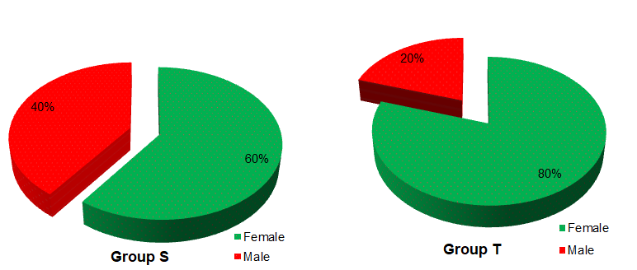

FIG I : SEX DISTRIBUTION

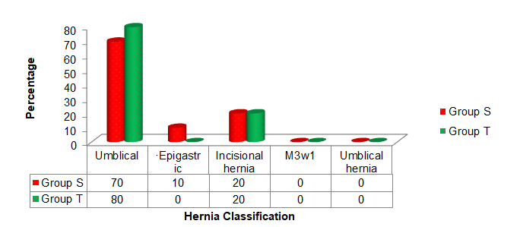

FIG II : HERNIA CLASSIFICATION

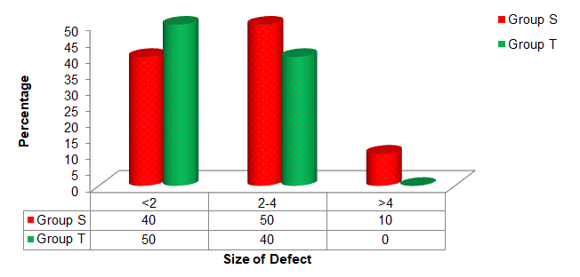
FIG III : SIZE OF THE DEFECT

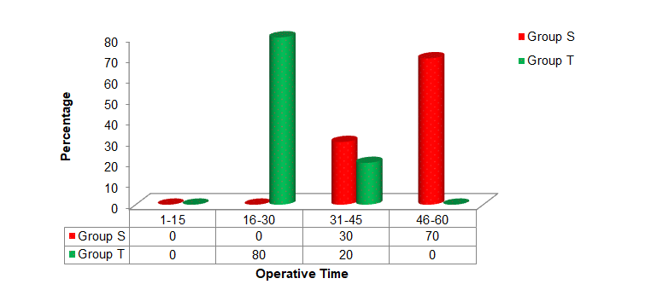

FIG IV : OPERATIVE TIME
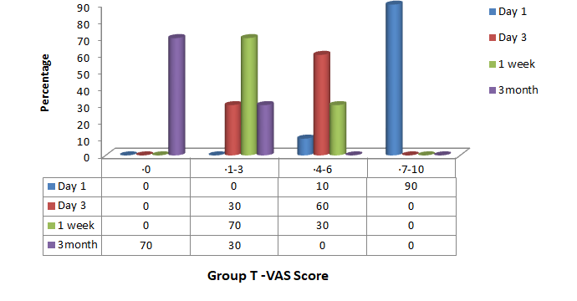

FIG V : PAIN SCORES IN GROUP T

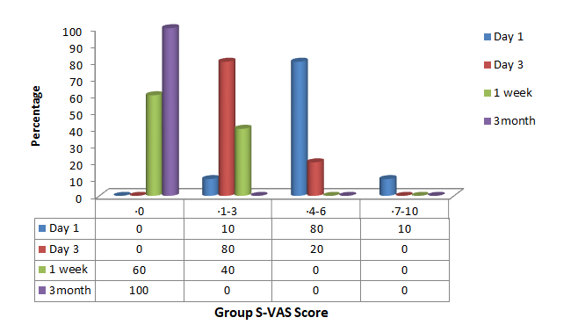

FIG VI : PAIN SCORES IN GROUP S
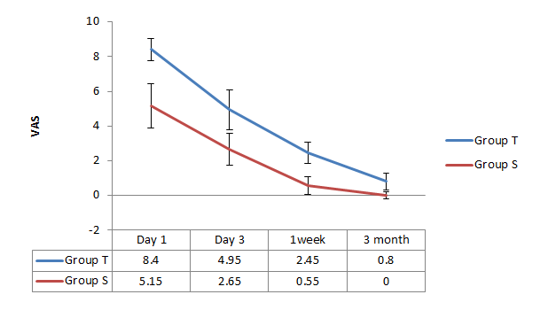
FIG VII : COMPARISON OF THE PAIN SCORES

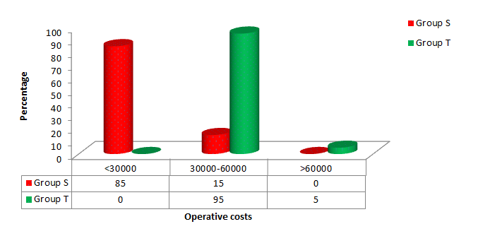

FIG VIII : OPEARTIVE COSTS

DISCUSSION
The preferred method of mesh fixation during laparoscopic ventral hernia is controversial. Many proponents of the use of trans-abdominal sutures cite lower recurrence rates due to higher tensile holding strengths of sutures in comparison to tacks. Other authors argue that the use of tacks reduces surgical time considerably while maintaining similar recurrence rates. These authors also argue that the use of tacks significantly reduces postoperative pain.
The post-operative pain is of great concern in LVHR as it increases consumption of pain killers, increases the incidence of post-operative ileus and subsequently prolongs the length of hospital stay. Sutures penetrate through the full thickness of abdominal wall musculature and fascia. This has been theorized to cause local muscle ischemia resulting in severe pain postoperatively. Fixation with only tackers was relatively weaker as the tackers did not fix the mesh to muscles and fascia as they penetrated through few millimeters of the abdominal wall and this may lead to partial or complete mesh displacement leading to recurrence.
So in this study we tried to combine the best of both worlds, the security of sutures and the pain profile which is better than the tackers. As we can see from the results there was a significant less amount of pain in all the days in the intra-corporeal sutures group. This resulted in early recovery of patients in post operative period and early discharge from hospital.
Also there was significant less cost as compared to the tackers group due to the use of a single ethilon suture material and early discharge of the patients. Our study had no recurrences until 6 months after surgery– additional follow up period is required to ascertain for long term recurrence rates.
On the flip side however, the surgeries in the intra corporeal suture groups were prolonged and it requires advanced surgical skills in laparoscopic suturing and knotting to do it properly. Also due to restricted degrees of freedom of laproscopic instruments it becomes more difficult to suture on the abdominal wall.
But with advancement in robotics and articulated laproscopic instruments some of the difficulties can be overcome and with practice the operative time can be decreased.

LIMITATIONS OF MY STUDY:
Limited sample size, so the significance of the results couldn’t be established. Patients weren’t randomized into the two groups and it was according to the surgeons choice and affordability of the patients. Follow up period of the study was short to look for recurrences.

CONCLUSION
Intra-corporeal suturing is a novel method of mesh fixation that can achieve secure fixation with reduced post-operative pain, nominal surgical costs with feasibility of mesh fixation to any part of the anterior abdominal wall. More studies has to be done to determine if the results are significant when applied to general population

REFERENCES

- William,McCaskie. Bailey & Love’s Short practice of surgery.27th ed. London;2018.p.1023-27.
- Lomanto, S., Iyer, G., Shabbir, A. and Cheah, W.K. (2006) Laparoscopic versus Open Ventral Hernia Mesh Repair: A Prospective Study. Surgical Endoscopy, 20, 1030-1035. http://dx.doi.org/10.1007/s00464-005-0554-2.
- Hoer, J., Lawong, G. and Klinge, U. (2002) Factors Influencing the Development of Incisional Hernia: A Retrospective Study of 2983 Laparotomy Patients over a Period of 10 Years. Chirurgie, 73, 474-480.
- Heniford, B., Park, T., Ramshaw, B.J. and Voller, G. (2003) Laparoscopic Repair of Ventral Hernia: Nine Years Experience with 850 Consecutive Hernia. Annals of Surgery, 238, 391-399.
- McGreevy JM, Goodney PP, Birkmeyer CM, Finlayson SRG, Laycock WS, Birkmeyer JD. A prospective study comparing the complication rates between laparoscopic and open ventral hernia repairs. Surg Endosc. 2003;17:1778–1780 [PubMed]
- Carbajo MA, Martin del Olmo JC, Blanco JI, et al. Laparoscopic treatment vs open surgery in the solution of major incisional and abdominal wall hernias with mesh. Surg Endosc. 1999;13:250–252 [PubMed]
- Nguyen SQ, Divino CM, Buch KE, et al. Postoperative pain after laparoscopic ventral hernia repair: a prospective comparison of sutures versus tacks. JSLS. 2008;12(2):113–116.
- Carbajo MA, Martin del Olmo JC, Blanco JI, et al. Laparoscopic treatment vs open surgery in the solution of major incisional and abdominal wall hernias with mesh. Surg Endosc. 1999;13:250–252 [PubMed]
- Heniford B, Park A, Ramshaw BJ, Voller G. Laparoscopic ventral and incisional hernia repair in 407 patients. J Am Coll Surg. 2000;190:645–650 [PubMed]

Date of Submission: 27 August 2020 Date of Publishing: 30 September 2020
Author Declaration: Source of support: Nil, Conflict of interest: Nil
Ethics Committee Approval obtained for this study? YES
Was informed consent obtained from the subjects involved in the study? YES
For any images presented appropriate consent has been obtained from the subjects: YES
Plagiarism Checked: YES
Author work published under a Creative Commons Attribution 4.0 International License

DOI: 10.36848/IJBAMR/2020/18215.56078

