Original article:
Impact of the COVID-19 crisis on work, mental well-being and self-rated health in NIS, Shymkent’s employees: how do we optimise health?
Turarbekov Dulat Muratbekovich¹, Kasimov Balkan², Alataev Alibek³, Zhautikov Yrysdaulet Abdullaevich⁴ Chandan Pal singh⁵

1= Vice Principal, NIS of Chemistry and Biology, Shymkent, Kazakhstan.
2= Director, NIS of Chemistry and Biology, Shymkent, Kazakhstan.
3= Administrator (Lawyer) NIS of Chemistry and Biology, Shymkent, Kazakhstan
4= Vice Principal, NIS of Chemistry and Biology, Shymkent, Kazakhstan.
5= Physics Teacher, NIS of Chemistry and Biology, Shymkent, Kazakhstan and corresponding author. (chandanengg@gmail.com)

Abstract:
The COVID-19 crisis has radically changed the way people live and work. Changes to the working arrangements of millions of employees who are now based at home and may continue to work at home, in some capacity, for the foreseeable future. The aim of this rapid review was to review the impact of Covid -19 and WFH(work from home) on individual workers’ mental and physical health, to develop recommendations for employers and employees to optimise NIS, Shymkent’s workers’ health. The coronavirus (COVID-19) pandemic has resulted in Decisions on how to promote employees’ health whilst working at home (WAH) need to be based on the best available evidence to optimise worker outcomes. Thirty-Two papers meet the selection criteria for this review. Researchers created a questionnaire to know mental health, Phyiscal health, safety, well-being, stress, relationship with co-workers, quality of life, strain and happiness of NIS, SHYMKENT’S employees. The impact on health outcomes was strongly influenced by the degree of organisational support available to employees, colleague support and social connectedness (outside of work).
Keywords: Covid -19 , WHO , Pandemic

INTRODUCTION:
On March 11, 2020, the World Health Organization (WHO) declared coronavirus (CODIV-19) a pandemic. Which means a global disease outbreak threatening the whole planet. The Coronavirus Disease 2019 (COVID-19) pandemic has deeply altered social and working environments in several ways. Social distancing policies, mandatory lockdowns, isolation periods, and anxiety of getting sick, along with the suspension of productive activity, loss of income, and fear of the future, jointly influence the mental health of citizens and workers [1].
Many countries have demonstrated leadership by implementing emergency measures to prevent the infection spreading. In this context, schools and university, kindergartens, cinemas, museums, restaurants have been closed, public gatherings and events have been cancelled, people quarantined, travel restrictions, close borders and cancelled flights from and to countries leads to psychological and mental effects on citizens. Global economic growth is seen falling to 2.4% for the whole year, compared to an already weak 2.9% in 2019’ (OECD, 2020). This situation can have a negative impact on business sustainability and individual employment. In fact, this has triggered furloughs and layoffs (World Economic Forum, 2020). Employees, in this case, need to take care of themselves, of their families and to try to maintain their job position. What about their mental health in this context?
Besides the negative impact on the individual, a pandemic can lead to sharp shocks to the worldwide economies and societies [2] Workplace aspects can play a crucial role on moderating or worsening mental health of people facing this pandemic scenario. Faced with this epidemiological catastrophe, individuals have presented anxiety-related behaviours [3], Which suggests that the coronavirus is not only a physical health’s risk, but it also weighs heavily on the mental health of individuals.
Indeed, it seems that during a pandemic outbreak, especially in the case of an unknown new virus, individuals’ mental health issues can sometimes be largely overlooked. Adequate social contact is critical for mental health [7], Therefore, perhaps the impact of COVID-19 on social behaviour and related psychological well-being could not be of greater relevance than to mental health services. Service users have existing psychological vulnerabilities, and experience lifestyle difficulties which mean the pandemic may exert increased adverse effect [8]. The prolonged stress could involve anxiety, depression, and the inability to manage traumatic and negative emotions. Furthermore, the constant fear of contagion affects daily life and leads to social isolation, modifying human relations.
Regarding the public health impact of the COVID-19 crisis, several studies suggest that working conditions have deteriorated and that employees are more likely to experience mental health problems, such as stress, depression, and anxiety [8,9,10,11]. One of the common stressors that research has highlighted is the fear of losing one’s job and, consequently, one’s income [7]. Moreover, social isolation, conflicting messages from authorities, and an ongoing state of uncertainty have been described as some of the main factors contributing to emotional distress and negatively affecting mental health and well-being [8, 14,15,16,17,18].
In 2019, according to the Statistics Committee[14] of the MoNE of Kazakhstan, there were 1.3 mln. active small and medium enterprises in Kazakhstan, employing 3.3 mln. people. Due to the quarantine measures and state of emergency, 69.6% of SMEs were forced to suspend their economic activities and another 2.2% completely stopped their activities. Since the introduction of the quarantine, only 10% of SMEs have taken measures to adapt to the new conditions: 5% of SMEs have implemented online services for customers, and 2.5% have implemented online services for employees. "Tourist business" (87%), "Educational services" (85%), "Beauty industry" (84%), "Sports and entertainment industry and shopping centres" (80%), "HORECA" (78%), "Wholesale and retail trade and service stations" (73%) and "Transportation services" (75%) are affected in Kazakhstan.
According to protection motivation theory (PMT [16], health attitudes and behavior depend on two key psycho- logical factors of risk perception, including one’s perceived threat due to the risk and coping efficacy with regard to the ability to cope with the risk. Perceived threat consists of estimates of the chance of contracting a disease (per- ceived vulnerability) and estimates of the seriousness of a disease (perceived severity). Coping efficacy refers to be- liefs about whether responses are available and effective in averting the threat (response efficacy) and whether people and groups can effectively respond to the risk and protect themselves from the hazard (self-efficacy).
The COVID-19 lockdown changed this by forcing many employees into mandatory WFH.
This posed various challenges for employees without prior WFH experience, such as organizing the workspace, establishing new communication channels with colleagues, coping with work isolation, or managing boundaries between work and non-work [17,18,19]. Without proper support from the employer or insufficient resources to manage these challenges, mandatory WFH may become a burden that negatively affects employees’ well-being and, in turn, their performance [17,20].
Furthermore, the increase in WFH has been highlighted as a potential threat to parents with small children at home, as this group is likely to experience difficulties in combining work duties with home schooling and household chores [20,].
Indisputably, the COVID-19 pandemic has had a strong impact on many aspects of our lives and will continue to do so for months and years to come. However, the consequences of the crisis and societal reactions to the challenges posed by the virus are not deemed solely negative.
The new situation also holds opportunities for positive shifts in our work and private lives that were impossible before the COVID-19 crisis. Many may see this crisis as an opportunity to learn how to cope with profound changes in everyday life and even to adopt new pro-active behaviours.
OBJECTIVE:
The purpose of this literature review is to deepen the psychological aspects linked to NIS, Shymkent’s employees, following the epidemic rise of COVID-19, in order to address upcoming psychological critical issues in the workplaces. This review sets the basis for a better understanding of the psychological conditions of NIS Shymkent’s workers during the pandemic, integrating individual and social perspectives, and providing insight into possible individual, social, and occupational approaches to this “psychological pandemic”.The objectives of the present paper were twofold. First, to examine the impact of COVID-19 on NIS employees’ mental health. Secondarily, to evaluate the main organizational interventions, from human resource management perspective, which may mitigate this impact.
As we write this paper, the coronavirus is spreading so fast. Considering its novelty, studies, which have investigated its impact on individuals’ mental health, are sparse. In addition, there are few studies that have examined this epidemiological catastrophe from a managerial perspective
However, a loss of in-person human contact may pose drawbacks [4]. Emerging reports suggest that loss of social interaction associated with the pandemic may lead to feelings of alienation and loss of self-worth [5] and that physical distancing can impact individual well-being [4] across the lifespan [6].
METHODOLOGY:
Researchers performed a literature using survey and data collection focusing on employee’s psychological problems that can be related to the workplace during the pandemic.
Survey was conducted during 9-19 June 2021 to collect the data for mental health exposure. Our sample compromised 106 NIS, Shymkent Employees who reported their answers on various scale to analysis mental health affected by Covid-19. The online survey was conducted using Microsoft form by using 20 questions. It took around 10 minutes to complete all questionnaires in this study.
Below are questions from survey
1 I feel, I have an extremely large amount of work to do
2 I can't complete work in the required time
3 I need to be constantly thinking about work throughout the working day
4 There are differences of opinion within my department
5 I have been full of energy
6 I have been inwardly annoyed or aggravated
7 I feel extremely tired
8 I have felt worried or insecure
9 I haven’ t been able to sleep well
10 Our organization has taken appropriate action in response to COVID-19
11 Senior Leadership cares about my health and safety
12 I am fully aware of how COVID-19 will affect my role at the organization.
13 I am able to be just as productive while working remotely(on-line) when compared to my usual work location.
14. I feel stressed due to change in work routines and organisation.
15. Difficult to find work -life balance in this time.
16. Not being able to stop or control worrying?
17. Do you have any other feedback that you would like to share regarding the organization’s response to COVID-19?
All response were reported one of the options: Very much, Moderately, Somewhat, not at all.
The Covid-19 pandemic led to a prolonged exposure to stress. Therefore, researchers showed an increased interest in measuring social and community uneasiness in order to psychologically support the population. This increased attention might help in managing the current situation and other possible epidemics and pandemics. The security measures adopted in managing the pandemic had different consequences on individuals, according to the social role invested.
Some segments of the population seem to be more exposed to the risk of anxious, depressive, and post-traumatic symptoms because they are more sensitive to stress.

RESULTS:
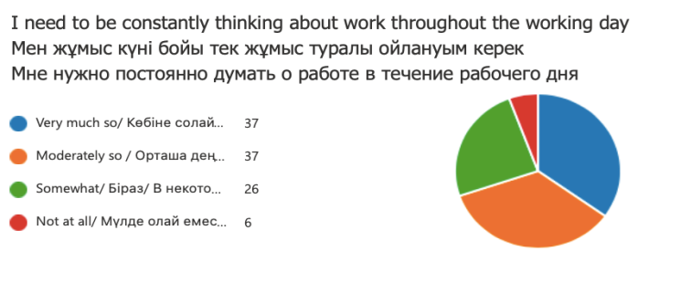
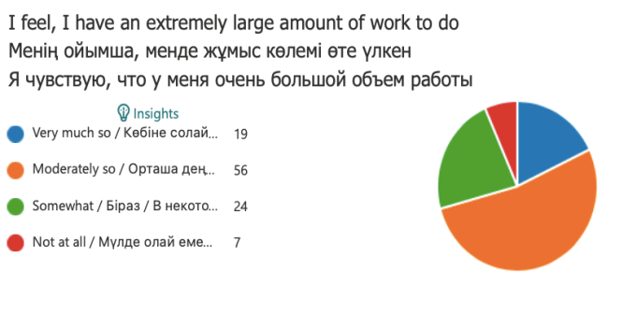
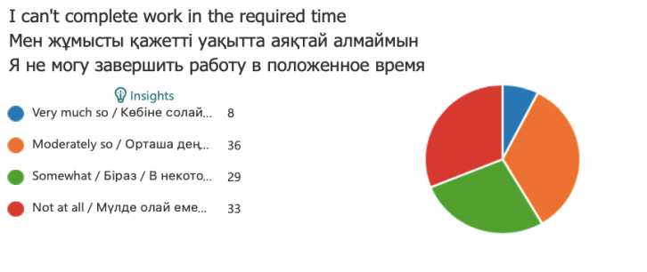

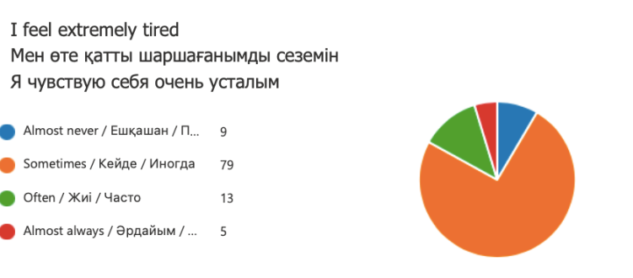

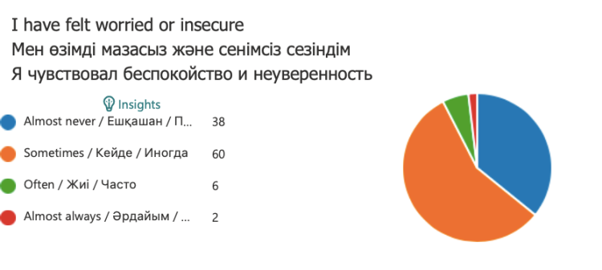

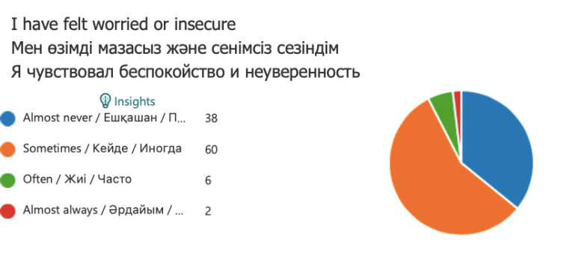

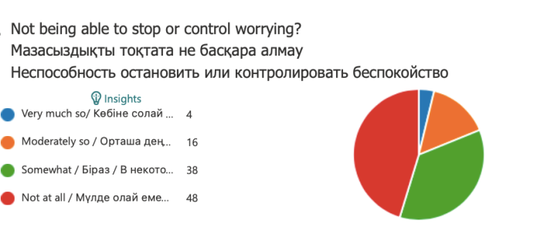

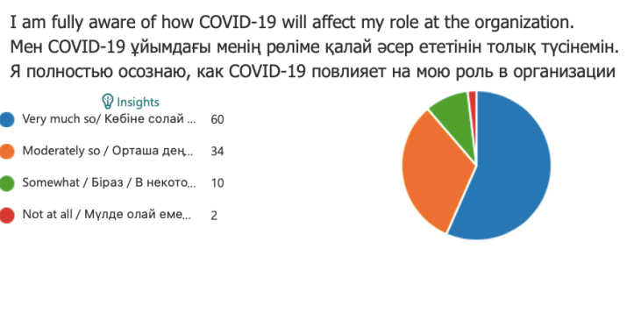

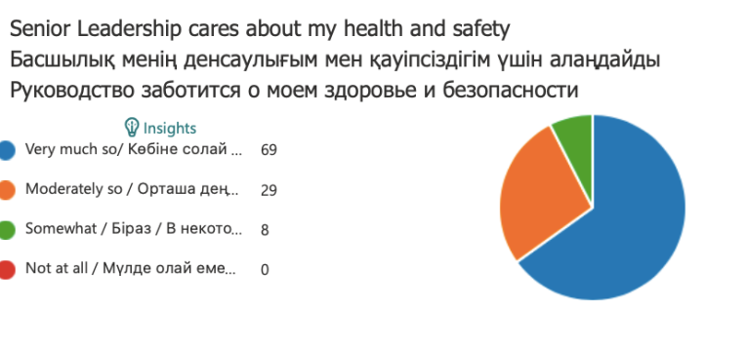

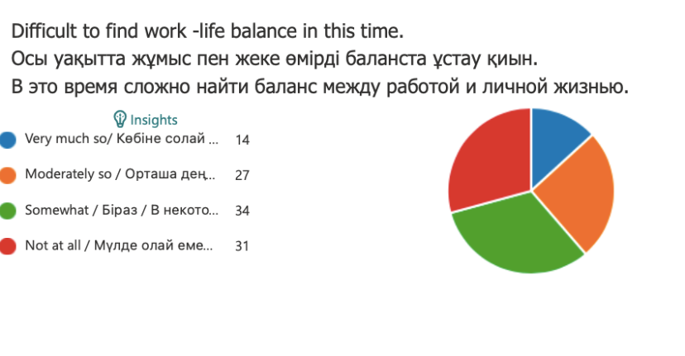

Analysis:
53% of people answered Moderately in response if they feel extremely large amount of work to do after pandemic. When it comes to think constantly for work after covid hit the country, 40% workers agree. More than 60% workers still feel about no differences of opinion, and they get always support even in WFH. Majority of participants never feel full of energy during working hours and it’s affecting their overall output. More than 60 % employees sometime feel they are inwardly annoyed during working hours and its leads to dissatisfaction with daily task and goals, subsequently 57% feel fear of loosing job and insecure about career.
Constantly thinking and fear of losing job is leading to sleep issue with employees, more than 57 % people can’t have proper and regular sleep. But good sign of organisational involvement for support and taking proper actions in response of covid-19 and majority of employees are very much support the question. Employees are satisfied form their line manager and senior leadership for taking care about their health and safety. More than 70% employees are much aware how covid and post covid can change their role in organisation so they can improve or learn new skills for new normal of future.
Discussion:
Due to the current pandemic situation, WFH is most common practise (except front liners) as part of a public health measure to prevent the spread of Covid. Although this measure was introduced rapidly, it is likely WFH will remain in place for some time and organisations will utilise this as a strategy to manage the necessary physical distancing requirements to prevent further outbreaks of COVID-19. This rapid review explored the impact of WFH on physical and mental health outcomes to inform the development of guidelines to support employers in creating optimal working conditions [20].
The majority of studies in the rapid review employed cross-sectional designs and were of variable quality. The definition of WFH and the number of days per week employees were working at home were often unclear. Of the 23 studies identified as relevant to this review, only one investigated the condition of mandatory WFH [21]. This discussion will outline the physical and mental health outcomes of NIS, Shymkent’s Employees and then, drawing on these findings, outline implications for practice.
Physical health and WFH was only examined in three studies. The very low number of studies identified could suggest the search strategy was not adequately targeted to capture studies assessing the physical health outcomes of WFH; however, a range of terms associated with musculoskeletal health were included. Grey literature may have offered further insights but was not included in this rapid review. An alternative explanation may be that in cases where employees are working at home for limited time periods, the use of standard guidelines for workstation arrangements have been considered sufficient and deployed to manage the physical health of workers.
The limited coverage of physical health outcomes of WFH was not expected. Previous research, in relation to the occupational health of employees, suggests the focus is more typically on the physical aspects of health [22].
Five studies [22, 23, 24, 25, 26] examined the influence of colleagues and organisational support on WFH. Suh & Less compared the effect of technostress (defined as work overload, invasion of privacy, and role ambiguity) on IT company employees doing low intensity WFH (< 2.5 days per week), to those doing high intensity WFH (> 2.5 days per week). Low intensity WFH employees experienced higher strain associated with work overload and invasion of privacy, related to IT complexity, pace of IT change, lower job autonomy, and being constantly in electronic contact with work. Bentley et al. [27] explored the influence of organisational (social and manager) support on health outcomes of WFH employees and found a similar relationship between lower levels of organisational support and higher psychological strain. Sardeshmukh et al. [24] also examined the effects of organisational support (via job resources and demands) and found associations between WFH and less time pressure, less role conflict, and greater autonomy, resulting in less exhaustion.
However, they also found WFH was associated with lower social support, lower feedback and greater role ambiguity which increased exhaustion; overall these negative effects did not outweigh the overall positive impact of WFH. Vander Elst et al found increased WFH hours were associated with less emotional exhaustion and cognitive stress which was mediated by support from colleagues. Those working more days at home experienced greater emotional exhaustion and cognitive stress associated with reduced social support from their colleagues. Grant et al. [28] interviewed employees WFH and identified colleagues’ support and communication as important influences on psychological well-being. Tietze et al. [29] interviewed seven employees WFH on a full-time basis as part of a three-month pilot scheme.
Employees reported an improved sense of personal well-being as they were no longer in a stressful office environment.
Implications for practice
Drawing on the evidence from the current rapid review, key themes were identified and are provided here as considerations to assist with developing optimal working conditions for employees WAH, including organisational support, co-worker support, technical support, boundary management support, and addressing gender inequities:
Institutional support
The current pandemic situation has resulted in many sudden and unexpected changes to work practices which potentially create uncertainty for employees, necessitating regular communication to ensure clarity around role expectations, clearly defined performance measures, appropriate workloads, and access to human resources support Systems which optimise regular, reliable, and consistent communication, using methods which are appropriate for employers and employees, need to be negotiated and implemented. In addition, organisations need to provide training and assistance for managers, school leaders supervising WAH employees. company may also consider financial compensation to employees for costs associated with WAH [30].
Co-worker support.
WAH can be isolating with employees feeling disconnected from their line managers and colleagues. Systems which facilitate effective formal and informal co-worker support are needed. Formal co-worker support that occurs in teams when people are collocated, such as sharing of tasks and incidental problem solving, requires facilitation whilst WAH. In the current mandated WAH situation, provision of regular face-face online contact opportunities and social support could replace the day in the office [31].
Technical support
The sudden and unexpected requirement to undertake technologically dependent work roles within the domestic environment has exposed the need for high quality technology services for those WAH. Effective WAH requires the provision of appropriate equipment and high-quality technology support in conjunction with training in the necessary software and systems needed by an individual [32].
Conclusion:
Overall, the findings from this study suggest the impacts of Covid and WFH (NIS, Shymkent) on individuals’ mental and physical health vary considerably. However, despite limitations with a relatively low number of studies, some consistent principles emerge which can be used to support employers in improving working conditions to mitigate the negative effects of WFH, and enhance the positive effects of WFH on employees’ health. At a minimum, opportunity for regular communication between managers and their team and between colleagues are important and help to reduce the negative impacts associated with feeling isolated whilst WFH. Now new normal is covid and post covid and all sectors will move to WFH and for many it will be mandatory. Researchers consider of the impact on the home environment and the financial impacts of being at home on a full-time basis (e.g., increased heating, cooling and telecommunication costs) is required. Some financial compensation may be appropriate for employees to reduce this fiscal burden, although some of these costs may be offset by reduced costs associated with commuting.

RESEARCH:

- Gabriele Giorgi,1 Luigi Isaia Lecca,2 Federico Alessio,3 Georgia Libera Finstad,3 Giorgia Bondanini,3 Lucrezia Ginevra Lulli,4 Giulio Arcangeli,2, * and Nicola Mucci2, COVID-19-Related Mental Health Effects in the Workplace: A Narrative Review, Int J Environ Res Public Health. 2020 Nov; 17(21): 7857. Published online 2020 Oct 27.
- Public responses to the novel 2019 coronavirus (2019-nCoV) in Japan: Mental health consequences and target populations. Shigemura J, Ursano RJ, Morganstein JC, Kurosawa M, Benedek DM. Psychiatry Clin Neurosci. 2020 Apr; 74(4):281-282.
- Shigemura J, Ursano RJ, Morganstein JC, et al. : Public responses to the novel 2019 coronavirus (2019-nCoV) in Japan: mental health consequences and target populations. Psychiatry Clin Neurosci. 2020;74(4):281–282. 10.1111/pcn.12988 [
- Haider, I.I., Tiwana, F. & Tahir, S.M. (2020). Impact of the COVID-19 pandemic on adult mental health. Pakistan Journal of Medical Sciences, 36 (COVID19-S4), S90– S94.
- Williams, S.N., Armitage, C.J., Tampe, T. & Dienes, K. (2020). Public perceptions and experiences of social distancing and social isolation during the COVID-19 pandemic:
- A UK-based focus group study. British Medical Journal Open, 10, e039334.Beam, C.R. & Kim, A.J. (2020). Psychological sequelae of social isolation and
- loneliness might be a larger problem in young adults than older adults. Psychological Trauma, 12 (S1), S58– S60.Hawkley, L.C. & Cacioppo, J.T. (2010).
- Loneliness matters: A theoretical and empirical review of consequences and mechanisms. Annals of Behavioral Medicine, 40, 218– 227.
- Brooks SK, Webster RK, Smith LE, Woodland L, Wessely S, Greenberg N, et al. The psychological impact of quarantine and how to reduce it: rapid review of the evidence. Lancet. 2020;395(10227)
- Rodríguez-Rey R, Garrido-Hernansaiz H, Collado S. Psychological impact and associated factors during the initial stage of the coronavirus (COVID-19) pandemic among the general population in Spain.
- Wang C, Pan R, Wan X, Tan Y, Xu L, Ho CS, et al. Immediate psychological responses and associated factors during the initial stage of the 2019 coronavirus disease (COVID-19) epidemic among the general population in China. Int J Environ Res Public Health
- Elmer T, Mepham K, Stadtfeld C. Students under lockdown: comparisons of students’ social networks and mental health before and during the COVID-19 crisis in Switzerland.
- Carvalho Aguiar Melo M, de Sousa Soares D. Impact of social distancing on mental health during the COVID-19 pandemic: an urgent discussion.
- United Nations Kazakhstan Covid-19 Socio-Economic Response & Recovery Plan UNCT Kazakhstan August 2020
- Carvalho Aguiar Melo M, de Sousa Soares D. Impact of social distancing on mental health during the COVID-19 pandemic: an urgent discussion. Int J Soc Psychiatry. 2020;66:625–6
- Maddux JE, Rogers RW. Protection motivation and self-efficacy: a revised theory of fear appeals and attitude change. J Exp Soc Psychol. 1983;19(5): 469–79.
- Ozcelik H, Barsade SG. No employee an island: workplace loneliness and job performance. AMJ. 2018;61(6):2343–66
- Shimazu A, Nakata A, Nagata T, Arakawa Y, Kuroda S, Inamizu N, et al. Psychosocial impact of COVID-19 for general workers. J Occup Health. 2020;62(1):1–24.
- Cho E. Examining boundaries to understand the impact of COVID-19 on vocational behaviors. J Vocat Behav. 2020;119:1–3.
- A rapid review of mental and physical health effects of working at home: how do we optimise health? Jodi Oakman, Natasha Kinsman, Rwth Stuckey, Melissa Graham & Victoria Weale BMC Public Health volume 20, Article number: 1825 (2020)
- ietze S, Nadin S. The psychological contract and the transition from office-based to home-based work. Hum Resour Manag J. 2011;21(3):318–34.Leka S, Jain A, Iavicoli S, Di Tecco C. An evaluation of the policy context on psychosocial risks and mental health in the workplace in the European Union
- Bentley T, Teo S, McLeod L, Tan F, Bosua R, Gloet M. The role of organisational support in teleworker wellbeing: a socio-technical systems approach. Appl Ergon. 2016;52:207–15.
23 Grant CA, Wallace LM, Spurgeon PC. An exploration of the psychological factors affecting remote e-worker’s job effectiveness, well-being and work-life balance. Empl Relat. 2013;35(5):527–46.
24. Sardeshmukh SR, Sharma D, Golden TD. Impact of telework on exhaustion and job engagement: a job demands and job resources model. N Technol Work Employ. 2012;27(3):193–207.
25. Suh A, Lee J. Understanding teleworkers’ technostress and its influence on job satisfaction. Internet Res. 2017;27(1):140–59.
26. Vander Elst T, Verhoogen R, Sercu M, Van den Broeck A, Baillien E, Godderis L. Not extent of telecommuting, but job characteristics as proximal
predictors of work-related well-being. J Occup Environ Med. 2017;59(10):E180–E6.
27. Bentley T, Teo S, McLeod L, Tan F, Bosua R, Gloet M. The role of organisational support in teleworker wellbeing: a socio-technical systems approach. Appl Ergon. 2016;52:207–15.
28. Grant CA, Wallace LM, Spurgeon PC. An exploration of the psychological factors affecting remote e-worker’s job effectiveness, well-being and work-life balance. Empl Relat. 2013;35(5):527–46.
29. Tietze S, Nadin S. The psychological contract and the transition from office-based to home-based work. Hum Resour Manag J. 2011;21(3):318–34.
30. Major DA, Verive JM, Joice W. Telework as a dependent care solution: examining current practice to improve telework management strategies. Psychol Manag J. 2008;11(1):65–91
31. Vander Elst T, Verhoogen R, Sercu M, Van den Broeck A, Baillien E, Godderis L. Not extent of telecommuting, but job characteristics as proximal predictors of work-related well-being. J Occup Environ Med. 2017;59(10):E180–E6.
32. Bosua R, Gloet M, Kurnia S, Mendoza A, Yong J. Telework, productivity and wellbeing: an Australian perspective. Telecommunications J Aust. 2013;63(1):11.1–11.12.

