**Original article:**

**Study of** **immunohistochemical expression of Hector Battifora Mesothelial -1 (HBME-1), E-Cadherin and CD-56 in the differential diagnosis of thyroid lesions and co-relation between their histopathology findings**

**1Dr. Ishita Sharma, 2 Dr. Leena Nakate**

1Final year Resident, 2 Prof and Head

Department of Pathology, BJGMC, Pune

Corresponding author: Dr. Ishita Sharma

**C:\Users\RDRL\Desktop\Quantitative analysis\88x31.png**

This work is licensed under a Creative Commons Attribution-NonCommercial 4.0 International License

Date of submission: 05 April 2023

Date of Final acceptance: 18 May 2023

Date of Publication: 02 June 2023

Source of support: Nil

Conflict of interest: Nil

**Abstract**

**Introduction:** Thyroid Gland is the most common organ to cause endocrine disorders after diabetes mellitus. Lesions of thyroid maybe benign or malignant forming a nodule clinically.

**Materials and Methods:** Study was a descriptive cross-sectional study in a Tertiary health care centre for a duration of January 2021 to June 2022 with a sample size of 37. Study population were resected thyroid specimen.

**Results**: HBME-1 was positive in carcinoma especially papillary thyroid carcinoma. Papillary thyroid carcinoma was characterized by a decreased expression of E-CAD and CD56 contrary to the surrounding benign thyroid tissues. There was no HBME-1 expression in benign thyroid tissues and weak in follicular adenomas. E-CAD and CD56 expression was significantly weakened in carcinomas, but enhanced in follicular adenomas and goitre.

**Conclusion:** HBME-1, CD56, E- Cadherin are useful markers that can help in differentiating various nodular lesions of thyroid especially benign and malignant.

**Keywords:** HBME-1, CD56, E- Cadherin

**Background:**

The thyroid gland is the most common organ to cause endocrine disorders, after diabetes mellitus (1). Diseases of the thyroid gland are common and comprise a spectrum of entities causing systemic disease (Grave's disease) or a localized abnormalities in the gland such as nodular enlargement or a tumour mass. In India, the prevalence of a palpable thyroid nodule in the community is about 12.2%, according to a recent study (2). Nodular lesions comprise those disorders that produce a clinical nodule and consist of non- neoplastic hyperplasia as well as benign and malignant tumour (2). Prevalence increases linearly with age, exposure to ionizing radiation, and iodine deficiency. Neoplasm of thyroid are relatively uncommon disease. They constitute only 0.7% of all cancers in females and 0.2% in males. However there has been an increase in the incidences of thyroid neoplasm in India and abroad (5). Thyroid carcinoma resembles closely it's benign counterpart in physical characteristics, measurable physiological parameters such as serum T3/T4 levels and ultrasound characteristics. Therefore, the surgical excision of the nodule and its histological examination is the only way to differentiate between the more frequent benign and much less frequent malignant nodules (6). In India, there are 2,16,000 new cases of thyroid malignancies per year (7) and hence the role of properly evaluating thyroid lesions is significant.

The differential diagnosis of thyroid nodules could be difficult due to the overlapping morphological features; therefore, many attempts have been described to find the additional criteria to distinguish thyroid pathologies in surgical material. A growing number of molecular or immunohistochemical (IHC) markers are being identified and tested with a considerable variability in the outcomes of these studies. In this study, we evaluated the expression of 3 IHC markers – Hector Battifora mesothelial cell (HBME-1), E-cadherin (E-CAD) and CD56 – in the histological samples of various thyroid lesions to determine their usefulness in the diagnosis of various conditions of thyroid.

The differential diagnosis of thyroid nodules could be difficult due to the overlapping morphological features; therefore, many attempts have been described to find the additional criteria to distinguish thyroid pathologies in surgical material and in less explored FNA cytological specimens. A growing number of molecular or immunohistochemical (IHC) markers are being identified and tested with a considerable variability in the outcomes of these studies. In this study, we evaluated the usefulness of applying the panel of 3 IHC markers – HBME-1, E-cadherin (E-CAD) and CD56 – on the histological samples of various thyroid lesion

**Materials and methods:**

This study is descriptive cross-sectional study that was conducted in a tertiary health care centre. Study duration was from January 2021 to June 2022. Study population was of total of 37 cases of histologically confirmed surgical specimen of thyroid nodular lesions. This study was conducted after getting ethical approval from the Ethical Committee.

The inclusion criteria were as follows: all surgical removed specimens of thyroid lesions, irrespective of age and sex. Exclusion criteria were as follows: Secondary thyroid lesions and cases of oncocytic thyroid neoplasms. Clinical details such as age, sex, menstrual status, obstetric history will be obtained from histopathological requisition form.

Tissue samples from primary tumour were sliced at 5mm thickness and were fixed in 10% neutral buffered formalin for 24 hours. Detailed gross examination was done. Multiple sections were taken following gross examination- from tumour, from adjacent thyroid tissue, from capsule, and all dissected nodes were submitted for histopathological examination. Formalin fixed paraffin embedded sections were taken. 4-5μm-thick sections were taken and stained with Haematoxylin and eosin and evaluated by two independent pathologists. Histopathological study of H&E sections will be done to assess histological subtype, capsular invasion/ breach, lymphovascular invasion. Histological grading of tumour will be done according to WHO classification of thyroid neoplasms 2022 (10) and staging according to pTNM classification designated by American Joint Committee on Cancer. (12)

For immunohistochemistry, the material required was purchased from Biogenex Life Sciences. The panel of antibody included were against HBME-1, E Cadherin and CD56. The antibodies provided are already diluted, ready to use. Known positive controls were used with each batch of IHC performed. Tissue section taken on APES/Poly L-lysine coated slides. Baking in incubator overnight at 600C. Deparaffinize sections in xylene, 2x5 minutes. Rehydrated with 100% ethanol, 2x3 min. Rehydrated with 95% ethanol, 1 min and rinsed in distilled water. Antigen retrieval using EZ-Retriever system was done. 10 minutes at 950C in citrate buffer, pH 6 followed by PBS wash, 3 times. Then Peroxide block 10 minutes at room temperature and slide kept in humid chamber. PBS wash, 3 times. Draw a hydrophobic barrier around tissue using PAP Pen. PBS wash, 3 times. Power block (100μL). Primary Antibody (100μL) PBS wash, 3 times Super EnhancerTM (100μL) then 20 minutes at room temperature (20-250C) PBS wash, 3 minutes Polymer-HRP (100μL) kept for 30 minutes at room temperature (20-250C) PBS wash, 3 times. 1 drop of DAB chromogen in 1 mL stable DAB buffer this is added to the tissue and incubate for 5 minutes at room temperature. Washed under running tap water. Haematoxylin counter stain (100μL). Then mounted.

For statistical analysis data was collected and entered in a systematic format in Microsoft excel 2013. It was checked for any duplicate or incomplete entries. All the parameters in the data were analysed for mean, frequency, percentage. The statistical analysis for correlation among these parameters was determined using Chi-square test. The Statistical Package for Social Sciences (SPSS) 22.0; IBM Analytics, New York, U.S.A was used for the analysis. All p values < 0.05 was considered to be statistically significant. The data collected was coded and entered in Microsoft excel 2013.

**Result**

In our study, there were a total of 37 cases of thyroid nodular lesions The study cases contained 59.46% (22/37) benign cases while malignant were 40.54% (15/37) of the total cases. There were 27/37 (11%) females and 10/37 (27%) males in the study. Mean age of the study participants in our study was 42.35±12.86 years. In all there were 6 (16.22%) cases were of colloid goiter, 7 (18.92%) cases were of multinodular goiter, 9 (24.32%) cases were of follicular adenoma, 12 (32.43%) cases were of papillary carcinoma, 2 (5.41%) cases were of follicular carcinoma and 1 (2.70%) case was of undifferentiated carcinoma.

|  |  |  |  |
| --- | --- | --- | --- |
| Histopathological Diagnosis | | HBME-1 Expression Intensity** | |
| Negative (N=20) | Positive (N=17) |
| Colloid Goitre(N=6) | Number | 6 | 0 |
| % | 100.0% | 0.0% |
| Multinodular goitre (N=7) | Number | 7 | 0 |
|  | % | 100.0% | 0.0% |
| Follicular Adenoma(N=9) | Number | 6 | 3 |
| % | 66.7% | 33.3% |
| Follicular carcinoma(N=2) | Number | 0 | 2 |
| % | 0.0% | 100.0% |
| Papillary Carcinoma (N=12) | Number | 0 | 12 |
| % | 0.0% | 100.0% |
| Undifferentiated carcinoma of thyroid (N=1) | Number | 1 | 0 |
| % | 100.0% | 0.0% |

**Table No 1: HBME-1 versus final diagnosis contingency table.**

Out of the total 37 cases HBME-1 positive expression was seen in 93.33% (14/15) malignant cases and only 18.18% (4/22) benign cases. The study showed that out of the total 37 cases taken, expression of HBME-1 was seen in 17/37 cases. 100% cases of papillary carcinoma (12/12) showed positive expression. 100% cases of follicular carcinoma (2/2) included in the study showed positive expression of HBME-1 (2/2), 33.3% (3/9) cases of follicular adenoma were considered positive for HBME-1 expression as their expression score was greater than 1.5. However, in 66.7% cases the expression score calculated after multiplying the percentage of cells showing expression of HBME-1 with their respective intensity score was less than 1.5 and hence were considered as negative for HBME-1. Therefore HBME-1 expression in follicular adenoma was variable. 0% cases showed expression of HBME-1 in multinodular goiter (0/7). 0% cases showed expression of HBME-1 in colloid goiter (0/6). 0% cases showed expression of HBME-1 in undifferentiated carcinoma (0/1). There was a significantly higher expression of HBME-1 in malignant lesions as compared to benign lesions. All cases of papillary carcinoma and follicular carcinoma showed expression indicating the higher rate of positive expression of HBME-1 in malignancy. However, due to less cases of follicular carcinoma in the study, conclusive results could not be drawn for follicular carcinoma. Therefore, it was inferred that HBME-1 was positive in malignancy of thyroid, particularly papillary thyroid carcinoma. The sensitivity of HBME-1 for predicting malignancy is found to be 93.33% with a confidence interval of 68.05% to 99.83%.

It was seen that CD-56 was expressed in 77.27% (17/22) benign cases and only 20% of malignant cases (3/15). Overall CD-56 was significantly expressed more in benign lesions as compared to malignant lesions.



2

Colloid goiter had 83.3% cases (5/6) with positive expression for CD56, Multinodular goiter had 85.7% cases (6/7) with positive expression for CD56 Follicular adenoma had 66.7% (6/9) cases that were positive for CD56 expression, Follicular carcinoma had 50% cases (1/1) that were positive for CD56 expression, Single case of undifferentiated carcinoma (0/1) was negative for CD56 as the number of cells that stained for CD56 were less, resulting in an overall negative expression for CD56. Papillary carcinoma had only 8.3% (1/12) cases that were considered positive for CD56 as CD56 was expressed in less percentage of cells in the total analyzable tissue. Therefore, on calculating the expression intensity for all cases of papillary carcinoma 91.7% (11/12) cases came out to be negative for CD56 expression. Therefore, CD-56 expression was significantly higher in benign than in malignant lesions. Malignant lesions like papillary carcinoma, where some cases showed staining of weak to moderate intensity in a smaller number of cells giving them low expression intensity and making them negative in such cases. Similarly undifferentiated carcinoma showed strong intensity but was expressed in only 30% cells, therefore making it negative for CD-56. Follicular carcinoma overall showed variable expression intensity for CD-56. Sensitivity of CD-56 to be negative in a malignant thyroid lesion came to be 80.00% with a confidence interval of 51.91% to 95.67%.

It was seen thatE- cadherin was positive in 77.27% (17/22) of benign cases and 33.33% (5/15) of malignant cases while it was negative in 22.73% (5/22) benign cases and 66.67% (10/15) malignant cases. Higher positivity for E cadherin was noted in benign lesions than in malignant lesions of thyroid.

**Table No 03: Distribution of E- Cadherin expression score stratified by Histopathological Diagnosis**

|  |  |  |  |
| --- | --- | --- | --- |
| Histopathological Diagnosis | | E-Cadherin Expression Intensity** | |
| Negative (N=15) | Positive (N=22) |
| Colloid Goitre(N=6) | Number | 1 | 5 |
| % | 16.7% | 83.3% |
| Multinodular goitre (N=7) | Number | 2 | 5 |
| % | 28.6% | 71.4% |
| Follicular Adenoma(N=9) | Number | 2 | 7 |
| % | 22.2% | 77.8% |
| Follicular carcinoma(N=2) | Number | 0 | 2 |
| % | 0.0% | 100.0% |
| Papillary Carcinoma (N=12) | Number | 9 | 3 |
| % | 75.0% | 25.0% |
| Undifferentiated carcinoma of thyroid (N=1) | Number | 1 | 0 |
| % | 100.0% | 0.0% |

83.3% (5/6) cases of colloid goiter were positive for E cadherin, 71.4% (5/7) cases of multinodular goiter were positive for E cadherin, 77.85% (7/9) cases of follicular adenoma were positive for E cadherin, 100% (2/2) cases of follicular carcinoma were positive for E cadherin, 25% (3/12) cases of papillary carcinoma were positive for E cadherin (however, 75.0% (9/12) cases of papillary carcinoma were scored negative for E cadherin expression as the percentage of cells expressing E cadherin was less). 100% (1/1) case of undifferentiated carcinoma were positive for E cadherin. Overall expression of E-cadherin was more in benign lesions when compared with malignant lesions of thyroid. Specificity for E- cadherin being negative in malignancy was 77.27% with confidence interval of 54.63% to 92.18%.

**IMAGES**

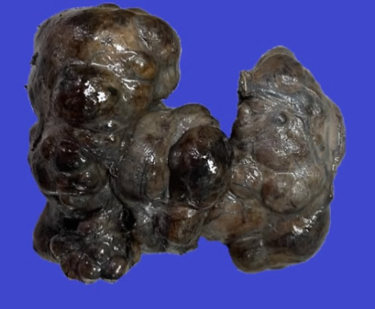

**Image 1. Gross image of multinodular goiter showing irregular nodularity**

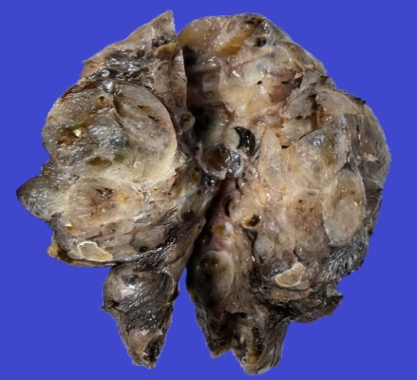

**Image 2: Cut surface of MNG showing variable sized colloid filled follicles**

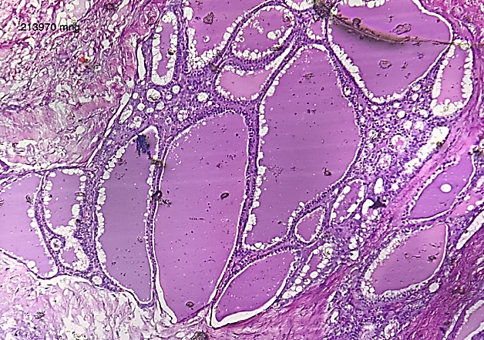

**Image 3:** **Microscopic image of H & E stained section of multinodular goiter**

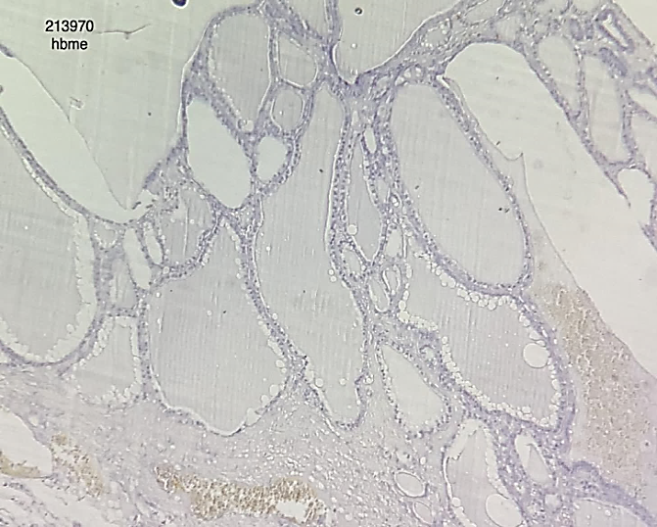

**Image 4: Multinodular Goiter negative for HBME-1**

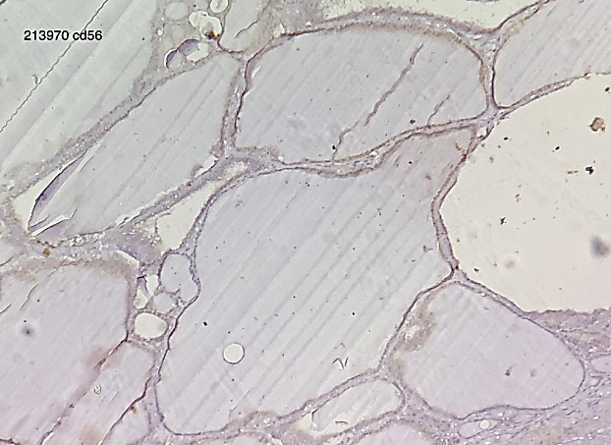

**Image 5: Multinodular goiter showing positive CD56**

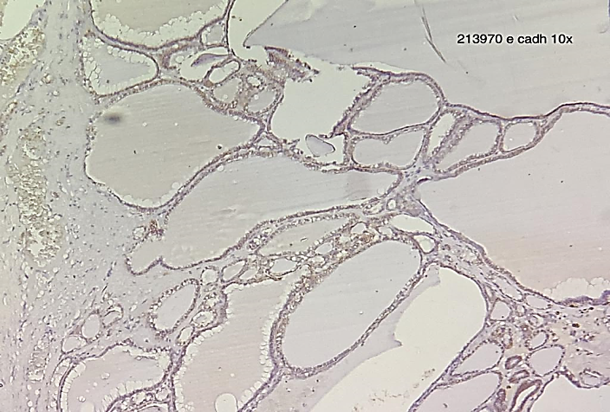

**Image 6: Multinodular Goiter showing positive E-Cadherin**

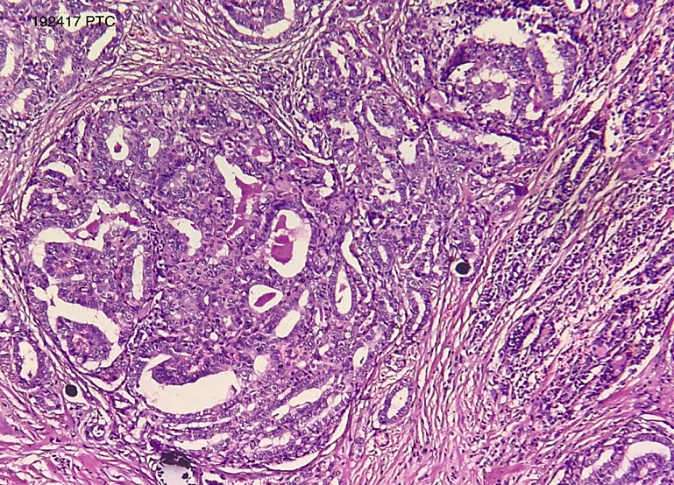

**Image 7: Papillary carcinoma of thyroid (H&E stained)**

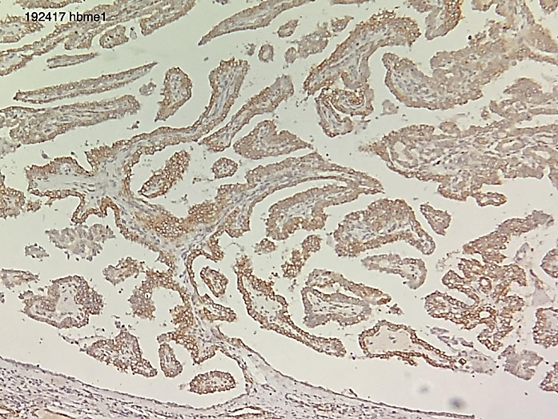

**Image 8: Papillary thyroid carcinoma strong positive for HBME-1**

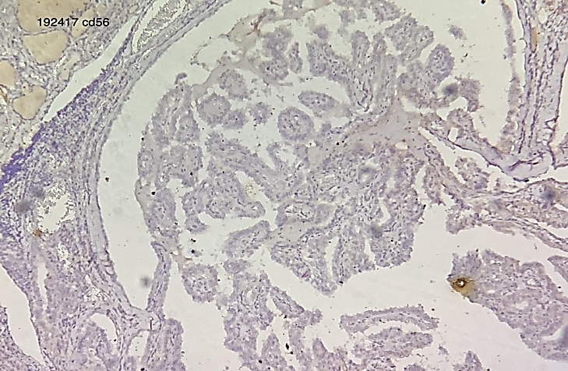

**Image 9: Papillary carcinoma of thyroid negative for CD56**

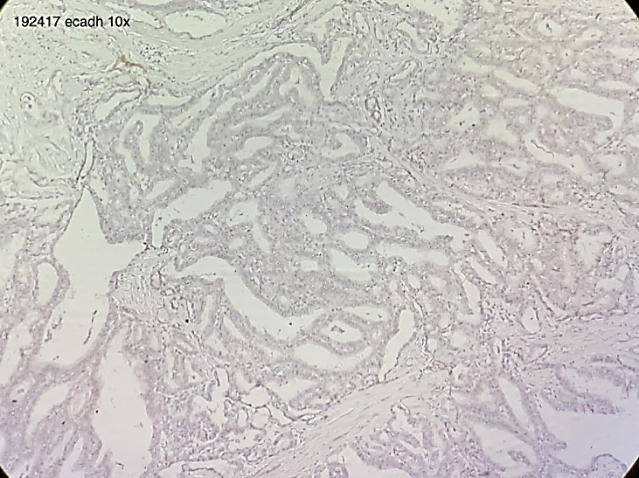

**Image 10: Papillary carcinoma of thyroid negative for E- Cadherin**

**Discussion**

The thyroid gland is an essential endocrine gland in the body that dictates the basal metabolic rate at the cellular level as well as many other vital physiological functions in the body including growth and development. Hence, diagnosis of the lesions of the thyroid gland that is poignant as these affect the hormone balance. Thyroid nodular lesions are the second most common endocrine lesions after diabetes mellites. As most of the thyroid nodular lesions that are benign do not require surgical management and can be treated conservatively, the correct diagnosis is of utmost importance.

FNA has limitations such as its inability to differentiate benign from malignant follicular neoplasms, since this diagnosis rests on the histologic identification of capsular and/or vascular invasion (13,14). In the last several years various IHC markers have been tried and tested on histology sections of various thyroid lesions and to a lesser extent on FNA samples with variable success rates. IHC markers can possibly help in distinguishing these lesions in which the histopathological features overlap or mimic each other.

Our study findings showed that papillary thyroid carcinoma (PTCs) had a high-level immunoexpression of HBME-1, with a sensitivity of 93.33%. However, the expression of HBME-1 by various benign lesions like colloid goitre, multinodular goitre and follicular adenoma, in the study was significantly lower when compared to malignancy. However, there were only 2 cases of follicular carcinoma and 1 case of undifferentiated carcinoma in the study group, out of which both cases of follicular carcinoma and the single case of undifferentiated carcinoma were positive for HBME-1. Due to a smaller number of cases of both follicular carcinoma and undifferentiated carcinoma in the study a definitive conclusion for them is difficult and further studies with a larger sample size are recommended. The p value for higher HBME-1 expression in malignant than benign lesions of thyroid was <0.0001 and was found statistically significant. This agrees with the study of Nasr et al (15) who reported HBME-1 to be the most sensitive and specific marker, staining 96% of PTCs. Another study by Saleh et al. (16) showed that the sensitivity and specificity of immunoexpression for HBME-1 to differentiate benign from malignant lesions was high (88.9%). A study conducted by Zhu X et al (17) showed HBME-1 sensitivity for PTC was 95.5%.

It is reported in the literature that CD56 is expressed at high levels in normal thyroid tissue and benign follicular lesions of the thyroid, such as follicular adenoma (FAs) and hyperplastic nodules (HNs), whereas there are high rates of negativity in papillary thyroid carcinoma (PTC). In our study it was found that the overall expression of CD 56 was higher in benign nodular lesions of thyroid (77.27%) as compared to malignant (20%). The p value of expression of CD 56 in benign versus malignant lesions of thyroid was 0.0007 and was statistically significant. However, it was seen that a negative CD56 was more reliable in predicting a malignant lesion. Hence, a negative CD 56 in predicting thyroid malignancy showed a sensitivity of 80.00%. The series published by El Demellawy et al. in 2008 reported 100% negativity in papillary thyroid carcinoma cases and 100% positivity in other benign lesions, though they also reported that since the well differentiated thyroid tumour of undetermined malignant potential (WDT-UMP) group was not included in that series, studying CD-56 in wider series including this group would be useful for differentiating these suspected lesions from follicular variant of papillary thyroid carcinoma (FVPTC) (18). Ceyran et al (19) found CD56 the most sensitive and the most specific marker to predict malignancy in thyroid. In their study, high rates (91.7%) of diffuse, strong, positive CD56 staining were observed in hyperplastic nodules, follicular adenomas, and lymphocytic thyroiditis and in the normal thyroid tissues around the papillary thyroid carcinoma areas, whereas there were high rates (91.1%) of CD56 negativity in papillary thyroid carcinoma (classical variant, follicular variant and micropapillary).

It is believed that the expression of E-cadherin, which is a cell-adhesion molecule, when reduced causes loss in cell adhesion, leading to excessive proliferation, cancer progression, and increased metastatic potential. This has been demonstrated in various in vitro studies. (20,21). In our study, E cadherin was found to be positive in 77.27% benign lesions and negative in 66.67% of malignant lesions of thyroid. The p value of E cadherin in benign lesions versus malignant lesions was found to be 0.0007, which was statistically significant. Mitselou et al. (22), observed a reduction of E cadherin expression in papillary carcinoma of thyroid compared to normal thyroid tissue. In tissue of various benign thyroid diseases like hyperplasia etc., included in their study, E-cadhe­rin expression was moderate to strong (25% and 75% of the cases, respectively). Soares et all (23) showed reduced and heterogeneous expression of E-cadherin in primary and metastatic papillary carcinomas, whereas follicular carcinomas showed moderate to strong homogeneous immunoreactivity, and poorly differentiated carcinomas showed no or very faint immunoreactivity. In 2012, Ozolins et al. (11) demonstrated on FNA samples that there was a significant reduction in E-cadherin expression in papillary carcinoma of thyroid. Ceyran et al (92) observed that E-cadherin expression displayed a loss in diffusiveness rate and density (86.1% and 92.1%, respectively) in papillary thyroid carcinoma. Additionally, the authors found that the reduced E-cadherin expression in papillary thyroid carcinoma was statistically significantly correlated with poor prognostic findings, such as lymph node metastasis, multiple foci, and a tumour diameter of >10 mm (P<0.05).

**Conclusion**

In conclusion, HBME-1, CD56 and E- Cadherin are IHC markers that can help in diagnosis of conditions where mere histomorphology is not sufficient. HBME-1 was found to be highly sensitive and specific for papillary carcinoma of thyroid. It was strongly expressed in follicular carcinoma as well as undifferentiated carcinoma of thyroid, however due to lack of adequate number of cases of these subtypes, definite conclusions in this regard could not be drawn and studies with larger sample size are recommended.

**References:**

1. GritzmannN, KoishwitzD, Rettenbacher T. Sonography of the thyroid and para thyroid glands. In: Weber AL, editor. The radiologic Clinics of North America. 3rd ed. New York: Elsevier; 2000 G:\Literature Template-1.doc [Page:11]

2. Review article by AG Unnikrishnan et all in Indian journal of endocrine and metabolism, 2011.; Baloch Z and Livolsi V. Pathology of thyroid and parathyroid disease. In: Sternberg's diagnostic surgical pathology. 4th ed. Edinburgh: Lippincott Williams & Wilkins;2004.

3. Hegedus L. Clinical practice: the thyroid nodule. N Engl J Med 2004

4. Ross DM. Diagnostic approach to and treatment of thyroid nodules. I. In: Rose BD, editor. Wellesley (MA): UpToDate; 2005.

5. Kishore N, Shrivastava A,Sharma LK, Chumber S, Kochupillai N, Griwan MS, et al. Thyroid neoplasm. A profile. IndianJ Surg 1996.

6. Pandit AA and Kinare SG. Fine needle aspiration cytology of thyroid. Indian J cancer 1983

7. Ghoshal B, Pal NC, Majumdar P. FNAB in the diagnosis of cold thyroid nodules: correlative study with histopathology and its applications in thyroid surgery. J Indian Med Assoc 1984

8.Etem H, Özekinci S, Mızrak B, Şentürk S. The Role of CD56, HBME-1, and p63 in Follicular Neoplasms of the Thyroid.

9. Shin MK, Kim JW, JU YS. CD56 and High Molecular Weight Cytokeratin as Diagnostic Markers of Papillary Thyroid Carcinoma. Kore J Pathol 2011

10. Zubair W. Baloch, Sylvia L. Asa, Justine A. Barletta, Ronald A. Ghossein, C. Christofer Juhlin, Chan Kwon Jung, Virginia A. LiVolsi, Mauro G. Papotti, Manuel Sobrinho‑Simões, Giovanni Tallini, Ozgur Mete, January 2022

11. Ozolins A, Narbuts Z, Strumfa I, Volanska G, Stepanovs K, Gardovskis J. Immunohistochemical expression of HBME-1, E-cadherin, and CD56 in the differential diagnosis of thyroid nodules. Medicina (Kaunas) 2012; 48: 507-14.

12. Fitzgibbons PL, Bose S, Chen Y-Y, Connolly JL, de Baca ME, Edgerton M, et al. Protocol for the Examination of Specimens from Patients with Invasive Carcinoma of the Breast. 2018 Jan. Version 4.1.0.0.

13. Shih SR, Shun CT, Su DH, Hsiao YL, Chang TC. Follicular variant of papillary thyroid carcinoma: diagnostic limitations of fine needle aspiration cytology. Acta Cytol 2005;49(4):383-6.

14. Wu HH, Jones JN, Grzybicki DM, Elsheikh TM. Sensitive cytologic criteria for the identification of follicular variant of papillary thyroid carcinoma in fine-needle aspiration biopsy. Diagn Cytopathol 2003;29(5):262-6.

15. Nasr MR, Mukhopadhyay S, Zhang S, Katzenstein AL. Immunohistochemical markers in diagnosis of papillary thyroid carcinoma: utility of HBME1 combined with CK19 immunostaining. Mod Pathol 2006

16. Saleh HA, Feng J, Tabassum F, Al-Zohaili O, Husain M, Giorgadze T. Differential expression of galectin-3, CK19, HBME1, and Ret oncoprotein in the diagnosis of thyroid neoplasms by fine needle aspiration biopsy. Cytojournal 2009.

17. Zhu X, Sun T, Lu H, Zhou X, Lu Y, Cai X et al. Diagnostic significance of CK19, RET, galectin-3 and HBME-1 expression for papillary thyroid carcinoma. J Clin Pathol. 2010;63(9)786-789.

18. El Demellawy D, Nasr A, Alowami S. Application of CD56, P63 and CK19 immunohistochemistry in the diagnosis of papillary carcinoma of the thyroid. Diagn Pathol 2008

19. Hanan AlSaeid Alshenawy,Utility of immunohistochemical markers in differential diagnosis of follicular cell-derived thyroid lesions, Journal of Microscopy and Ultrastructure, Volume 2, Issue 3, 2014, Pages 127-136, ISSN 2213 879X,

20. Erdem H, Gündogdu C, Sipal S. Correlation of E-cadherin, VEGF, COX-2 expression to prognostic parameters in papillary thyroid carcinoma. Exp Mol Pathol 2011; 90: 312-7.

21. Sethi K, Sarkar S, Das S, Rajput S, Mazumder A, Roy B, Patra S, Mohanty B, El-Naggar AK, Mandal M. Expressions of CK-19, NF-kappaB, E-cadherin, beta-catenin and EGFR as diagnostic and prognostic markers by immunohistochemical analysis in thyroid carcinoma. J Exp Ther Oncol 2011

22. Mitselou A, Ioachim E, Peschos D, Charalabopoulos K, Michael M, Agnantis NJ, et al. E-cadherin adhesion molecule and syndecan-1 expression in various thyroid pathologies. Exp Oncol 2007.

23. Soares P, Berx G, van Roy F, Sobrinho-Simoes M. E-cadherin gene alterations are rare events in thyroid tumors. Int J Cancer 1997